# Spring and Spring Boot Framework

Spring and Spring Boot Framework are the basic framework which are basic and easy understanding for building web applications. The iterative approach to learn the spring in this module is give below.

* Iteration 1 – Tightly coupled Java code
* Iteration 2 – Loose Coupling – Interfaces
* Iteration 3 – Loose Coupling – Spring Level 1
* Iteration 4 – Loose Coupling - Spring Level 2

Group 🡪 Package name; Artifact 🡪 Class name;

In intellij, for imjporting the spring intializr, go the file 🡪 open 🡪 select the springframework project.

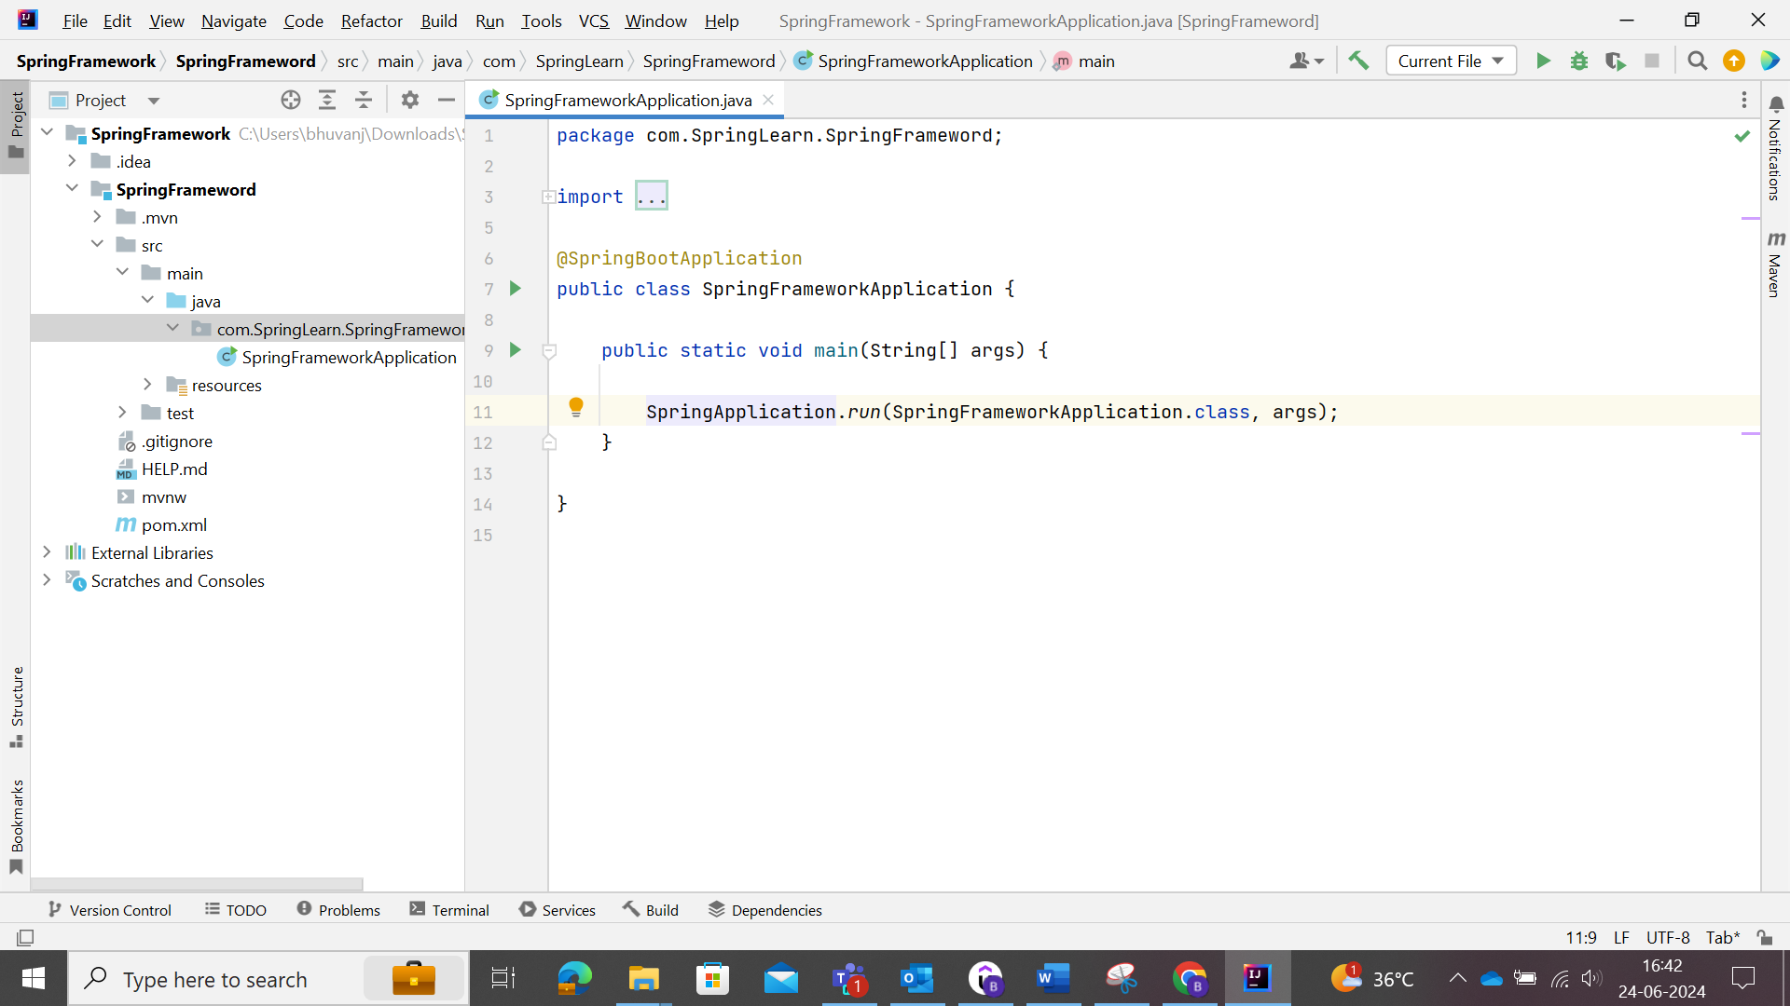

src/main/java 🡪 availability of source files.

src/main/resources 🡪 storing the configuration files.

src/test/java 🡪 writing the test code.

Iteration 1: Tightly Coupled Java Code

* GameRunner class
* Game classes: Mario, SuperContra, Pacman etc..,

We need to create the GameRunner class instance and launch the Mario in that class.

## Tightly Coupled and Loosely Coupled

Coupling: It is the amount of work involved in change in something.

Here, real time application example.

A change in engine in car is very hectic work 🡪 tightly coupled.

A change in wheel in car is easy comparatively 🡪 loosely coupled.

Since there is always changes in the requirements of the business, frameworks, and others, mostly develop the software in loosely coupled.

Game 1

Main Class

GameClass

Console <Interface>

<am

Game 2

Game 3

If there is no console(interface), then we must change GameClass frequently for getting the specific object of the game. Hence there will be lot of code change. So, it is tightly coupled.

Due to presence of interface, there is no need of change code for GameClass execution in main class and just need to update the specific object of the Game. So, it is loosely coupled.

## Wiring Dependencies

Making the access and connection of classes, interfaces according to the requirements.

Here, console (Interface) is a dependency of GameClass.

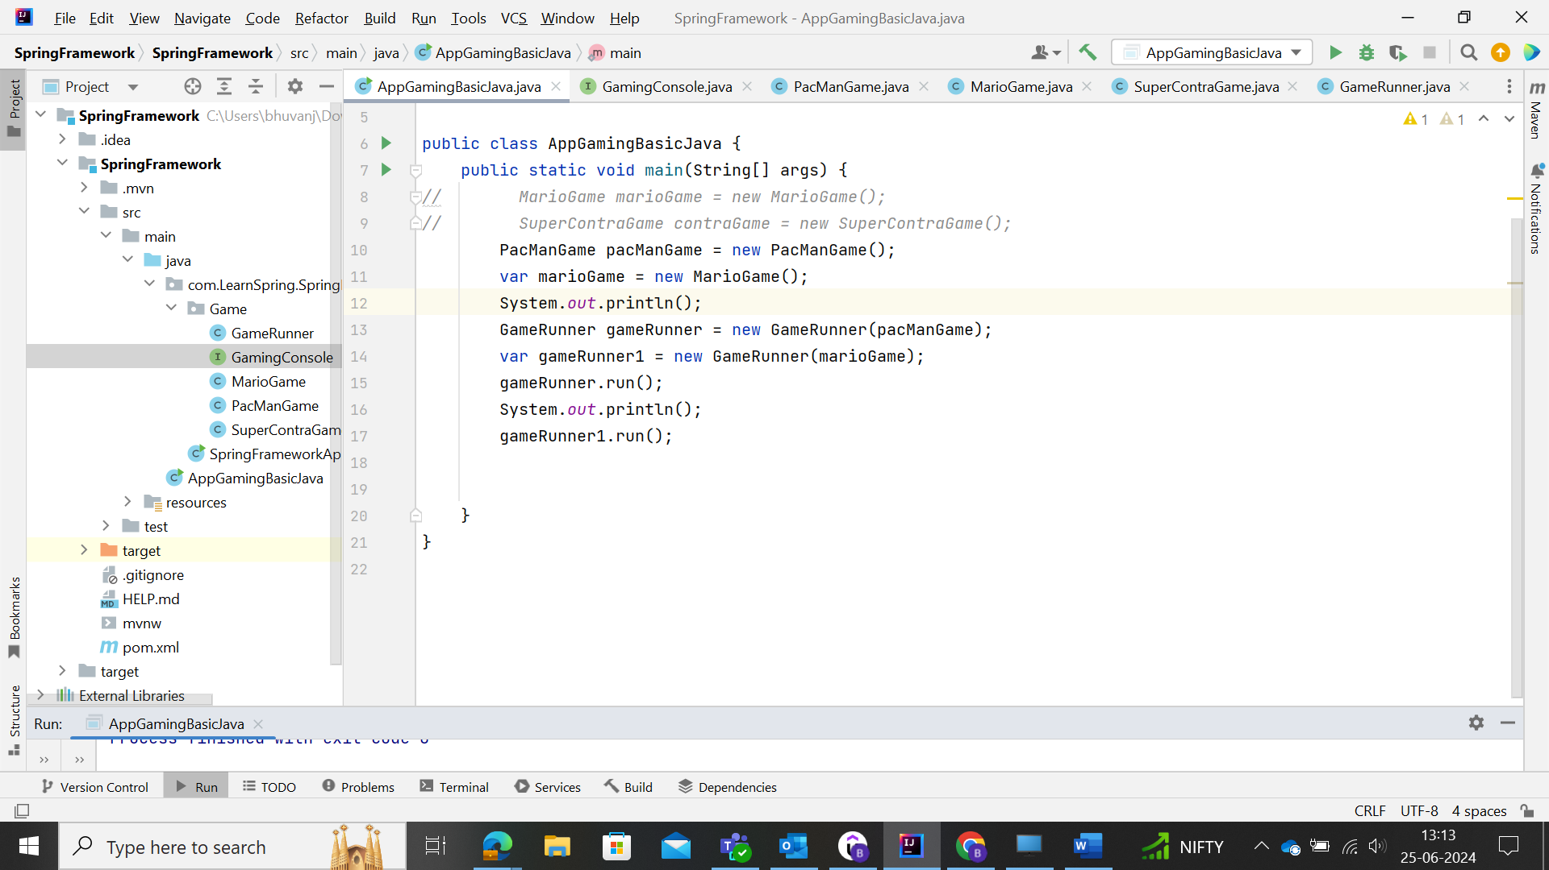

Here the dependency object marioGame is created and that dependency is injected or wired to the gameRunner class accordingly. In the above, it was made manually. This could be achieved by making use of Spring framework to do that.

For that, we must create the **JVM Spring Bean** appropriately.

1. Launch the **Spring Context**.
2. Configure the things that we want to manage them in the Spring.

The configuration in Spring Context could be done by **@Configuration** Class.

Launch the Spring Context 🡪 **@AnnotationConfigApplicationContext 🡪** Like GameRunner Class for running in the main class.

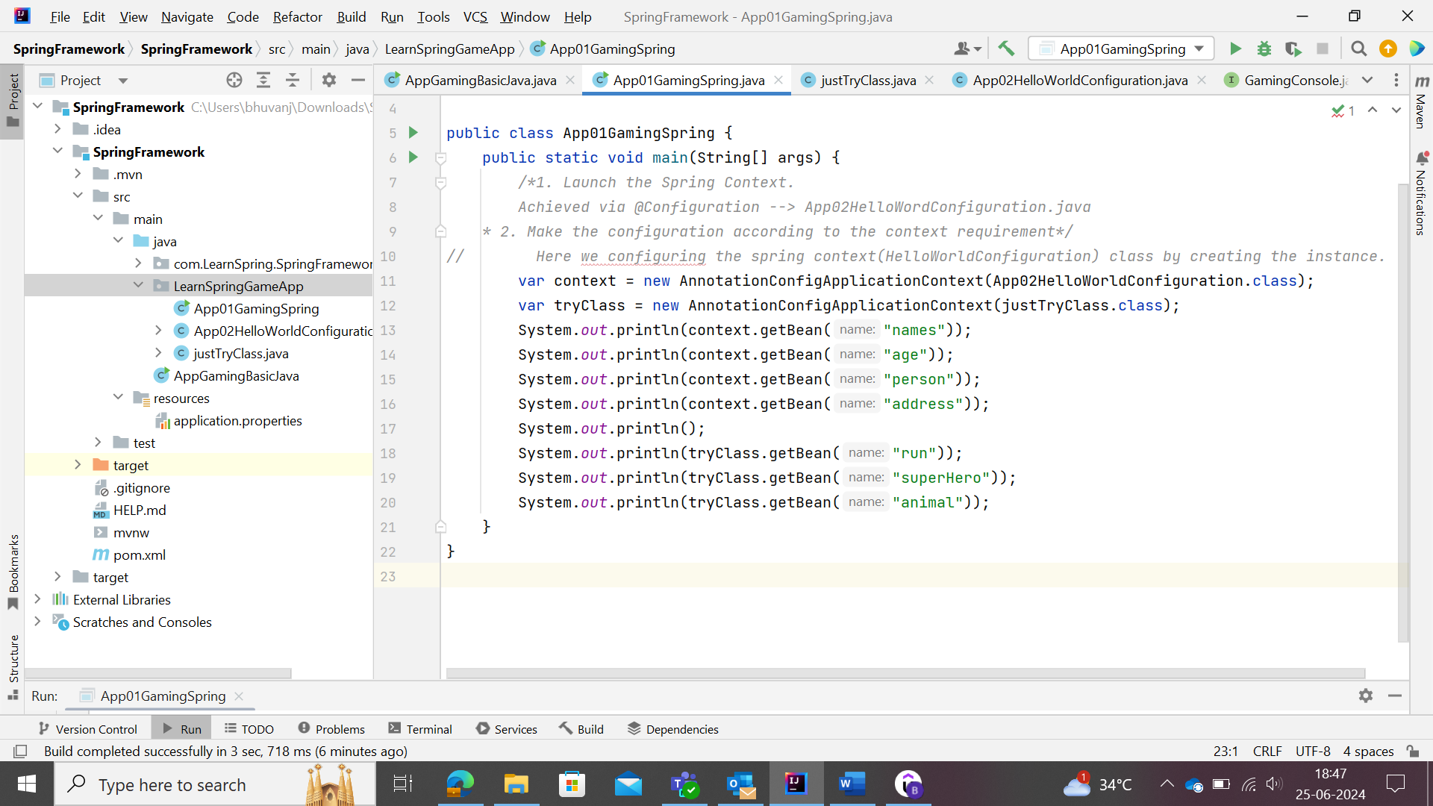

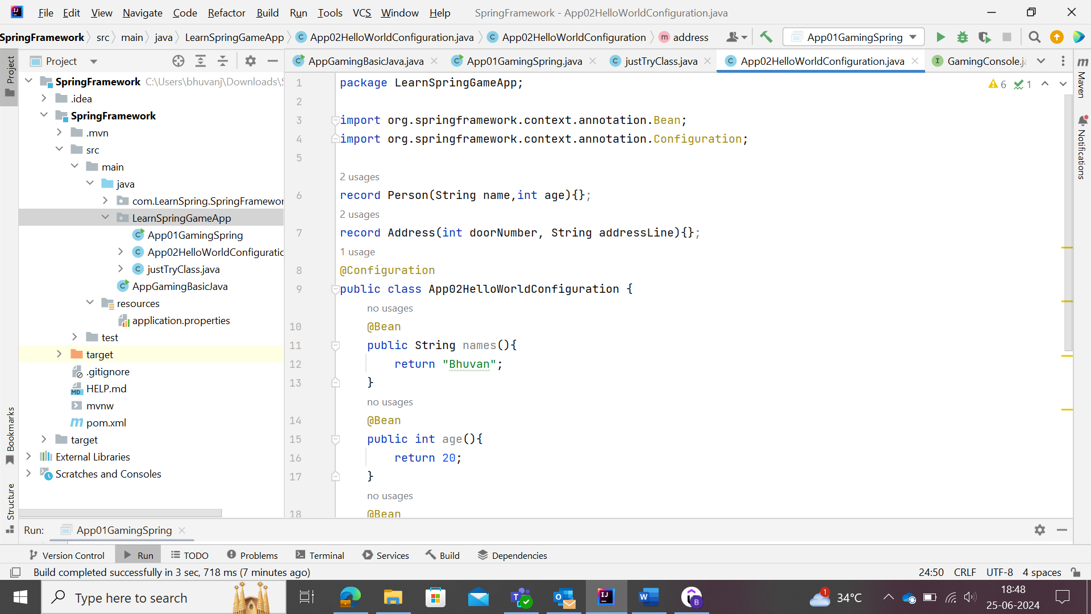

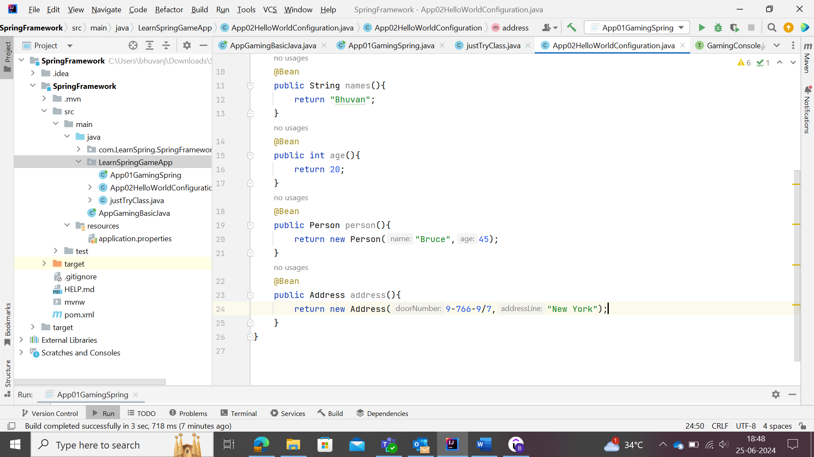

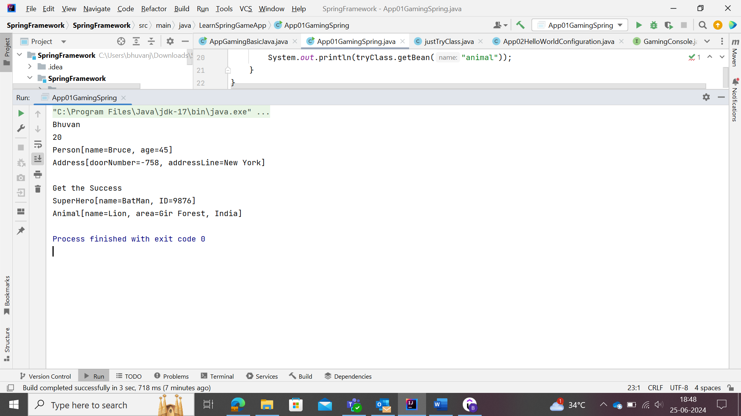

The bean call was done as by mentioning the method in the class. But this could be achieved by making use of Bean naming methods.

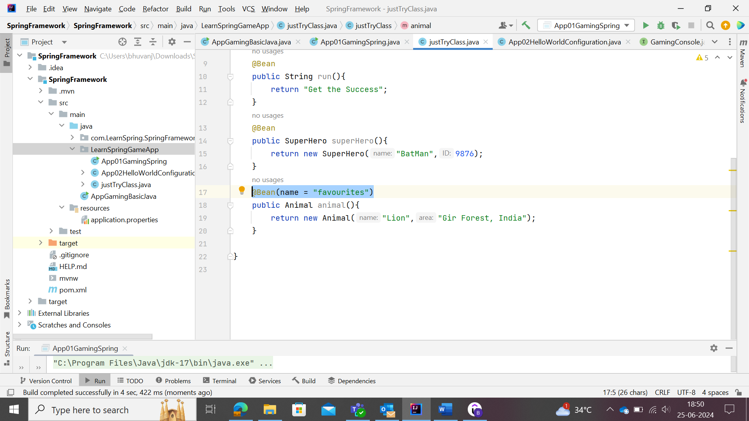

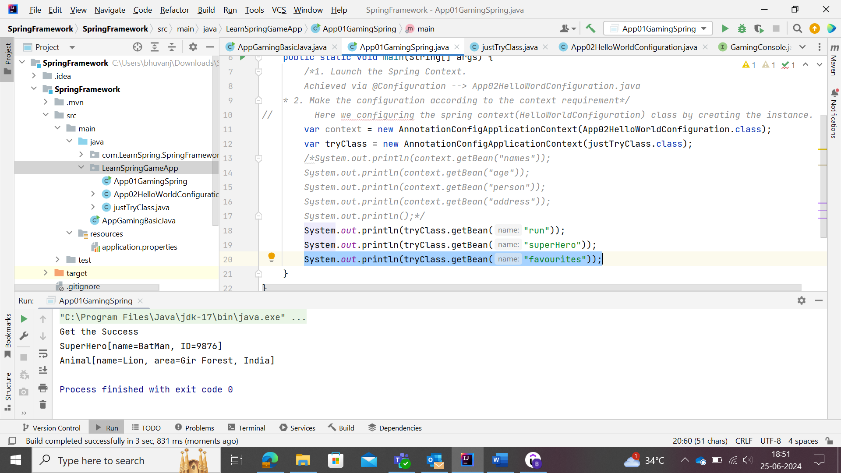

Spring Bean 🡪 it is Java Object which is managed by Spring Framework. The Spring Framework which is used to manage these beans (objects) are termed as “Spring Context or Spring Container or IOC Container.

Listing all the beans managed by Spring Framework

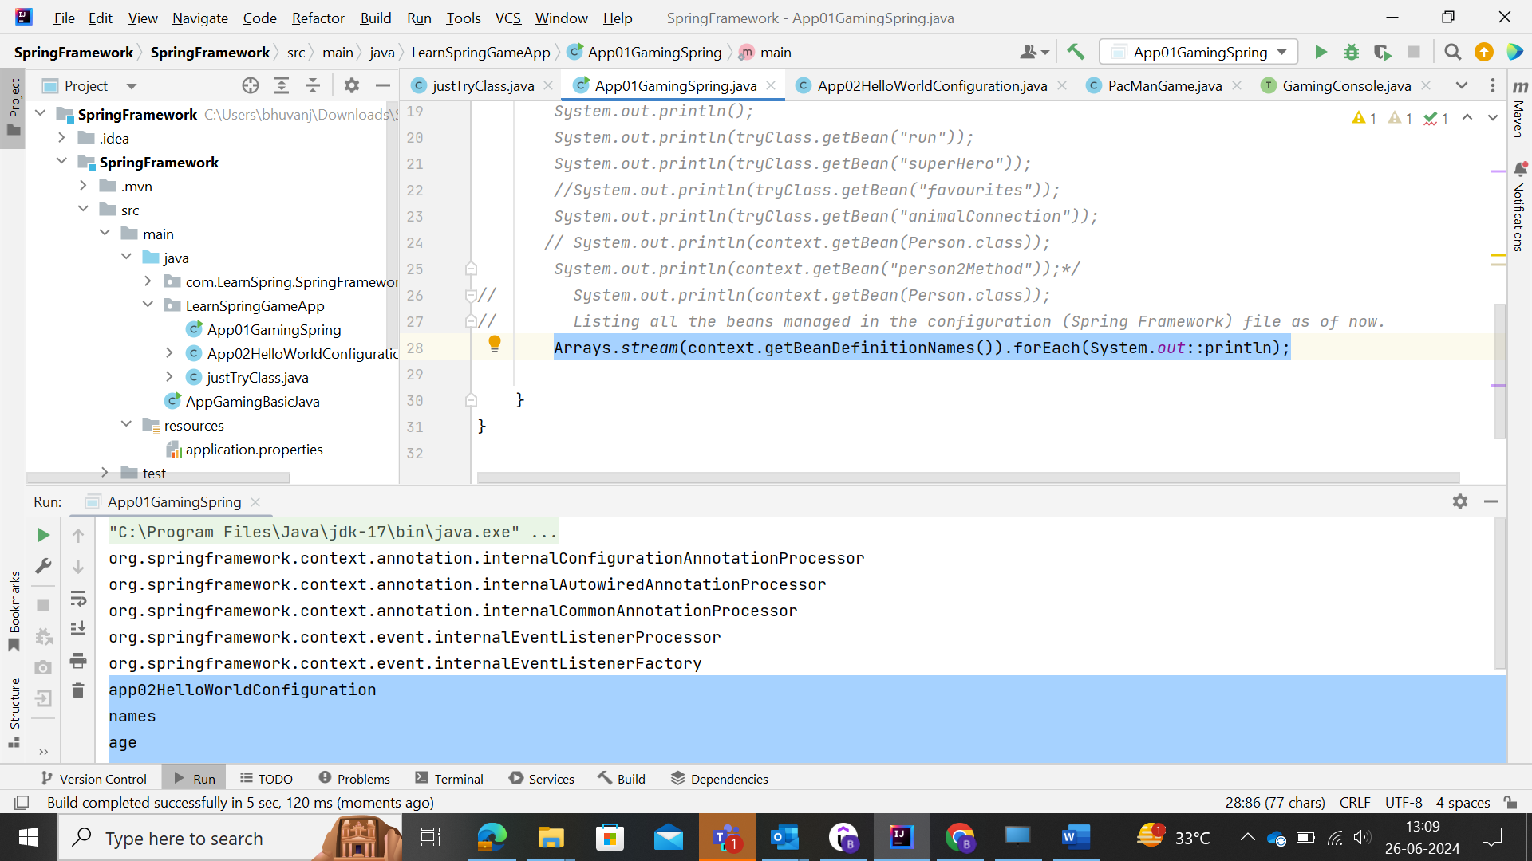

Here ***context.getBeanDefinitionName***() 🡪 returns the list in the String Array format. So, this could be make use of loop format and printed as above.

*Arrays.stream(context.getBeanDefinitionNames()).forEach(e->System.out.println(e));*

*Arrays.stream(context.getBeanDefinitionNames()).forEach(System.out::println);*

Two annotations are used to access the beans with the same class objects could be executed.

One could be making use of @Primary annotations and another one is @Qualifier(“Name”) annotation.

@Primary 🡪 will make that mentioned bean as primary and executed as first with respect to the similar other beans

@Qualifier 🡪 user need to auto wire that bean to respective object.

Without Primary:

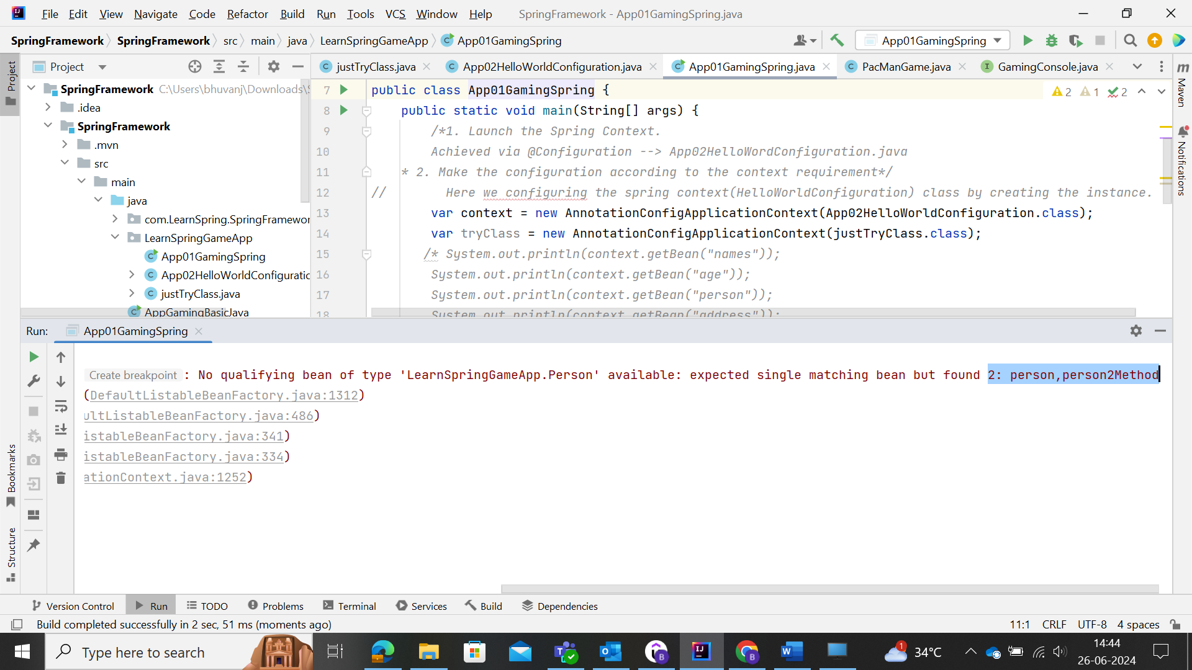

With primary mentioned Bean

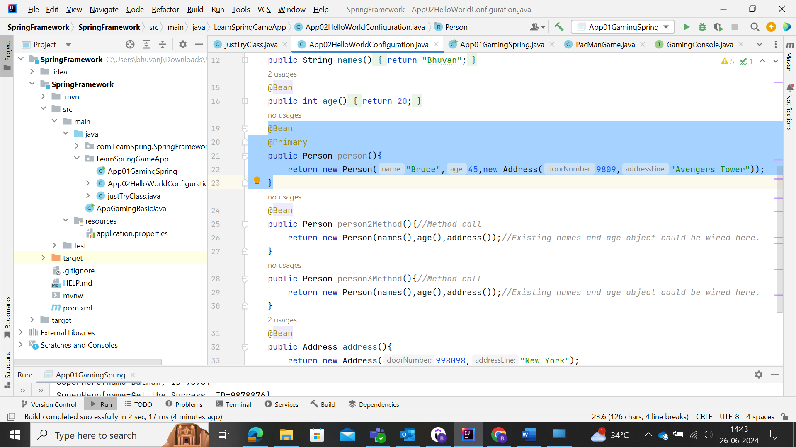

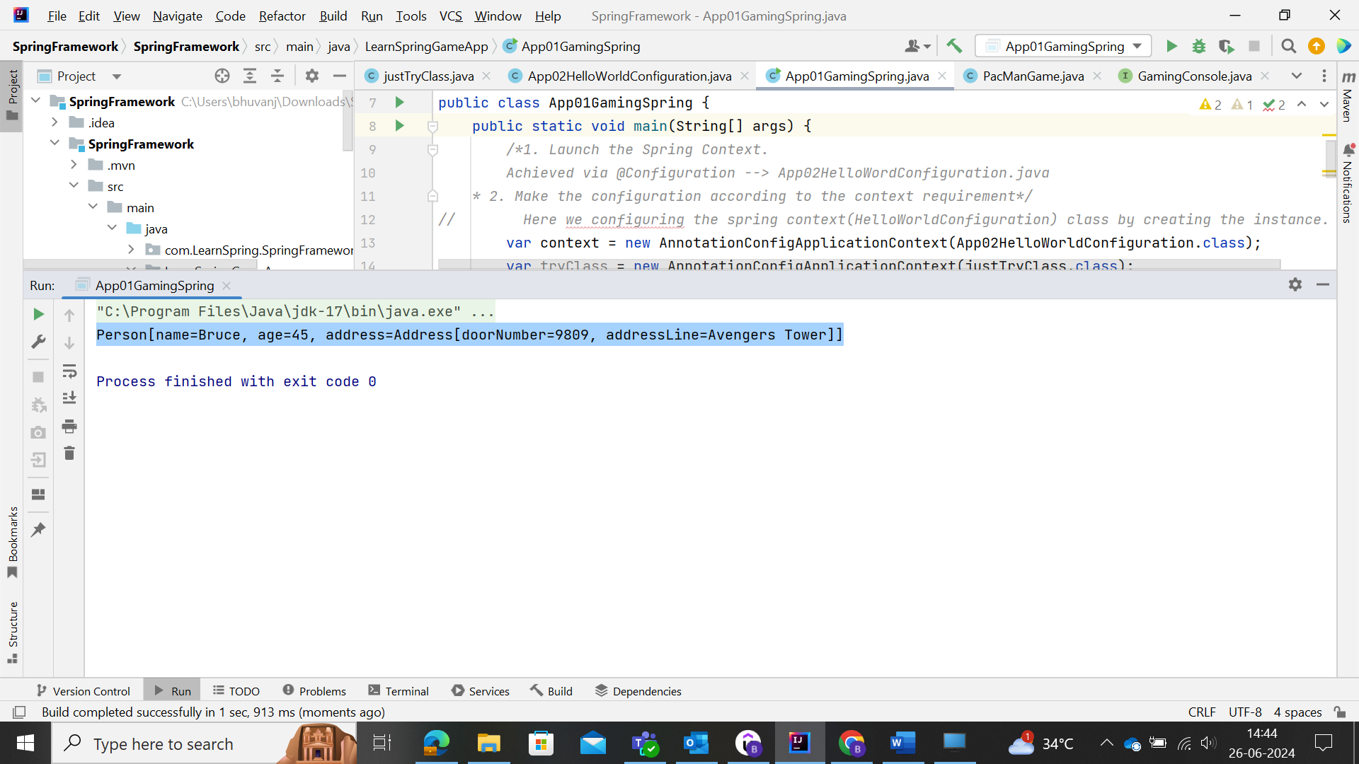

Mentioning another Bean as primary

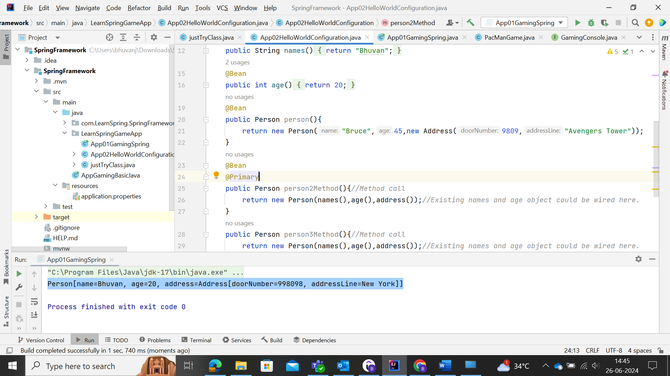

Now with Qualifier in Address Bean

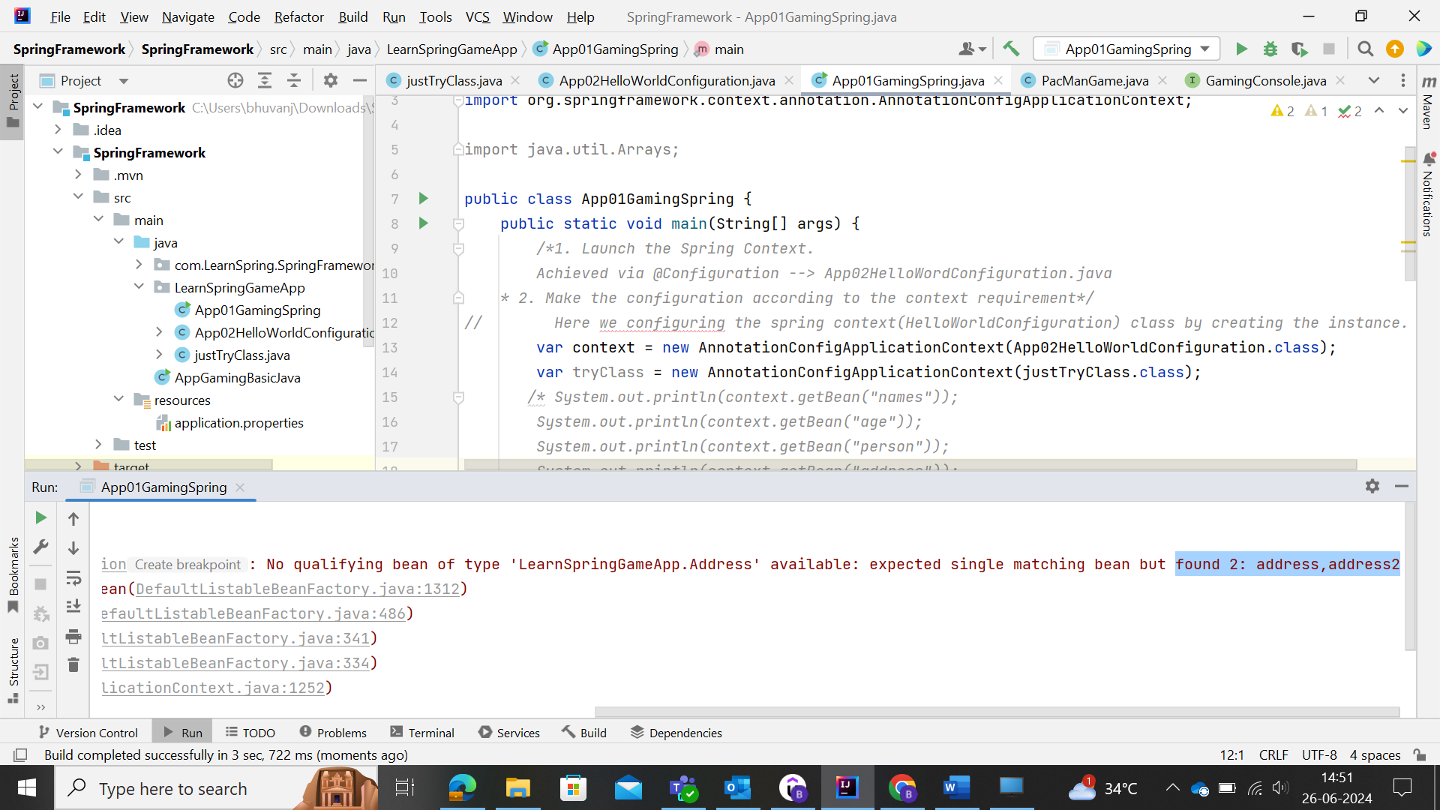

Configuration files are class with Spring beans.

Main Class for the execution of the Frame

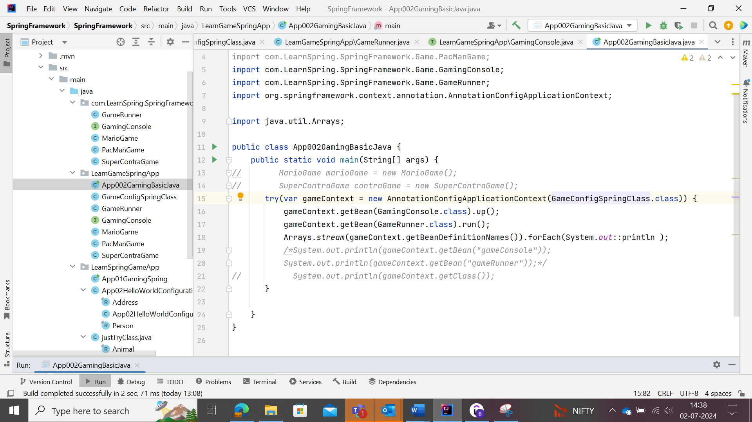

Configuration file for creating the beans to execute in the Spring Context (main) class.

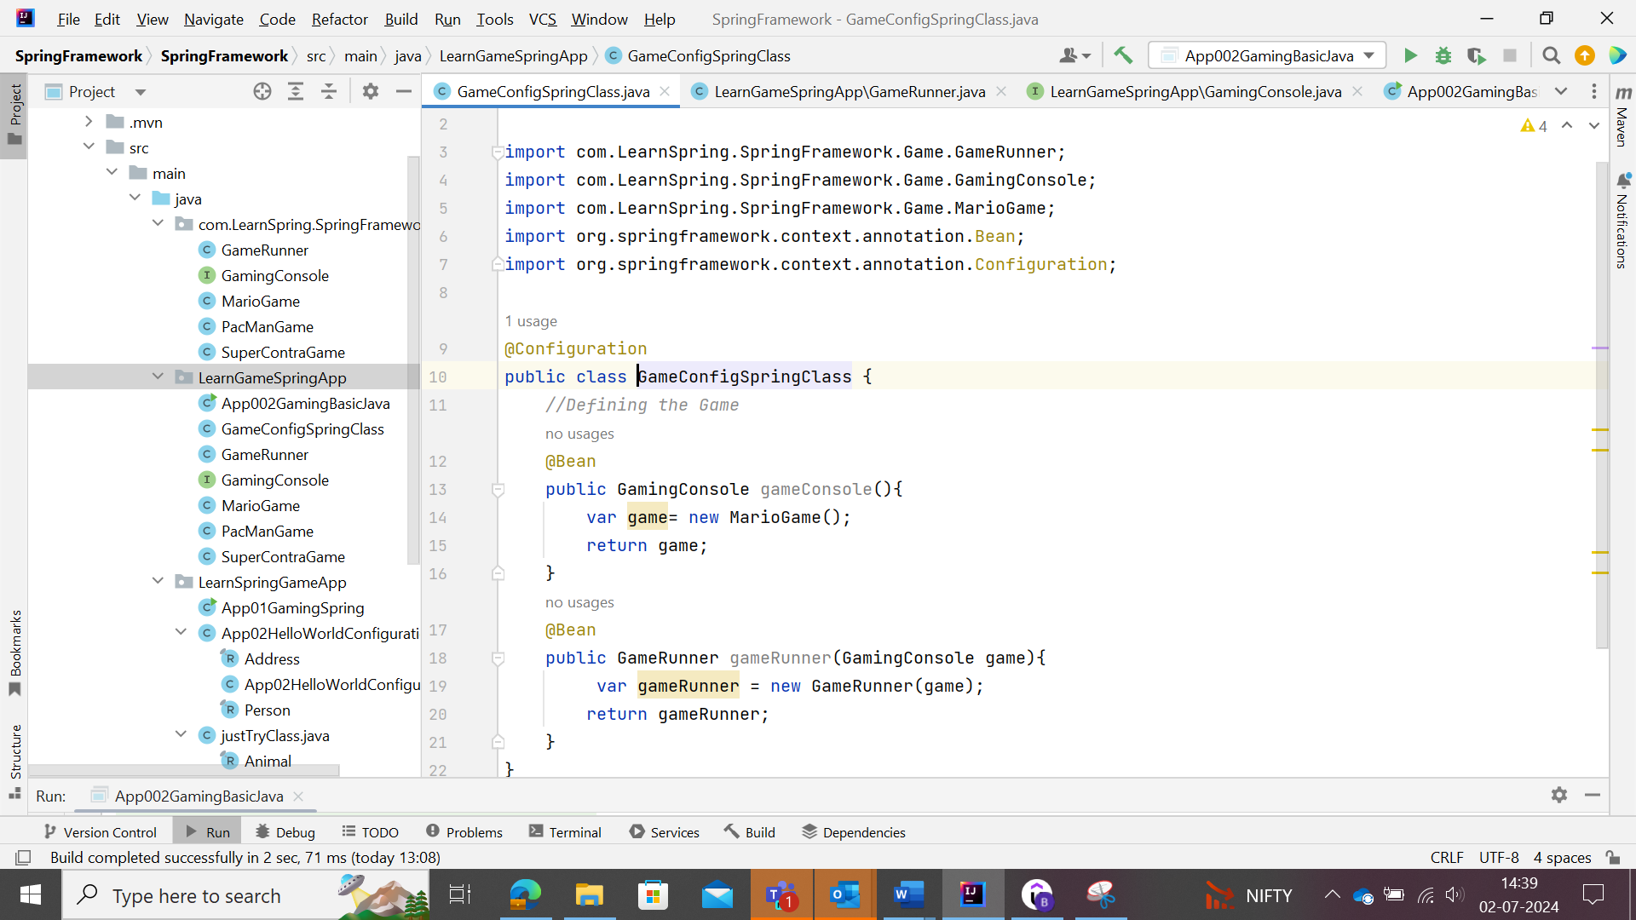

In the above, the object of Gaming Console is created, and that object is being executed while creating the object for GameRunner class.

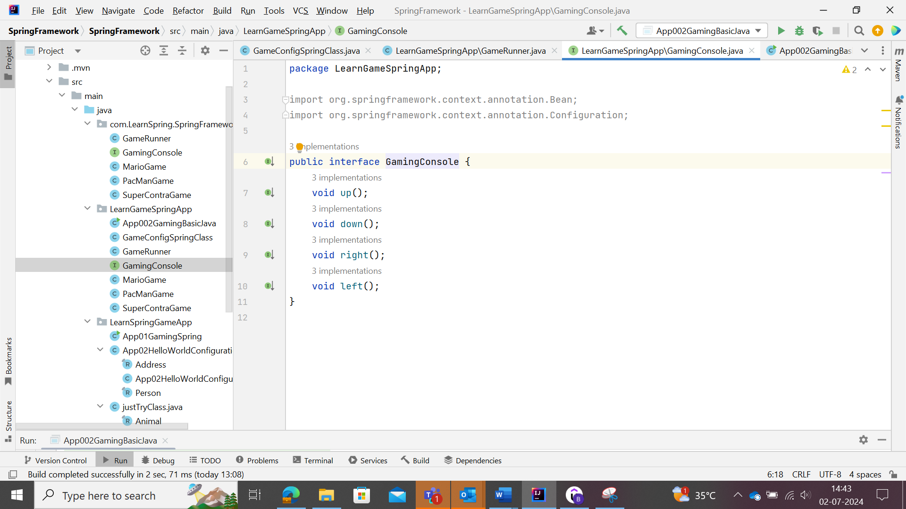

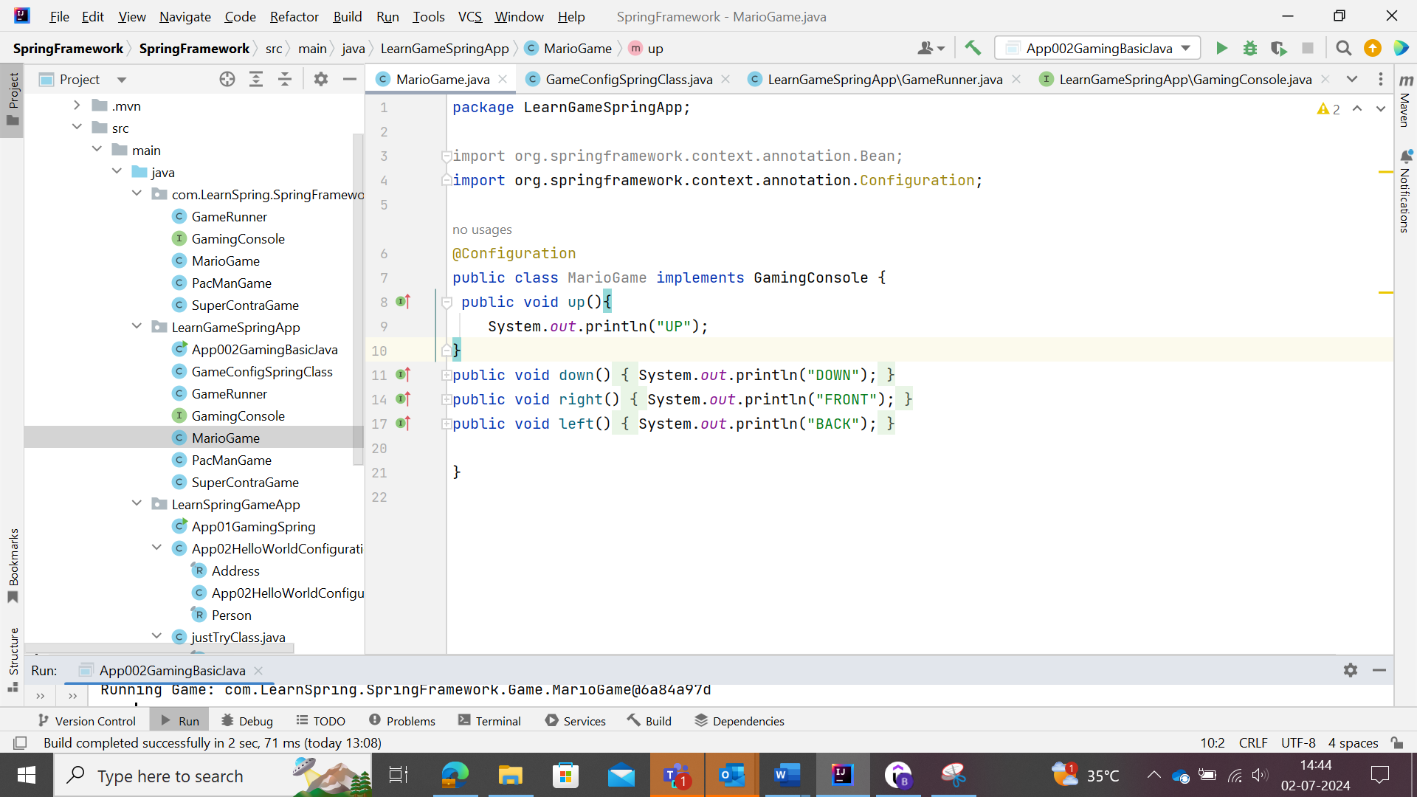

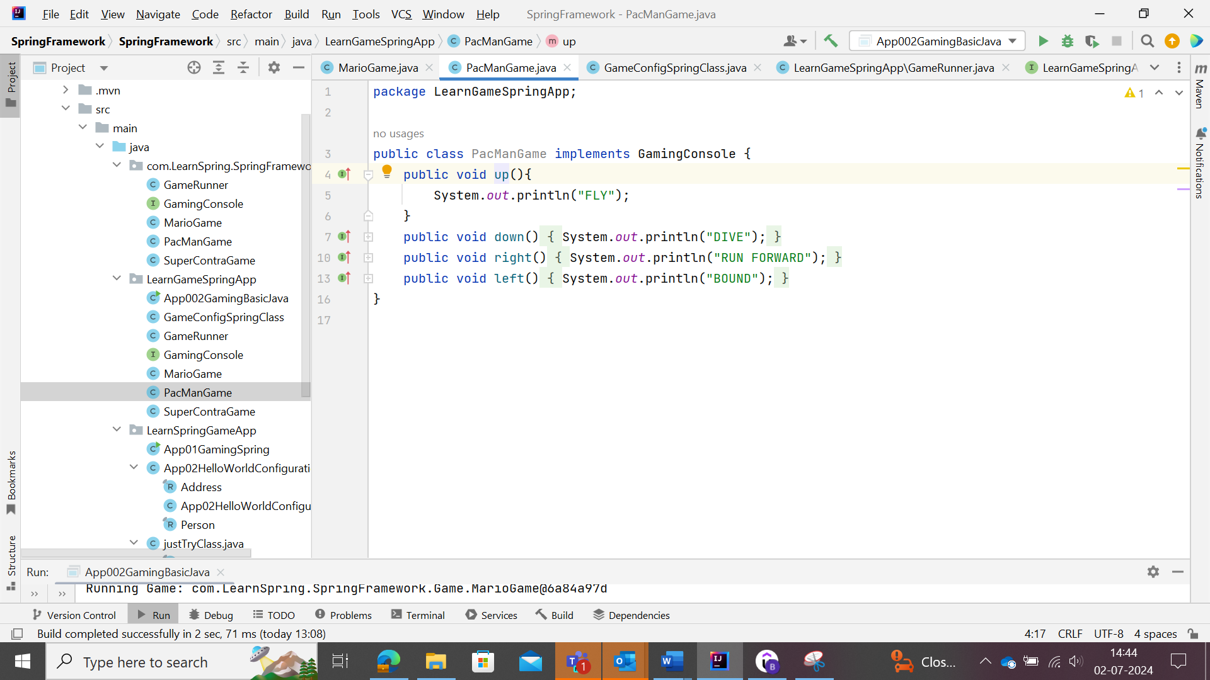

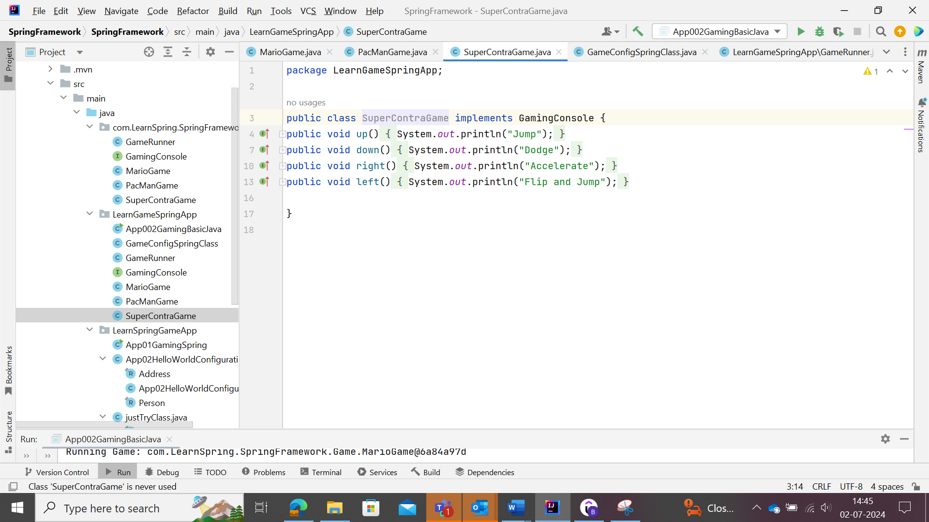

Creating beans without manually entering @Bean using the Spring Framework.

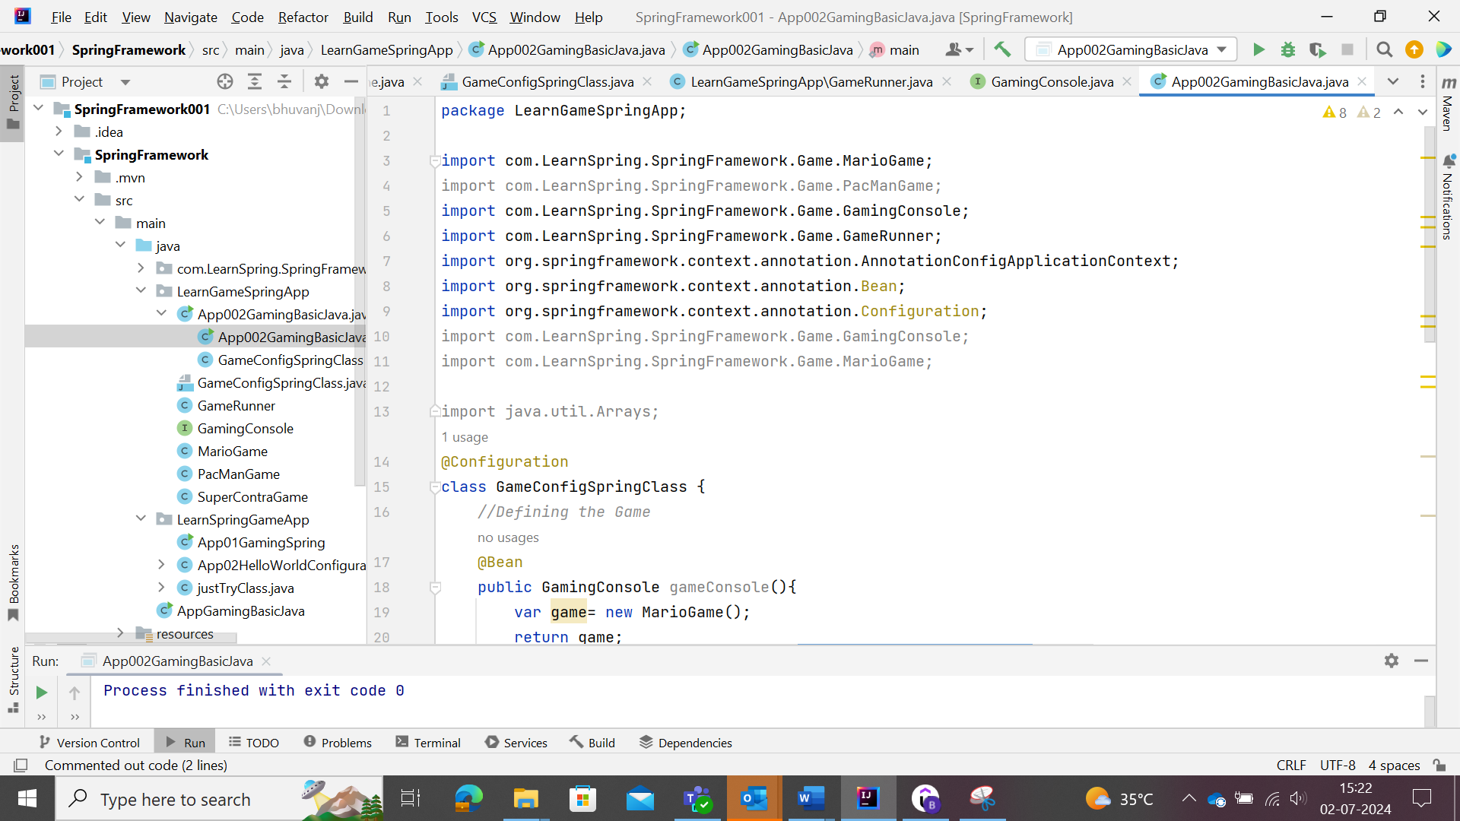

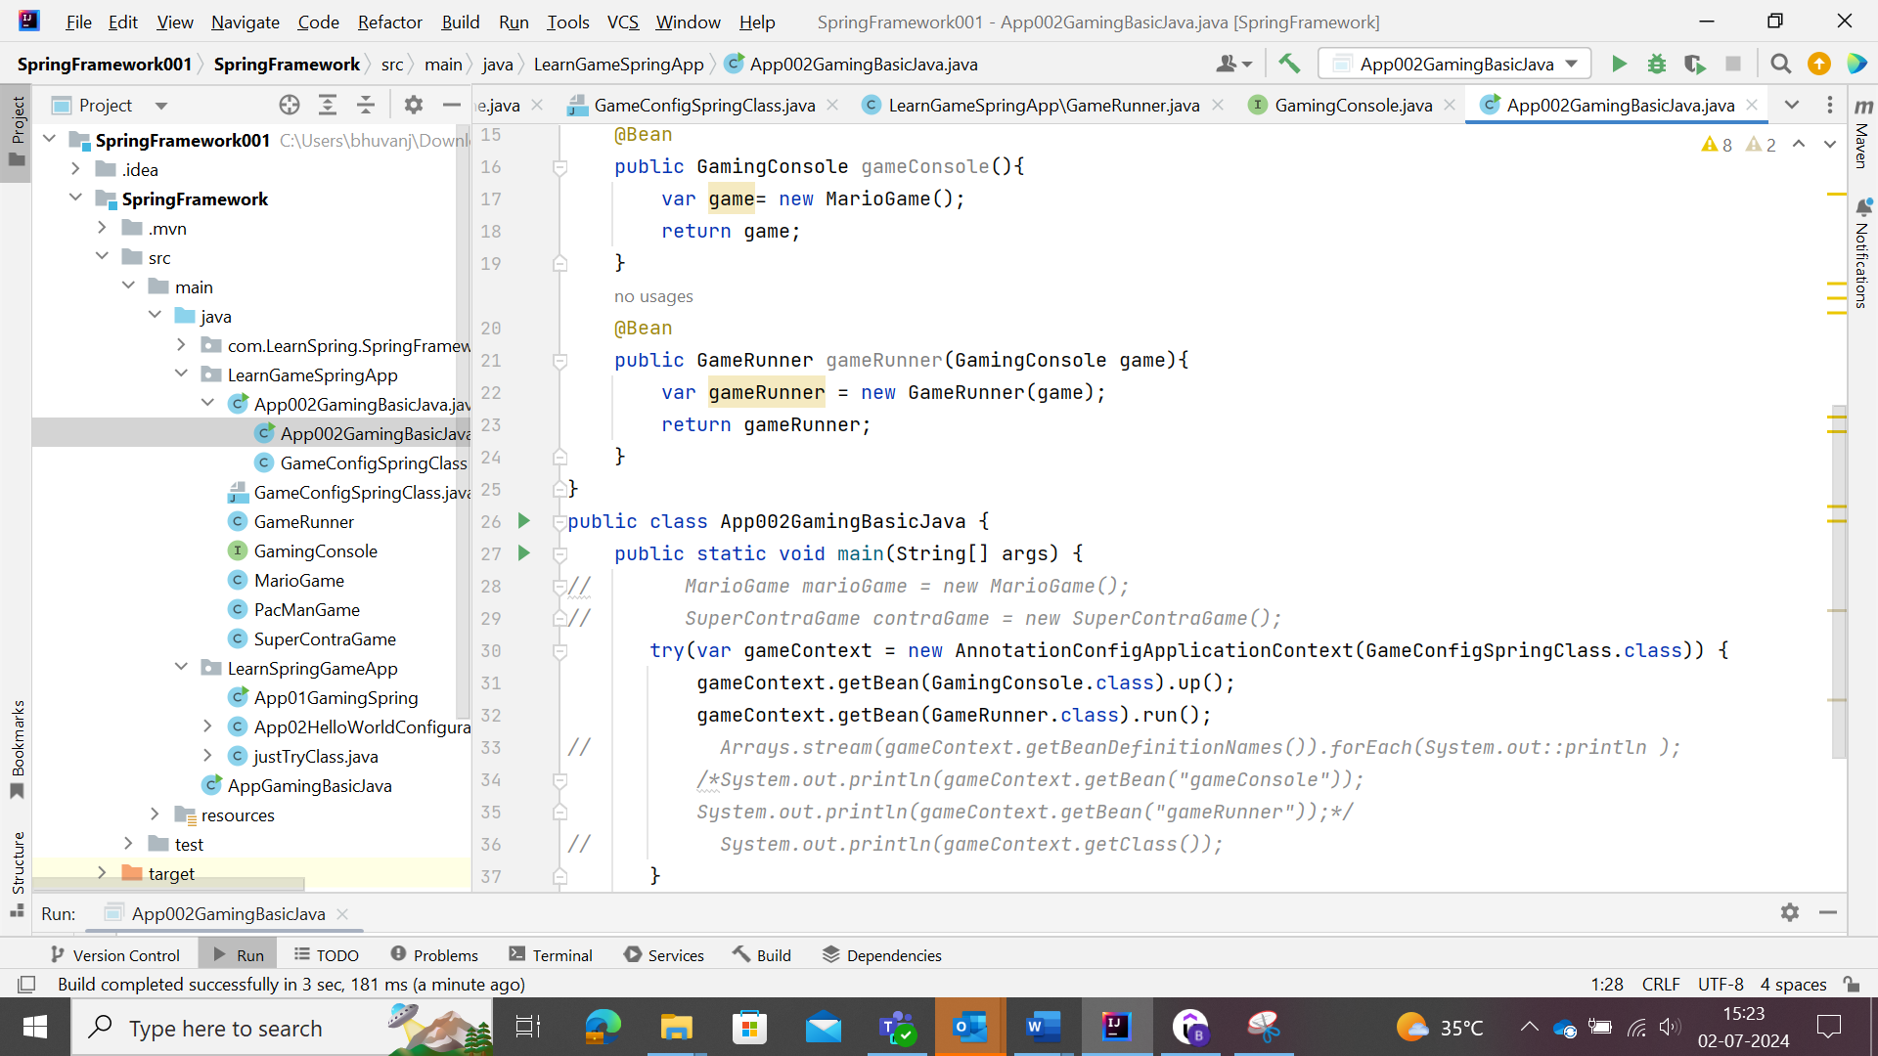

The spring could create the object for particular class or interface by making use of the @Component annotation which will create objects for that class or interface.

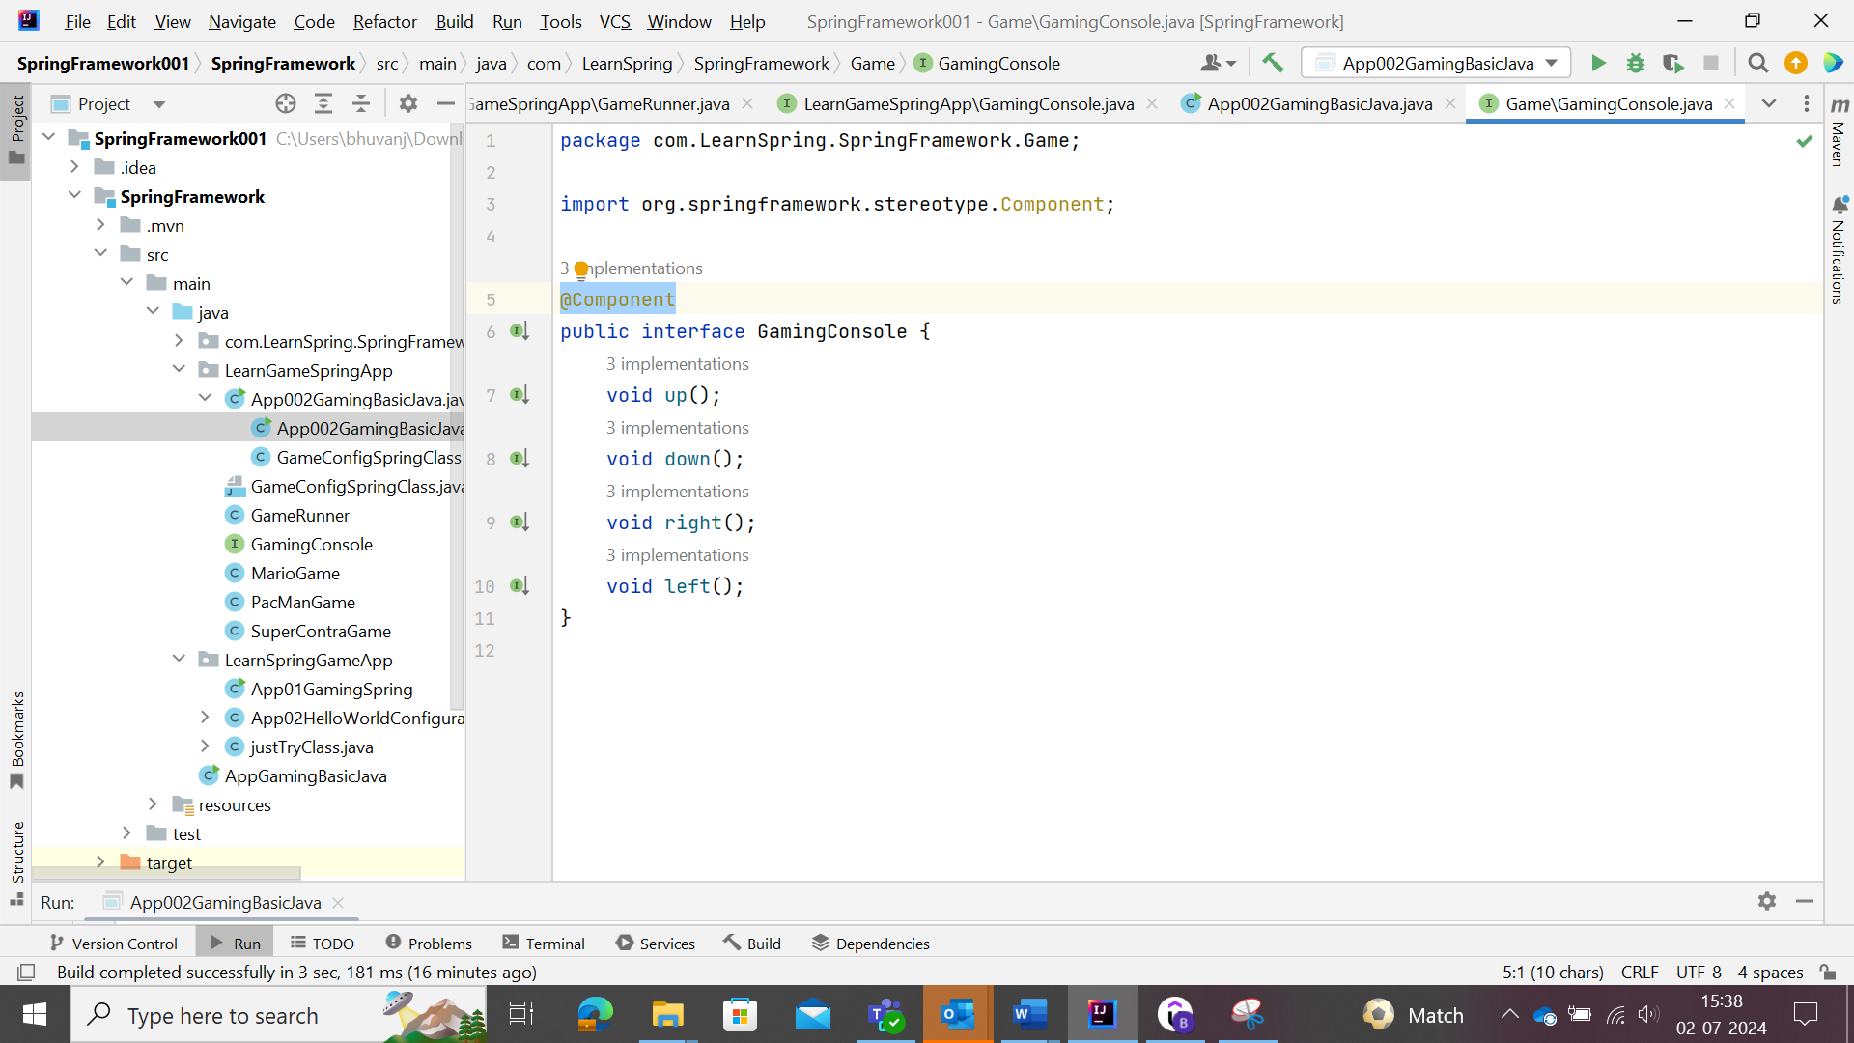

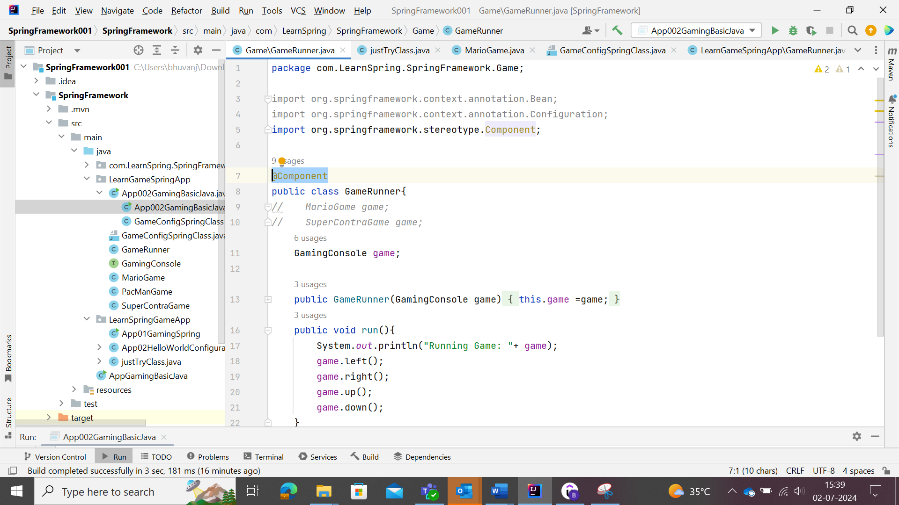

In main class, user needs to define from which package , the class or interface objects need to be created. This could be achieved by making use of @ComponentScan(“Package Path”) in the main class.

Change to the main class

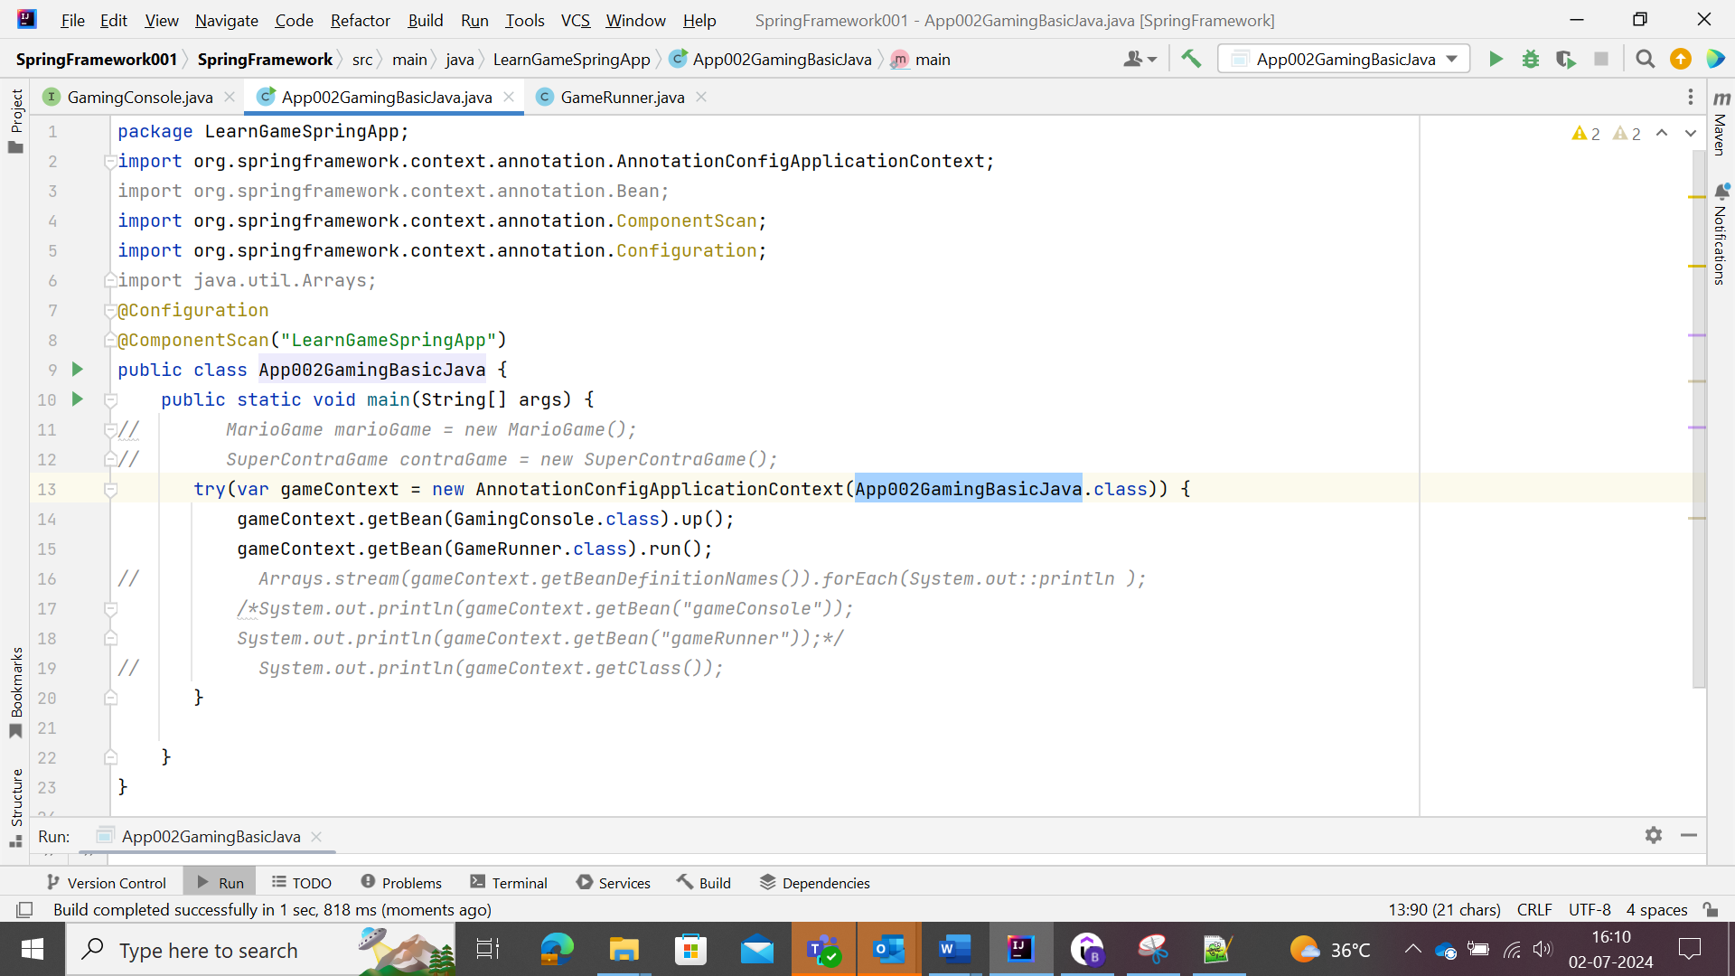

Here we could see that the Config class was removed, hence there is a reduction in code and the object could also be created as bean through Spring automatically.

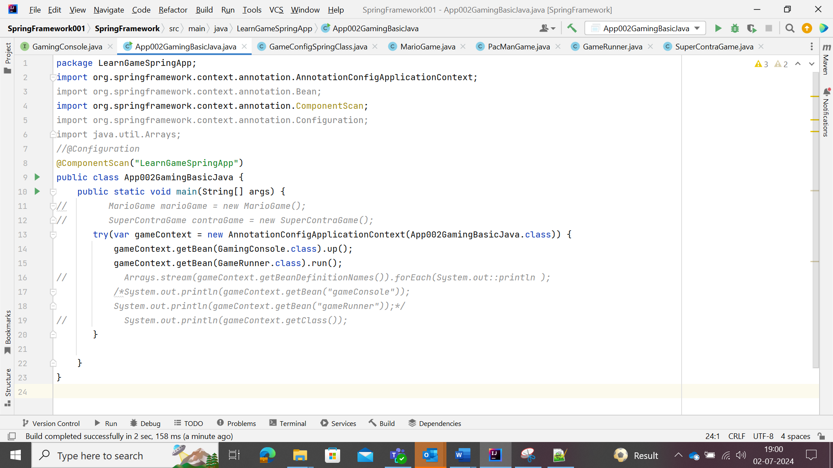

@ComponentScan(“Package_name”) get the class/interface whatever in the package, it will fetch the @Component Annotation packed class/interface available in it.

Error/Logical error: Manual Bean in the @component class/interface leads to the implementation of the specified bean irrespective of the component and the method called with @ComponentScan(“Package_name”).

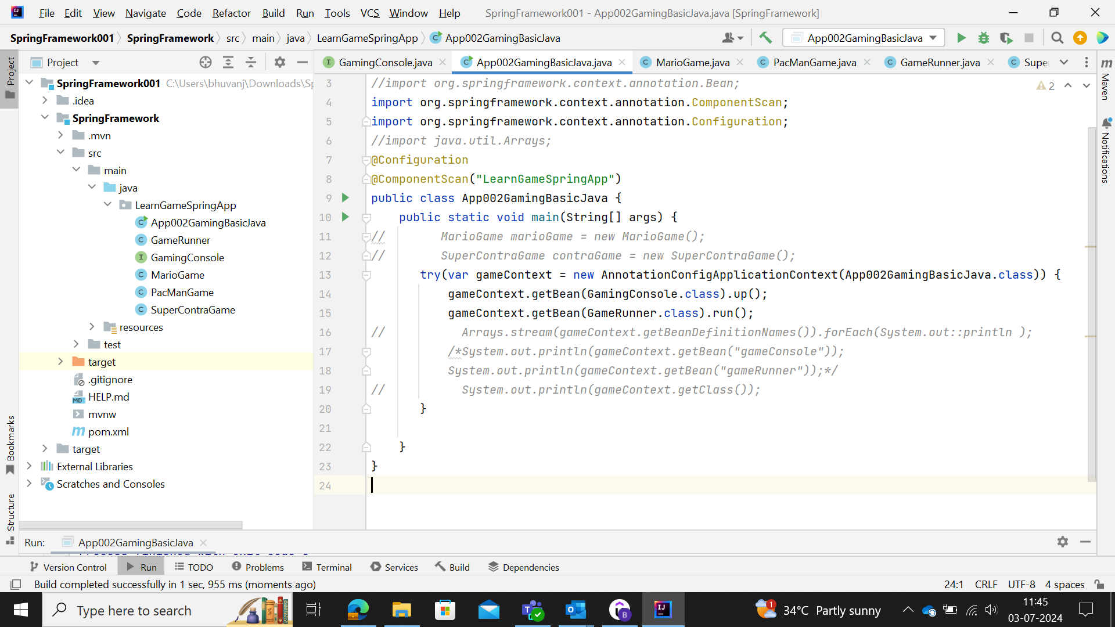

Here both Configuration and Spring Launch context class is same.

The GameRunner and MarioGame are in same package and hence @ComponentScan(“Package_name) updated once which scan and get the @Component created objects accordingly.

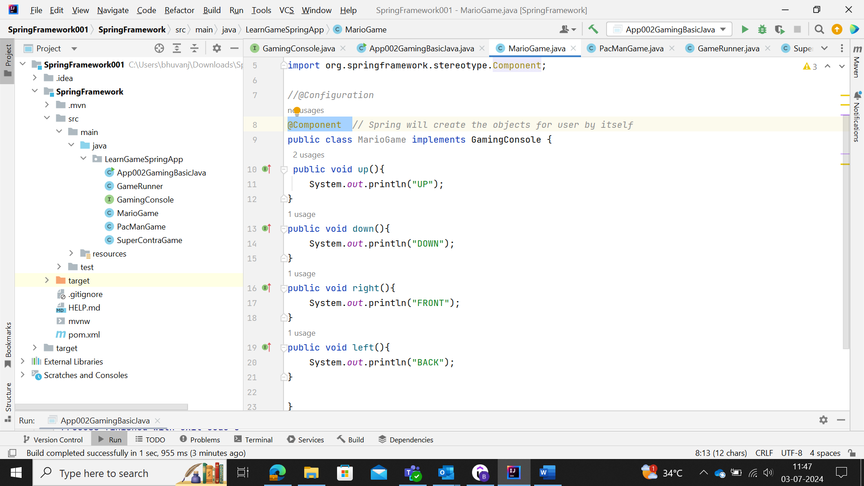

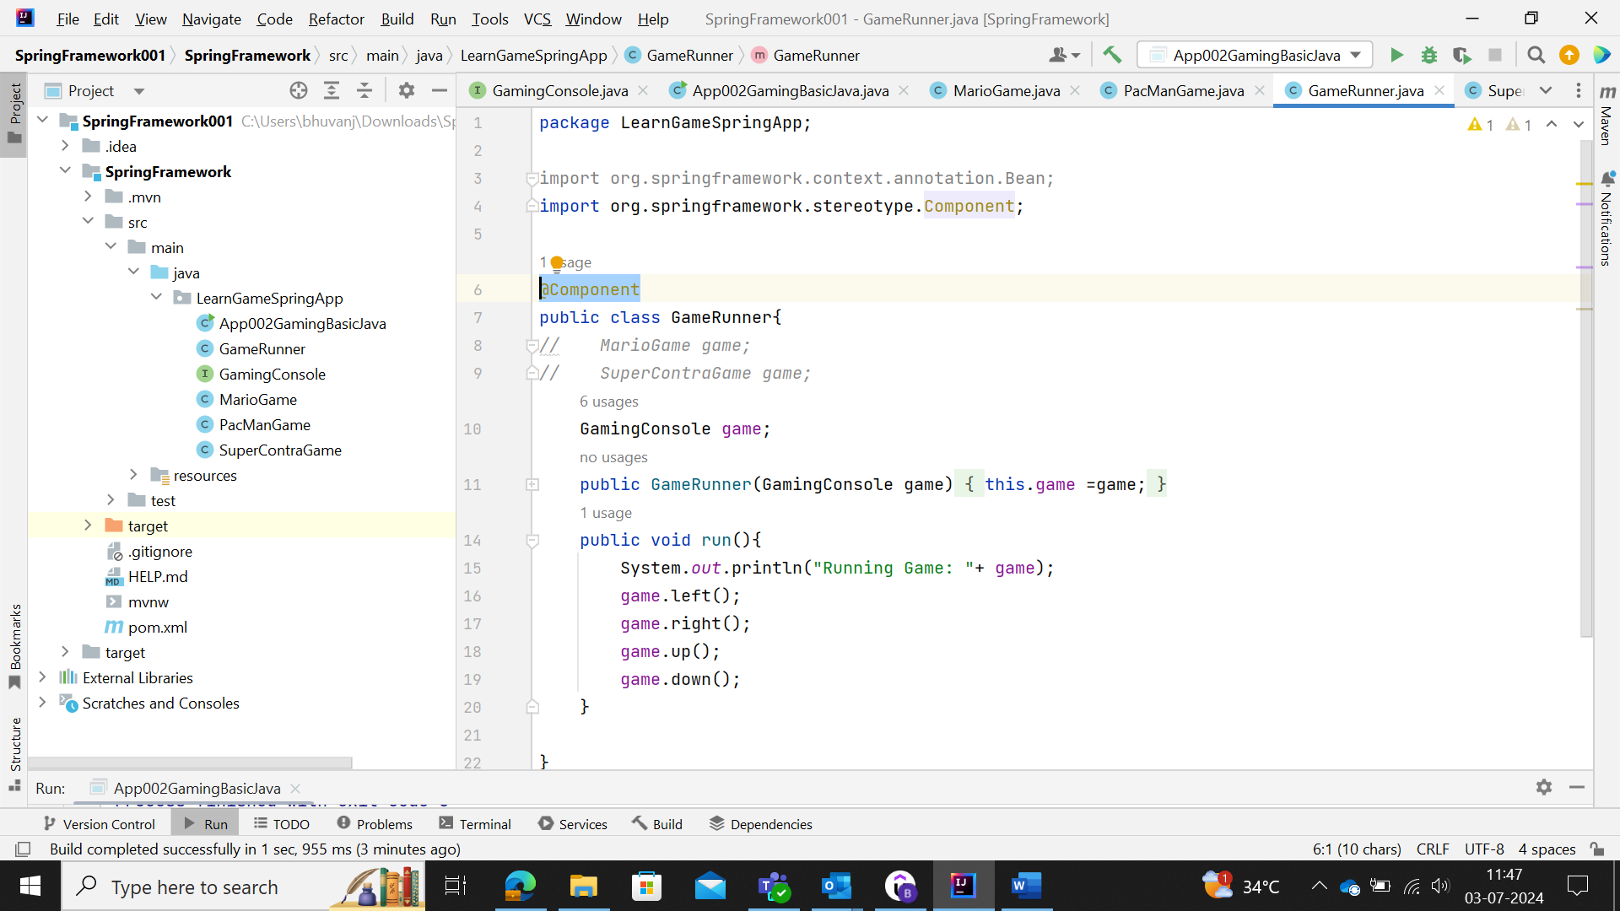

If we update more than one objects/bean for the same interface to be updated, then user will find the below error

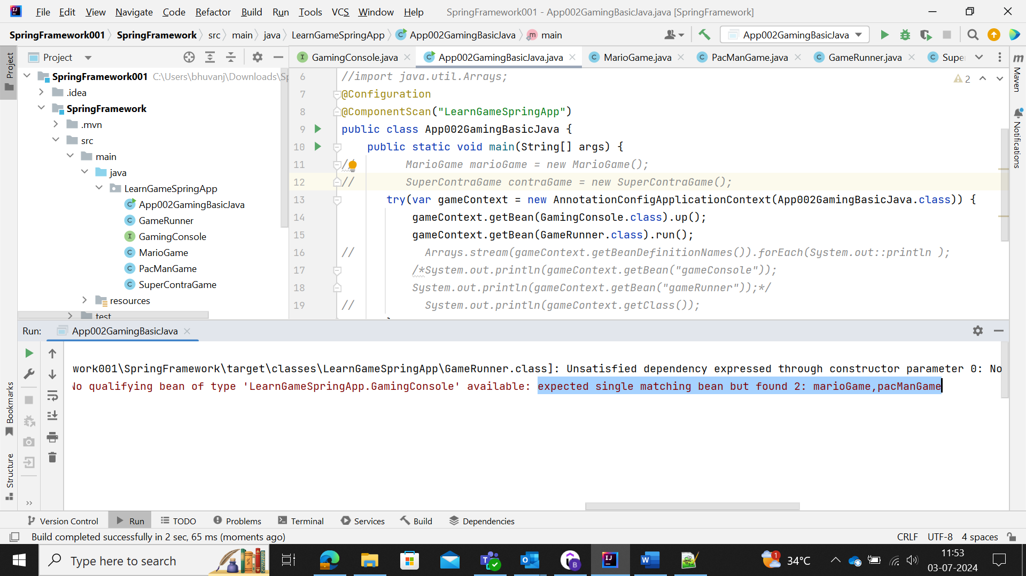

MarioGame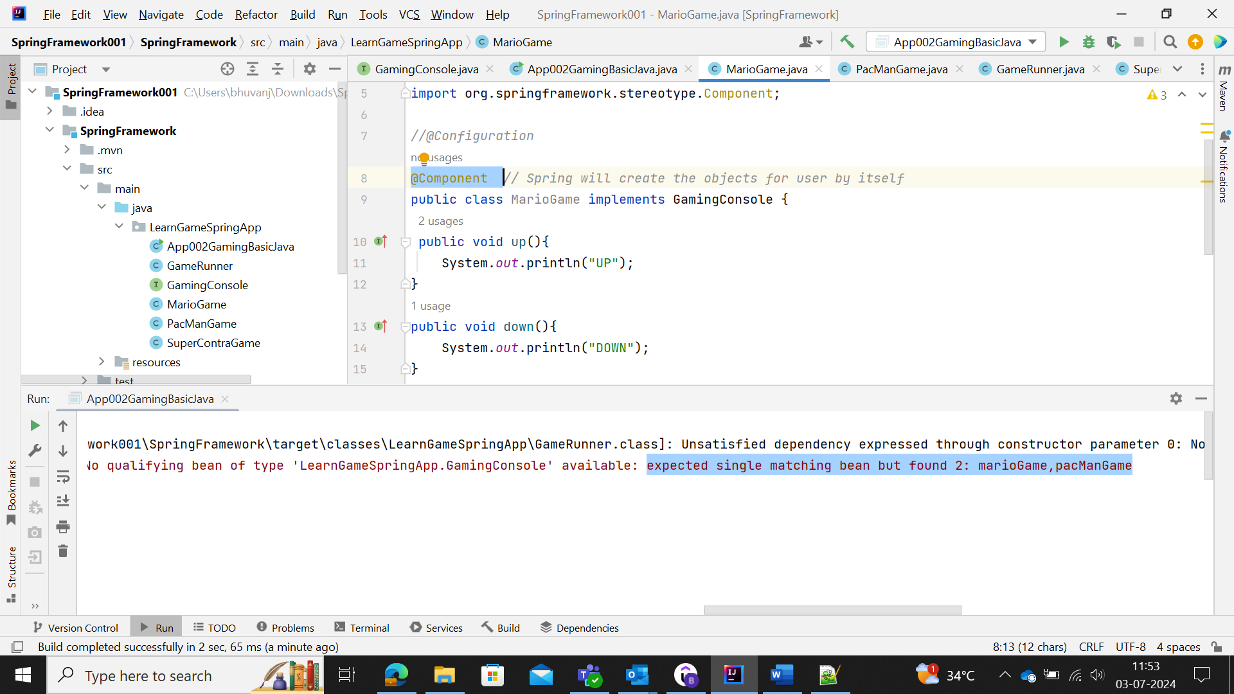

PacmanGame

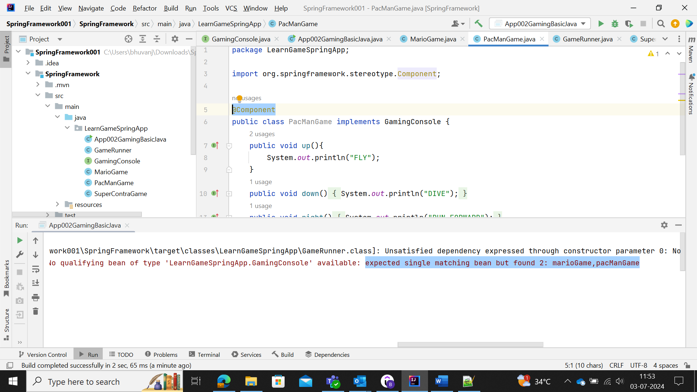The above is termed as NoUniqueBeanException error.

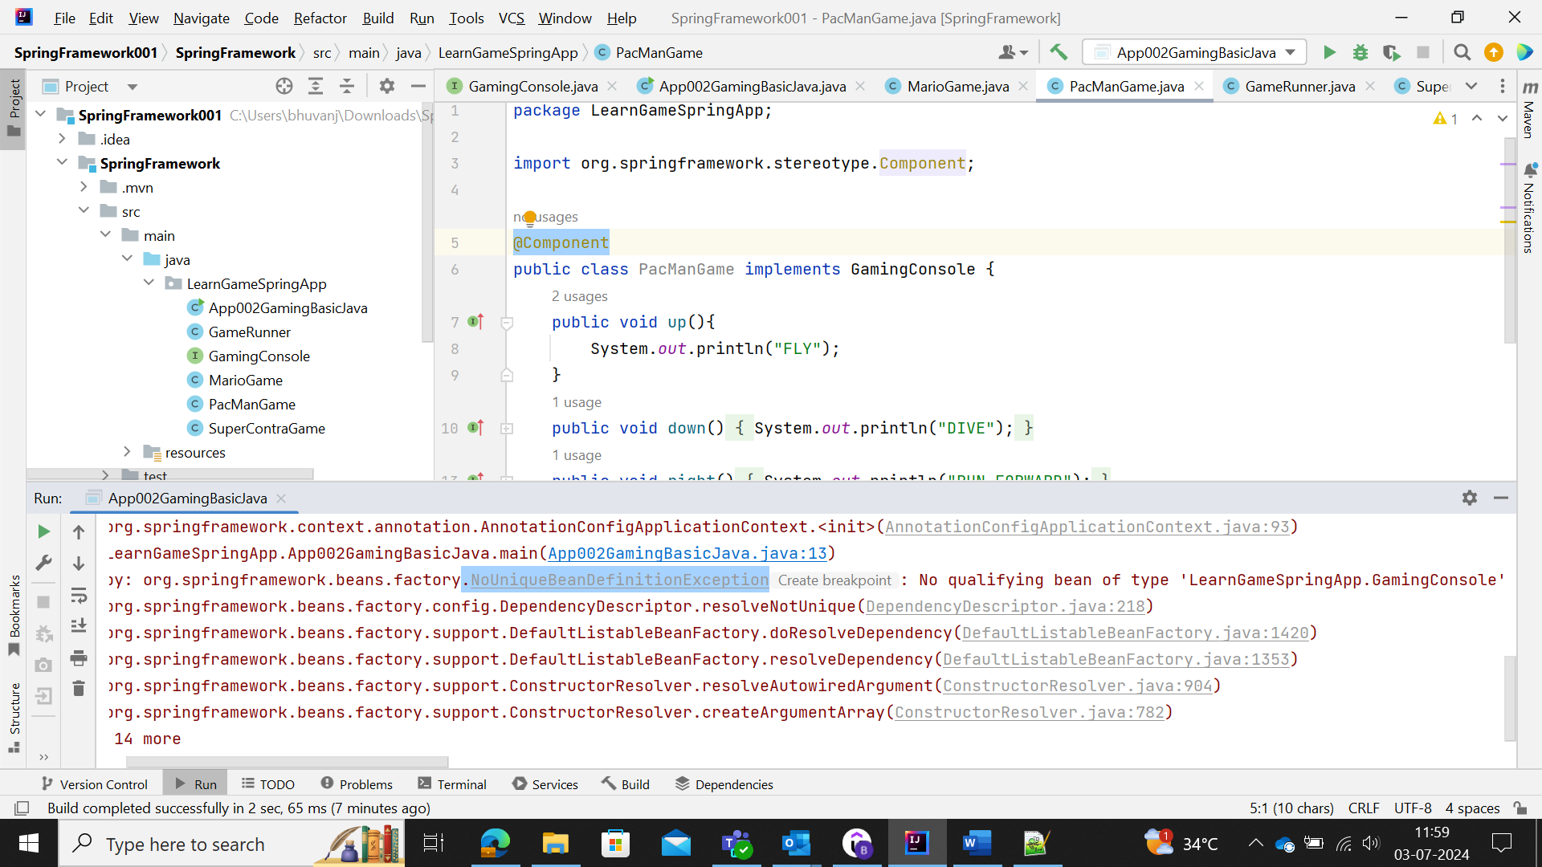

So, remember whenever multiple beans comes to role, then the bean could be implemented by making use of **@Primary** annotation.

Here primary is given to PacMan Game, so PacMan will execute

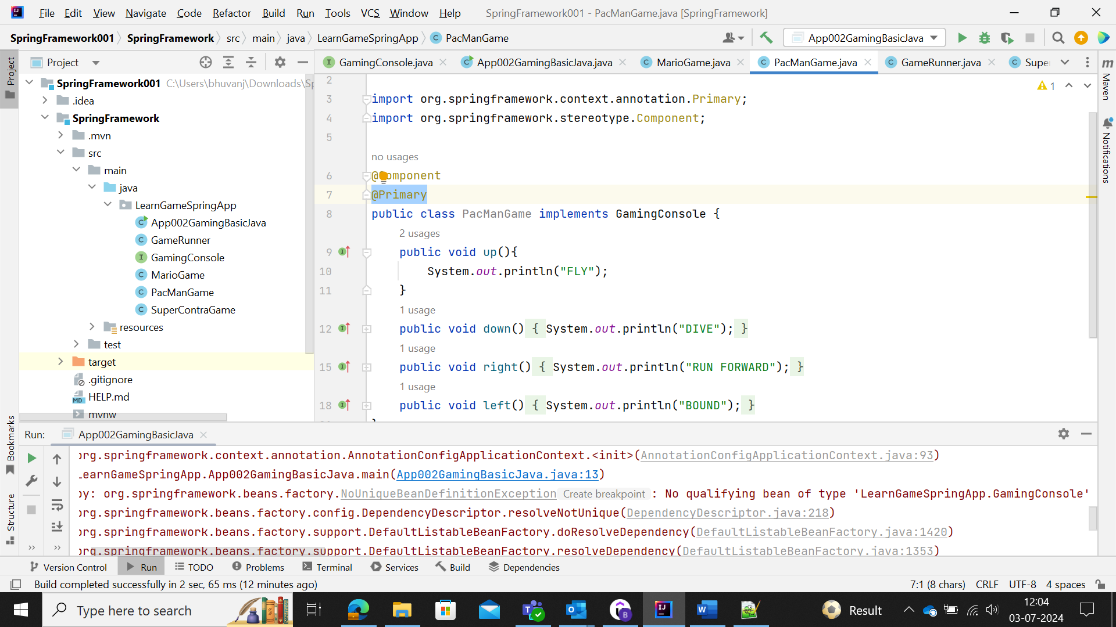

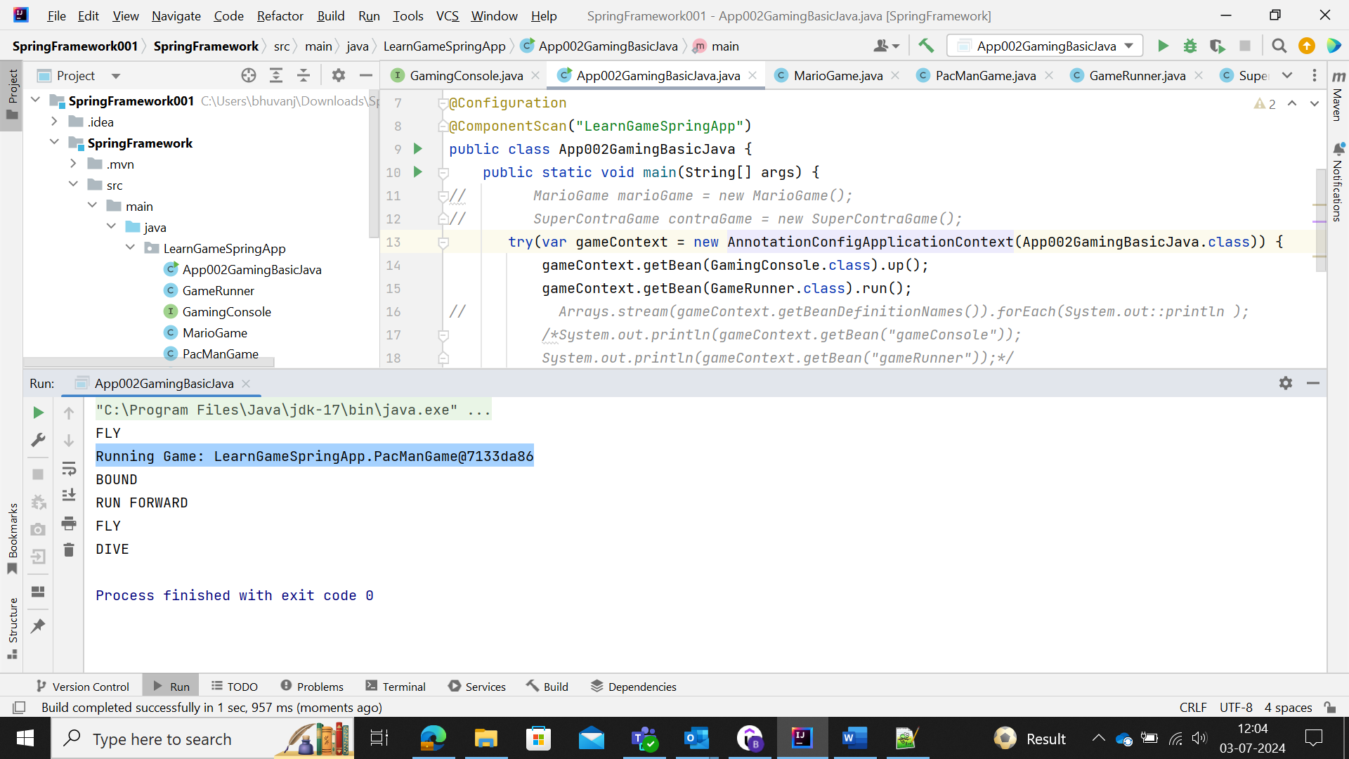

But when the Primary is PacMan, but the preference is MarioGame, then @Qualifier annotation comes to play.

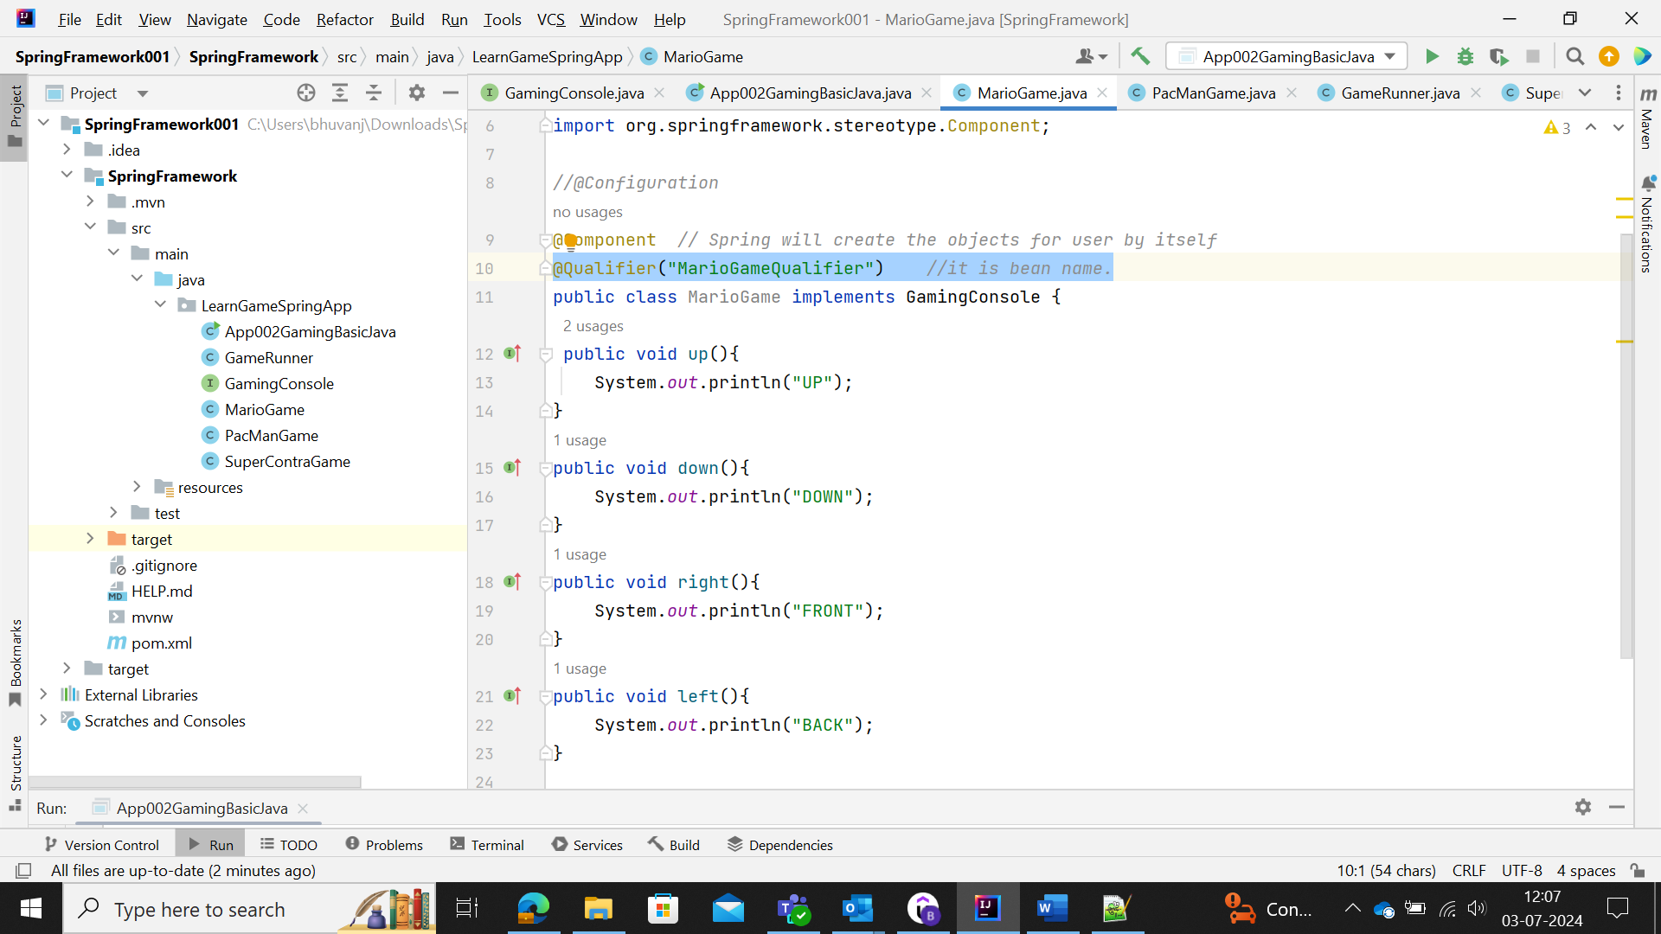

But for @Qualifier(“Bean_Name”) , it has to be autowired with the GameRunner Class.

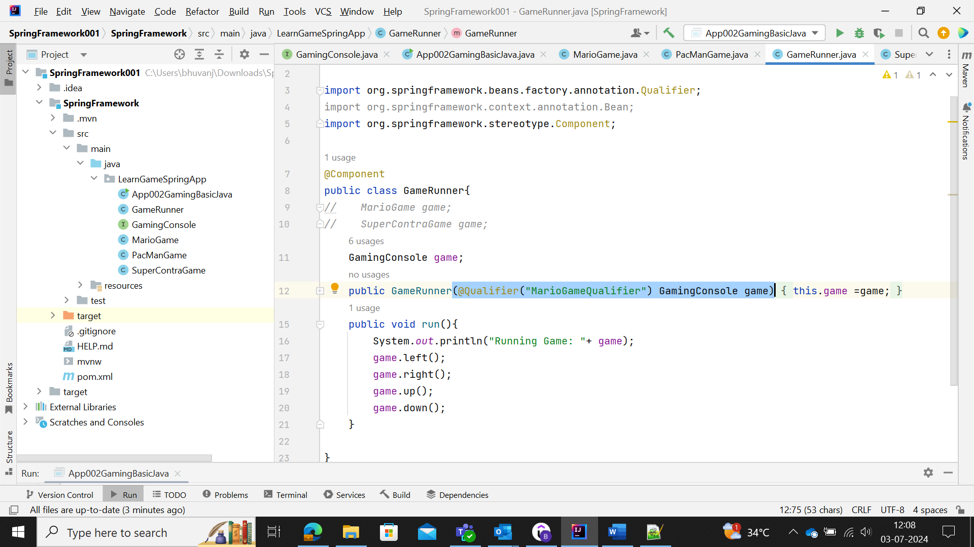

This is called Constructor Injection.

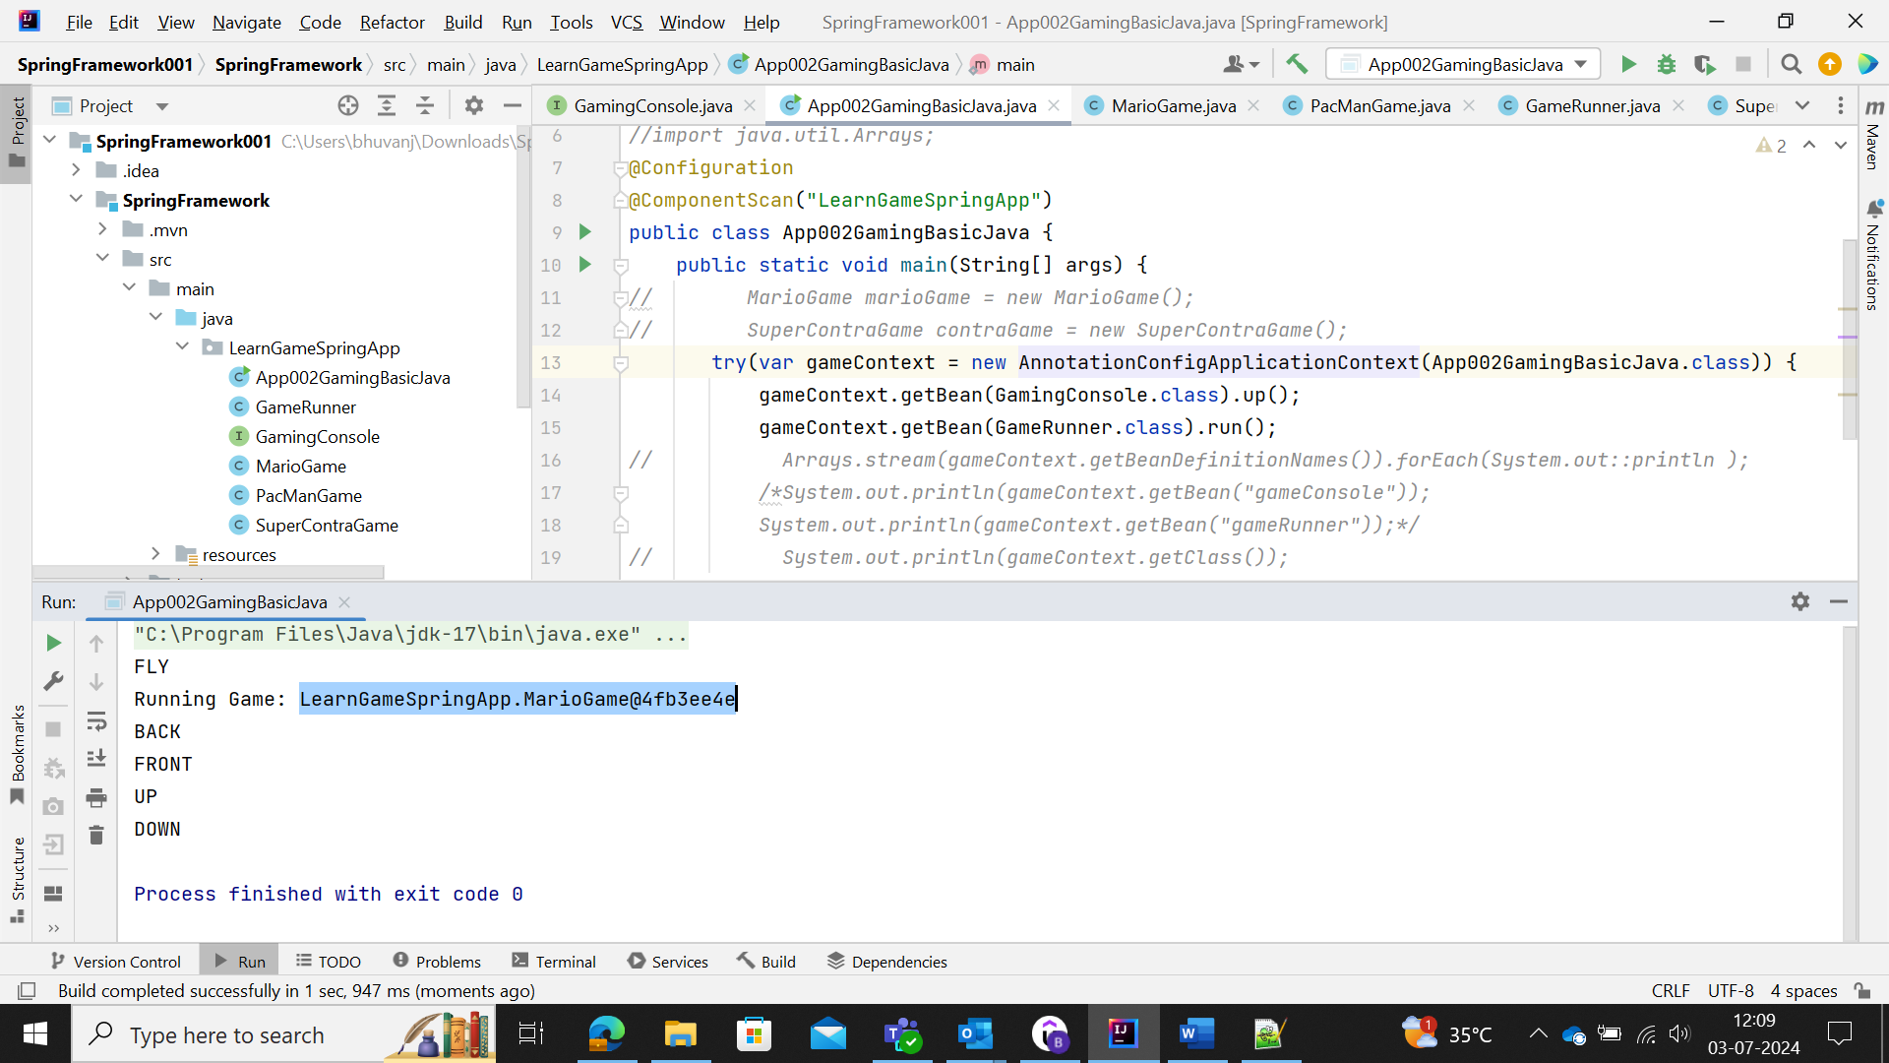

Note: here we autowired the GameRunner classes with the @Qualfiier bean and hence the (GameRunner.class).run() 🡪 MarioGame objects will be implemented.

(GamingConsole.class).up() 🡪 is not autowired for the Qualifier bean, hence it proceeds with the @Primary bean accordingly.

### Primary VS Qualifiers

When the class need any bean from the number of beans, then one can make use of @Primary annotations for any bean to be implemented.

When the class need only one bean particularly from the total number of beans, then user need to make use of @Qualifier bean, that must be wired manually or @Autowired (annotation) to make use of the bean to be implemented.

### Dependency Injection

Dependency Injection is the process of identifying beans, their dependencies and wiring them together (provides IOC 🡪Inversion of control)

**Constructer-Based:** Dependencies are set by creating the bean using its constructor.

**Setter-Based:** Dependencies are set by calling setter methods on your beans.

**Field Based:** No Constructor or Setter methods. Dependencies are injected by using reflection.

Mostly programmers use Constructor-Based Dependency Injection, where are the parameters are defined and no need for **@Autowire** annotations. But other two injections need @Autowire annotation with need of defining the parameters separately.

## Spring Framework Advanced Features

### Lazy Initialization of Spring Beans

@Lazy is the annotation mostly enabled and updated when the class/method is annotated with @Component or @Bean.

@Lazy 🡪 used to initialize the bean/component only when the class is called in the main class.

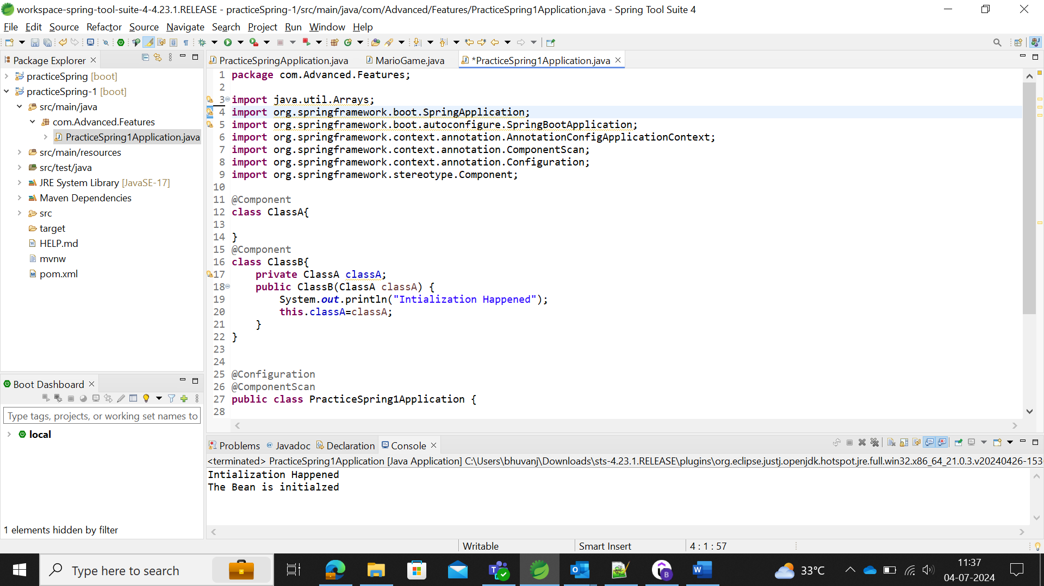

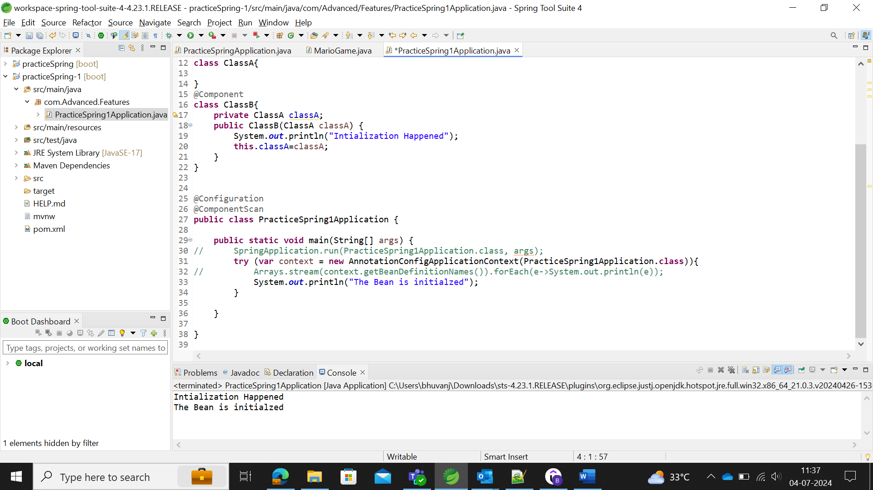

From the Main class, classB is not initialized or access, hence the classB bean is not started.

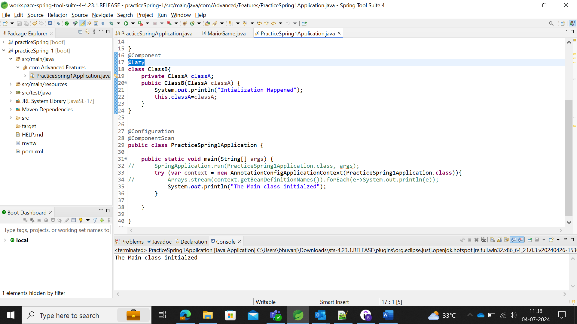

Now, the ClassB coded to call from the Main method.

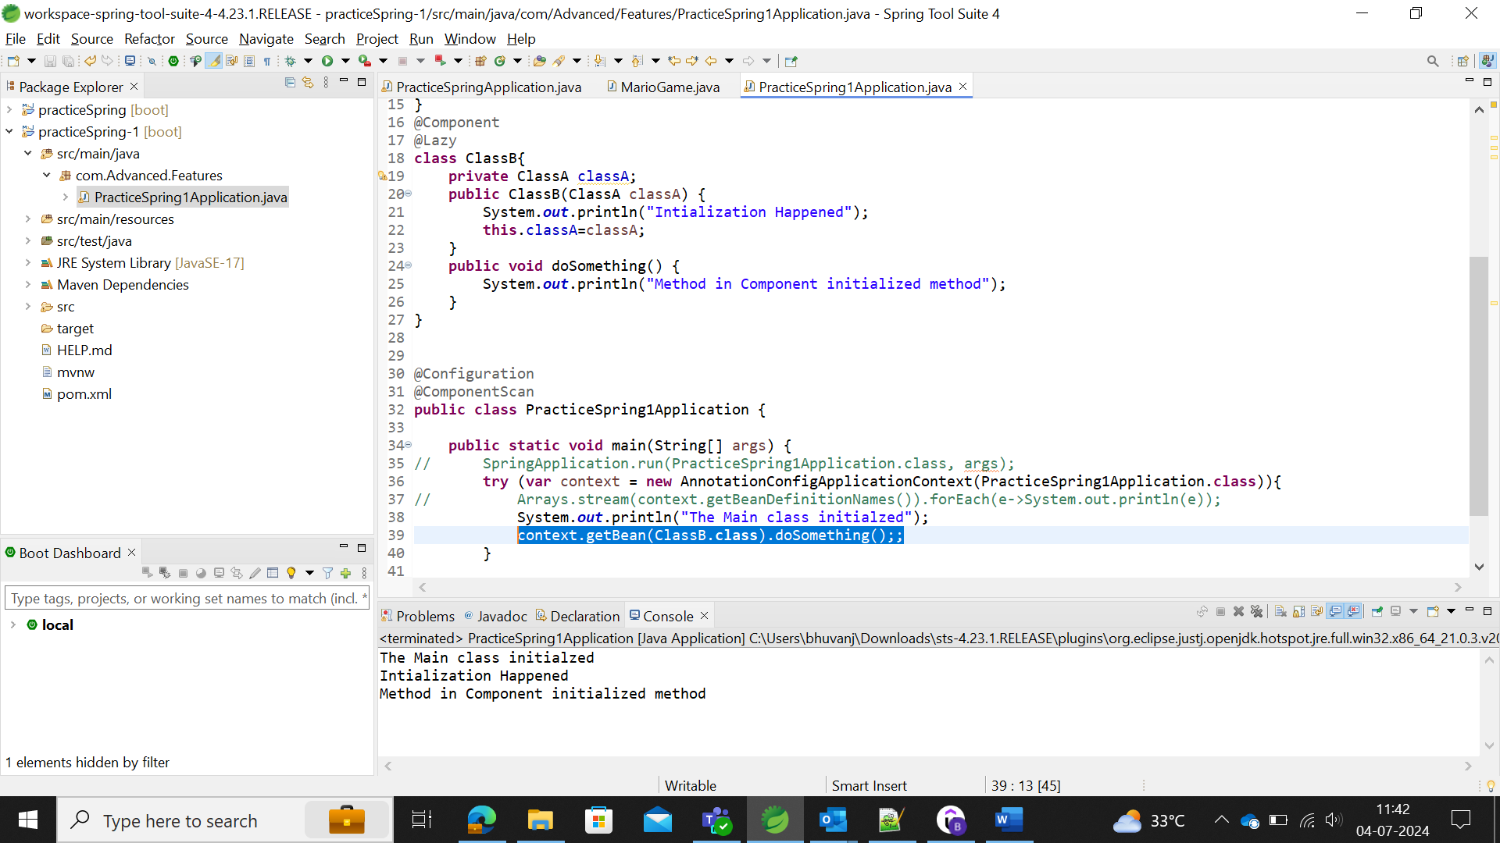

After the main class initialization, the classB class initialized only when the classB is accessed.

The above is termed as Lazy Initialization and the eager initialization is regular initialization of the beans. Mostly, Eager initialization is recommended since, any errors in the configuration of beans are discovered immediately.

In the application start up, errors in the configuration files couldn’t be identified when the user use the Lazy initialization, i.e.., It could be identified only as runtime exception, but in eager initialization, it won’t allow the configuration file to start.

### Spring Framework Scopes

Scopes in the Spring IoC container used for the object values in the class.

There are two types of scopes namely **protype and singleton class**, where protype scope annotated class will create the instances (object) of the class with different objects (different hashcode) for the specific class. There will be n number of objects for each n number of object call for the same class, whereas for singleton classes will create the same object (same hashcode) for the specific class for the n number of object call.

**NormalClass or Singleton class Scope**

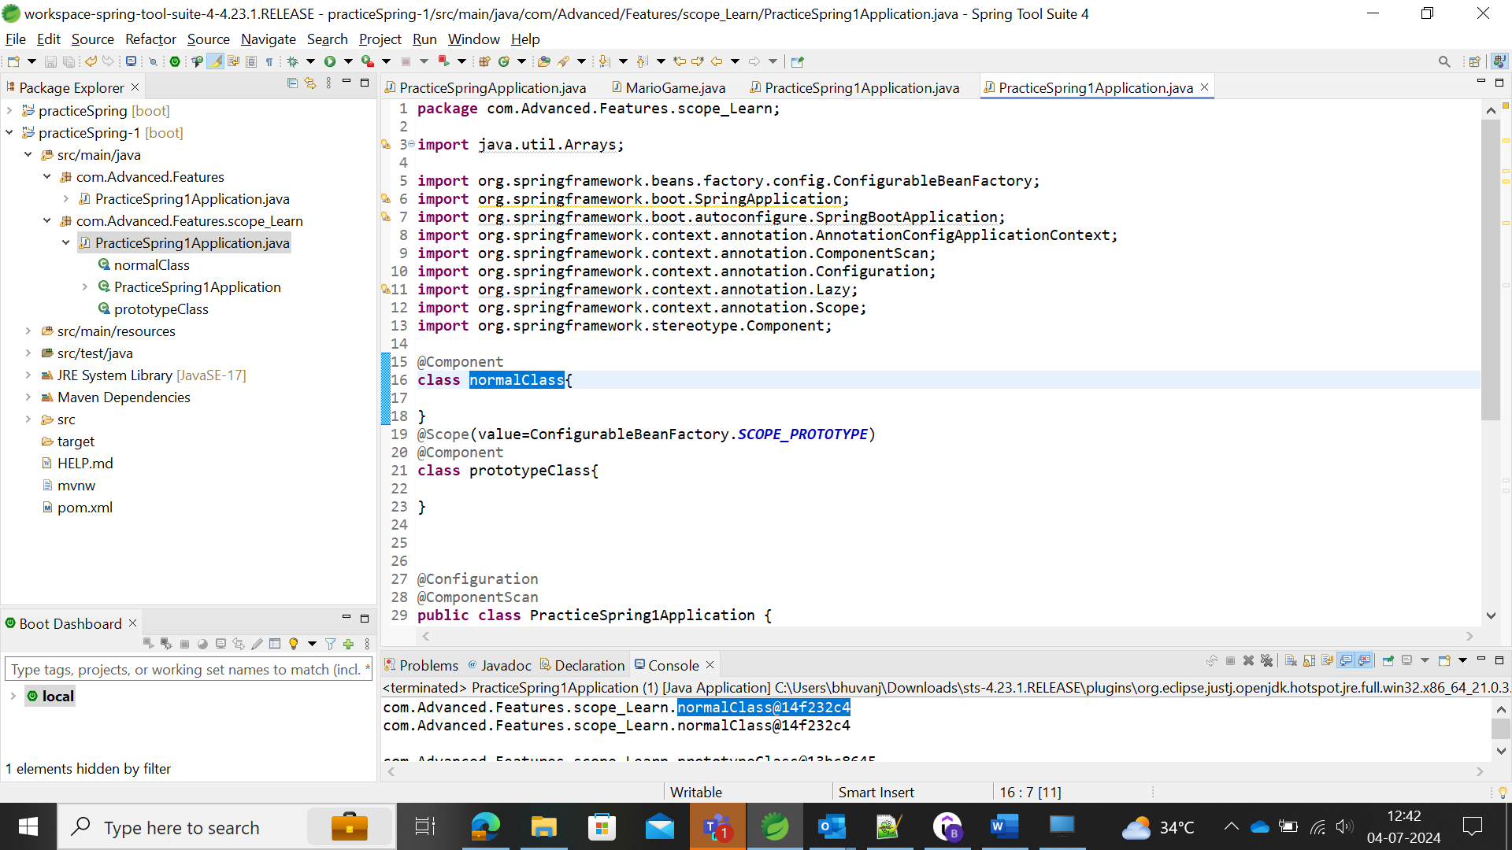

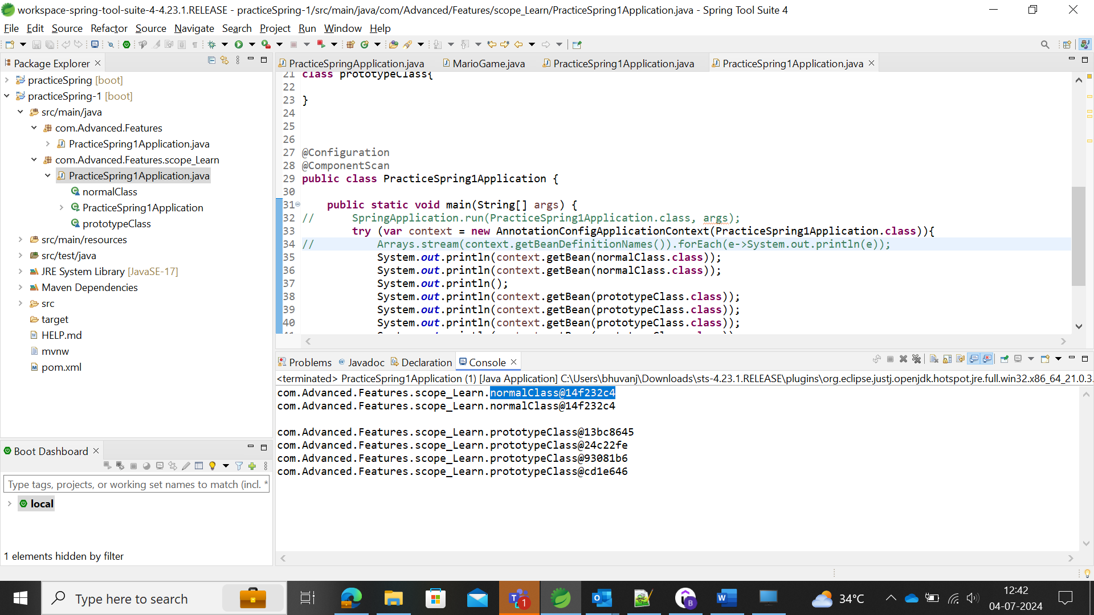

**Prototype Class**

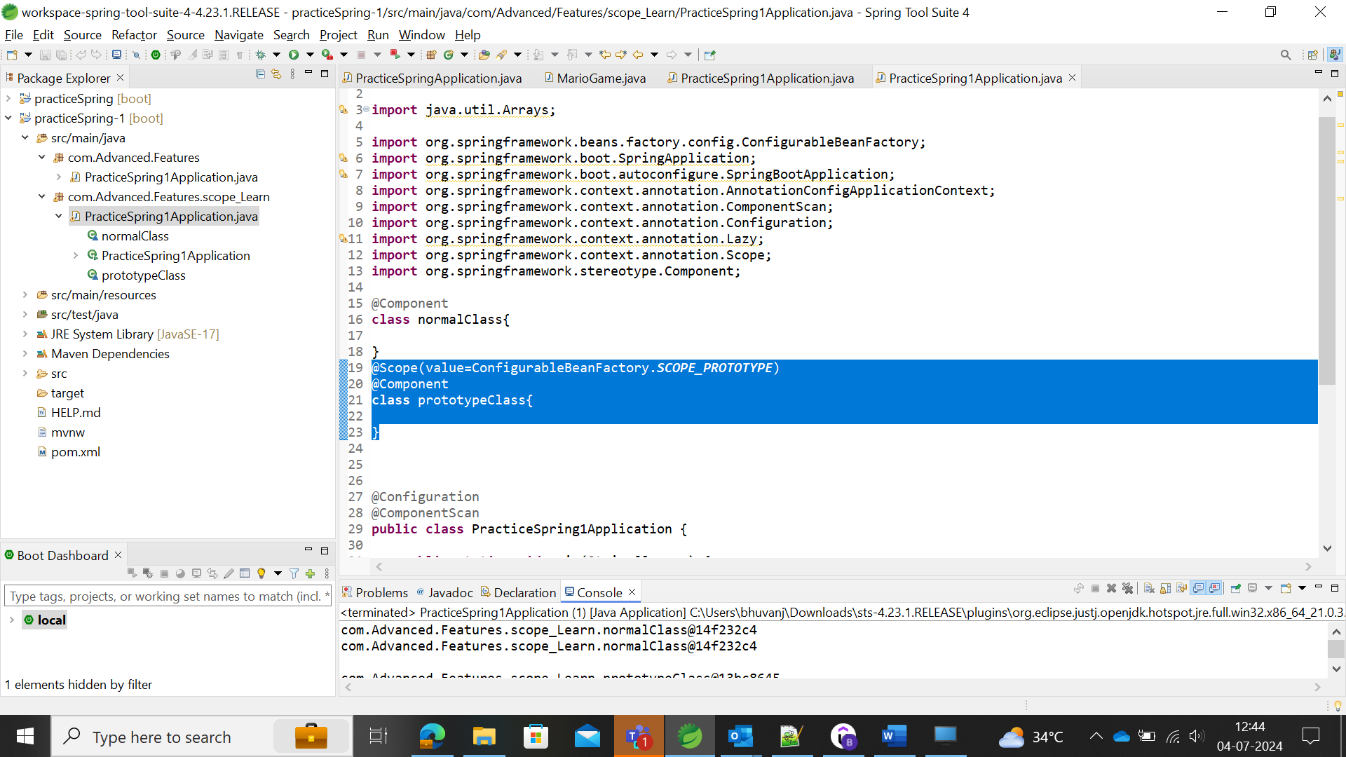

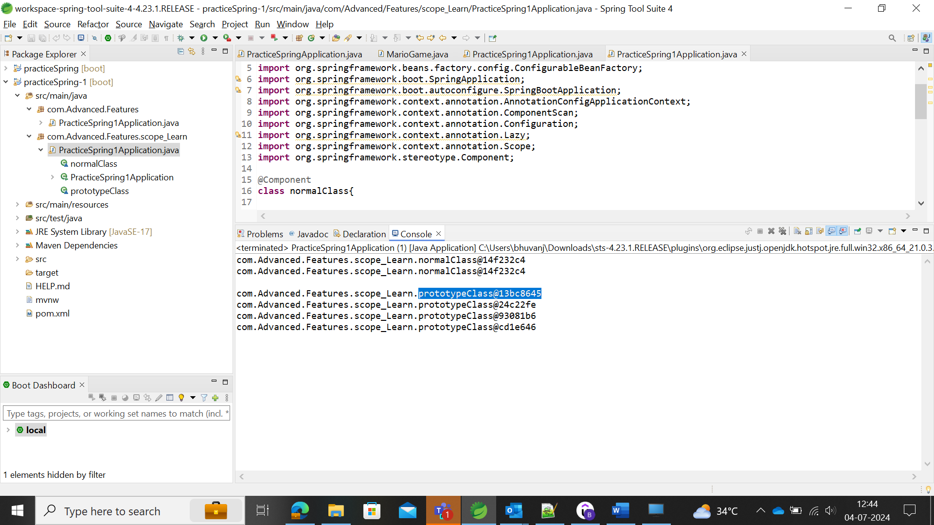

Scopes are applicable for the web-aware Spring ApplicationContext.

Eg: Request – One object instance per single HTTP request.

Session – One object instance per user HTTP session. It belongs to one user where multiple requests would be raised.

### PostConstruct and PreDestroy

PostConstruct

The PostConstruct annotation is used on a method that needs to be executed after dependency injection is done to perform any initialization.

Whenever the dependencies needs to be implemented after they’re autowired, post construct annotation is used to initialize the dependencies(Eg: getting the data from Database, etc.,).

Before using the PostConstruct annotation, in the constructor, the dependencies are Autowired, but the methods are not initiated.

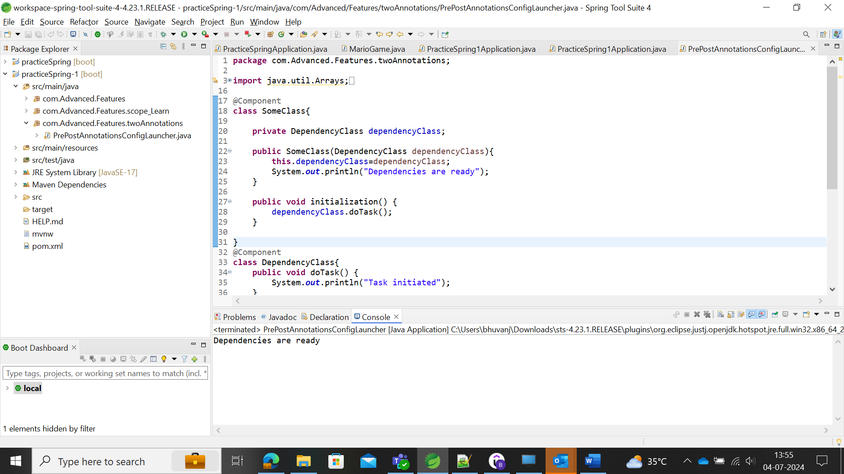

After PostConstruct annotations, user could see the initiation of the methods in the class.

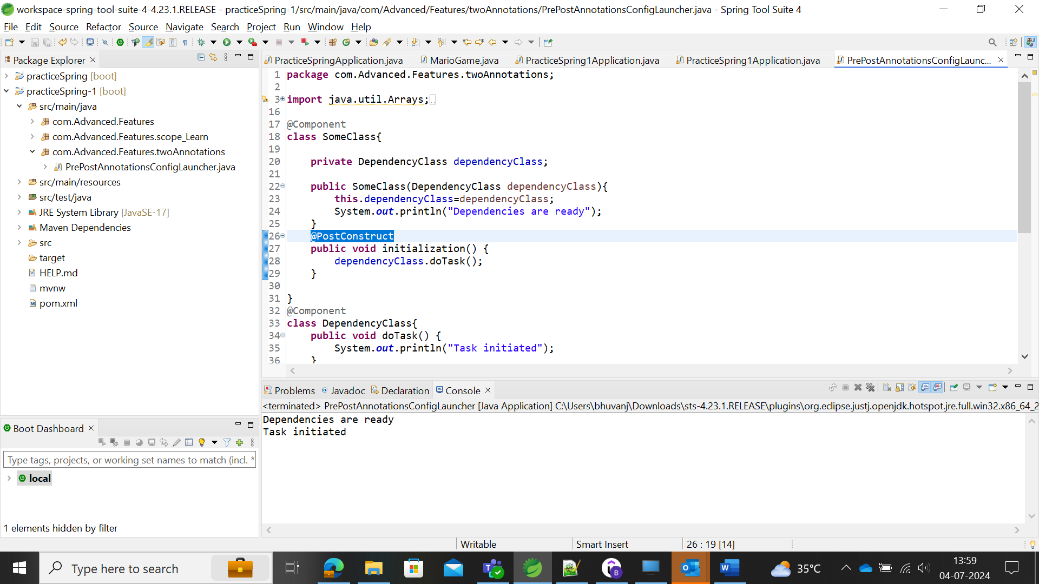

PreDestroy

For example, before completing the execution, user need to close the connections with the dependencies. For that, PreDestroy annotation is used to close it.

The PreDestroy annotation is used on a method as a callback notification to signal that the instance is in the process of being removed by the container. The method annotated with PreDestroy is typically used to release resources that it has been holding. This annotation must be supported by all container-managed objects that support the use of the PostConstruct annotation except the Jakarta EE application client.

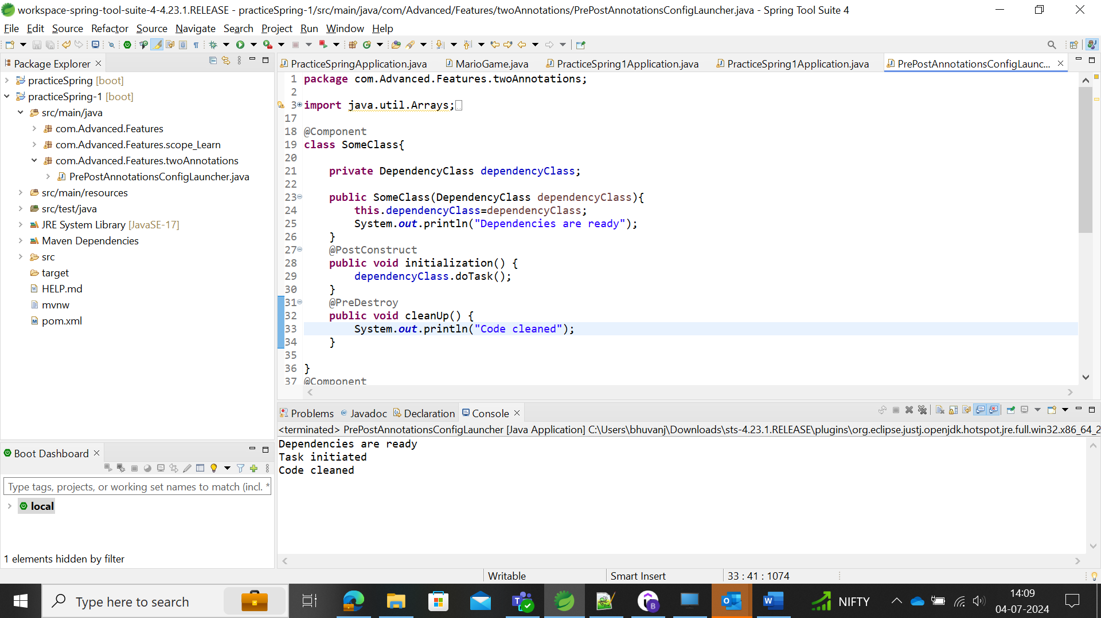

## JAVA EE

The enterprised edition of the Java is termed as that of “J2EE or Java EE or Jakarta EE”, which have the

* Jakarta Server Pages (JSP) 🡪 used to create views in the web applications.
* Jakarta Standard Tag Library (JSTL) 🡪 have the library tags which used to show the dynamic information in your webpages.
* Jakarta Enterprise Beans
* Jakarta RESTful Web Services 🡪 for building the REST web services.
* Jakarta Context and Dependency Injection (CDI) 🡪 API for Dependency injection.

### Jakarta Contexts and Dependency Injection

CDI has the specifications (interface)

Important API annotations are

* Inject🡪 autowired in spring.
* Named 🡪 Component in spring.
* Qualifier
* Scope
* Singleton

In the STS, we can add the Jakarta dependency in the pom.xml and save it

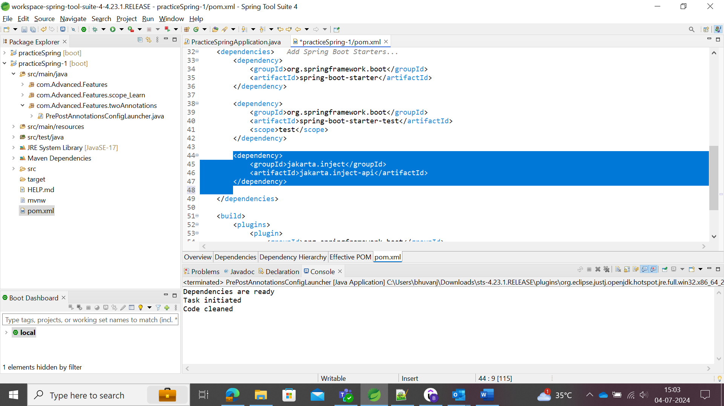

The dependency could be updated as ***Right click 🡪 Maven 🡪 Add Dependency 🡪 enter the Group ID and Artifact ID as Jakarta respectively.*** Save it to build the frame in the tool.

### XML

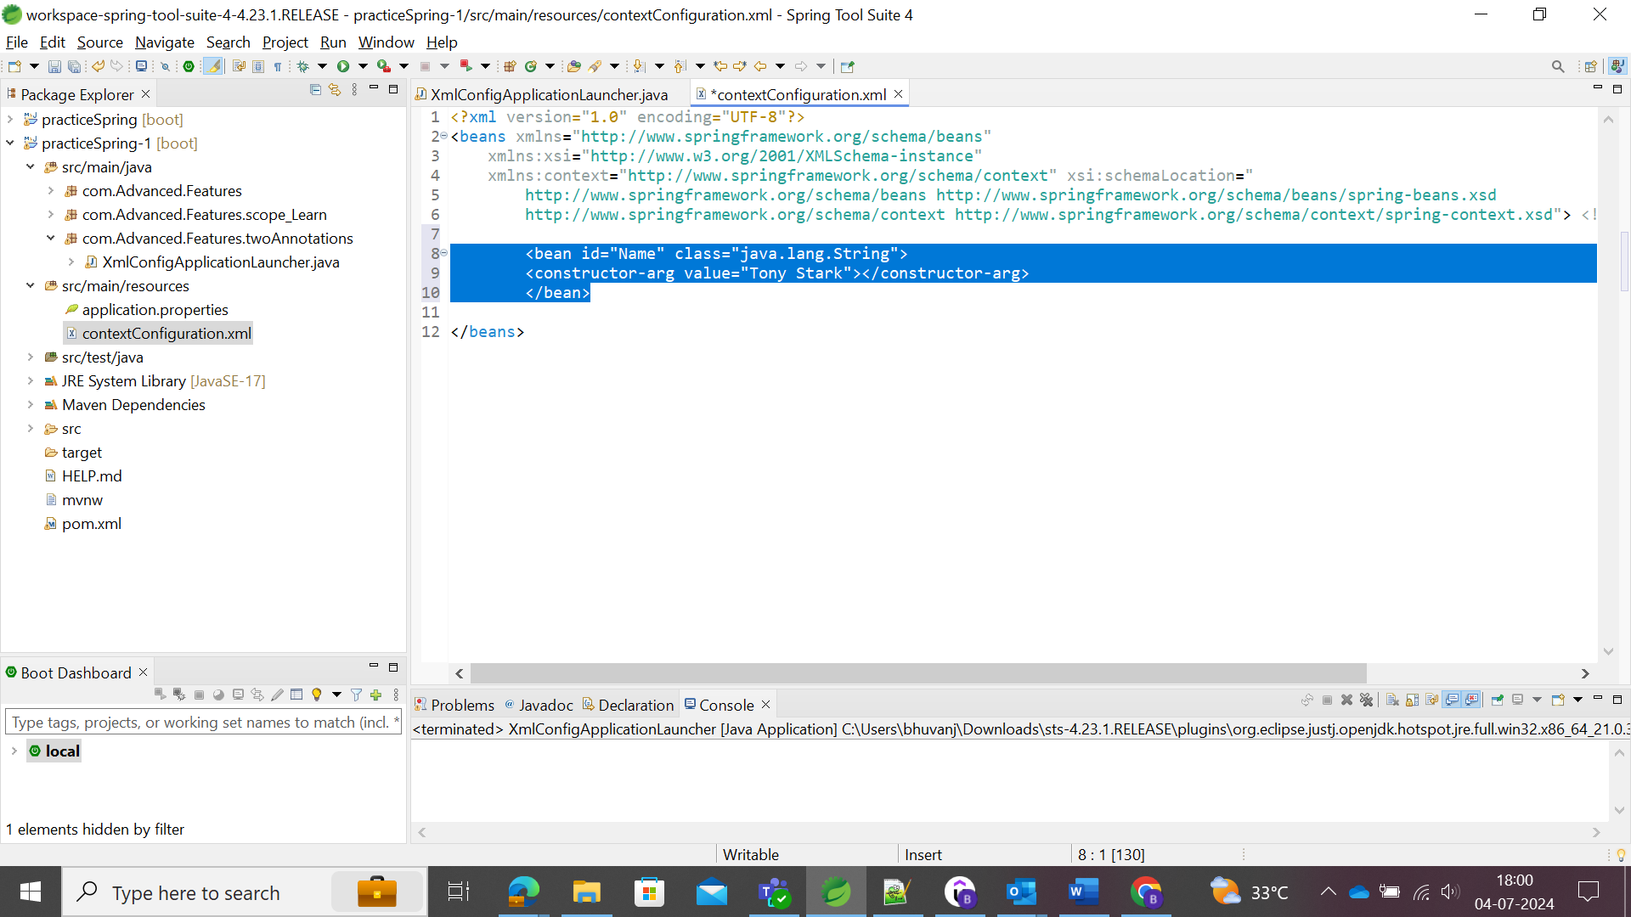

Adding the Beans in the customized xml Configuration file and map to the main class.

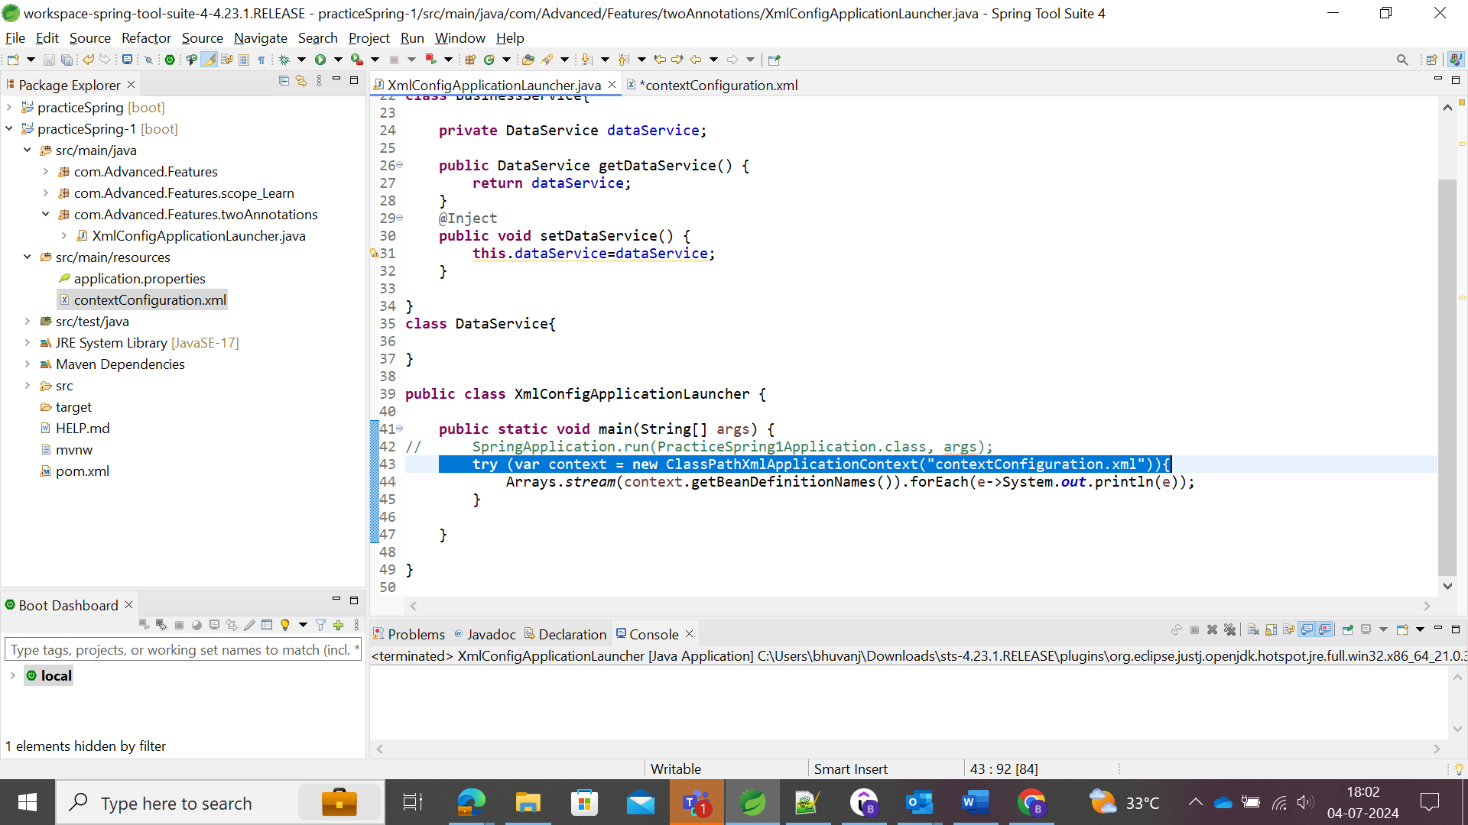

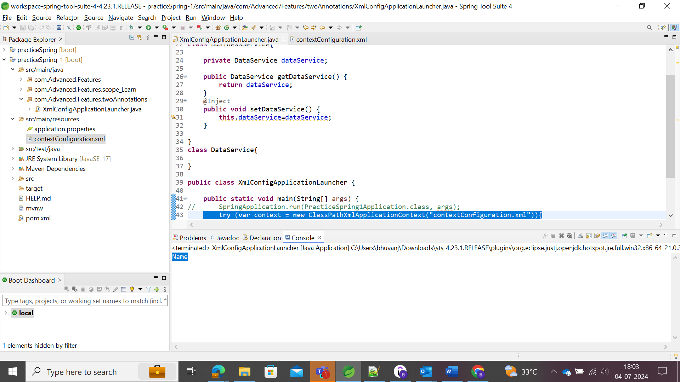

The bean created in the xml file with id=”Name” is updated in the console and for updating the value mentioned in the xml file could be updated as follows:

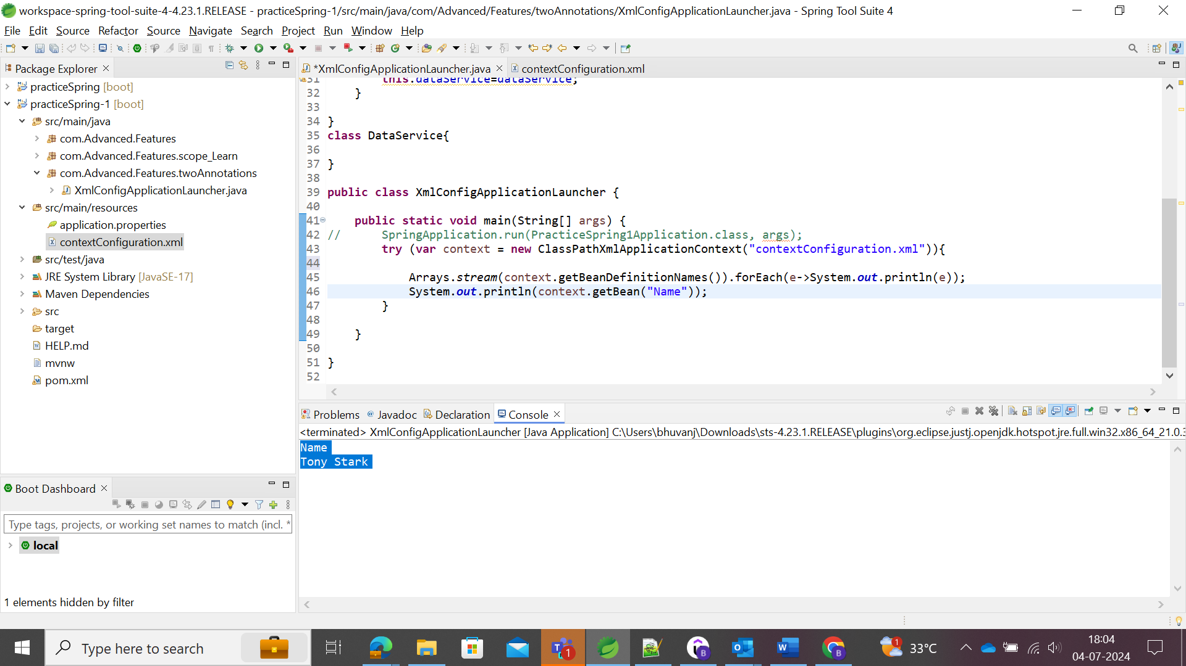

Beans with id and their values are updated.

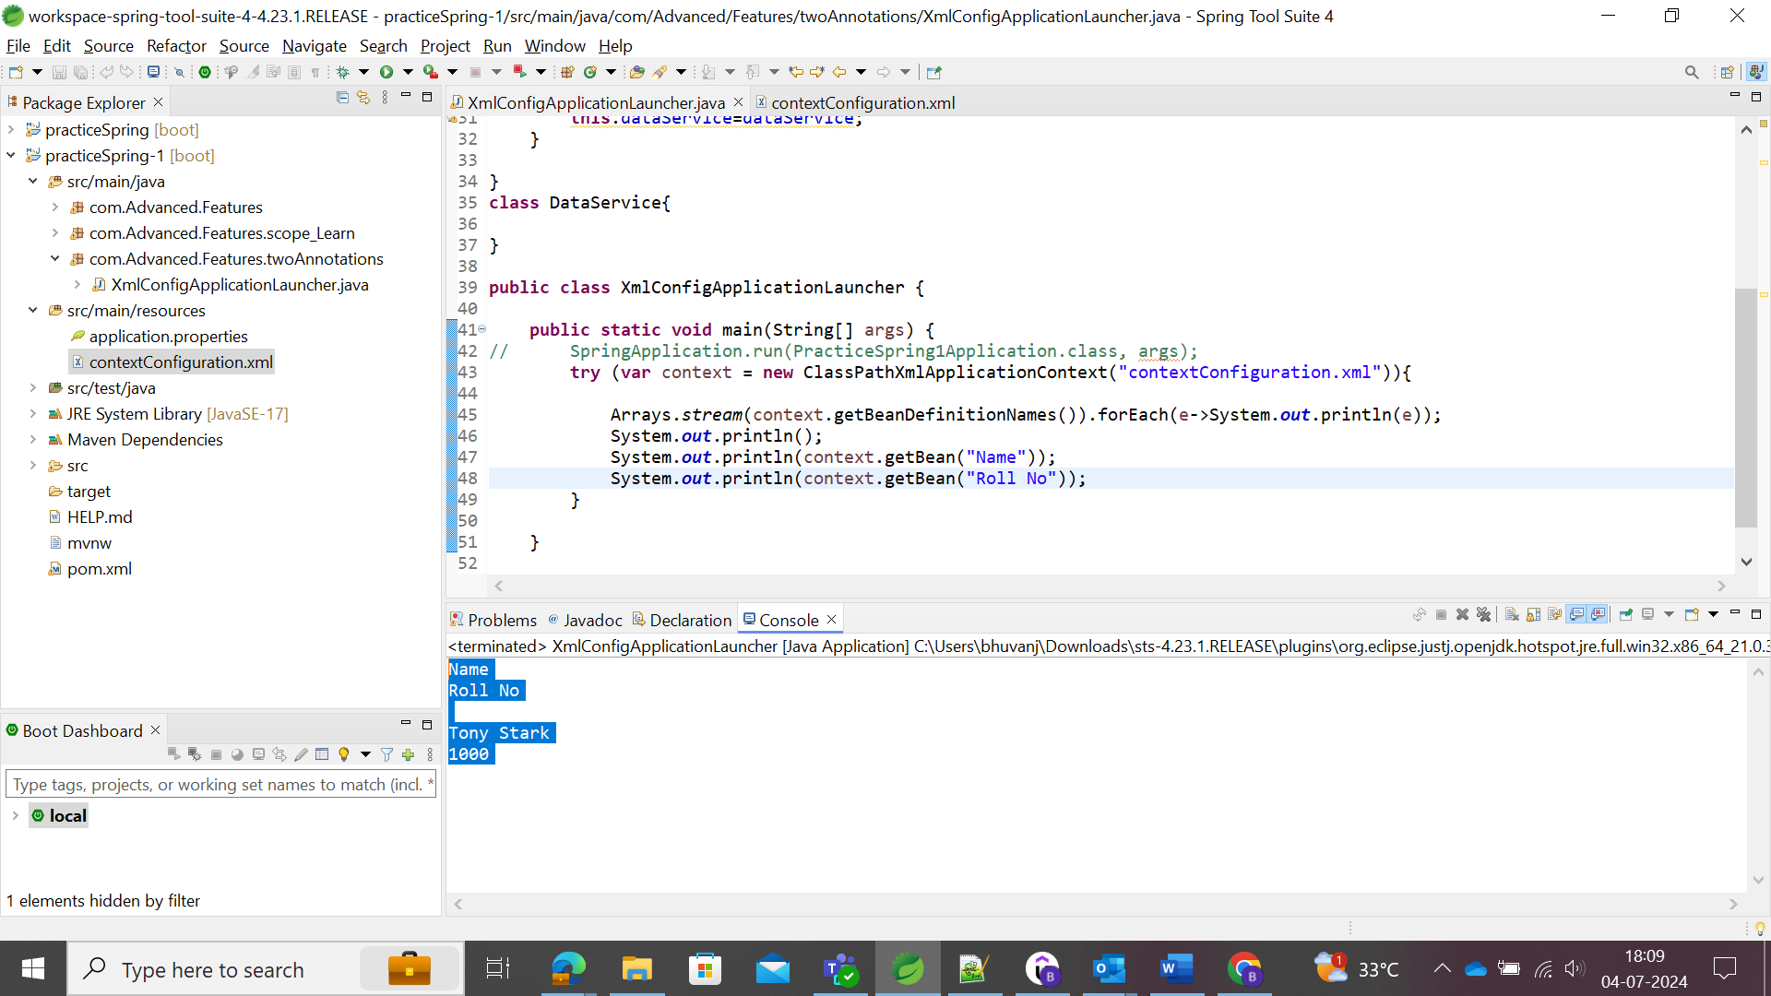

### Spring Stereotype Annotations

@Component 🡪 Generic annotations used across all the classes.

Specializations of Component

* @Service 🡪 indicates that annotated class has business logic.
* @Controller 🡪 indicates that annotated class is a controller for web applications.
* @Repository 🡪 indicates that annotated class could be able to manipulate or retrieve the data.

|  |  |
| --- | --- |
| @Configuration | Used to make the Java Configuration File of the class which defines some beans and later these files will be configured by the Spring Container |
| @ComponentScan | Defines the scanning of the components in the specified package. If there is no package available there, then it will start to scan the package where the annotation is defined. |
| @Component | The class which is annotated by component, then spring creates the bean for each method defined in it. |
| @Service | The class which is annotated by service has a business logic to implement. |
| @Controller | Annotated class has controllers in it for web applications and REST API. |
| @Retrieve | This is one of the @component indicating the annotated class is used to retrieve and/or manipulate the data from the database. |
| @Primary | Annotation |

# Spring Boot

Creation of Simple Rest API “Hello World” Application.

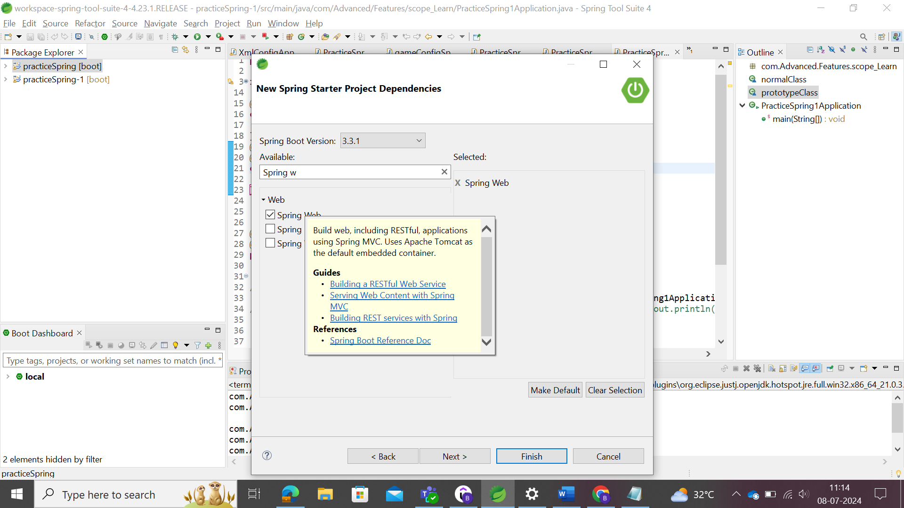

Spring Web dependencies are very useful since it has default Apache Tomcat as a Default embedded server to build the simple REST API applications.

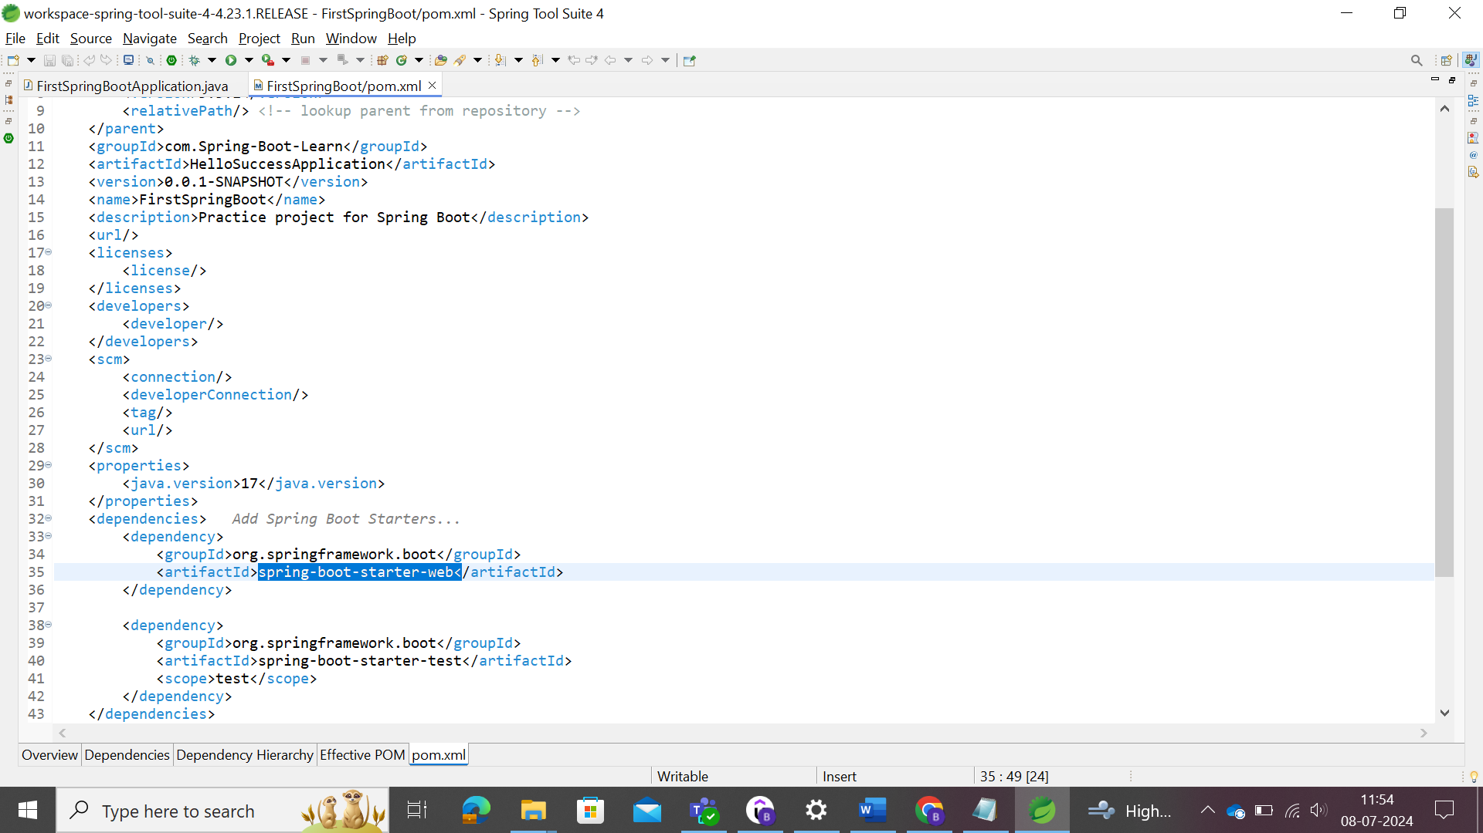

spring-boot-starter-web provides the web service for creating the web application in the spring boot.

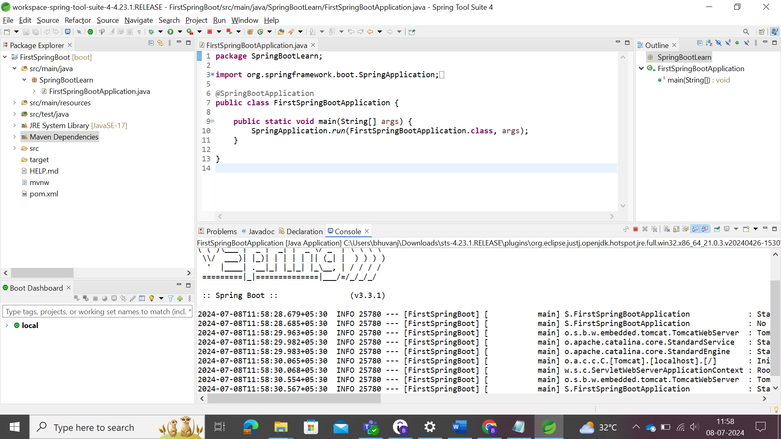

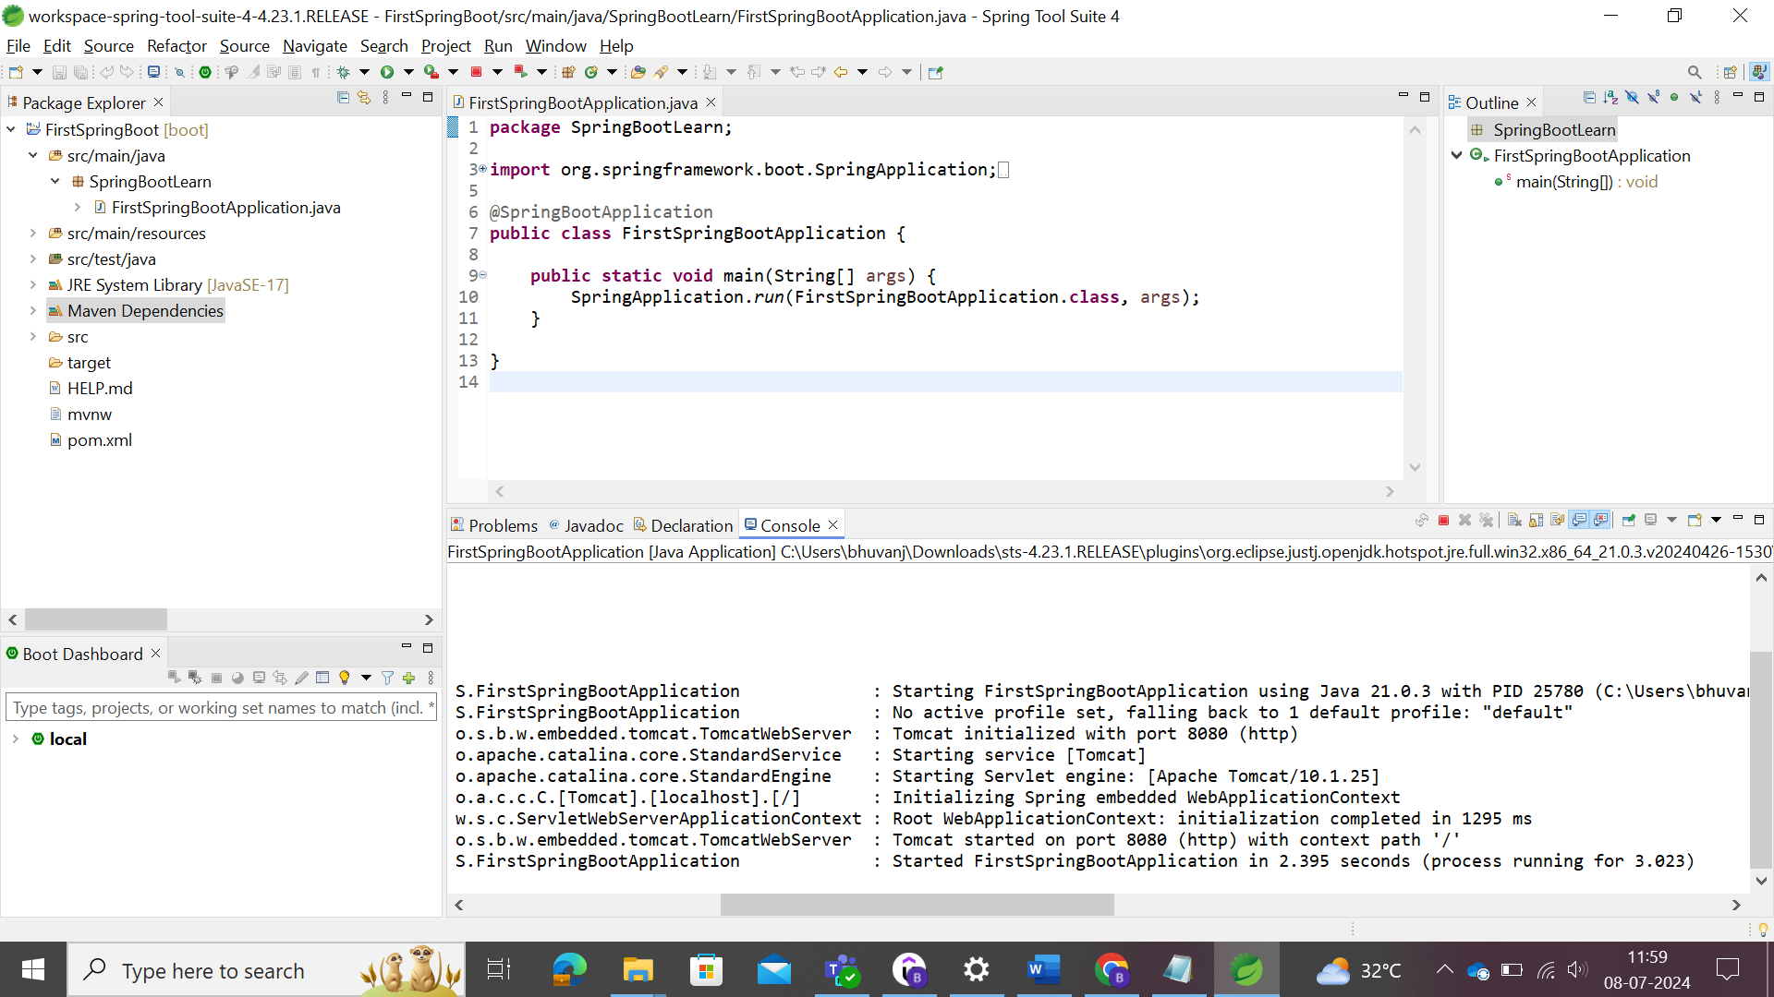

We need to create the web application from the site <https://localhost:8080/courses> where it should return the some messages regarding that.

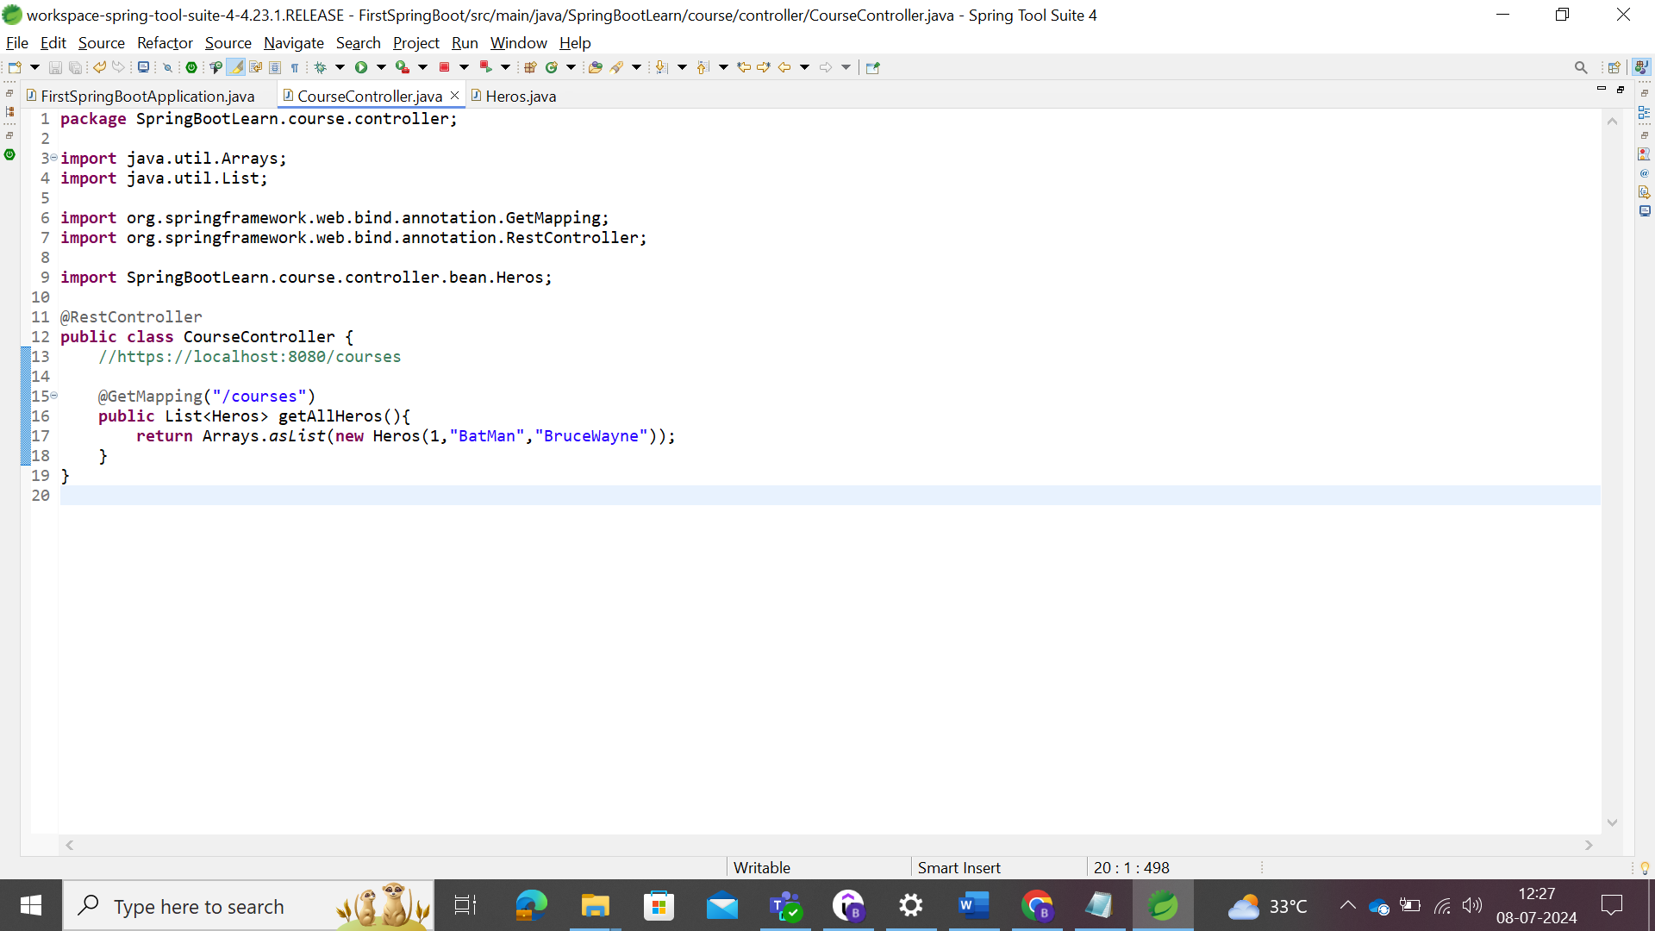

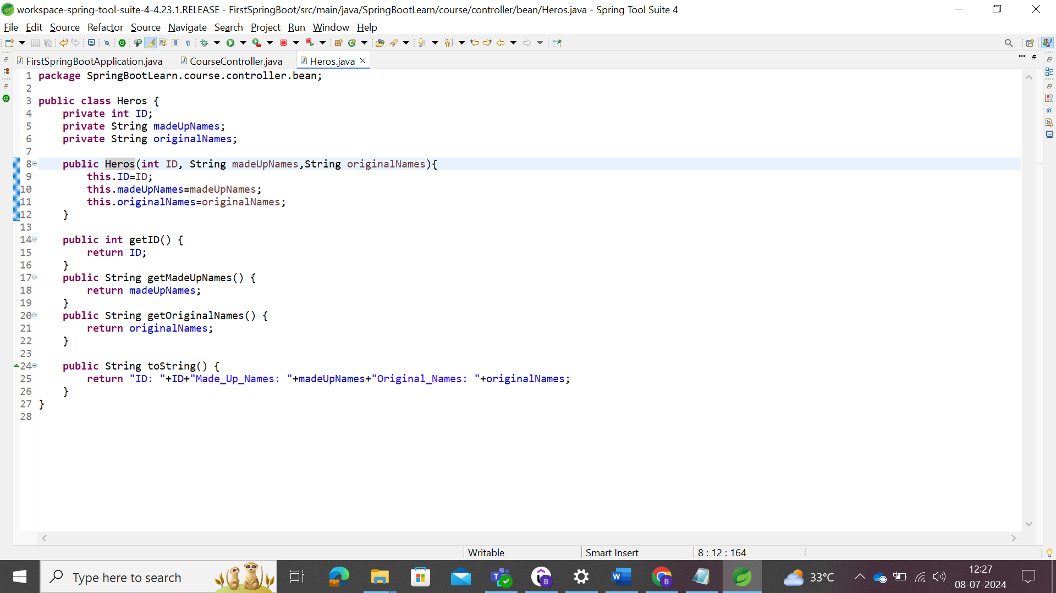

Ran Successfully.

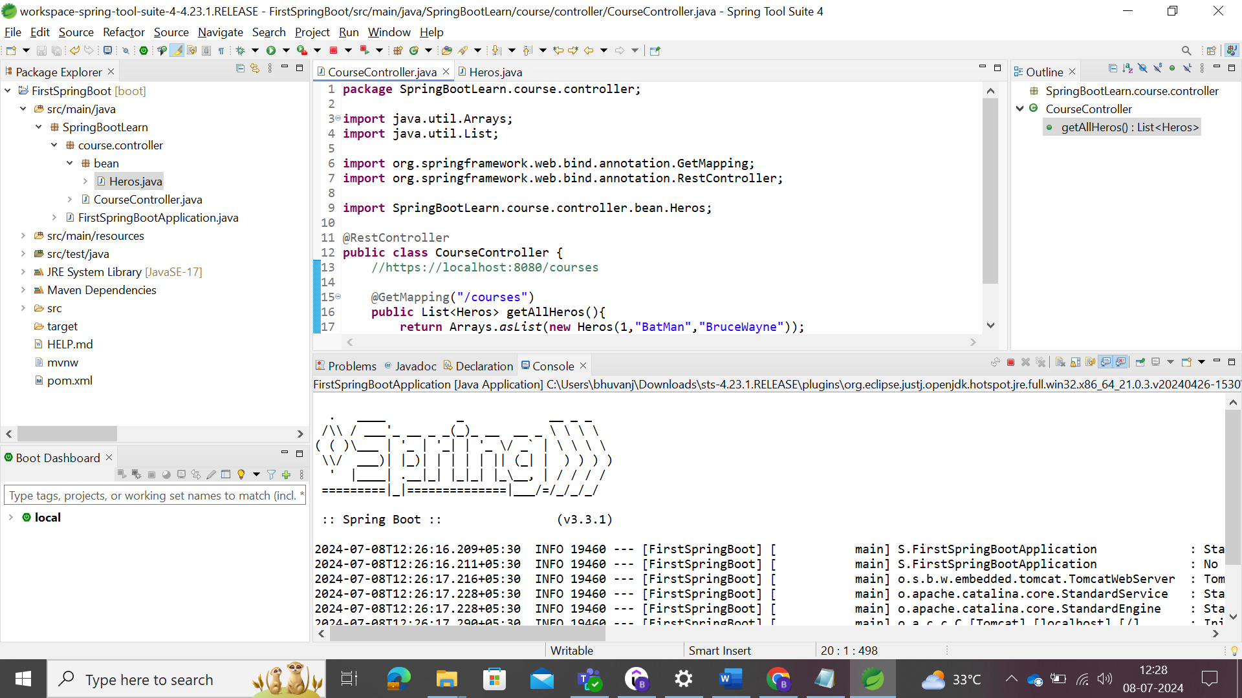

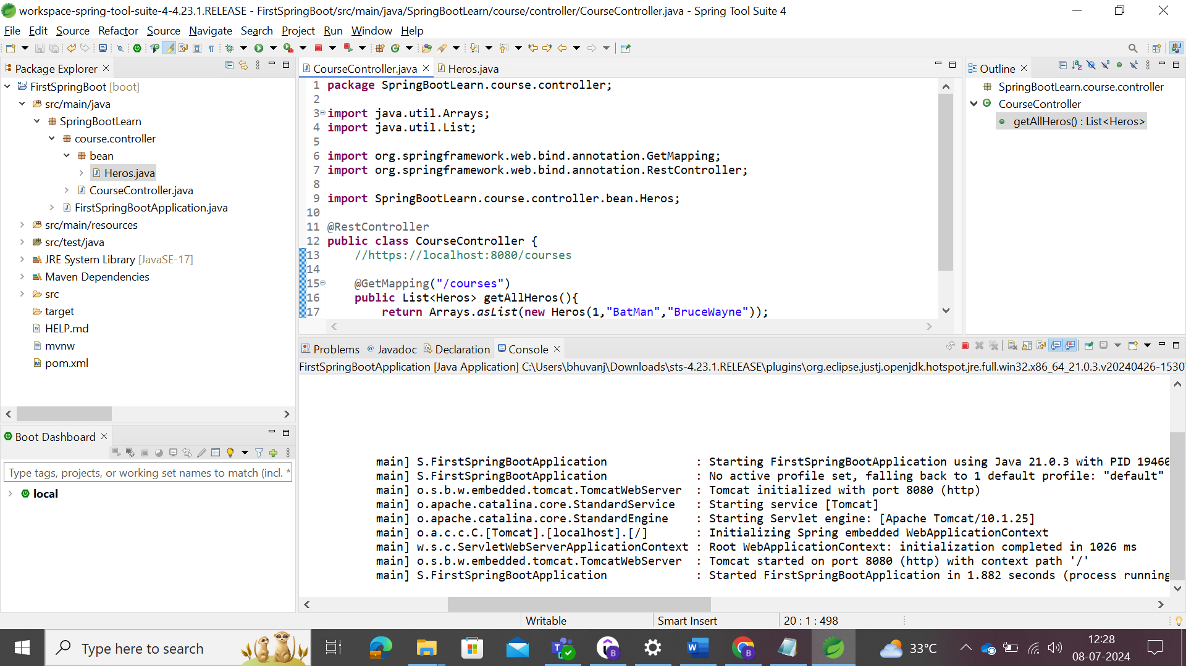

Go to browser and type localhost:8080/courses

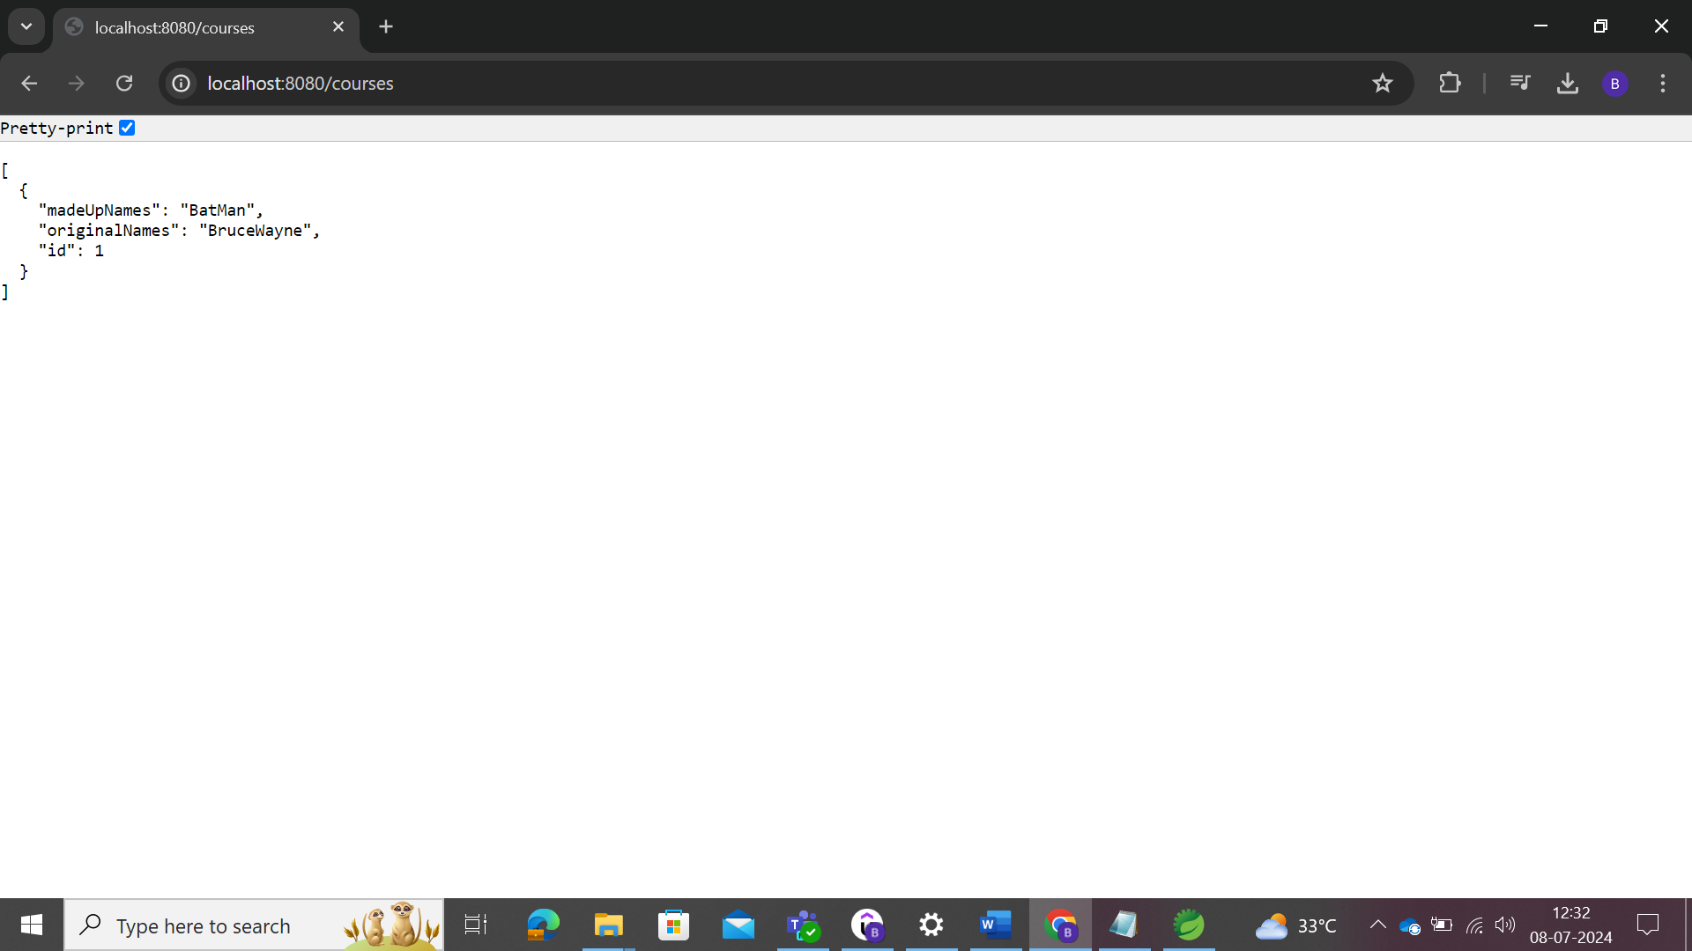

Hence the simple API is created. With JSON extension, the following could be viewed

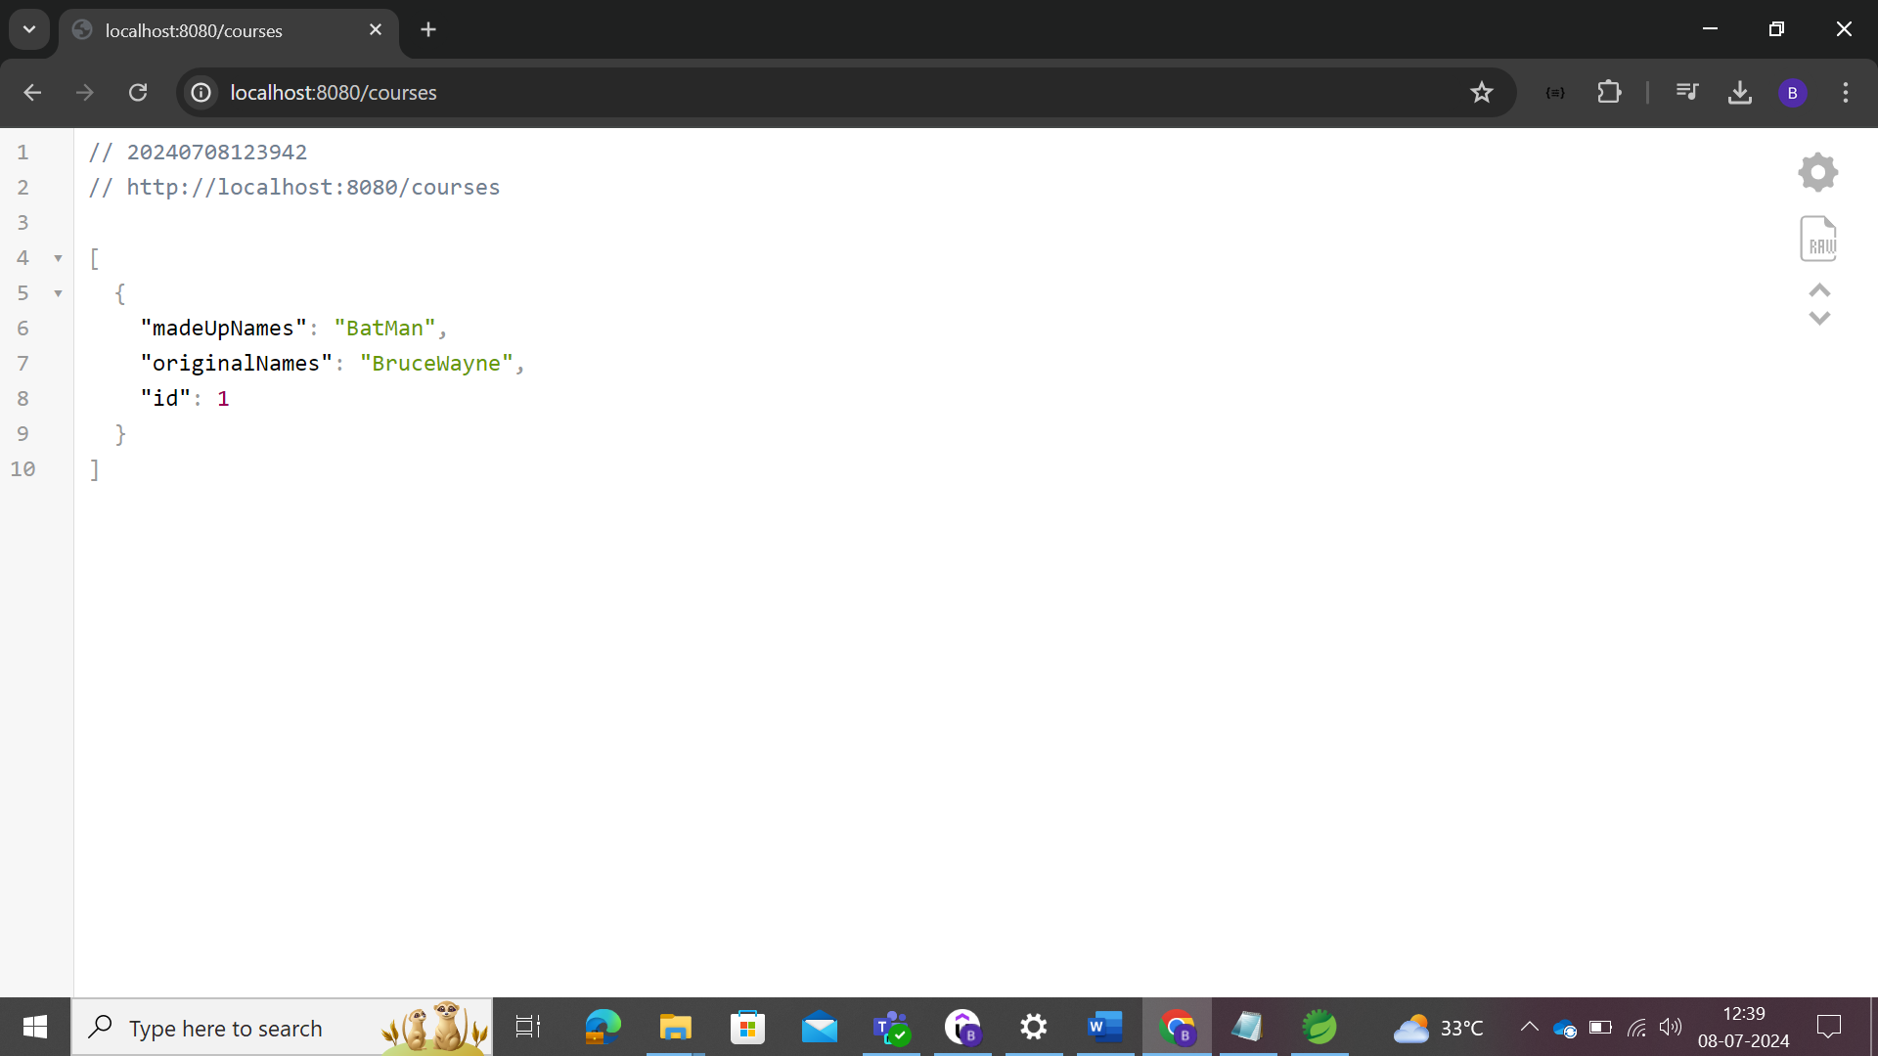

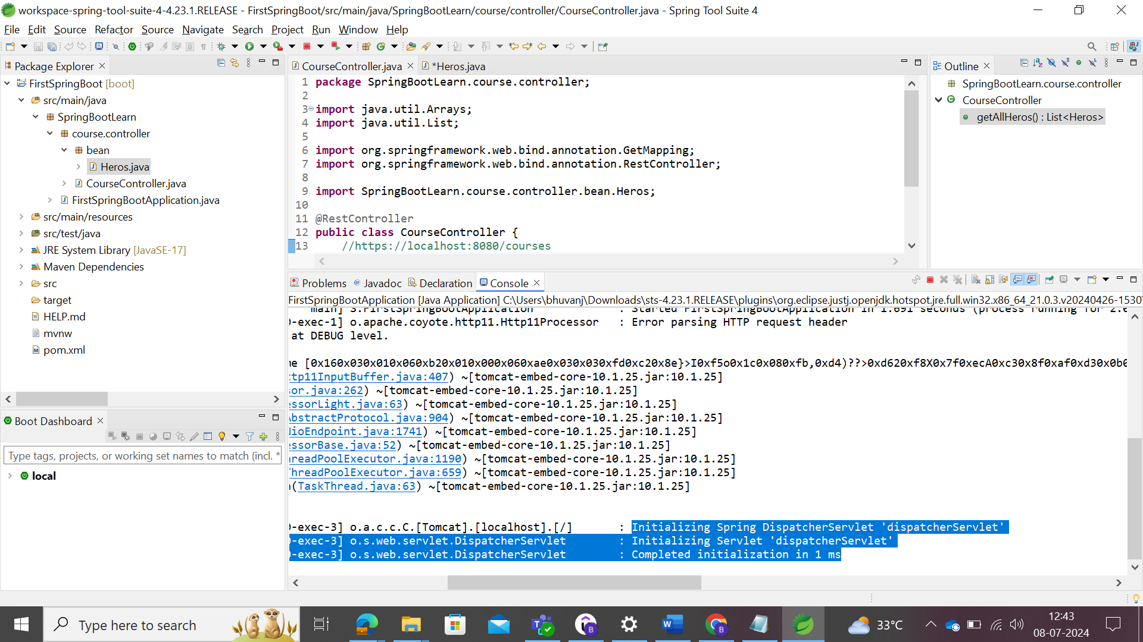

Before the spring boot annotations, spring framework must configured with maven dependencies, web.xml, spring.context.xml and tomcat server.

Checking the auto configuration in the Spring Tool Suite

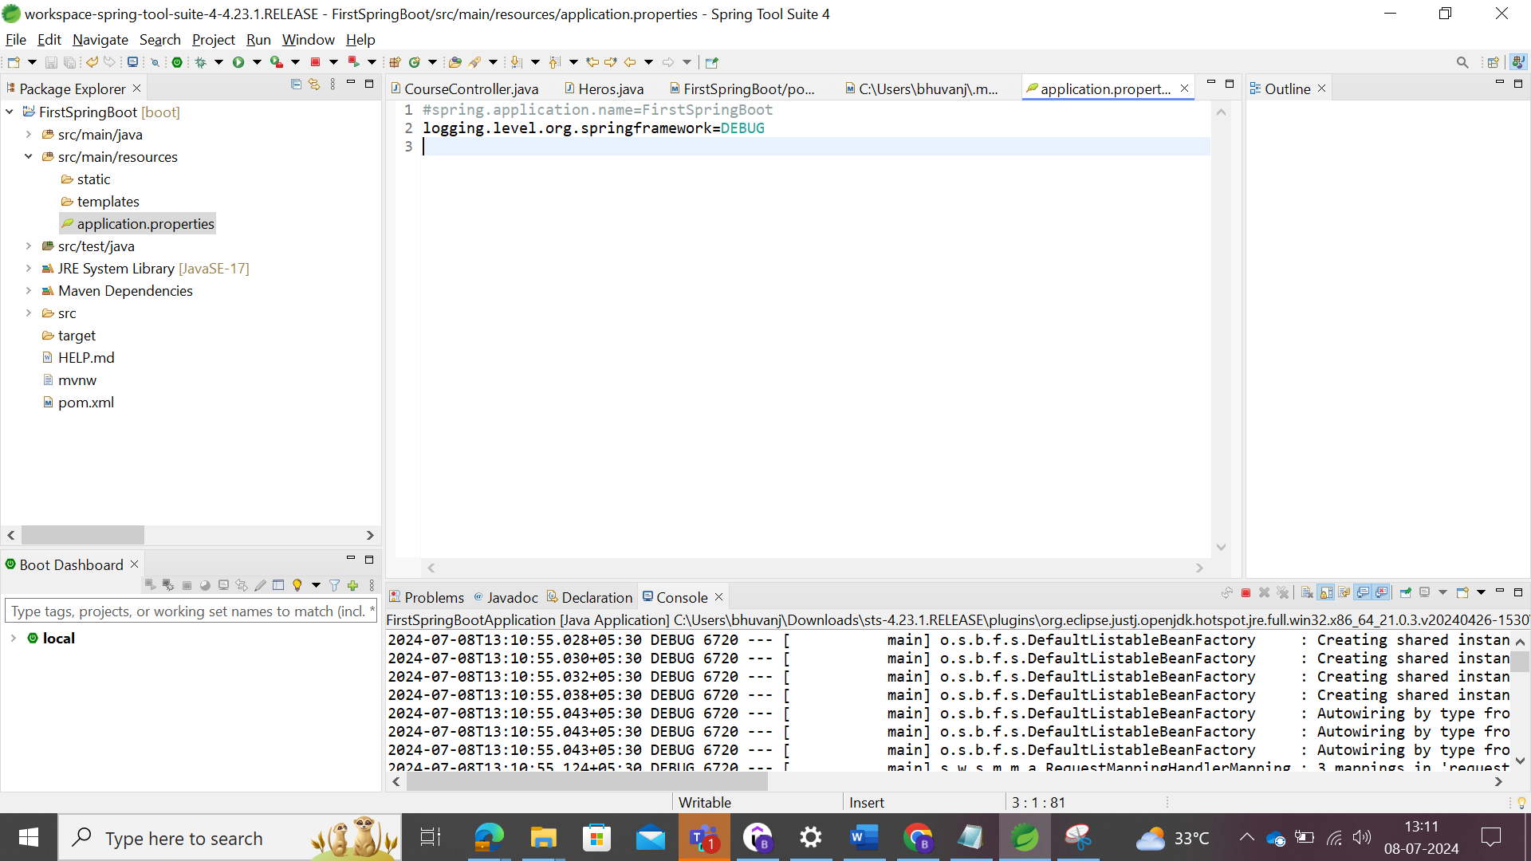

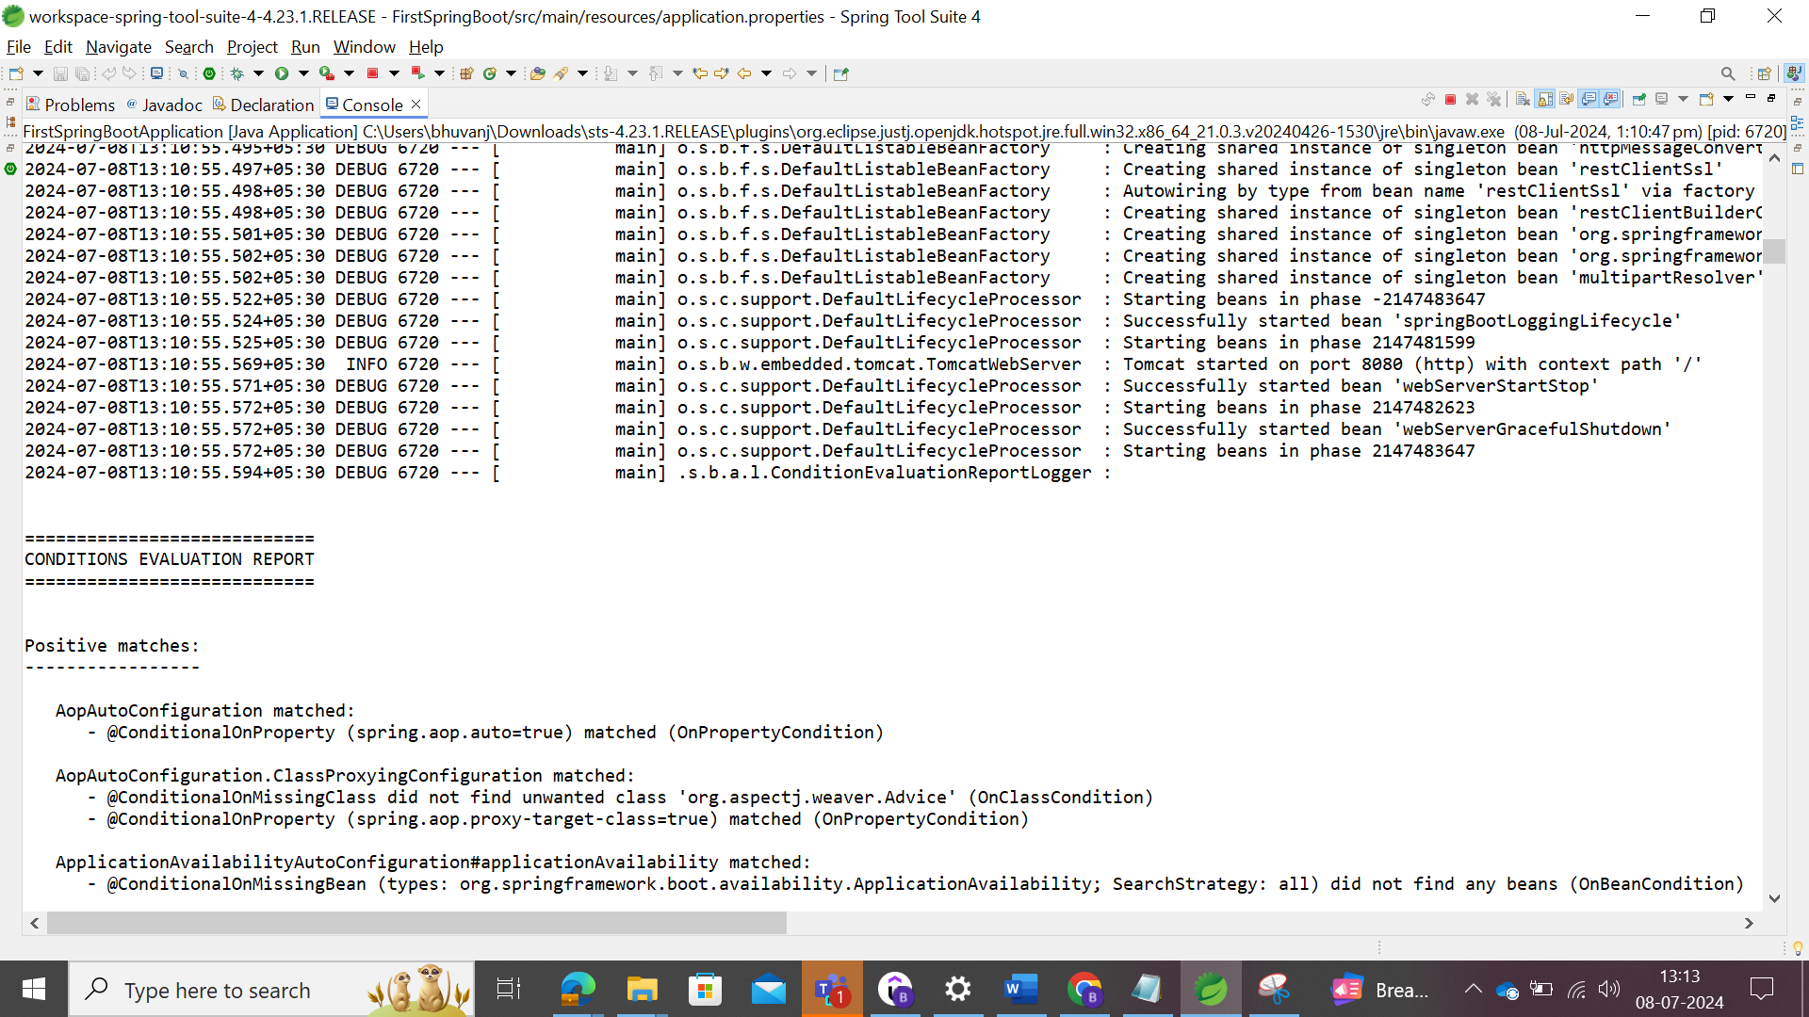

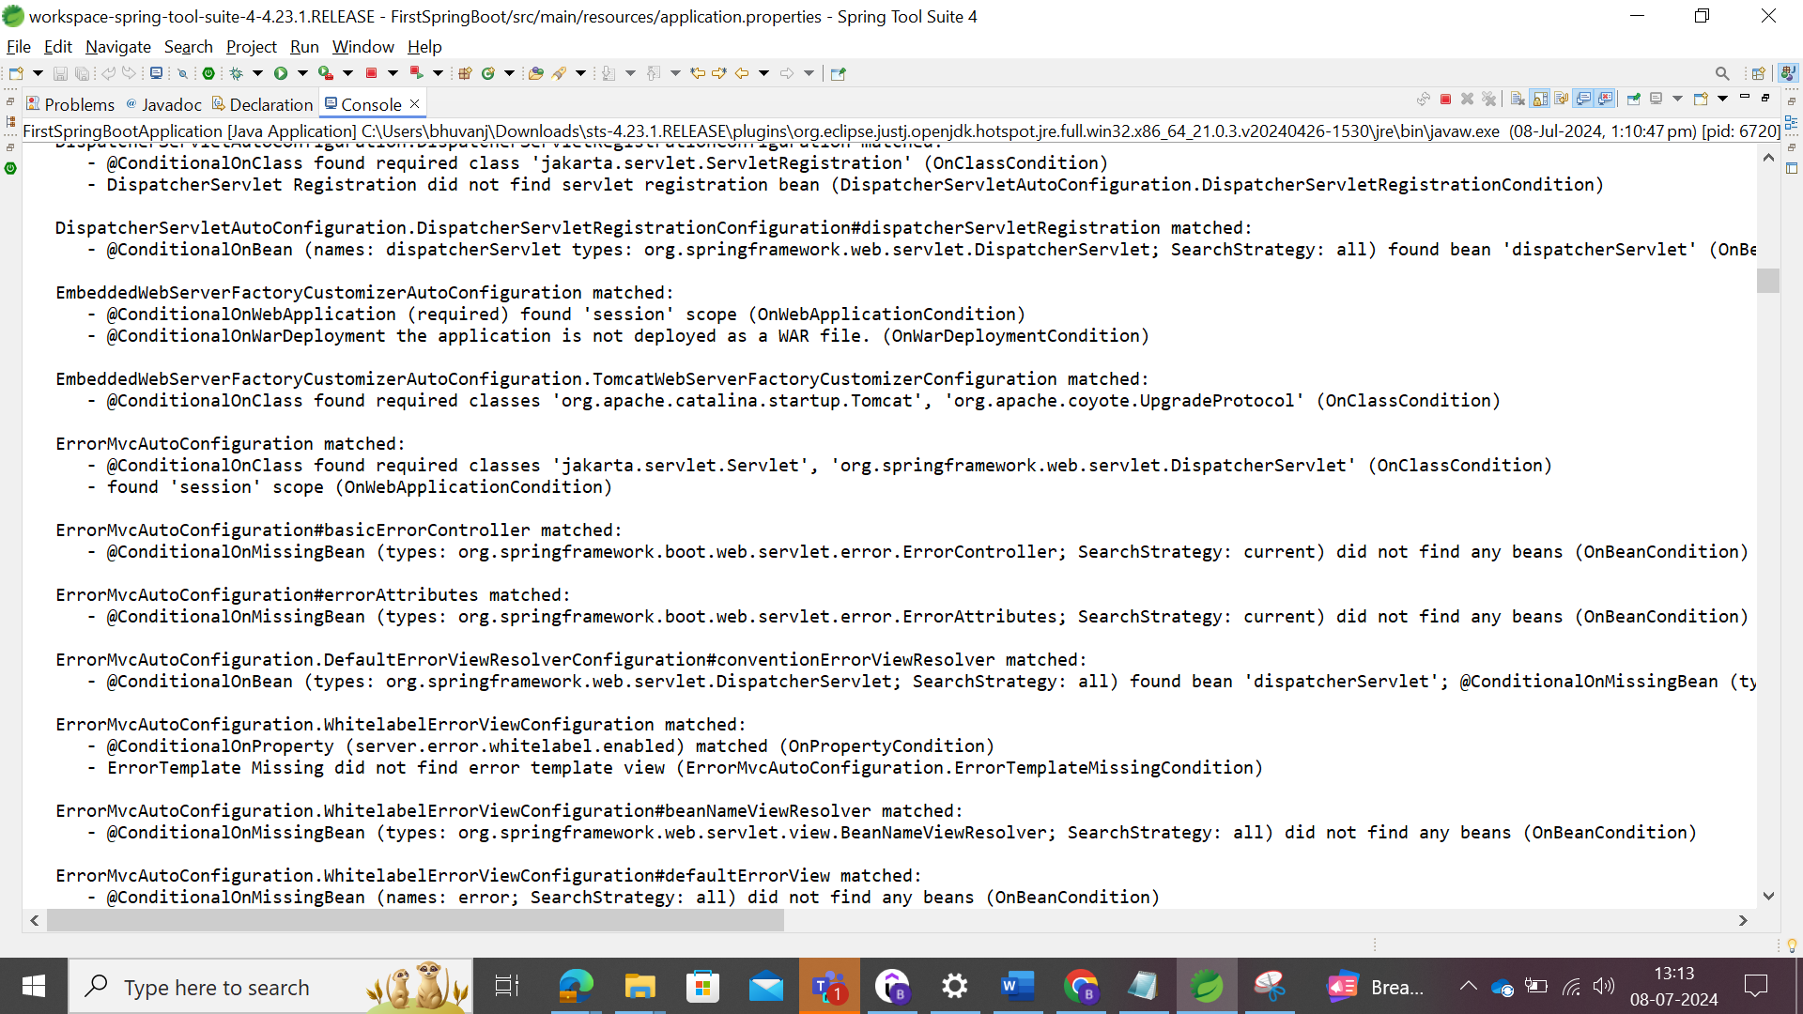

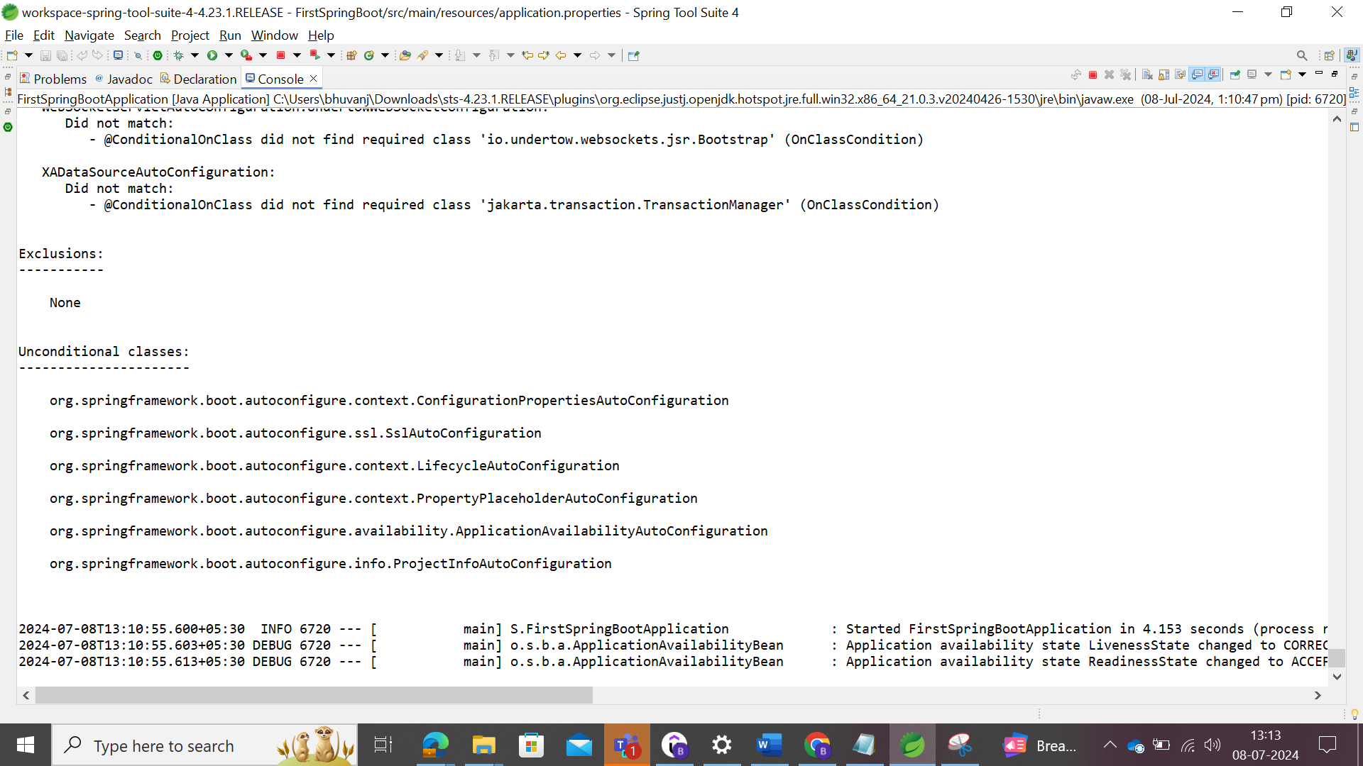

JSON files where the beans are converted to JSON files which are done by **Jackson framework** available in spring boot.

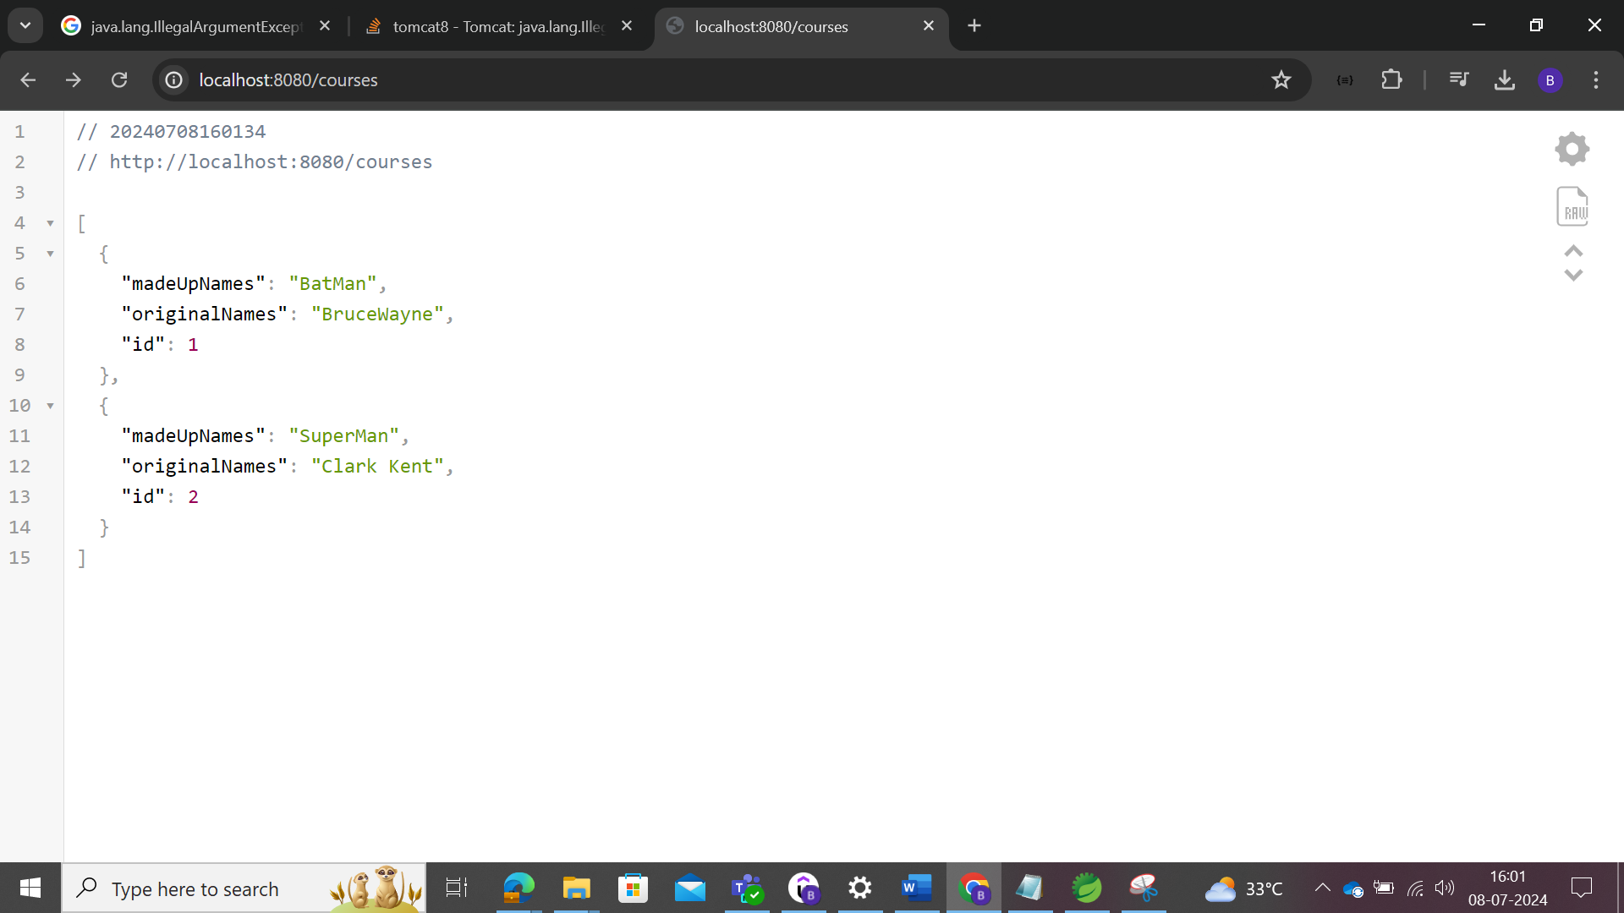

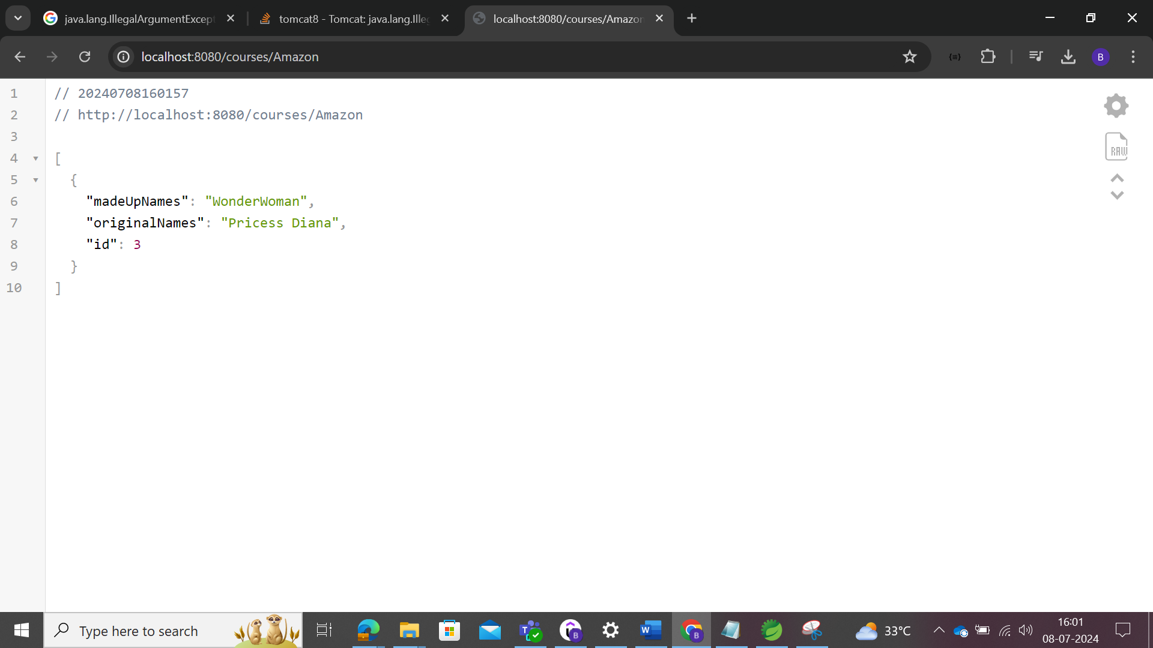

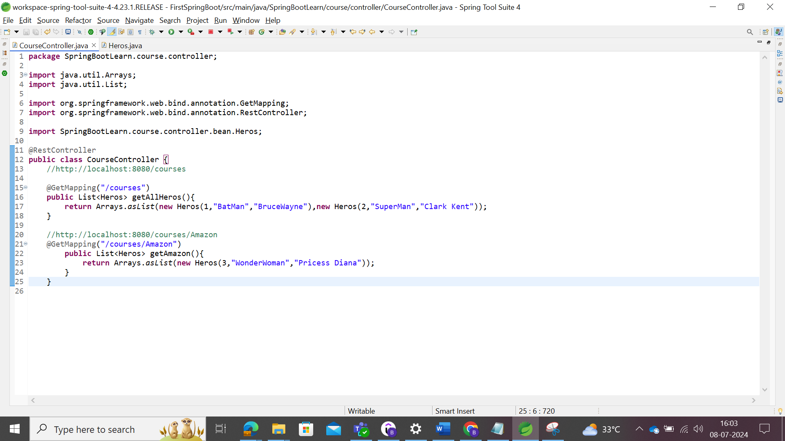

### Spring Boot Embedded Server-Jar Execution

Before Spring Boot, to deploy the application in the server, user should install Java, then web/application server like tomcat/WebSphere/WebLogic/etc., and to deploy the WAR files in the web.

But in Spring boot, for making the scenario super easy, a server is embedded along with the application. Once the java installed, while building the application, the jar file generated

To create the jar file of the project, user should follow the steps to implement

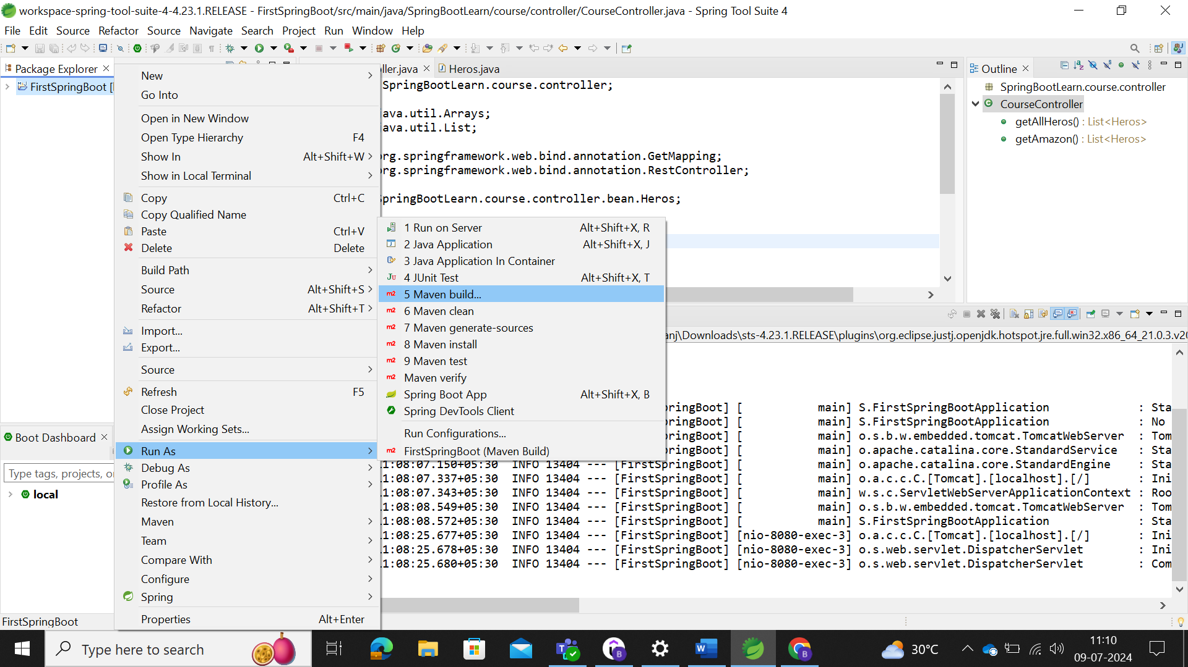

Update the goal to implement

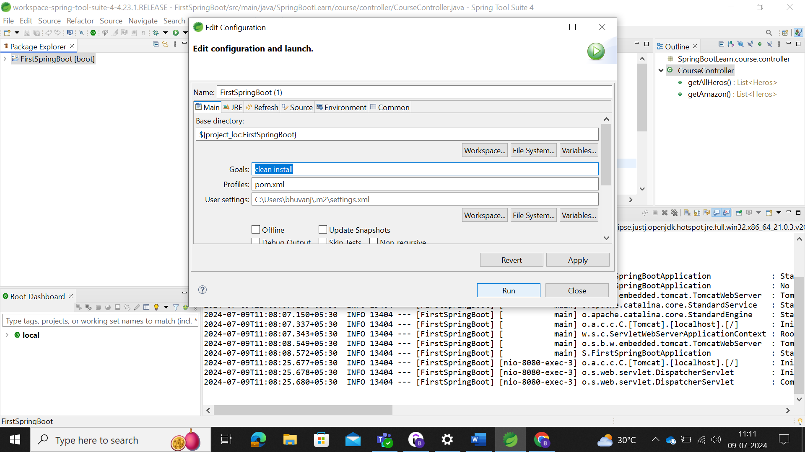

For the first time, jar building will take some time.

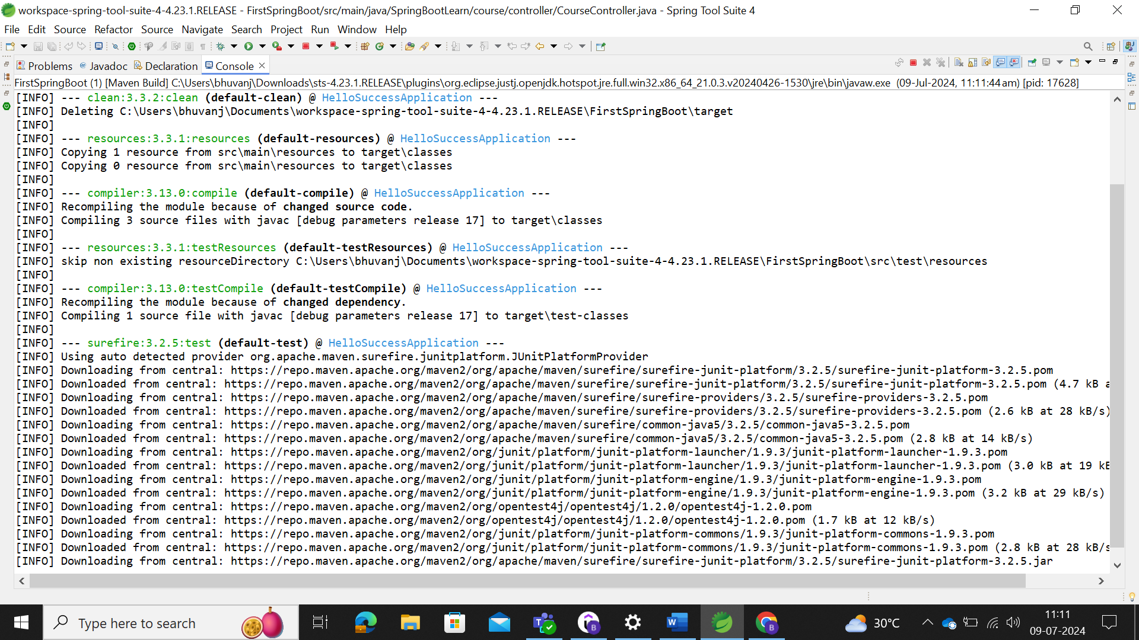

Jar file build is completed.

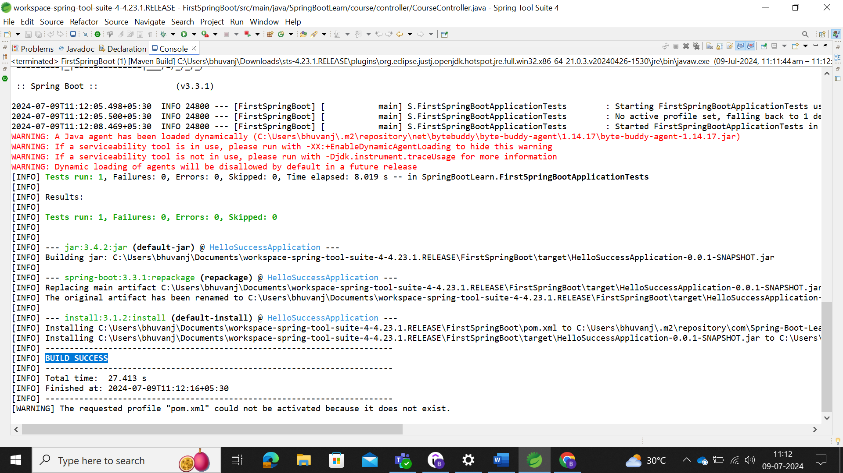

Path where the jar file is built and available.

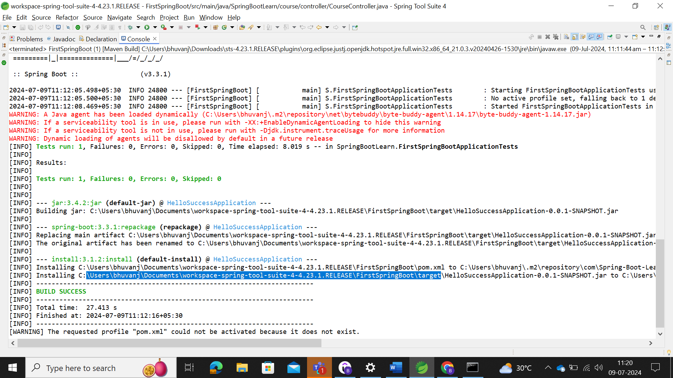

Select the target folder to execute. Go to command prompt to check the execution of the files. Change the directory with the above location.

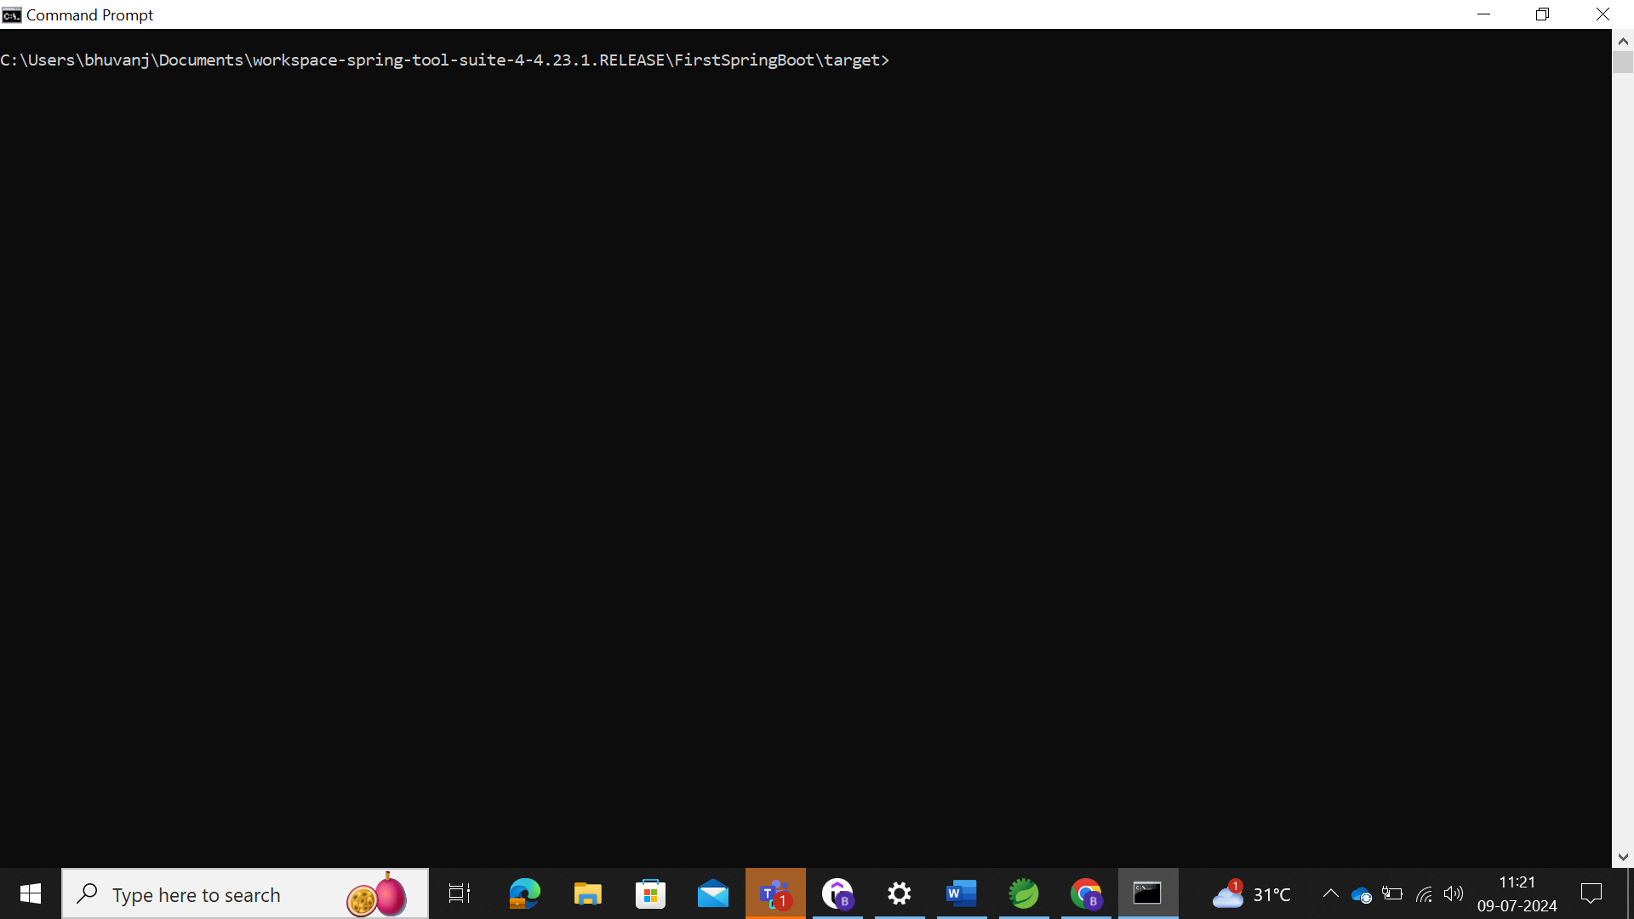

In Windows cmd, use dir to view the list of files in the location instead of ls.

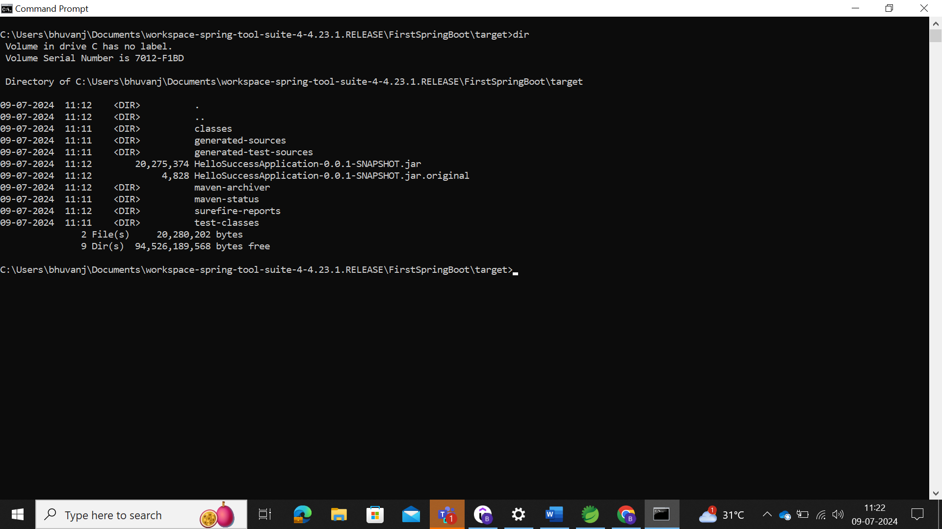

Here, we could use the jar file to execute the tomcat.

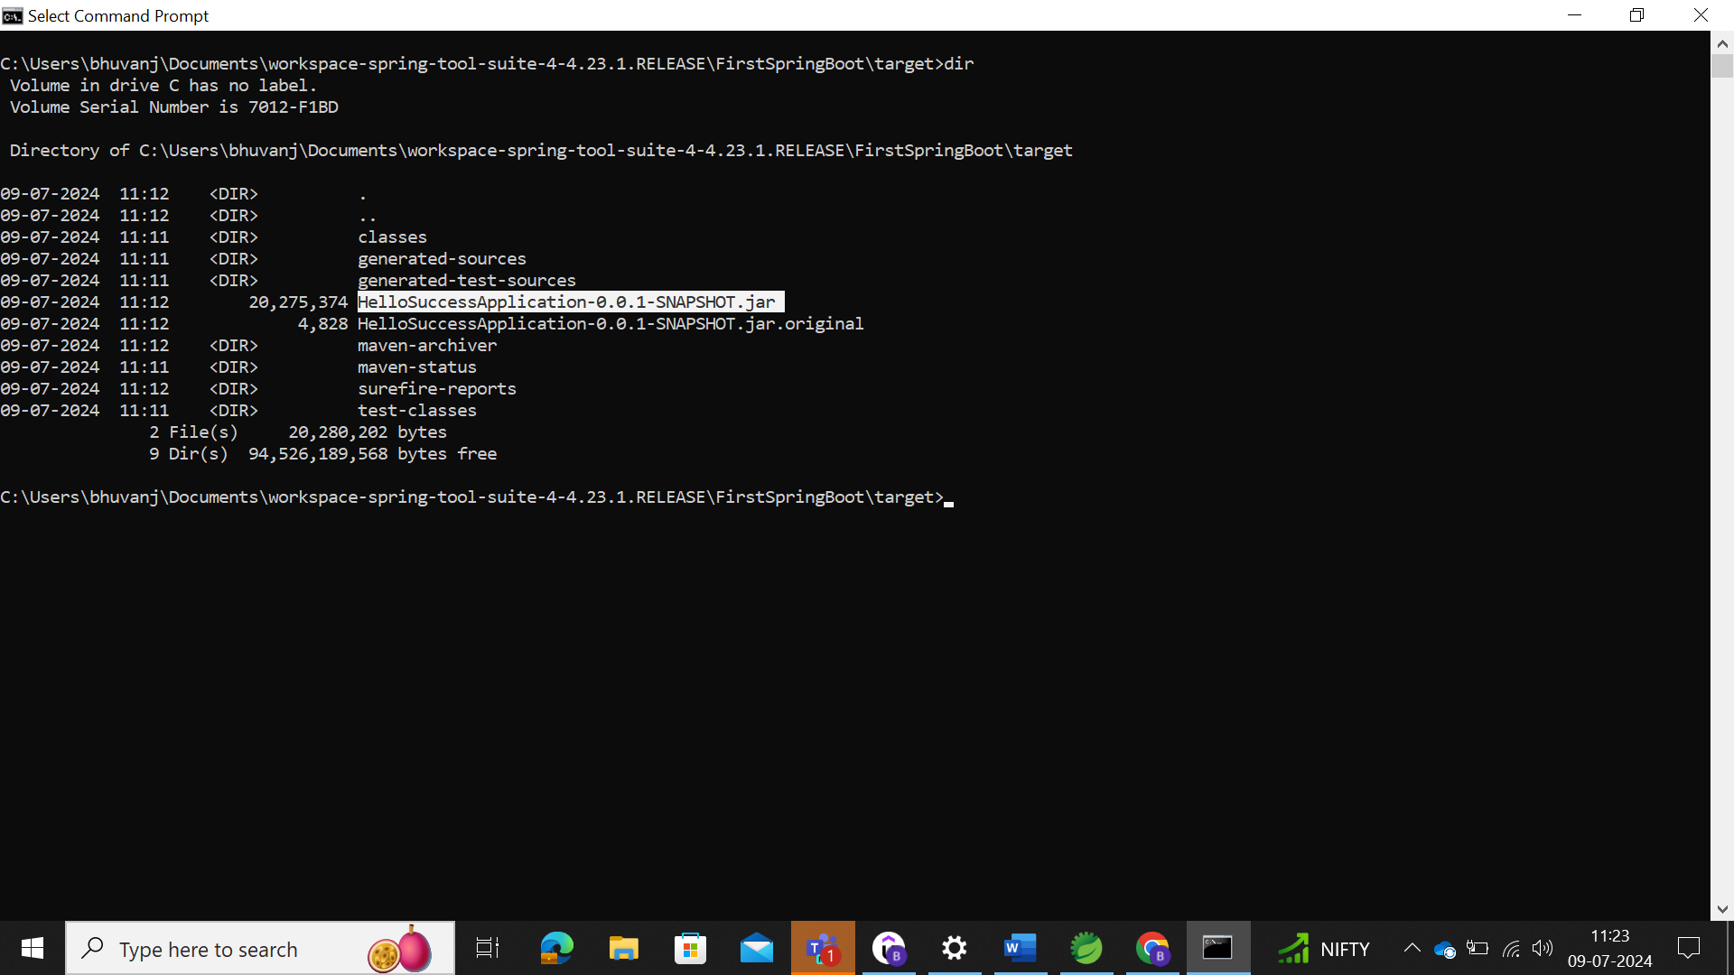

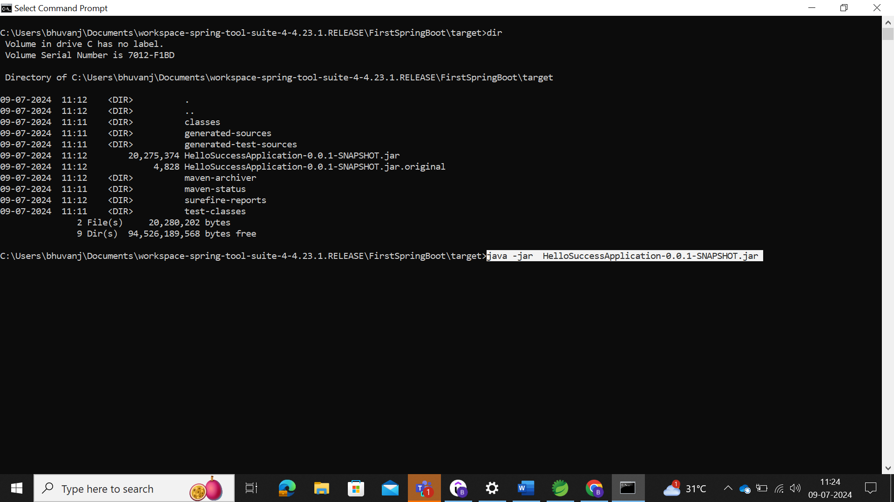

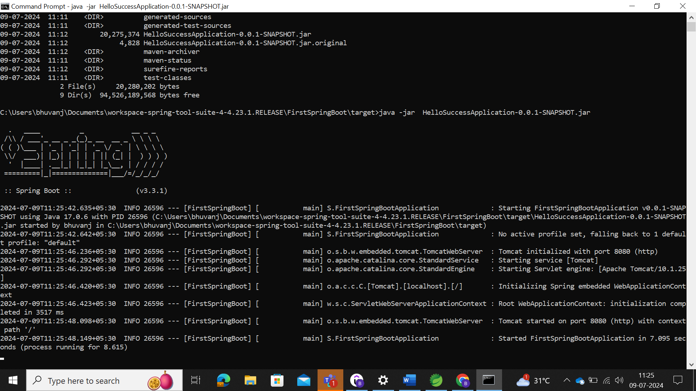

From the above, we could be able to see that jar files are being executed and it is running now.

So, at that time, we could be able to view that in local server.

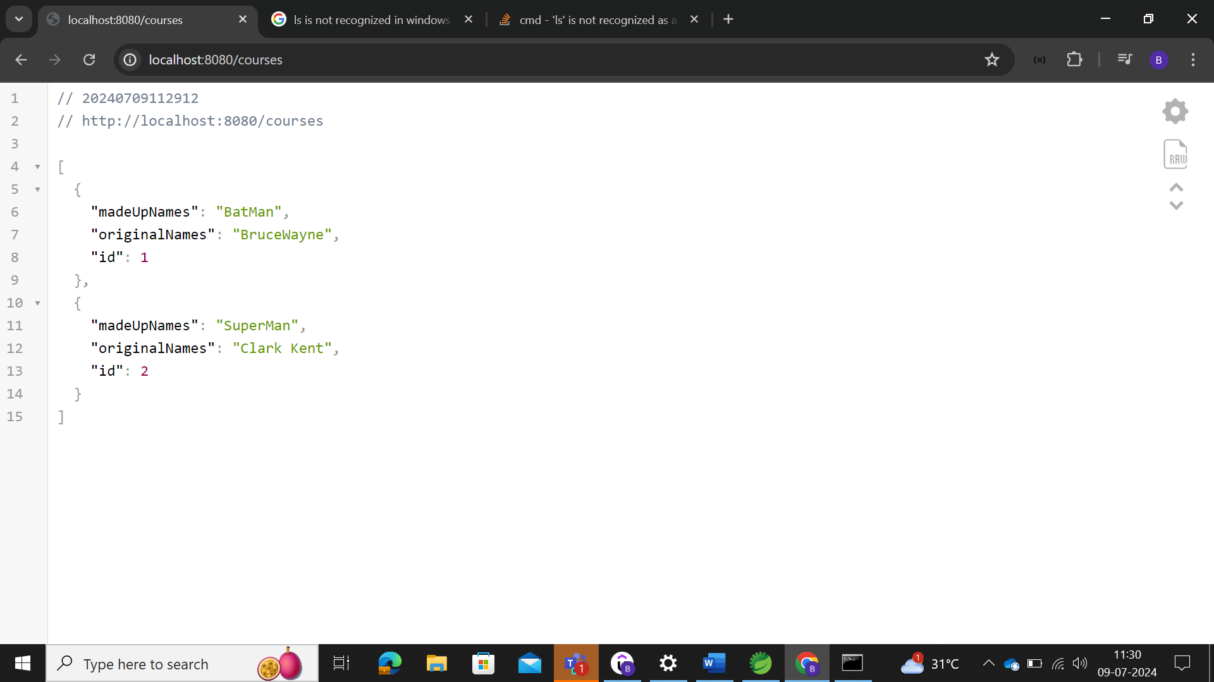

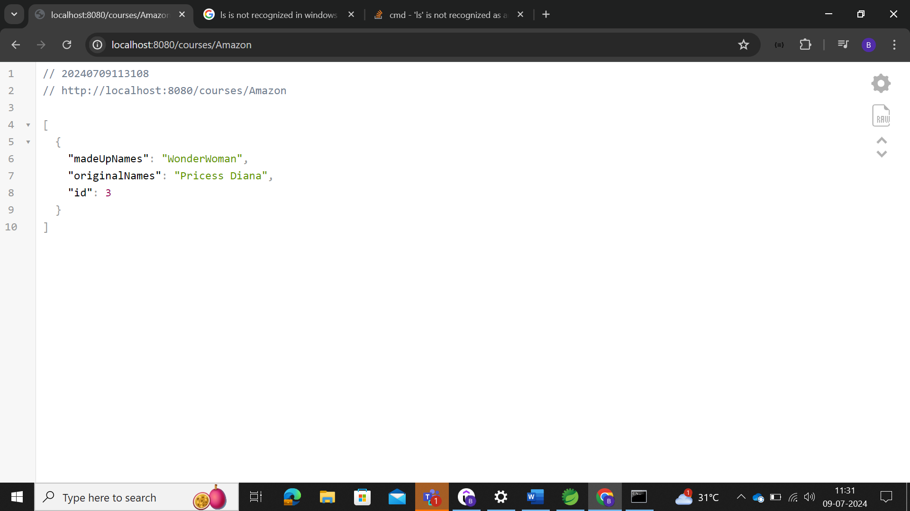

The above is spring-boot server termed as tomcat, but there also other servers termed as that of jetty, and undertow.

### Spring Boot Actuator

User to monitor and manage your application in your production and provides various endpoints like bean, health, metrics, and mappings.

Spring Boot Actuator: Monitor and manage your application in your production. It provides a few endpoints:

1) beans - Complete list of Spring beans in your app

2) health - Application health information

3) metrics - Application metrics

4) mappings - Details around Request Mappings

Add the actuator dependency in the pom.xml, as given below.

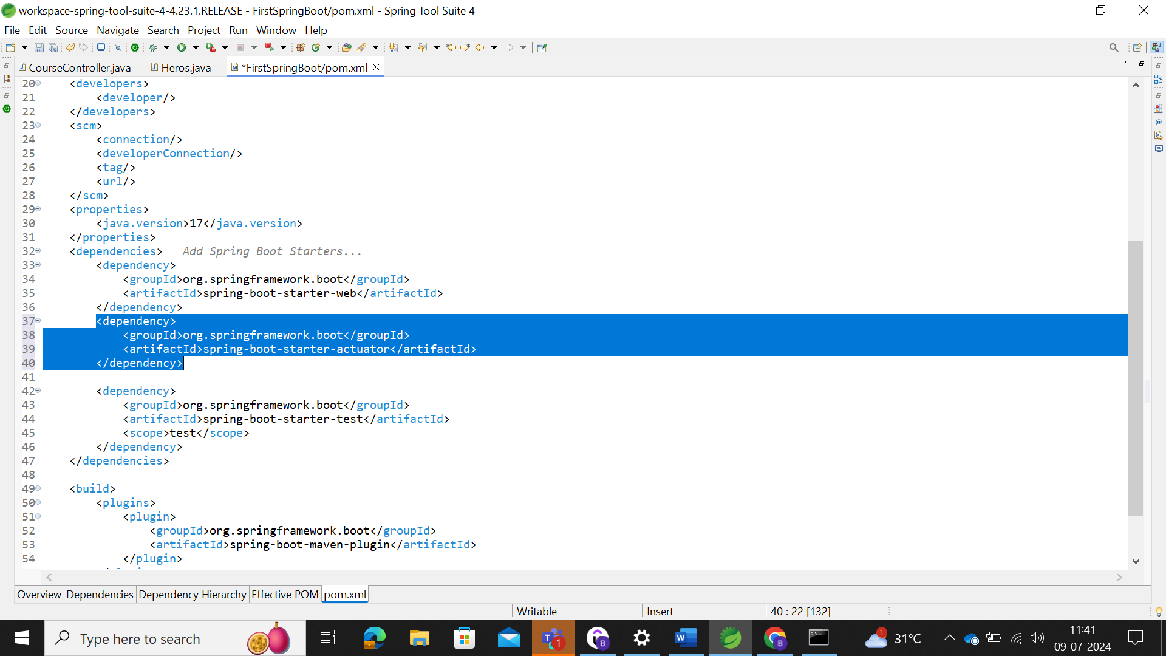

Run the application

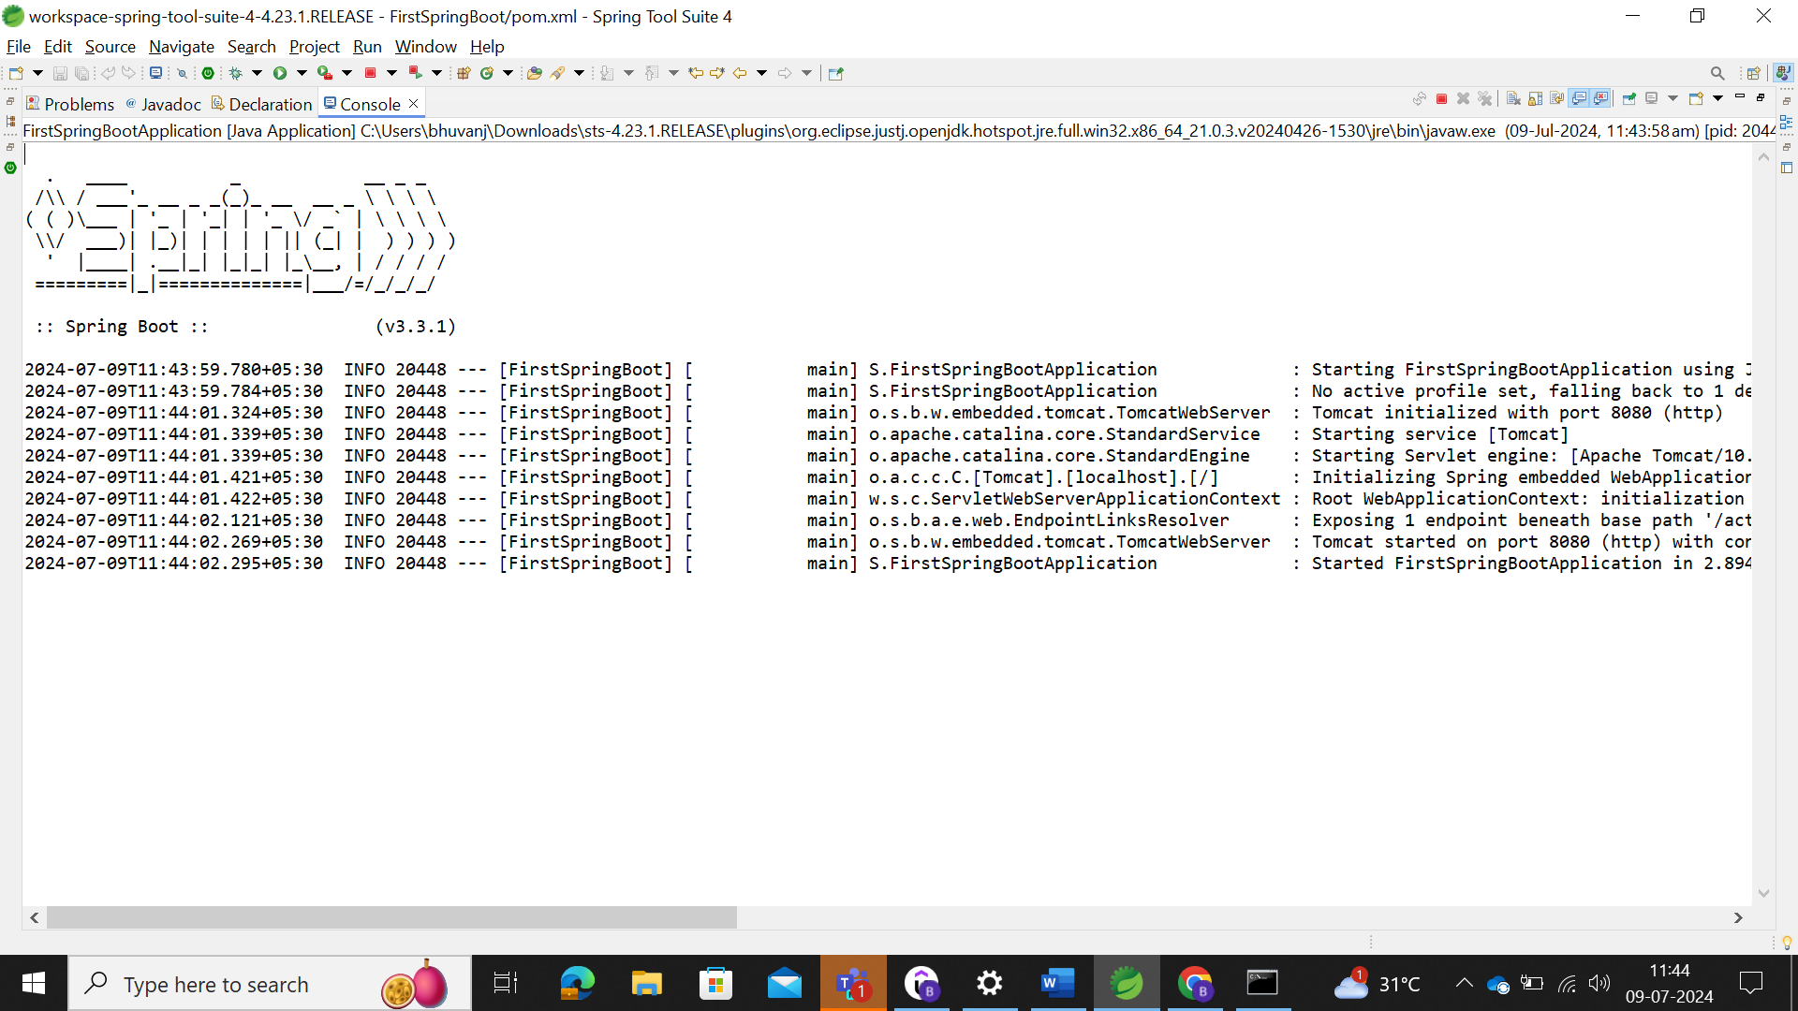

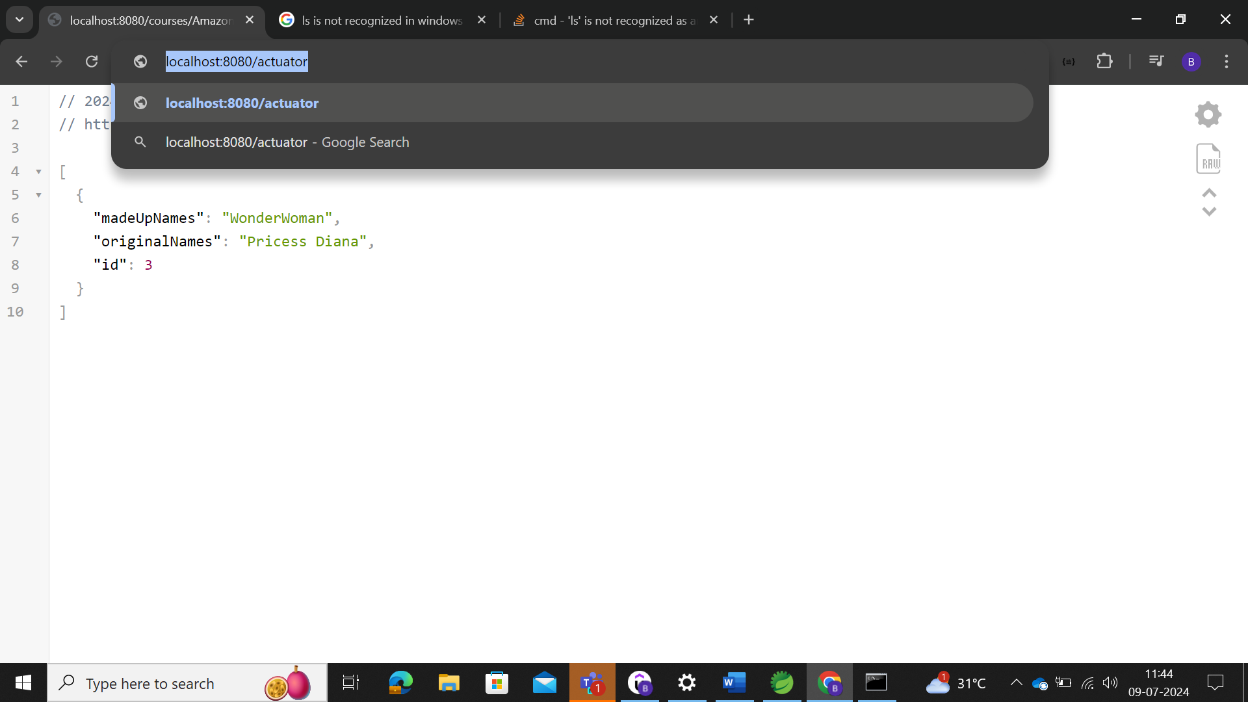

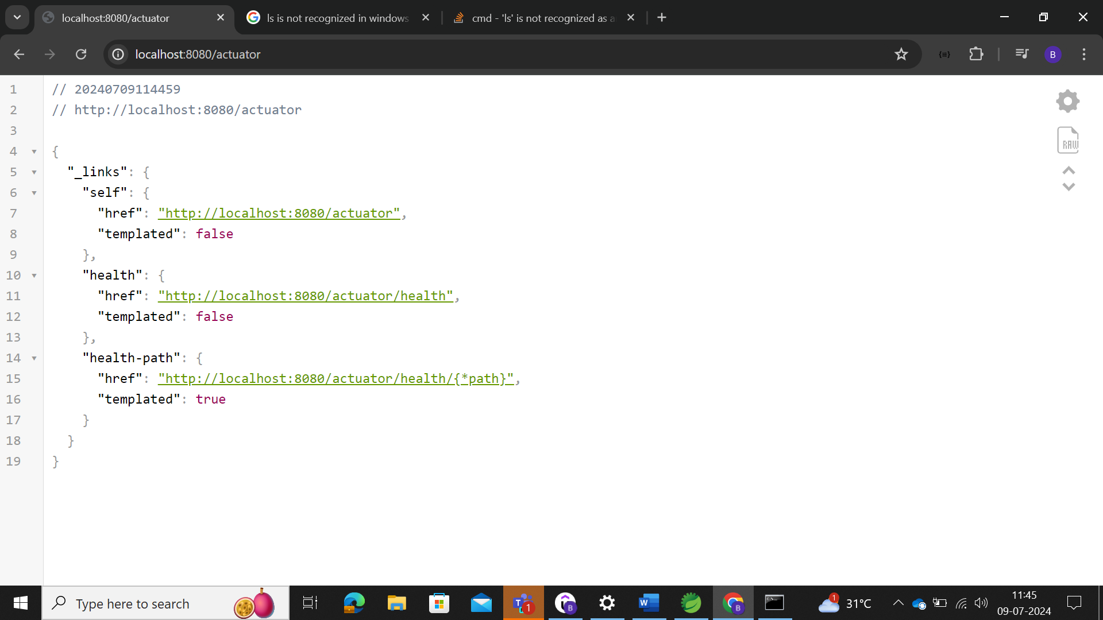

To enable all the APIs in the actuator, we can make use of the **management.endpoints.web.exposure.include=\*** in the application.properties file to enable all APIs. Here actuator is managed in the management.

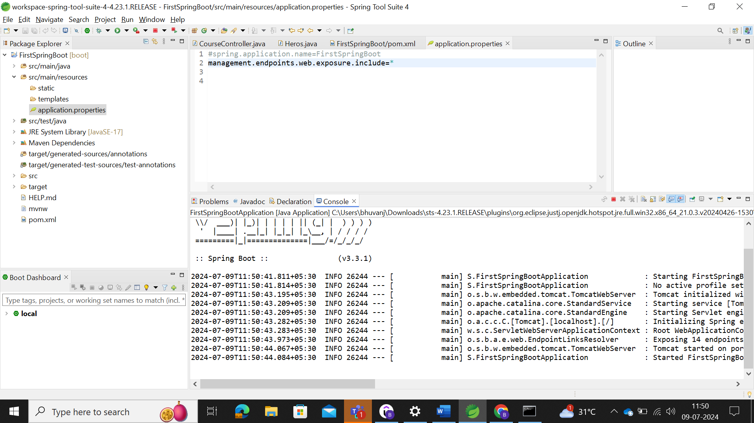

Enabled all the endpoints in actuator.

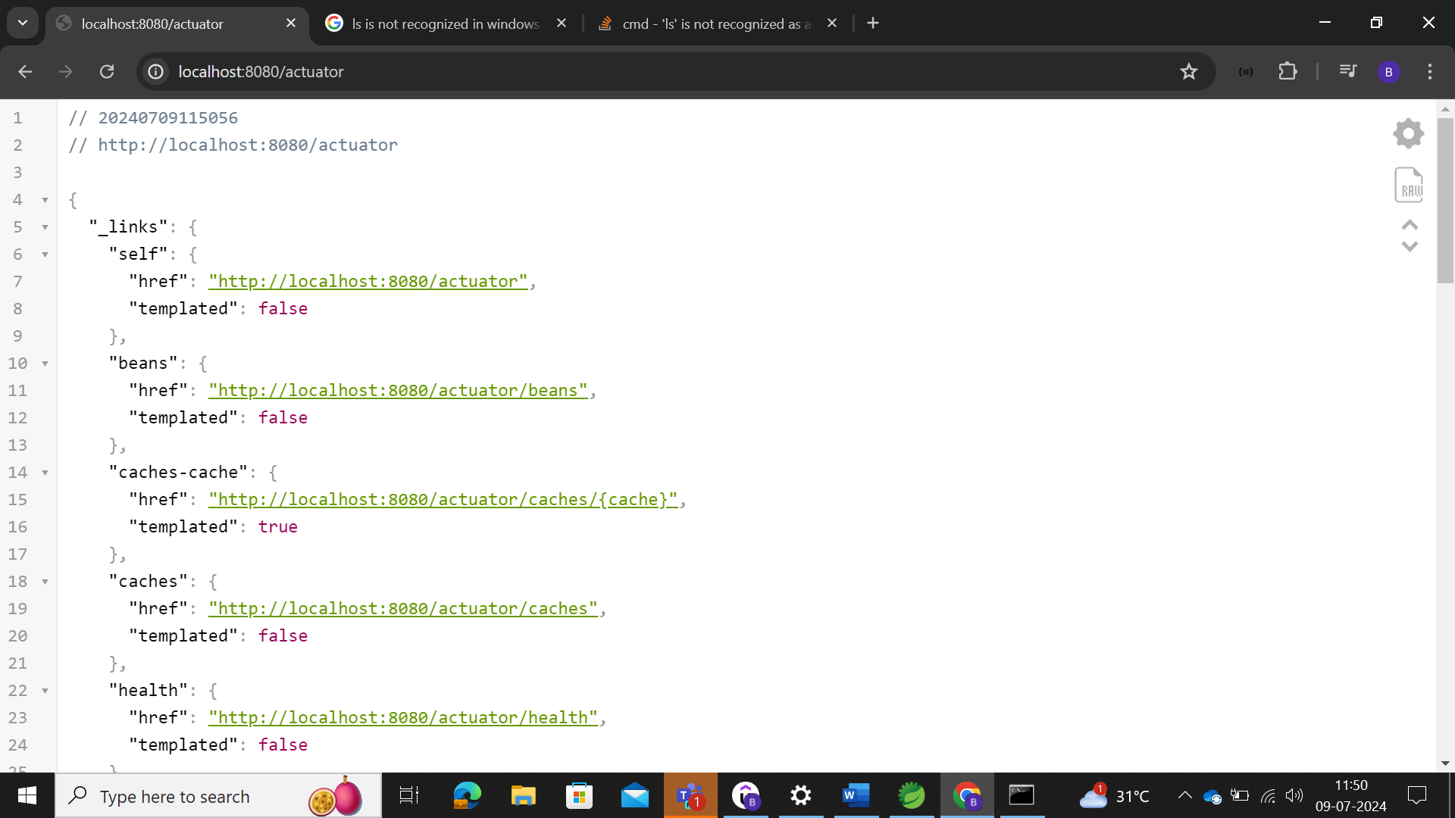

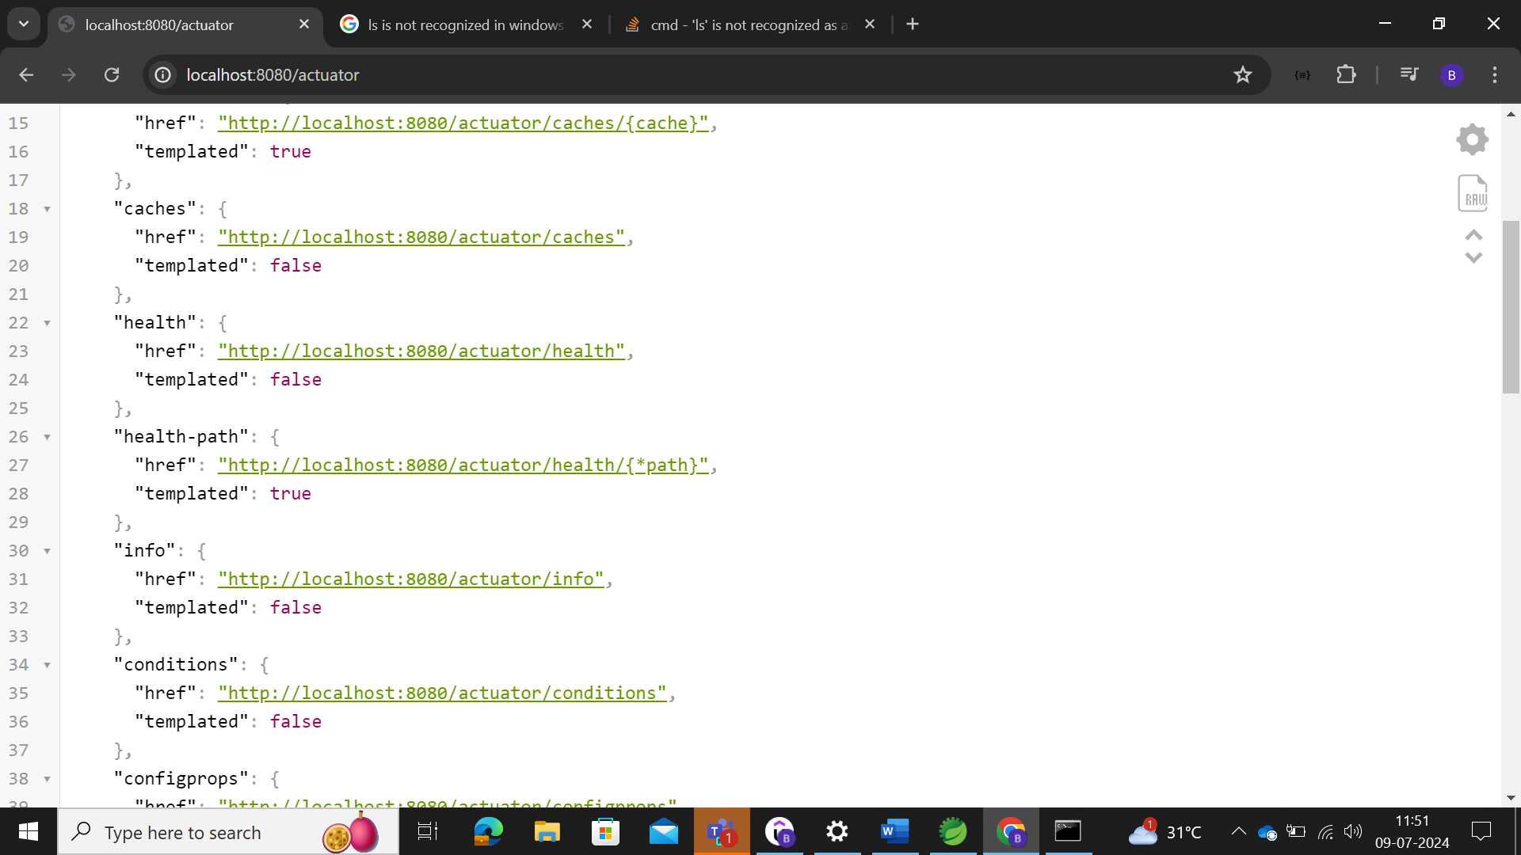

This bean will show the number of bean created or mapped in the application.

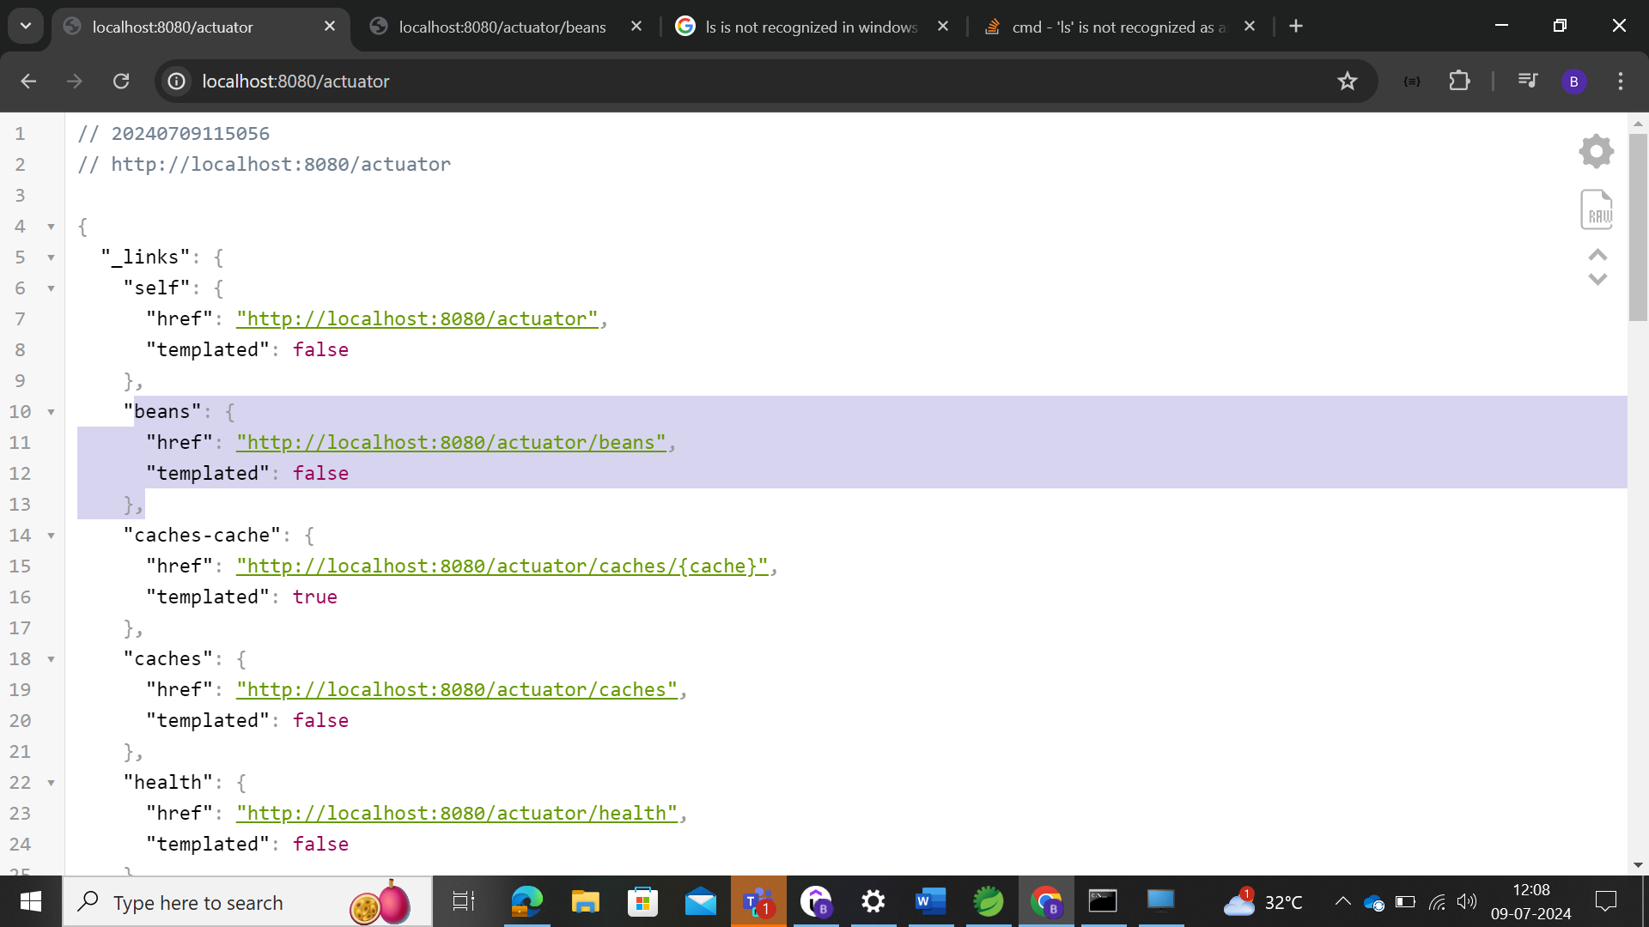

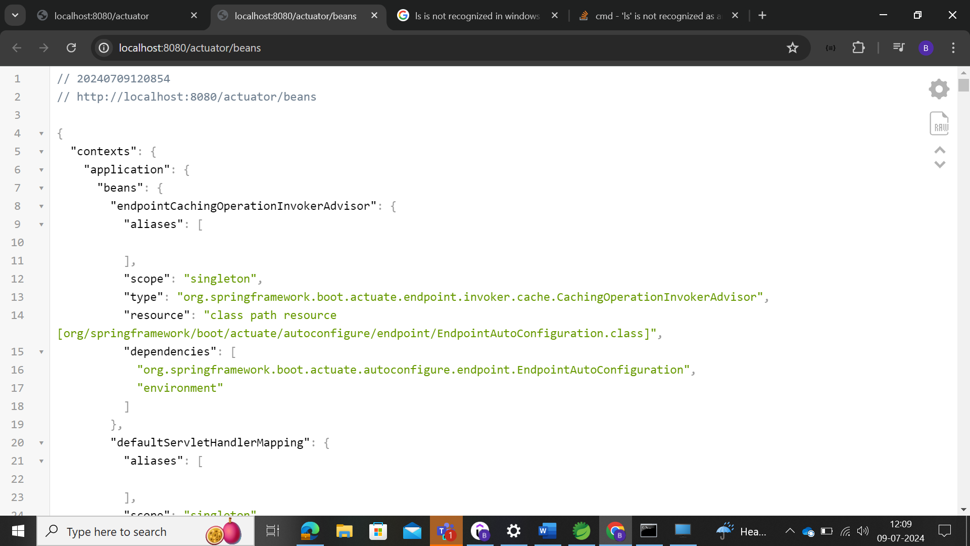

While creating applications, we have updated as the RestController.

Without Json extensions

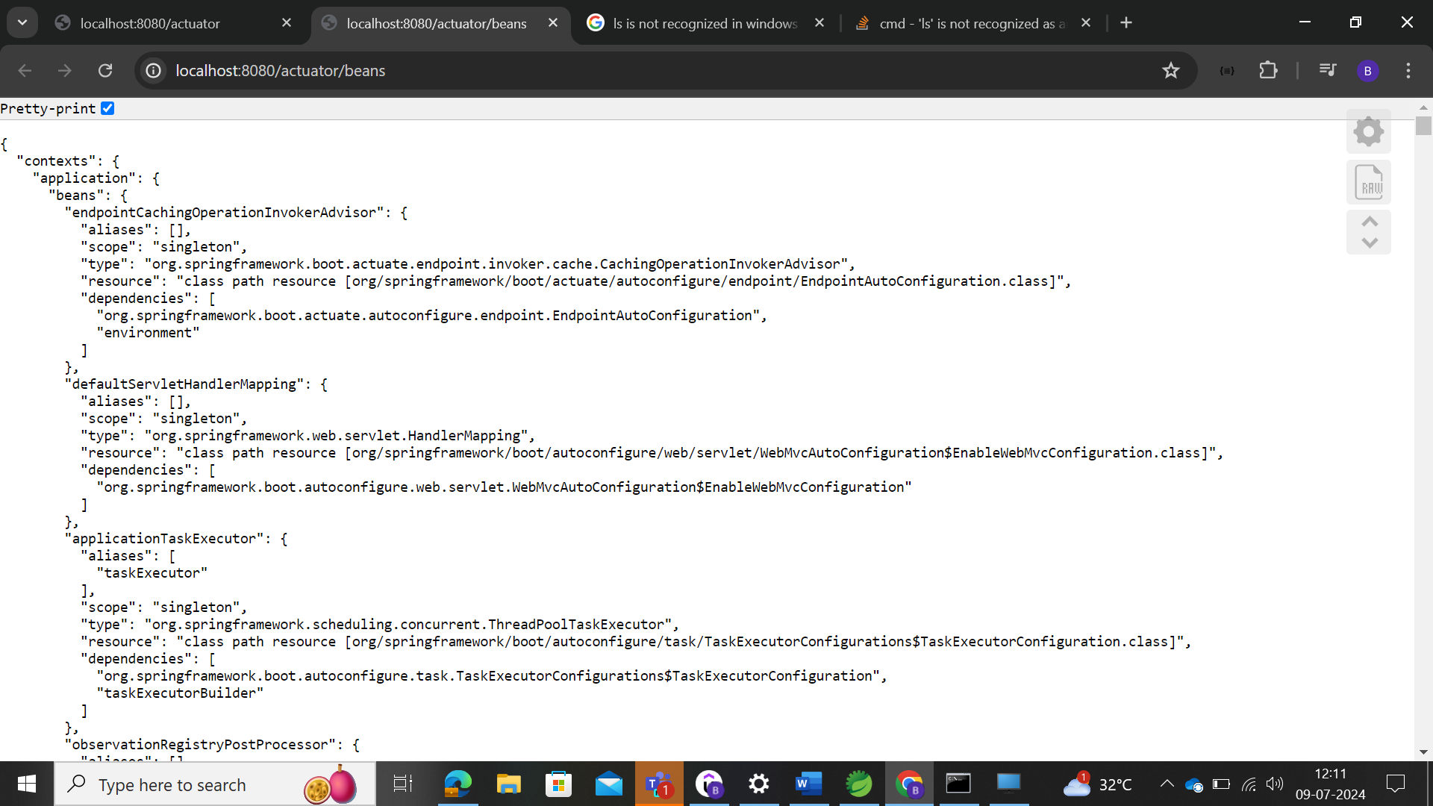

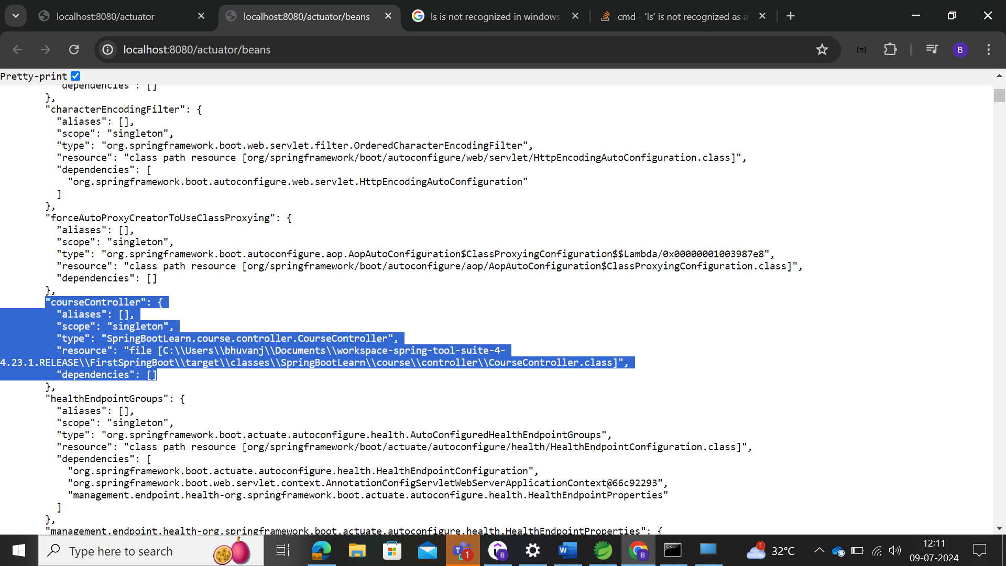

In the actuator, we could able to view the metrics, where in metrics, user could be able to view the no of server requests that has been passed in the "**http.server.requests**", metrics of actuator.

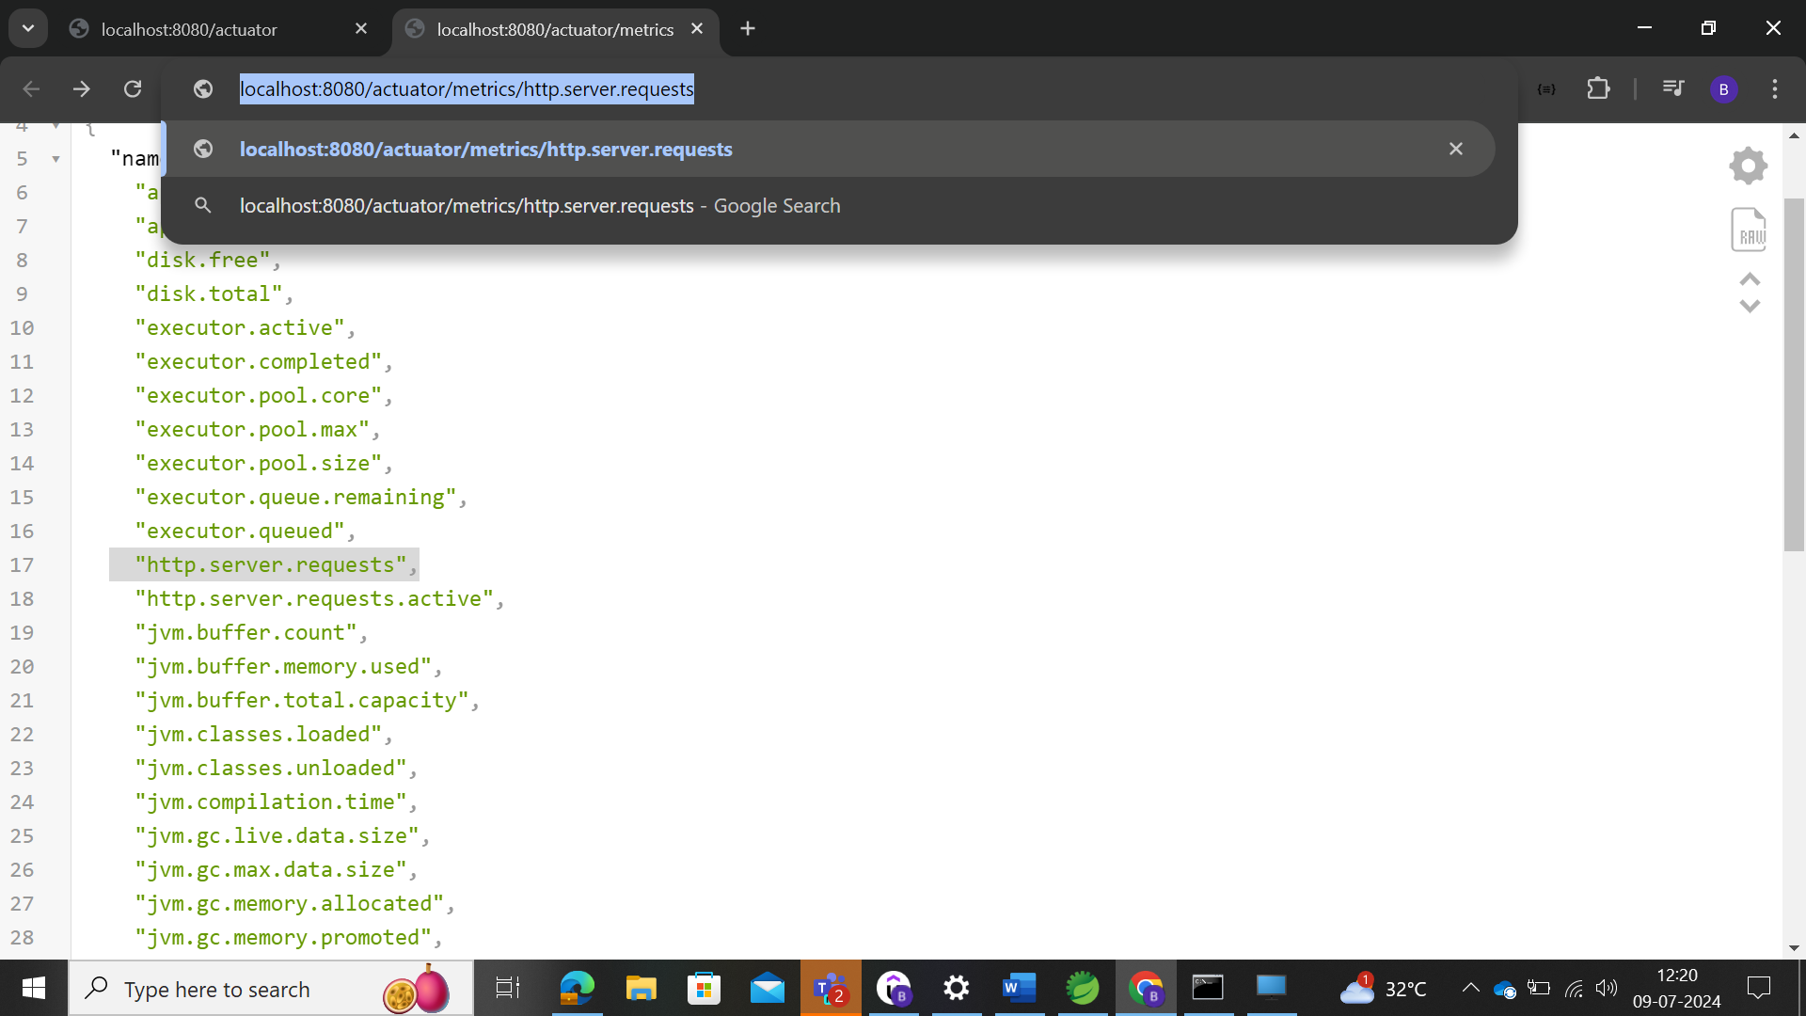

Here user could be able to view the count of server requests.

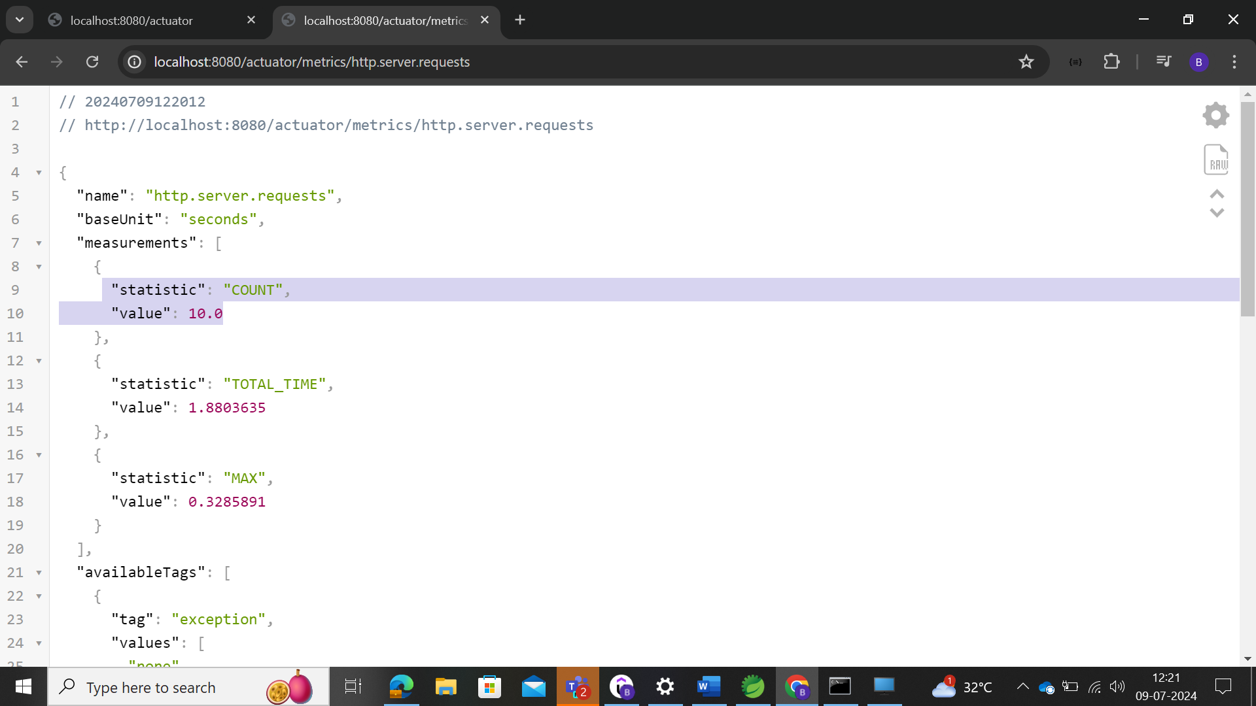

### Spring Boot Devtools

**Spring-boot- devtools** 🡪 used to update in the dependency

This devtool dependency is used, when the user needs to update the code and need to start and stop the code run every time they make the changes.

After adding this dependency, user could change the code and need not stop and start again, it automatically start executing once saved. This is happening at the runtime, **need to add the runtime as scope in the dependency.**

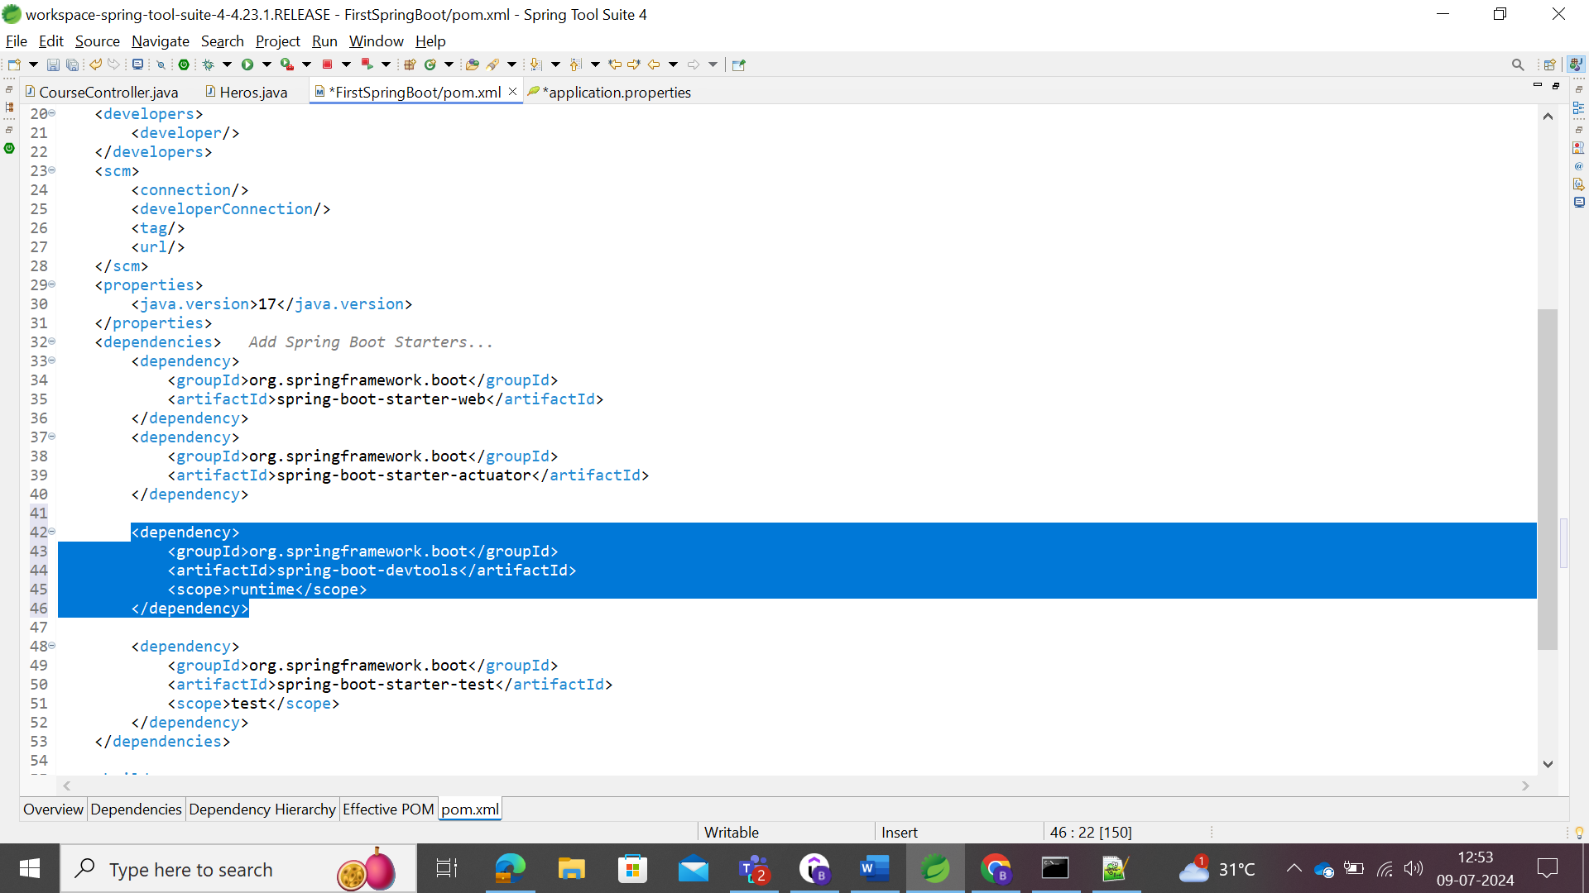

After that we run the code

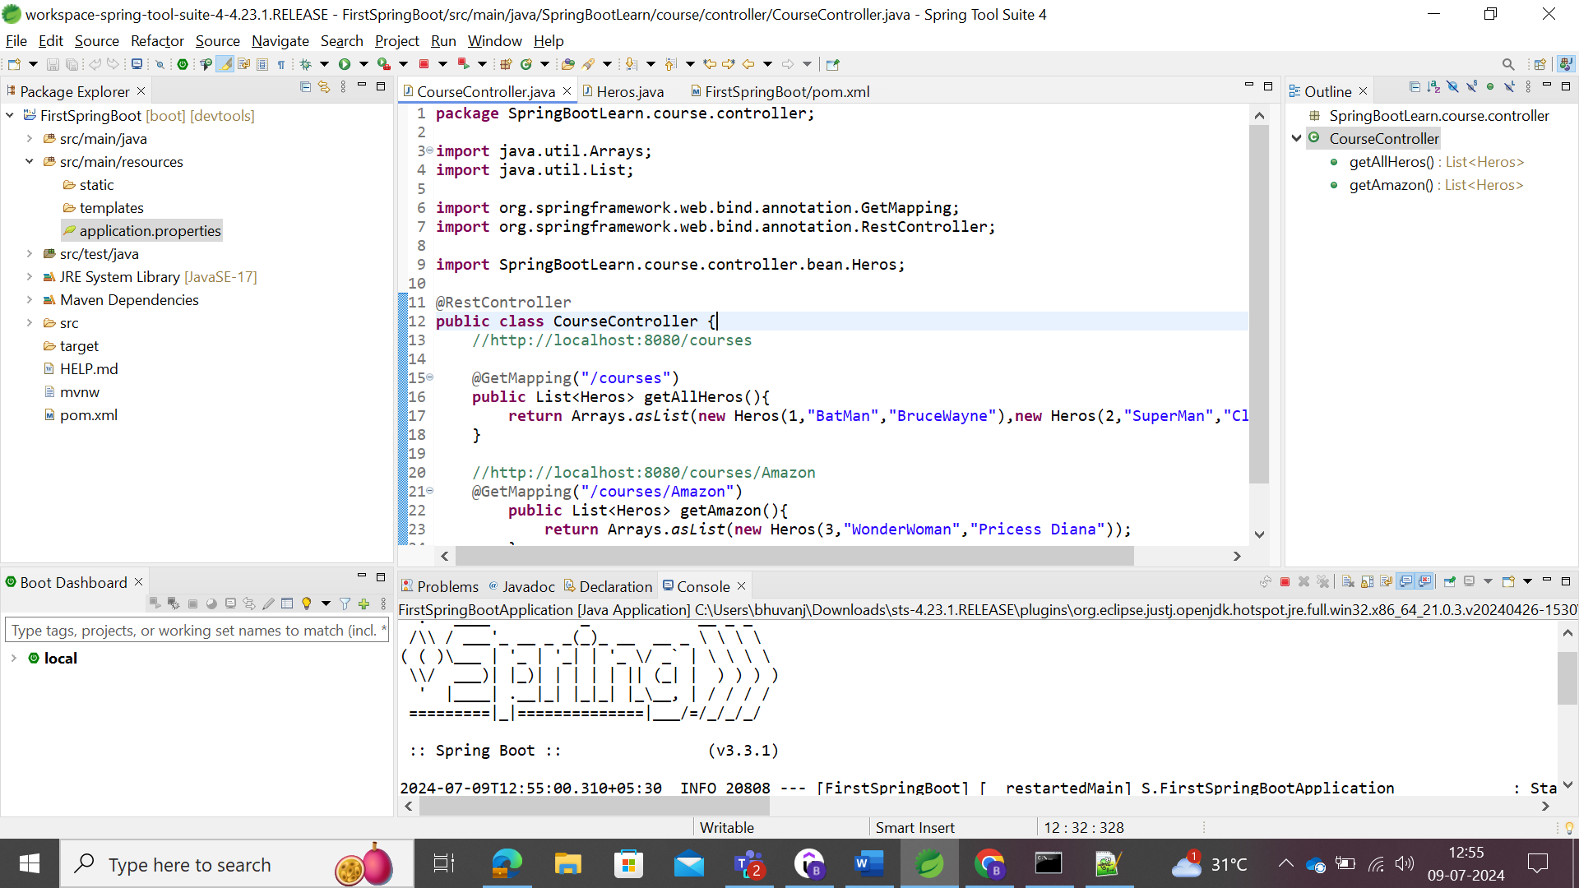

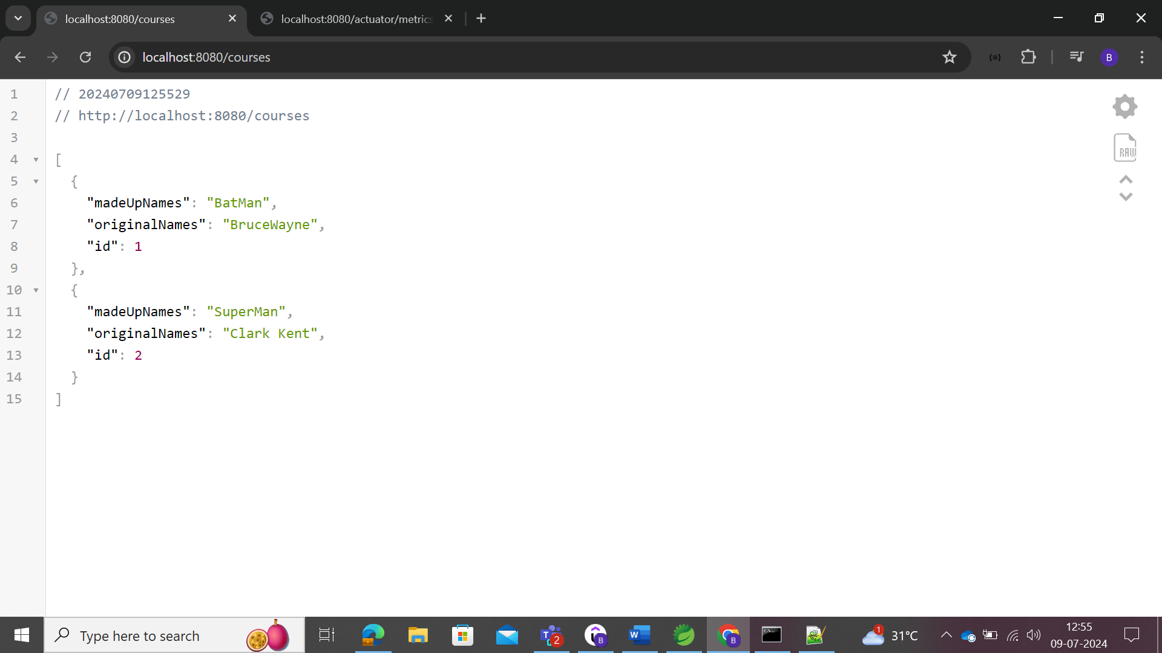

Made the changes while the server is running

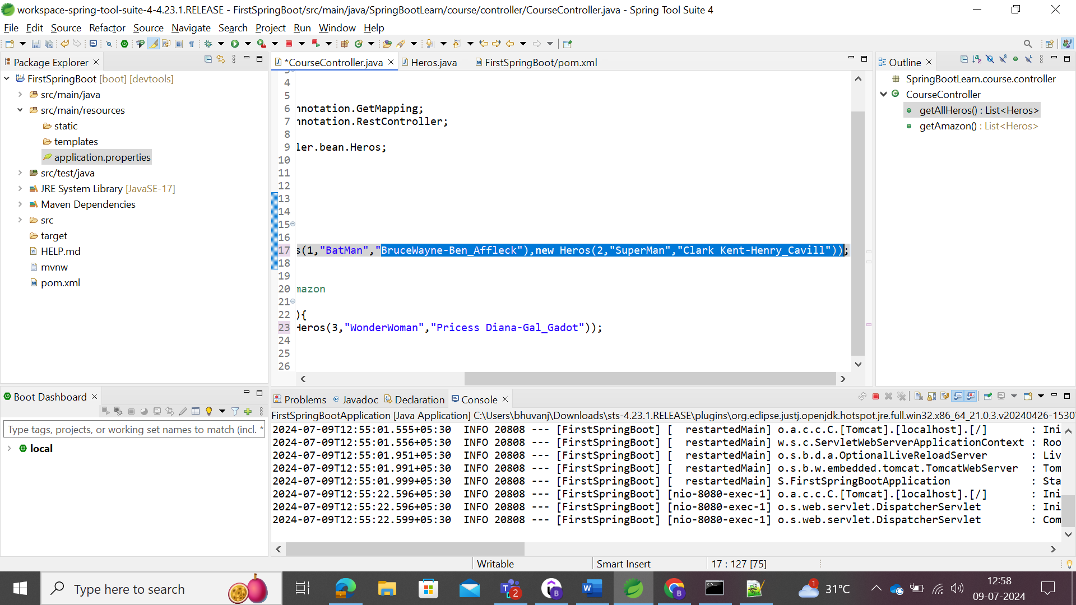

After saving, it will auto update in the server, where the console will pop as shown below to update.

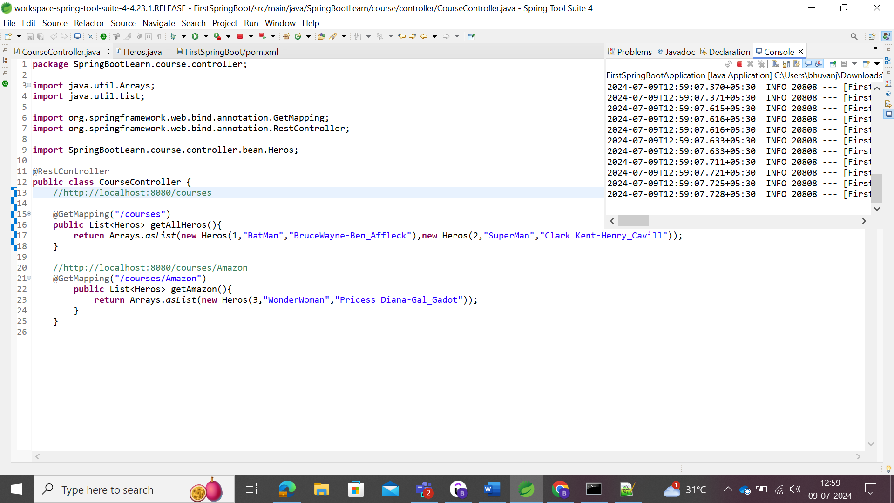

The server shows the updates.

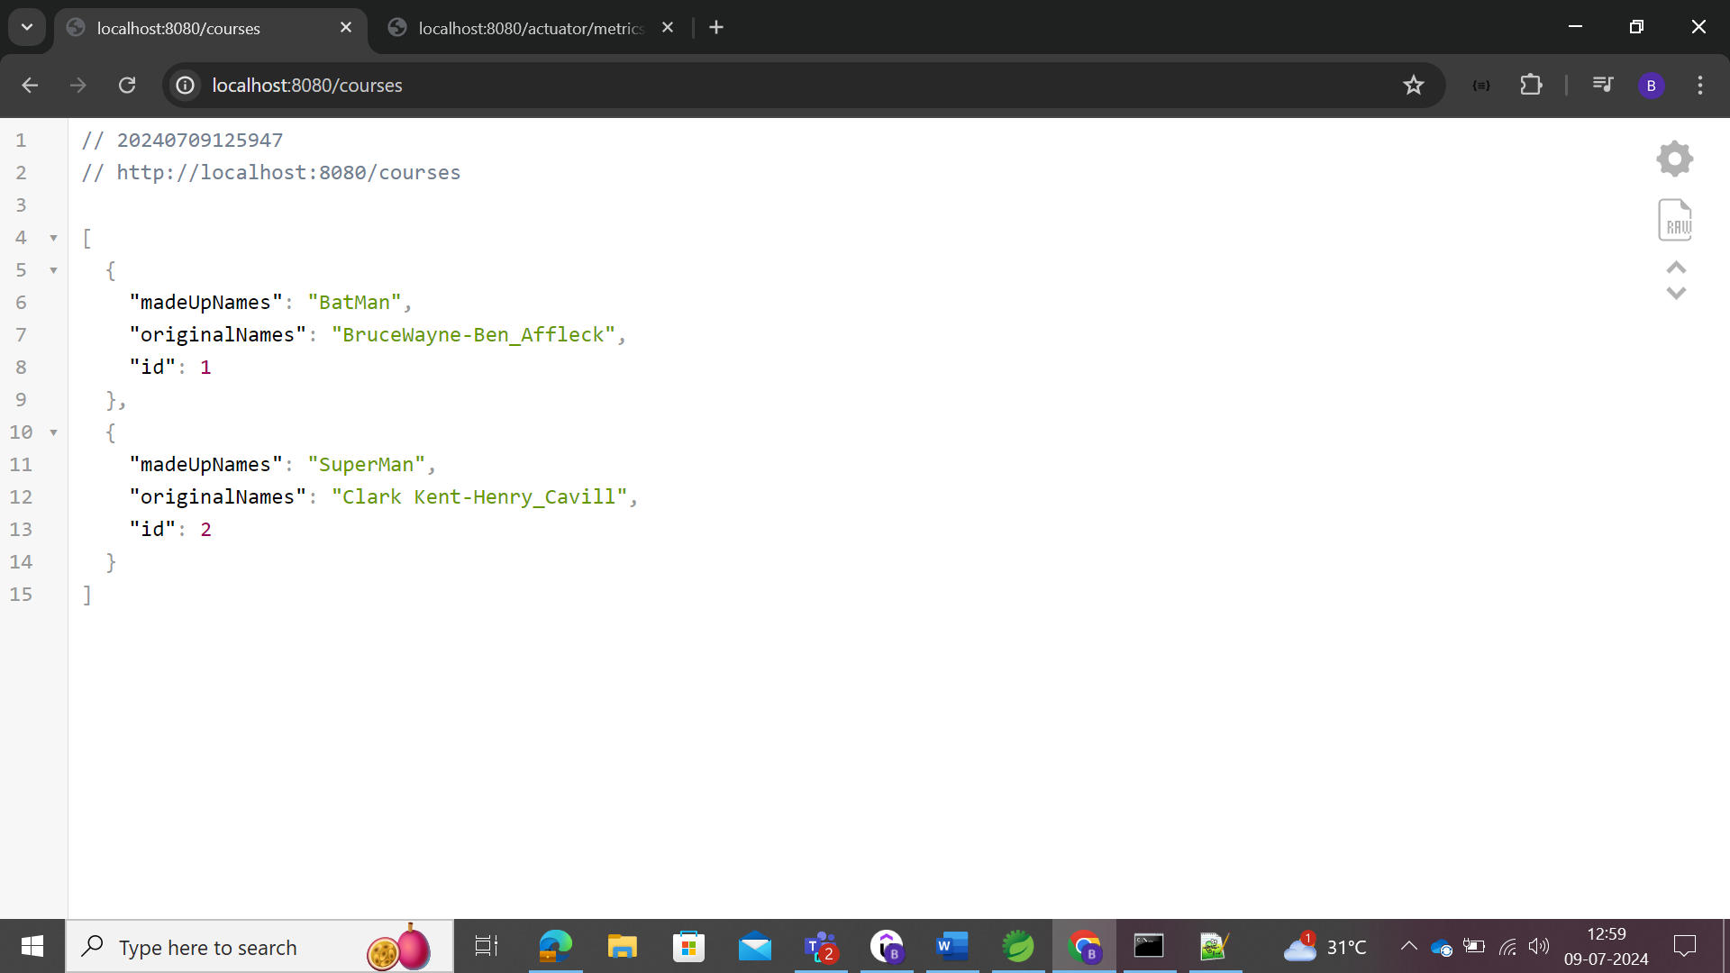

Spring Boot Application is the combination of 3 annotations:

* @SpringBootConfiguration
* @AutoEnableConfiguration
* @ComponentScan

# JUNIT_Beginner

JUnit is framework which is used for the Unit Testing of the coding.

Deploying and testing the complete application 🡪 System Testing and Integration Testing

Testing the specific unit of code independently 🡪 Unit Testing.

Simple code to check for the Junit coding test. The below code is Java code to check.

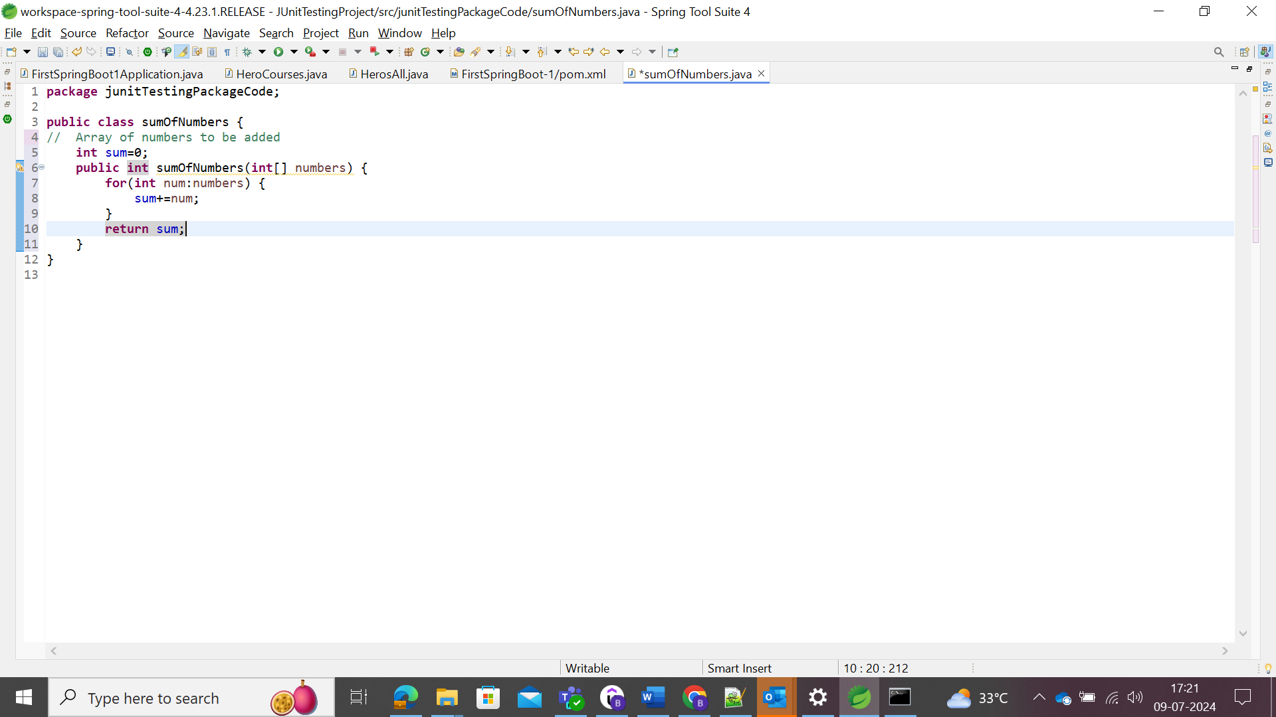

For testing code, it shouldn’t be in the same source folder (src) as in the main folder, but in the separate folder. Select the src and create the Source Folder.

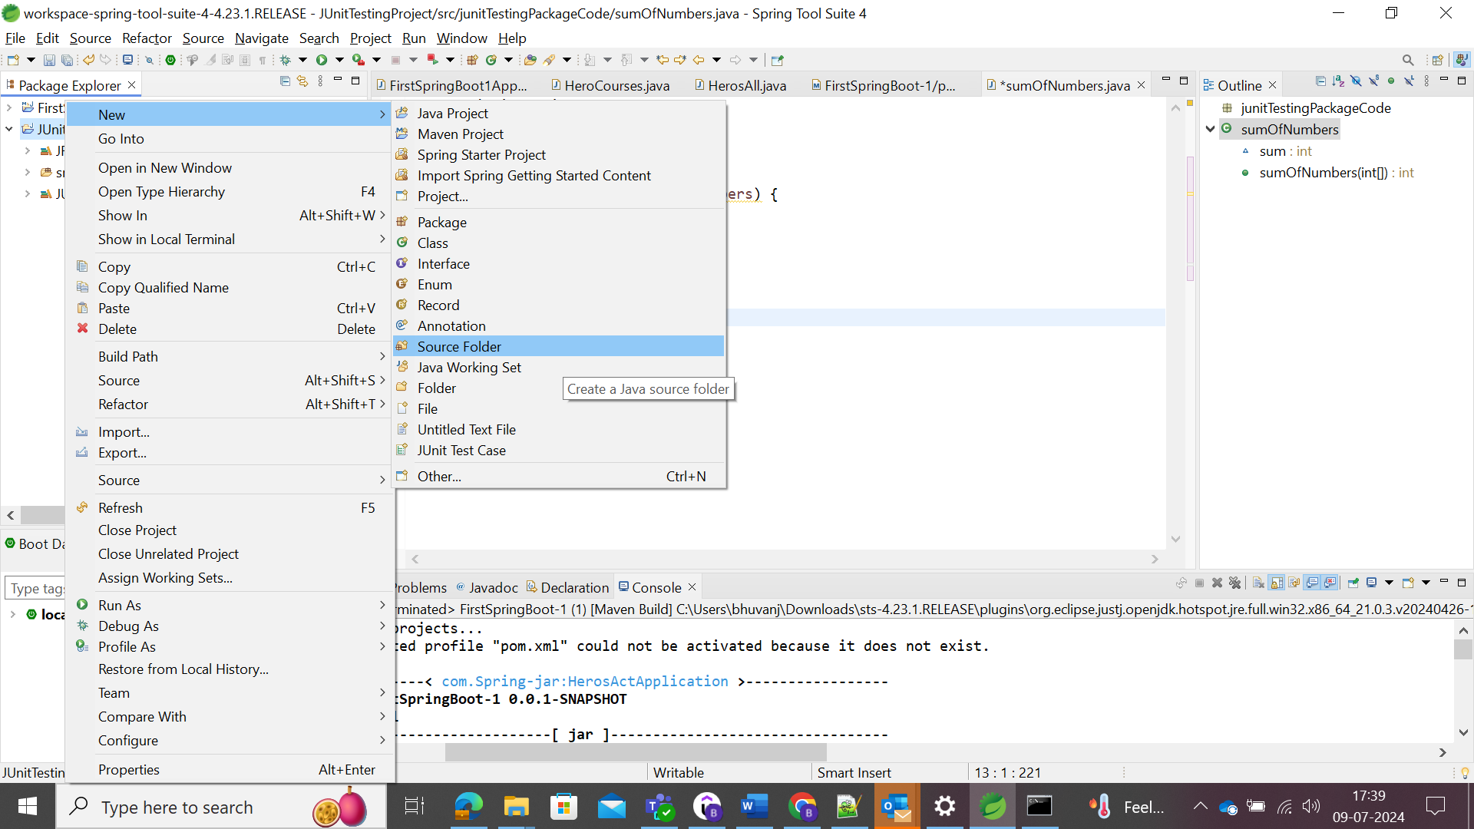

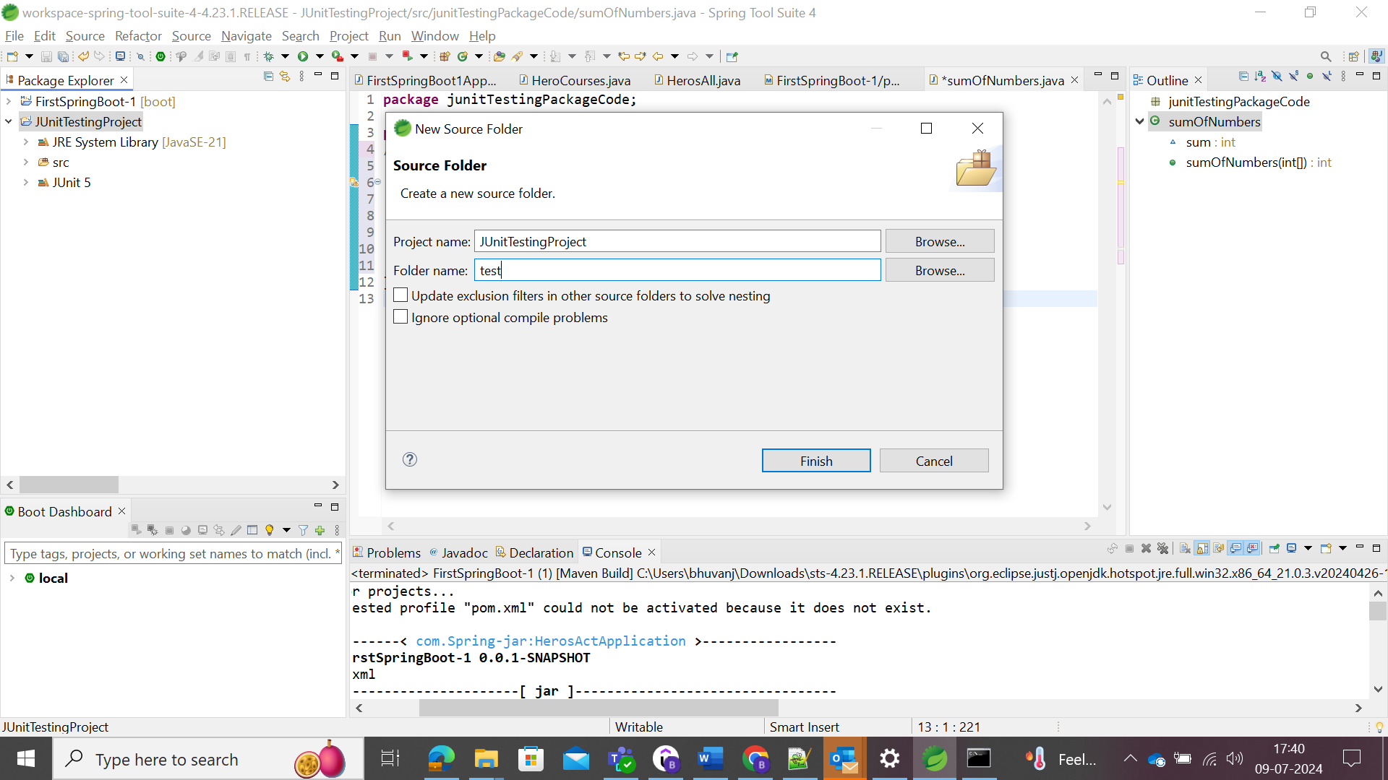

To write the testing code, select the JUnit Test Case file as follows.

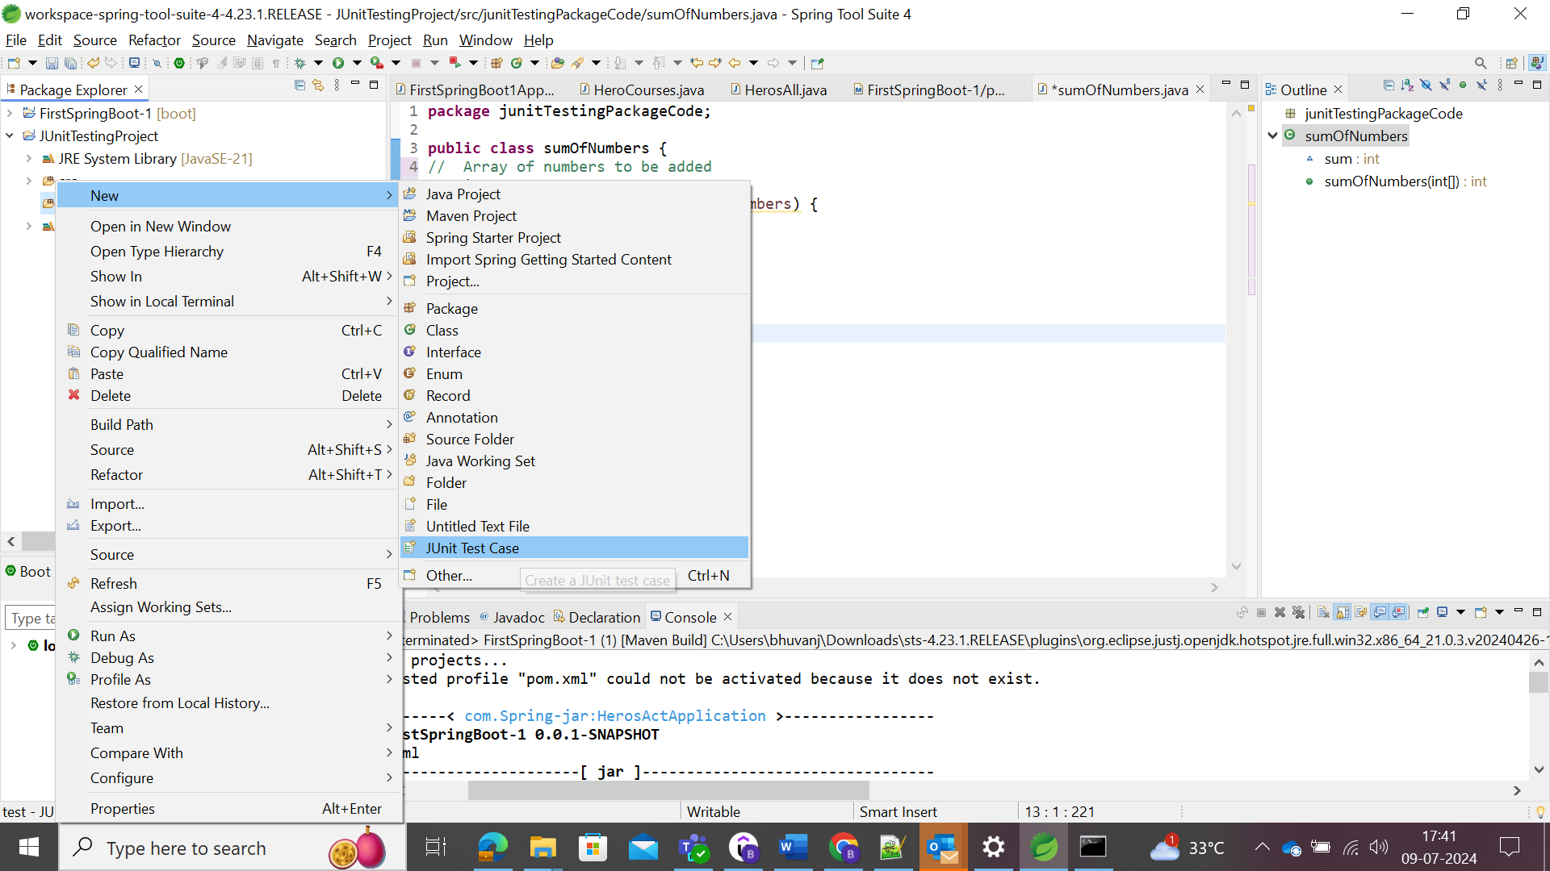

Select the latest version as shown

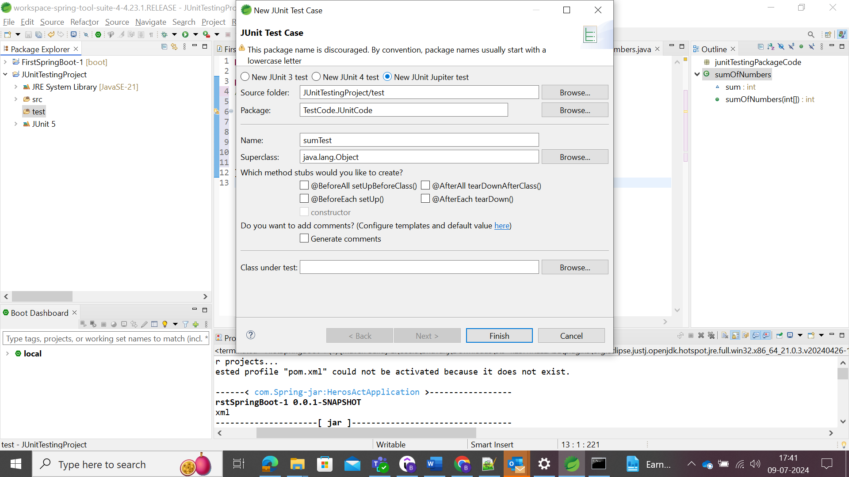

Note: Delete the modularization file if any created during the project ceation.

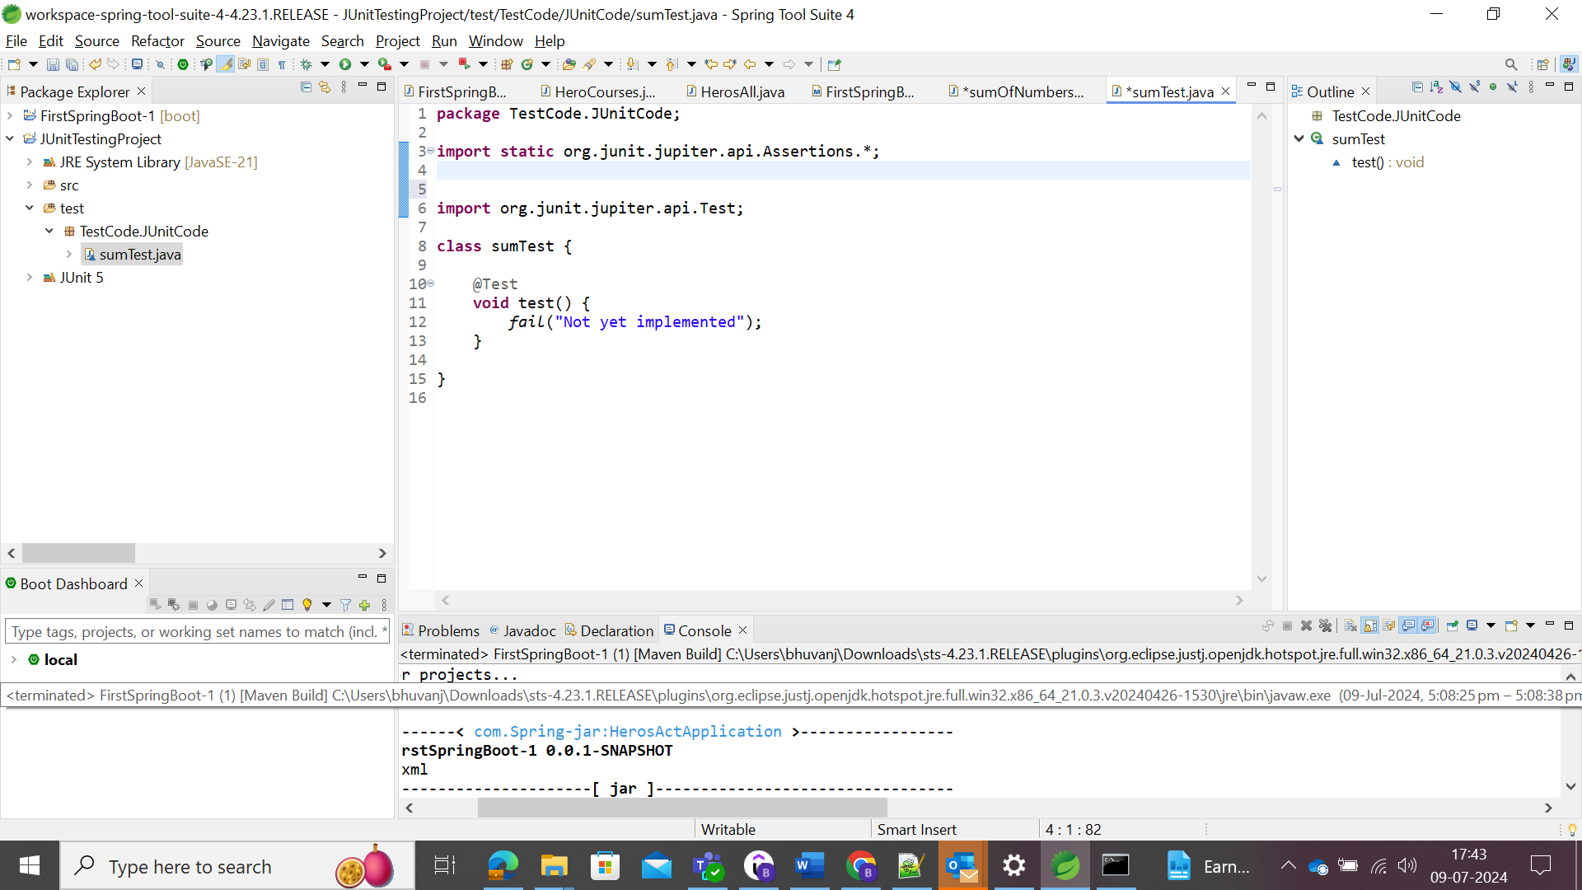

The above implements that if the code is successfully, fail and update as Not yet implemented. To make it pass, the code successfully ran, then remove the fail code.

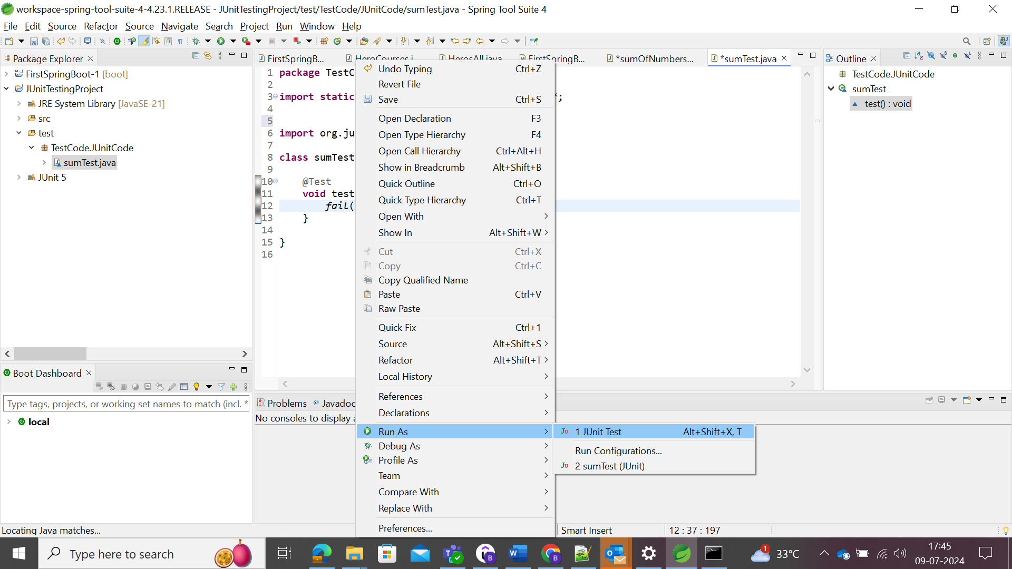

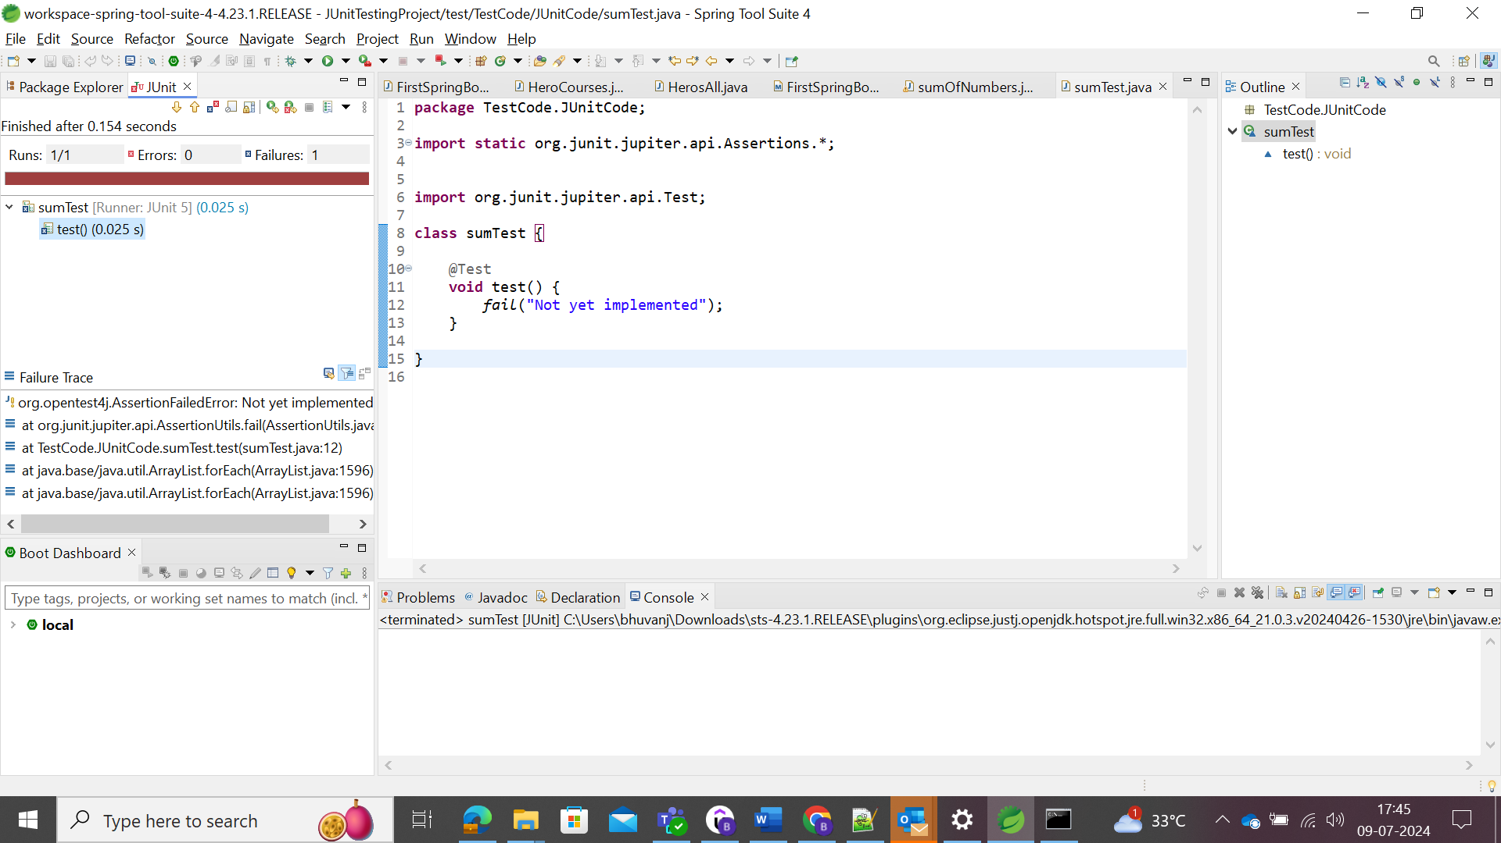

By removing the fail implementation, we could see the below results.

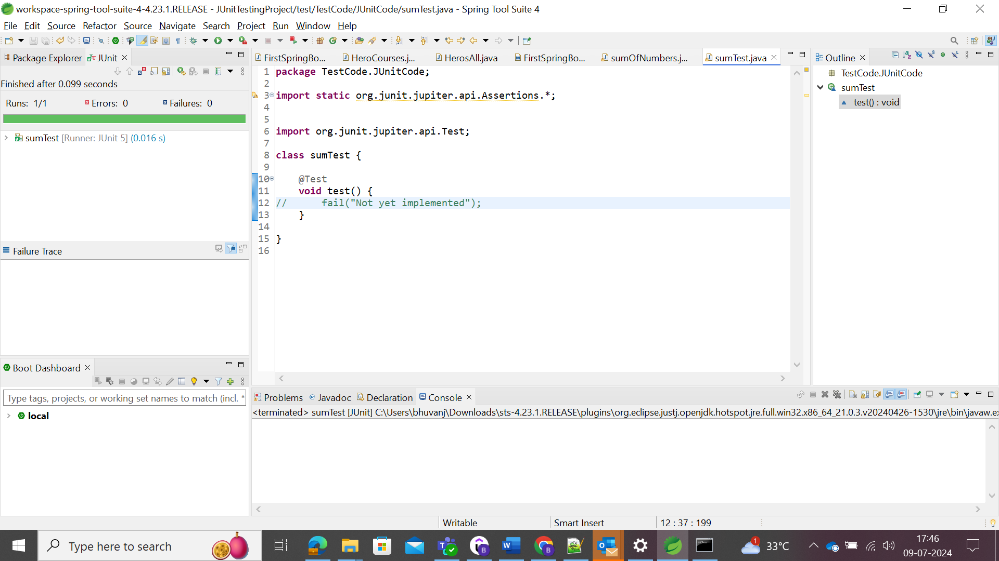

With respect to the conditions,

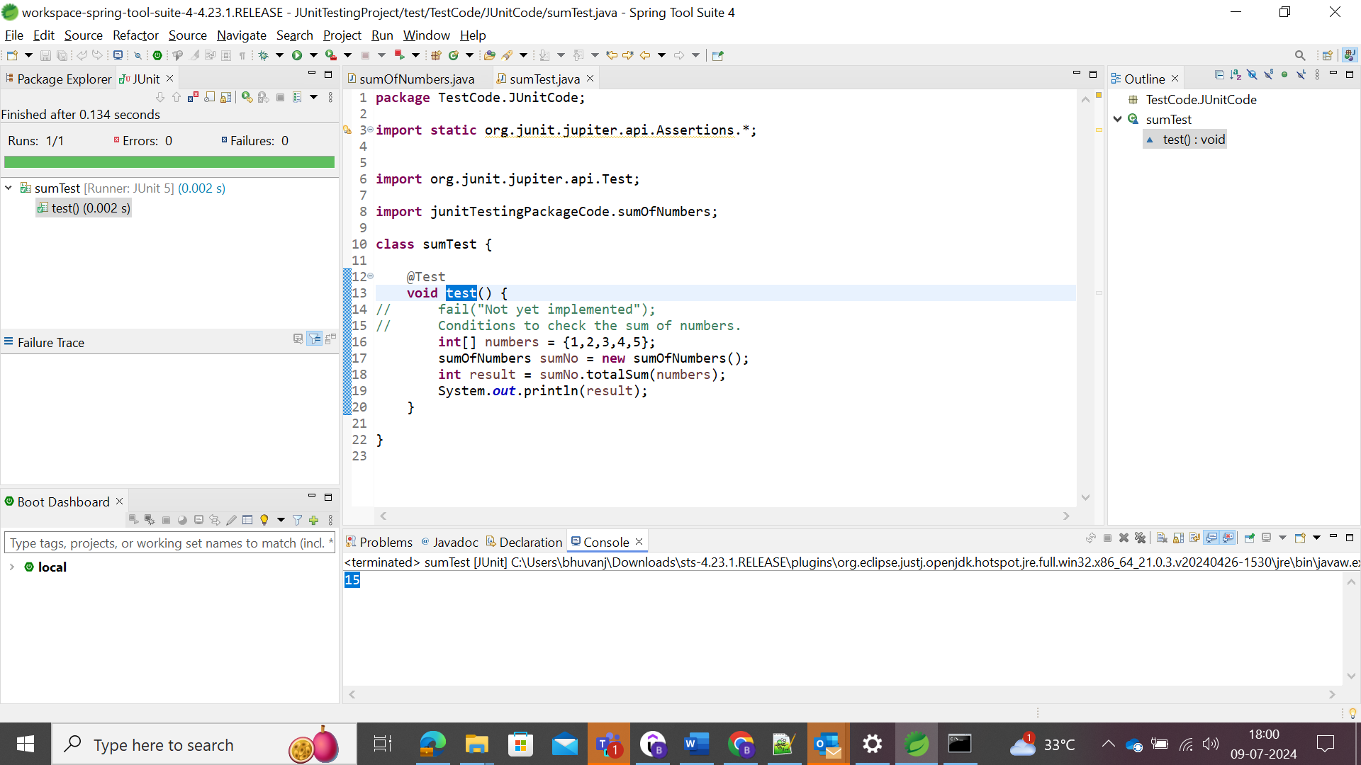

In console, user could be able to view the sum of the numbers.

Since, the expected and actual output is same, user could able to view the actual output in the console and no error in Junit screen.

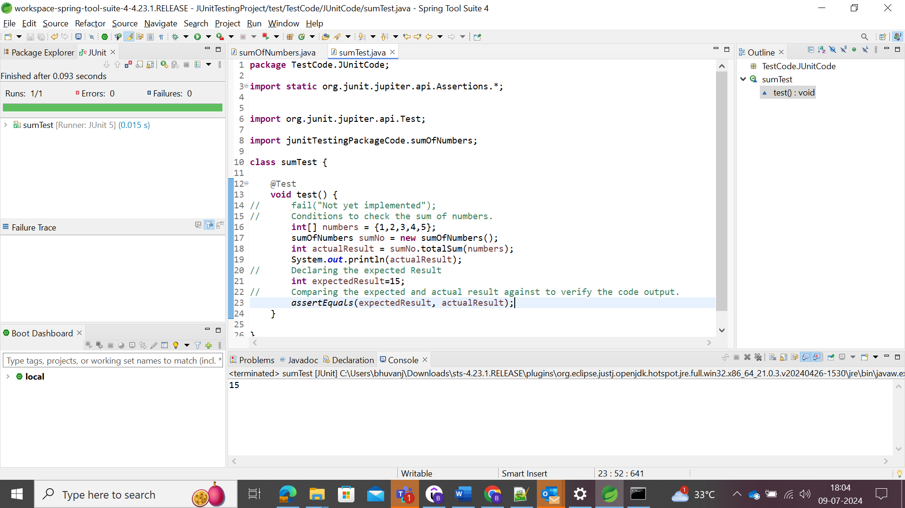

If the expected result and actual output is varying, then user could be able view the actual output in the console and the error in the Junit screen.

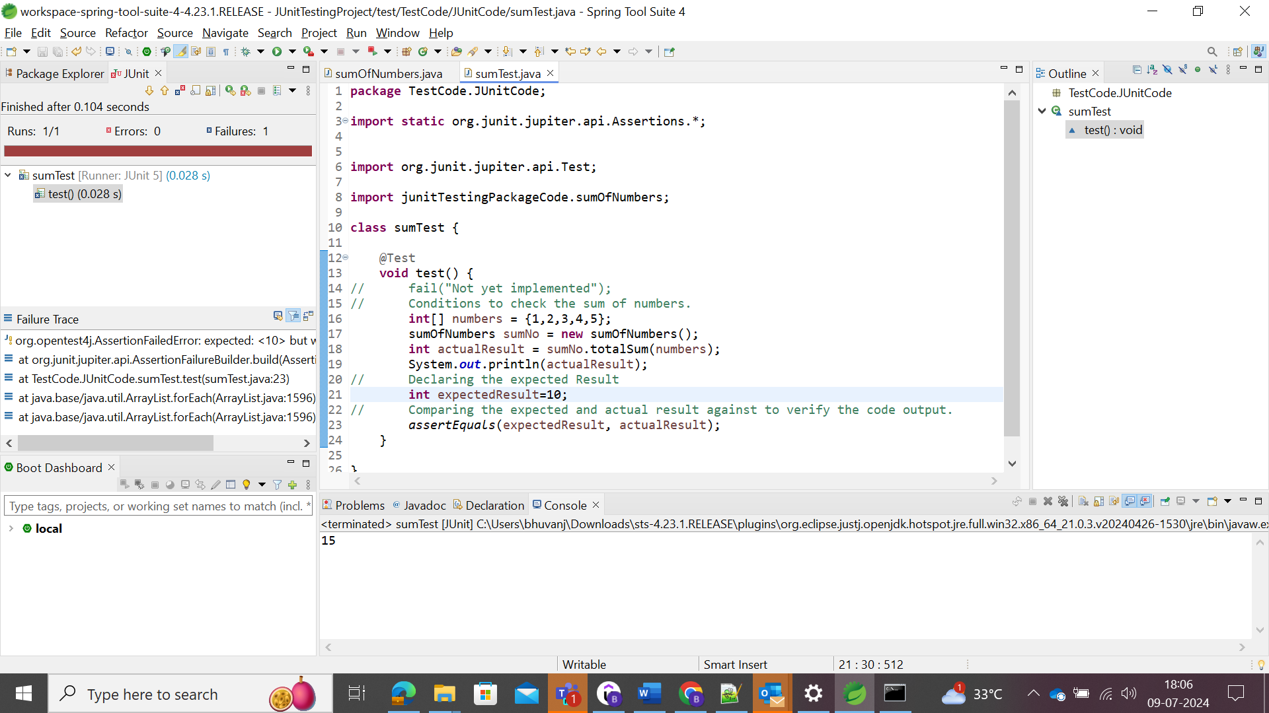

Multiple condition check for the single unit check could be written

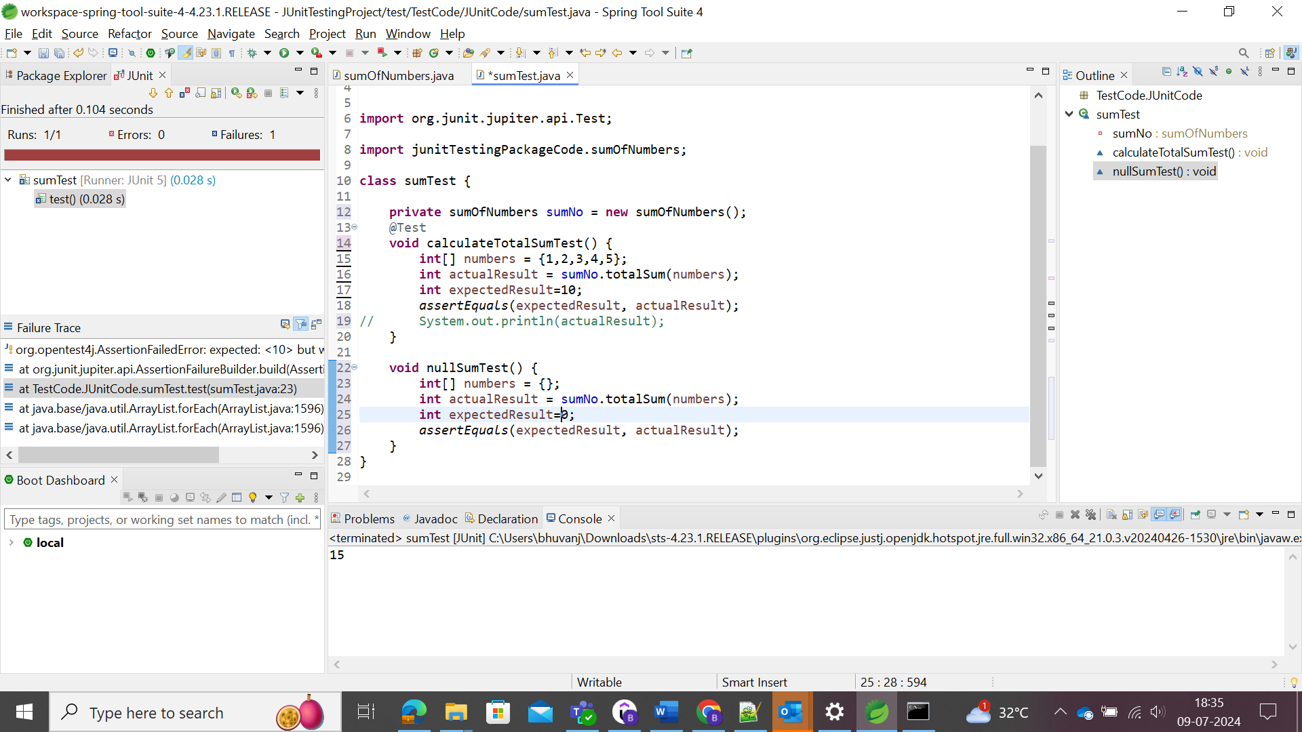

Here two test conditions were tested for the java code successfully.

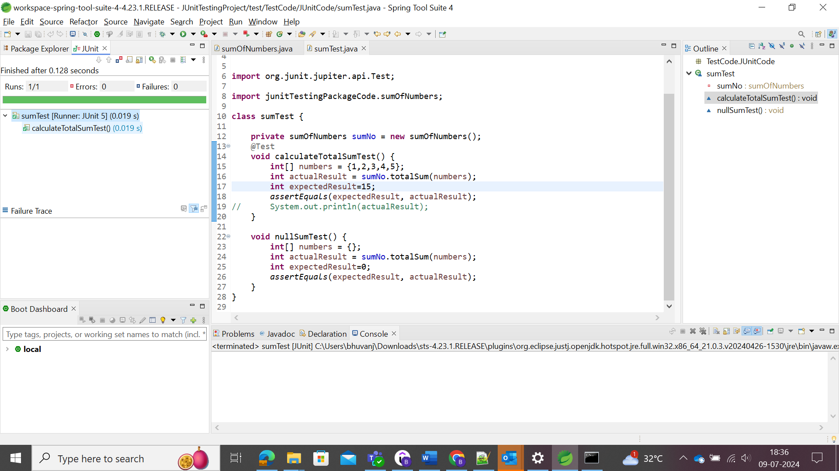

Write the code in number of lines as favour. Select relatable variables, and make in same line for code reduce. Select the variable 🡪 Refactor 🡪 Inline.

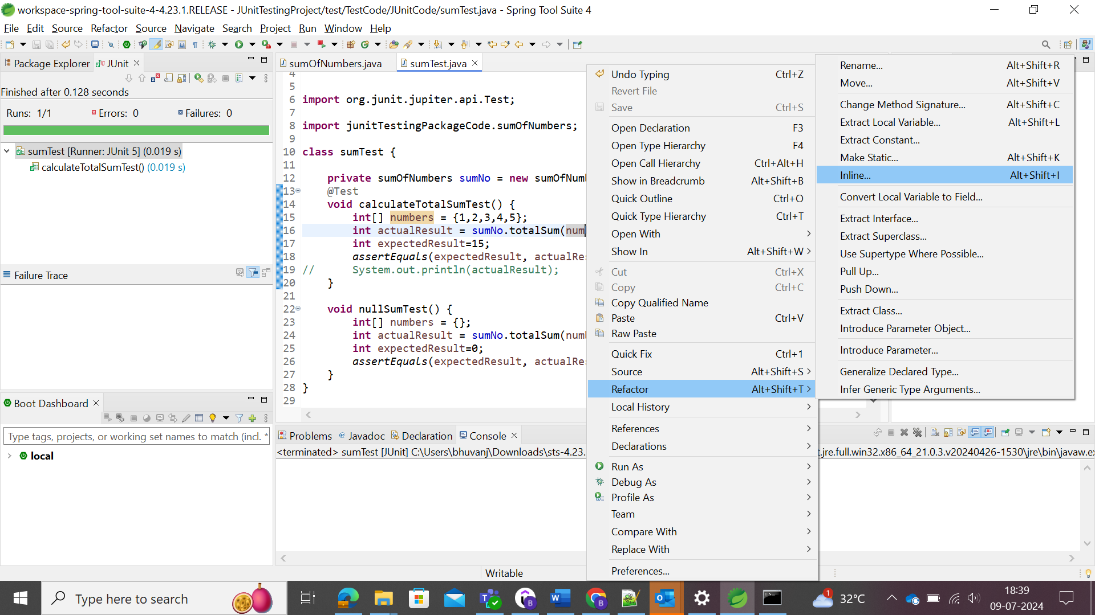

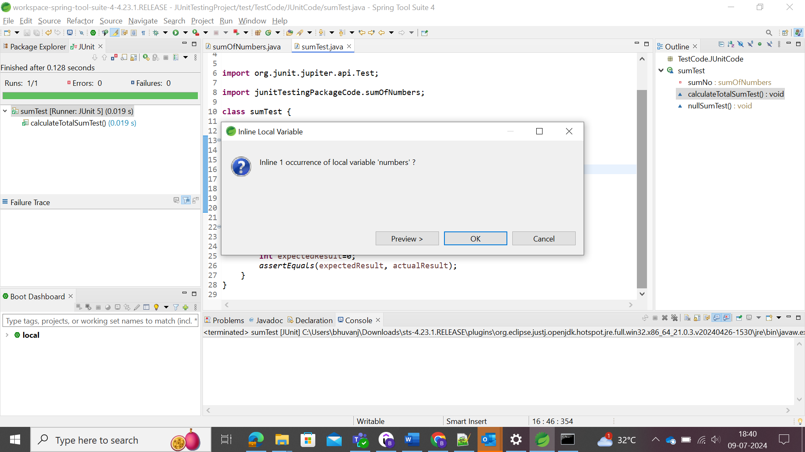

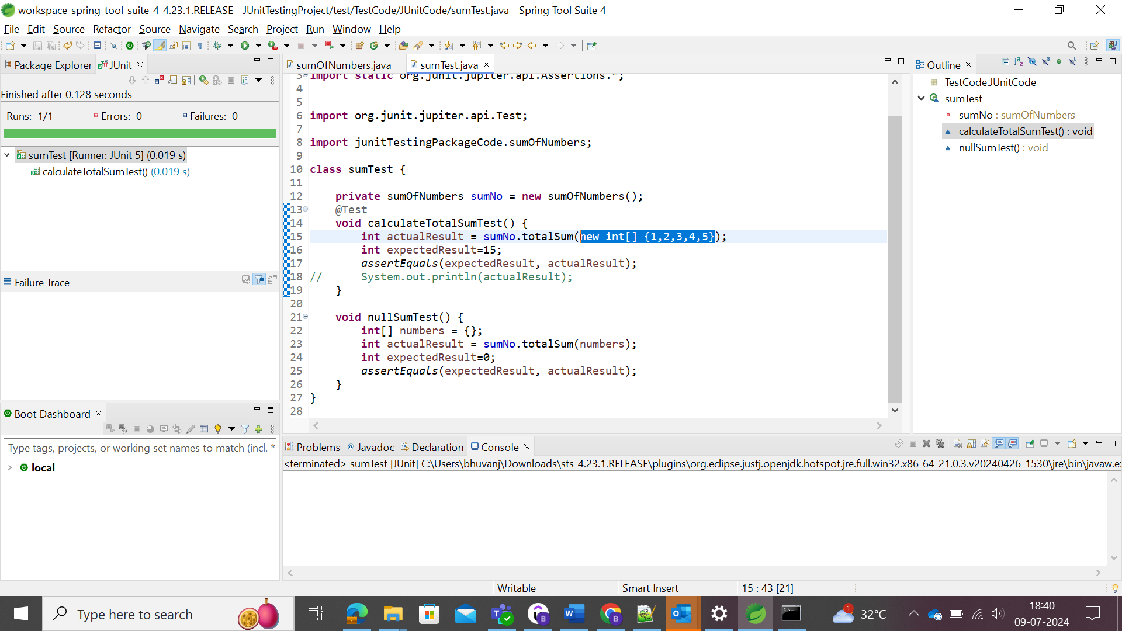

After refactoring for the variable inline, the code is reduced to single line.

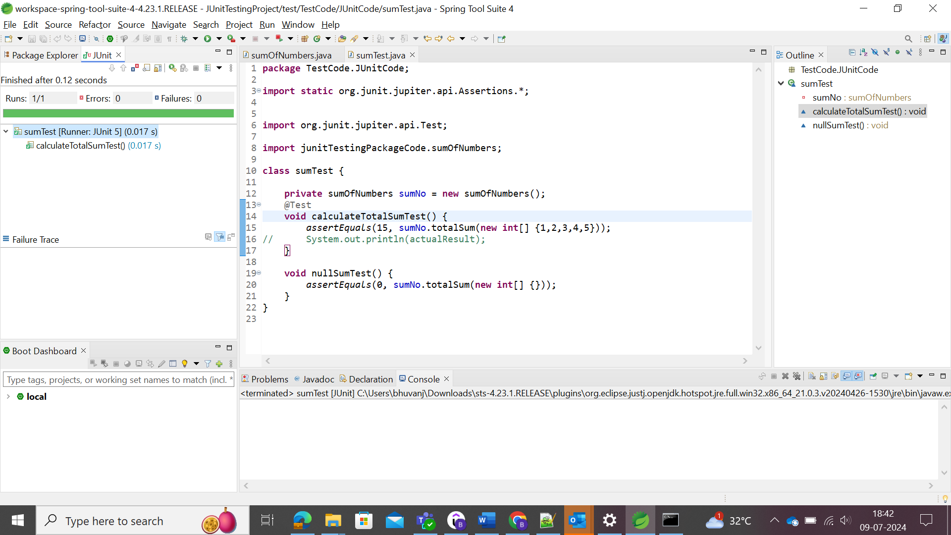

assertEquals(type,comparingMethod,String ErrorMessage)

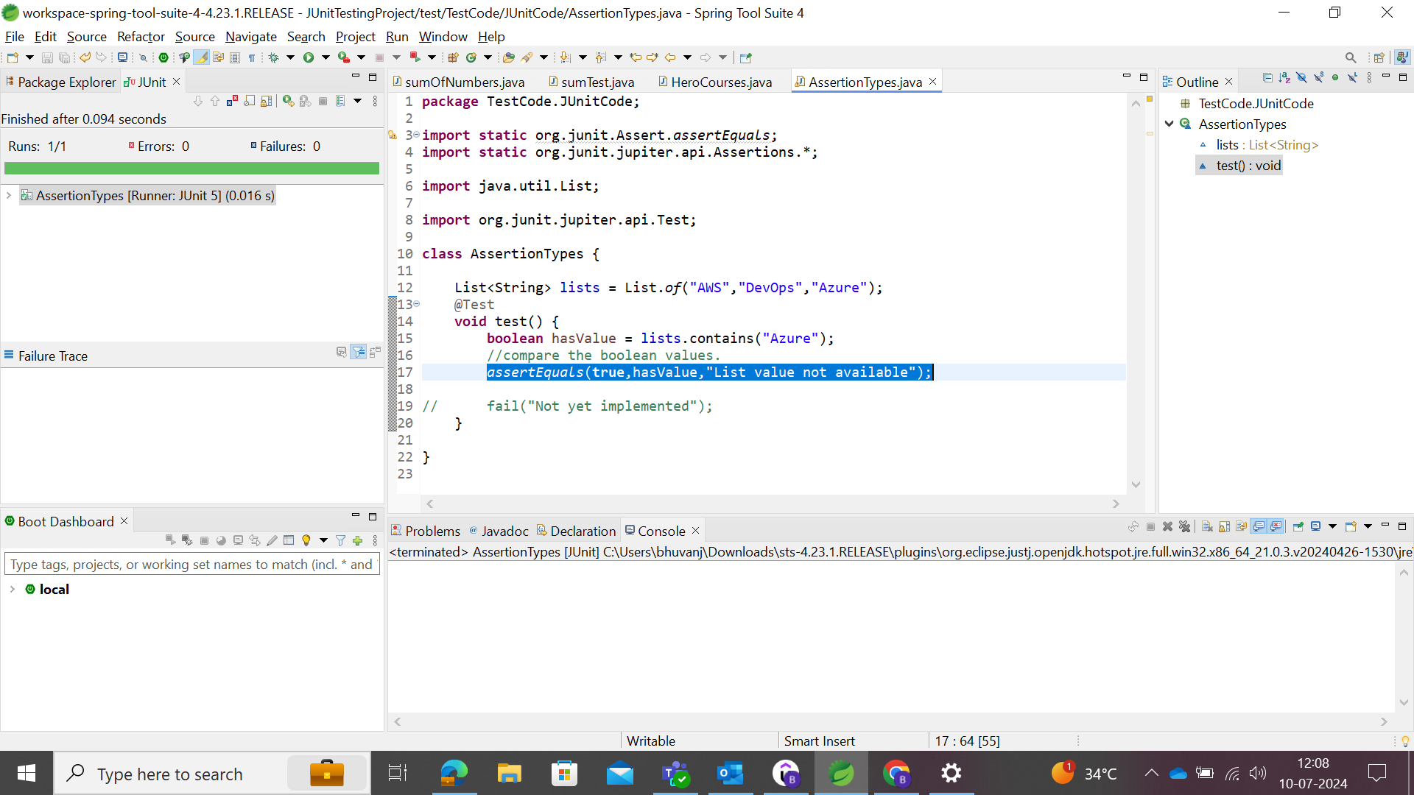

There is no order of execution/testing the method/code in the Junit. It will automatically test the code. 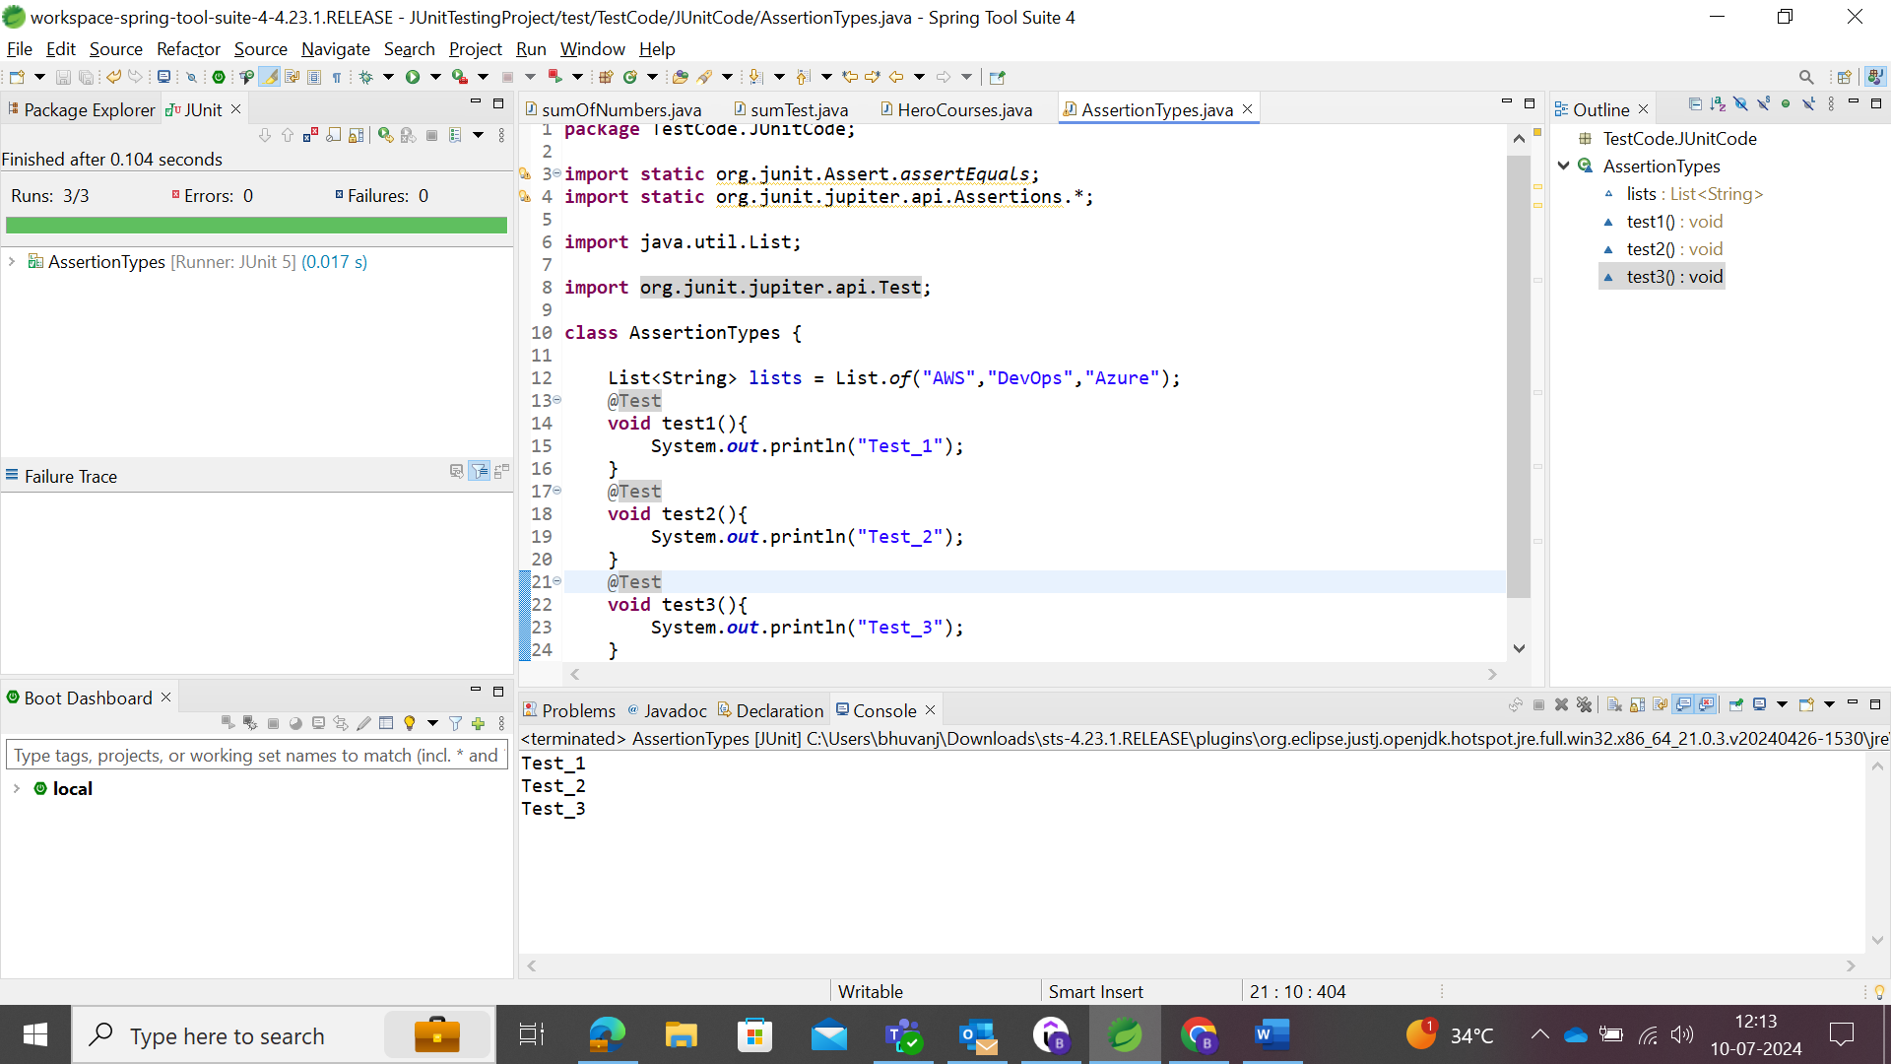

In case, if user needs to test certain method/code, user could use the following Assertions.

@BeforeEach and @AfterEach methods

The abover assertions/annotations will execute the code the method before and after each other methods repeatedly.

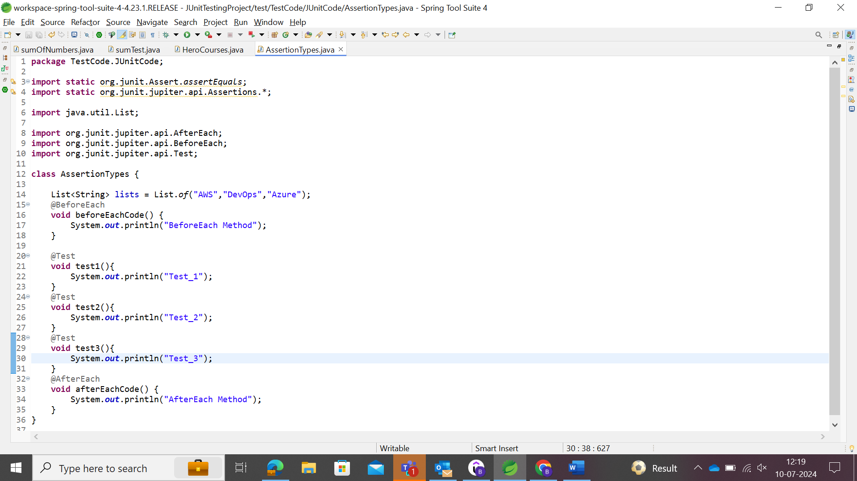

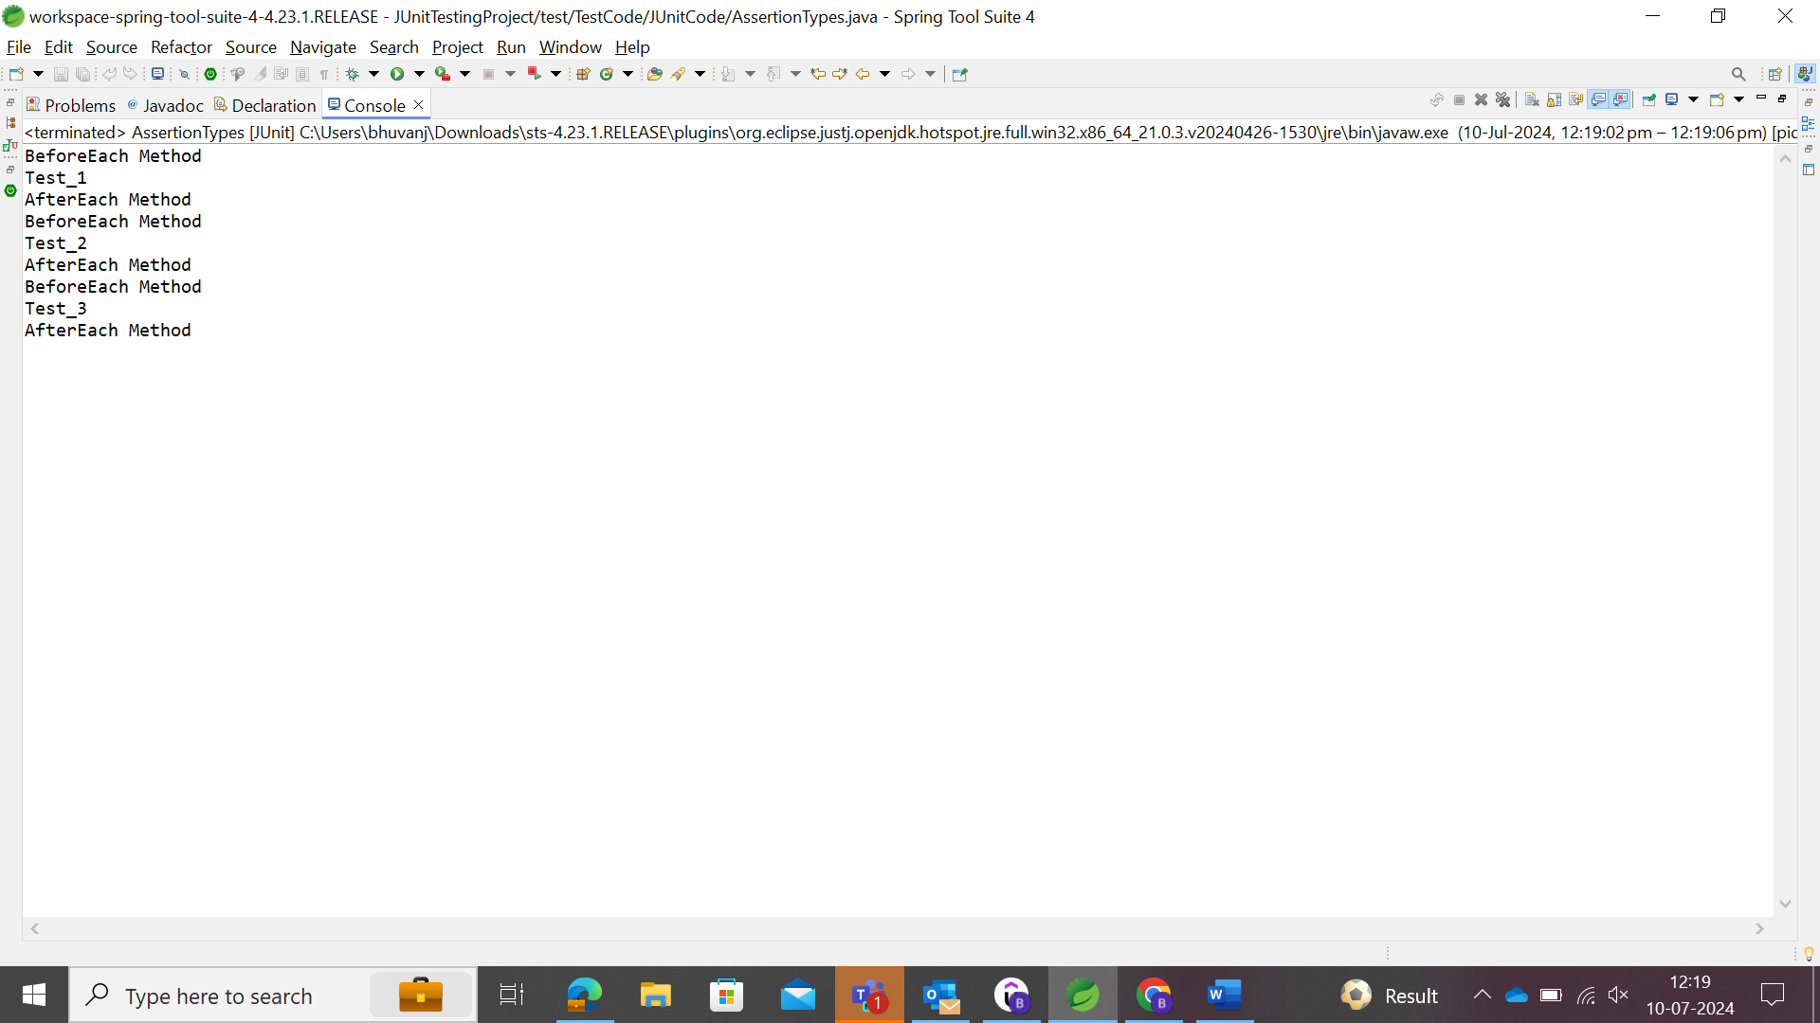

In case, user needs to execute some code before starting of all code or after completion of testing of all code, assertions like @BeforeAll and @AfterAll methods could be used.

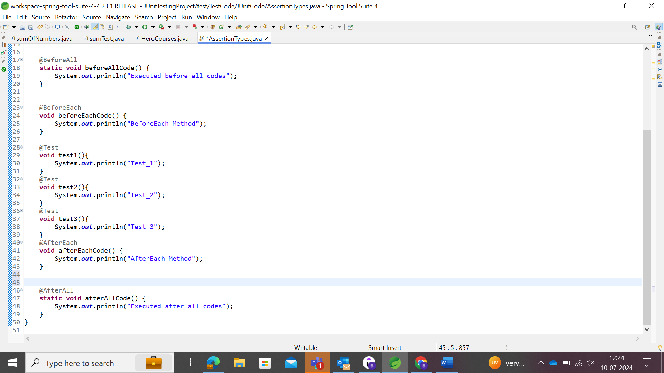

@AfterAll and @BeforeAll annotations/assertions are all mostly made use of the classes without being created the objects. So, the static keyword is used since it is using the class directly.

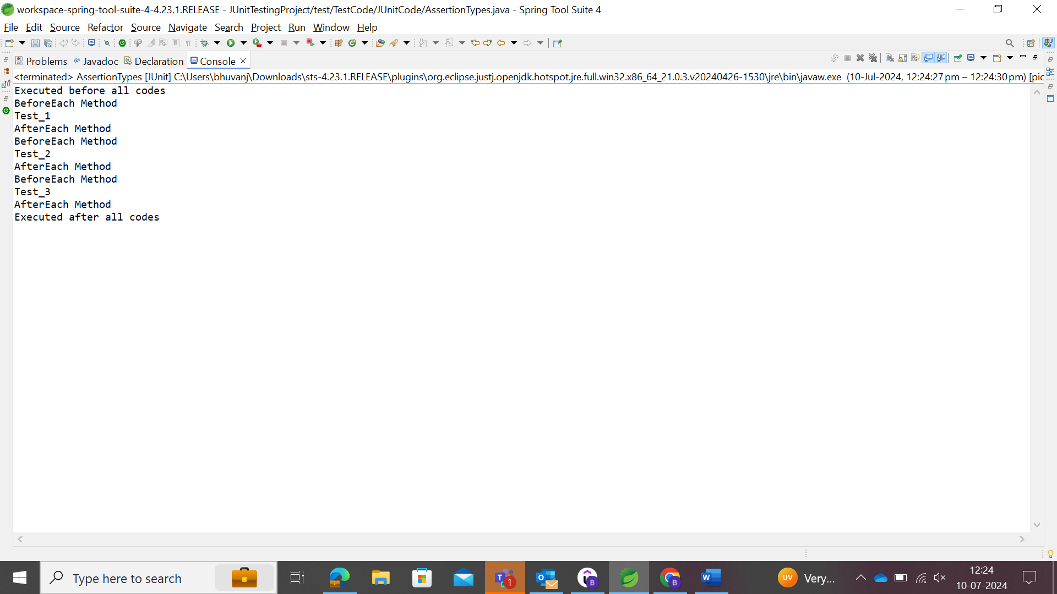

# Maven

Apache Maven is a software project management and comprehension tool. Based on the concept of a project object model (POM), Maven can manage a project's build, reporting and documentation from a central piece of information.

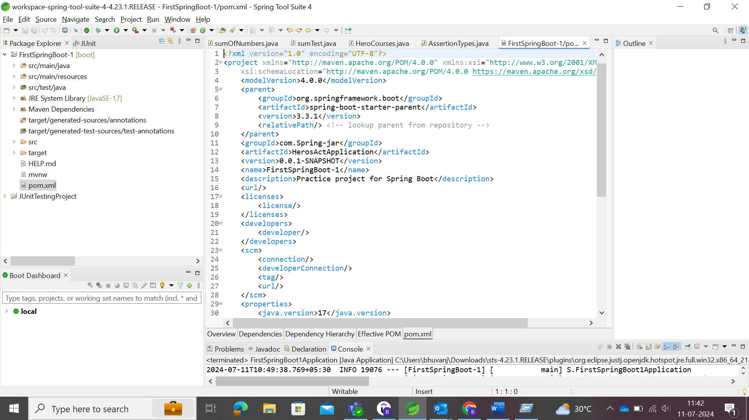

pom.xml 🡪 Project Object Model

Maven Dependencies: Frameworks & Libraries are defined for execution.

The dependencies defined in pom.xml are dependent on other dependencies. Those other dependencies are terms as Transitive Dependencies.

Spring-boot-starter dependency which dependent on spring-boot-starter-web (connecting the web), spring-boot-starter-test (Junit code testing). Once the dependency added in the pom.xml, maven started to download those dependencies and the dependencies dependent of that specific dependency.

Dependency Management manages the all the versions of the dependencies in the project.

The minimum requirement for a POM are the following:

* project root
* modelVersion - should be set to 4.0.0
* groupId - the id of the project's group.
* artifactId - the id of the artifact (project)
* version - the version of the artifact under the specified group

**Example:**

<project>

<modelVersion>4.0.0</modelVersion>

<groupId>com.mycompany.app</groupId>

<artifactId>my-app</artifactId>

<version>1</version>

</project>

To configure the maven dependencies project, version, groupId, artifactID, modelVersion are essential.

The above is the **com.mycompany.app:my-app-1**

if we were to turn **com.mycompany.app:my-app:1** into a **parent artifact** of **com.mycompany.app:my-module:1**,we will have to modify **com.mycompany.app:my-module:1's POM** to the following configuration:

<project>

<modelVersion>4.0.0</modelVersion>

<parent>

<groupId>com.mycompany.app</groupId>

<artifactId>my-app</artifactId>

<version>1</version>

</parent>

<groupId>com.mycompany.app</groupId>

<artifactId>my-module</artifactId>

<version>1</version>

</project>

This could be attained by the mentioning the com.mycompany.app:myapp as parent using parent dependency or Super POM.

Suppose if the parent pom is not in the device, To address this directory structure (or any other directory structure), we would have to add the <relativePath> element to our parent section.

<project>

<modelVersion>4.0.0</modelVersion>

<parent>

<groupId>com.mycompany.app</groupId>

<artifactId>my-app</artifactId>

<version>1</version>

<relativePath>../parent/pom.xml</relativePath>

</parent>

<artifactId>my-module</artifactId>

</project>

### Maven Build Lifecycle

Whenever the maven commands run, the maven build lifecycle executes.

* Validate – Checking the code for syntax and other valiations
* Compile – Compiling the Java code
* Test – Run the unit Test
* Package – Create the Jar file
* Integration Test – Run the Integration test
* Verify – Verify the Jar file
* Install – Install Jar file to target folder
* Deploy – If deploy configured, then maven would also deploy to an environment

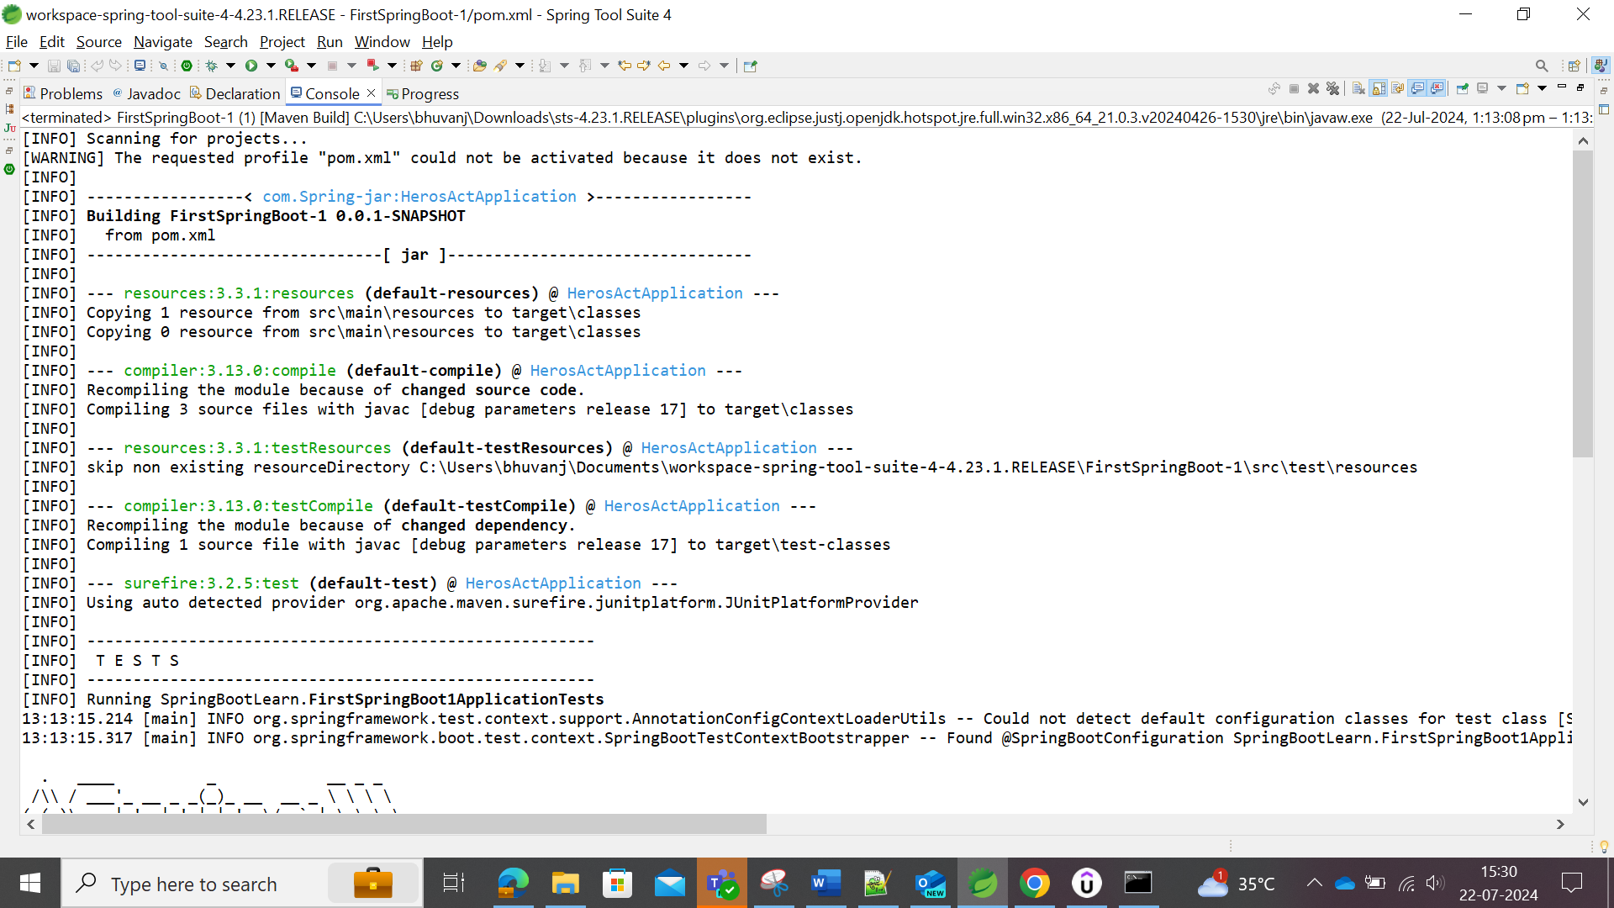

Validate and compiled the code including the test code as part of Maven Build Lifecycle.

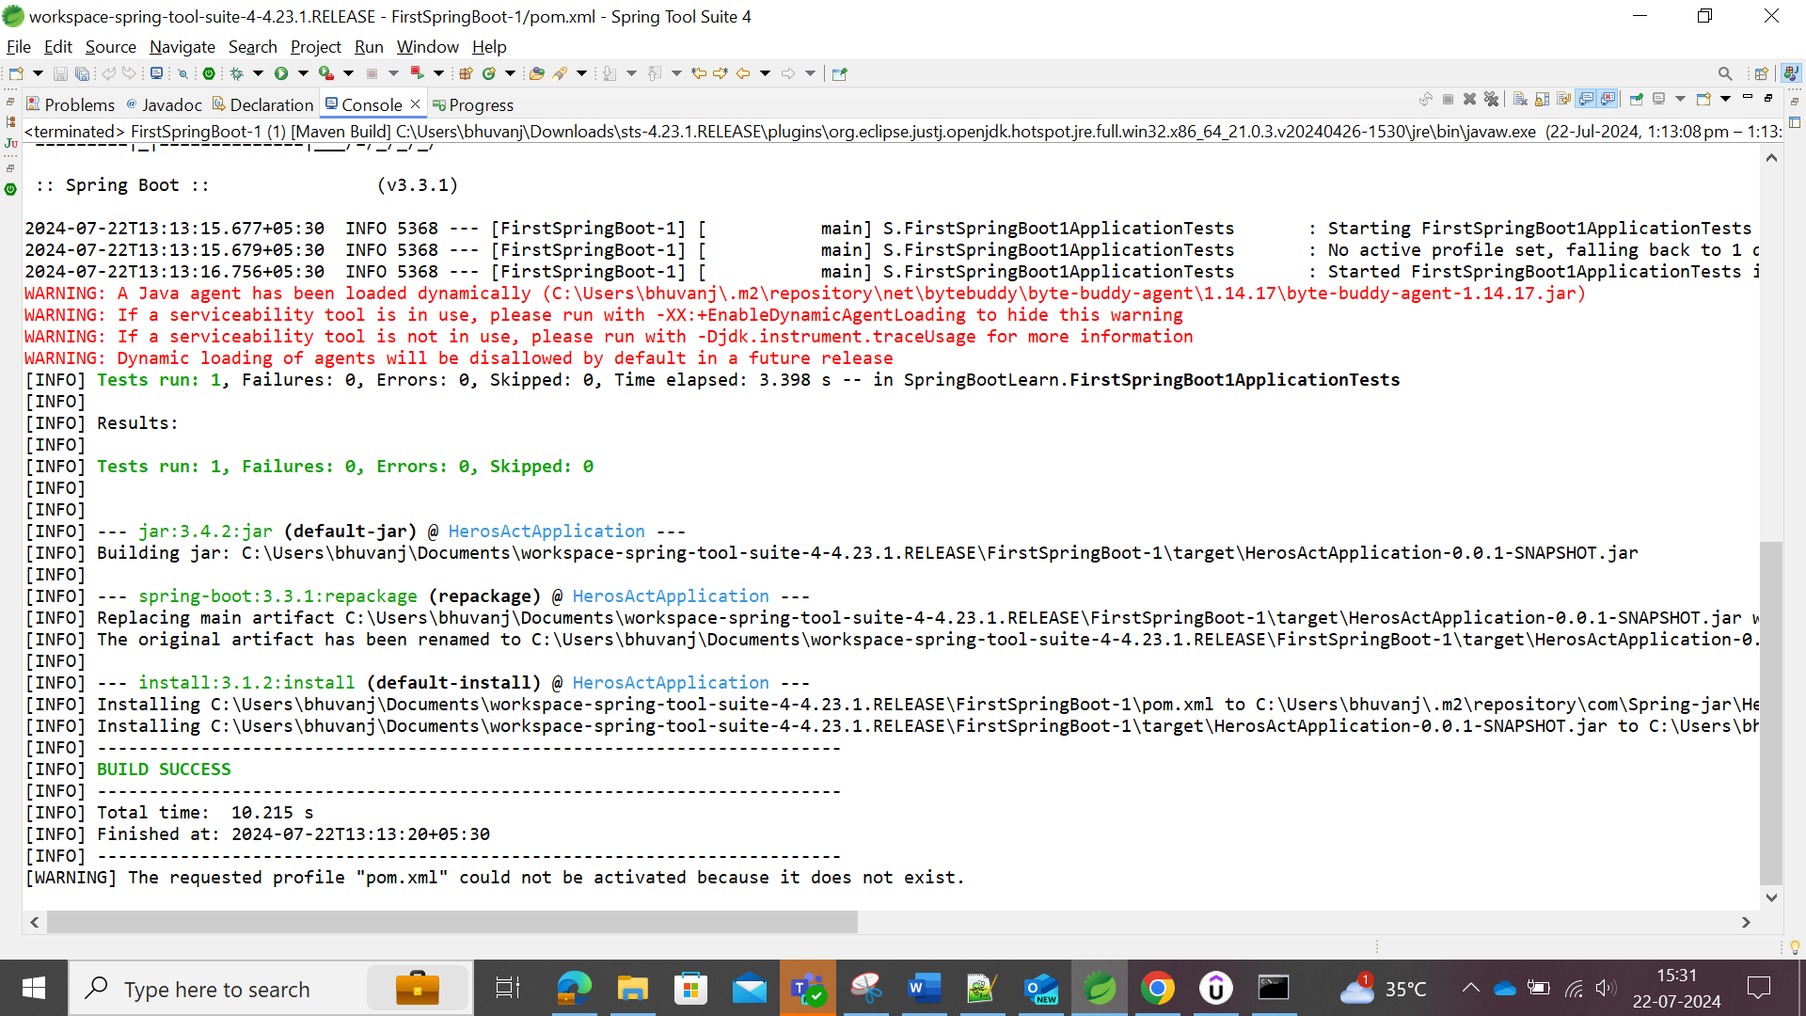

At repackage, the jar files built and at install, the jar files are installed.

Repositories in Maven are two types as follows:

* + 1. Maven Central Repositories
    2. Maven Local Repositories

All dependencies like spring-boot-starter and other dependencies were being downloaded from the Maven Central Repositories where the jars of those dependencies were indexed by artifact id and group id.

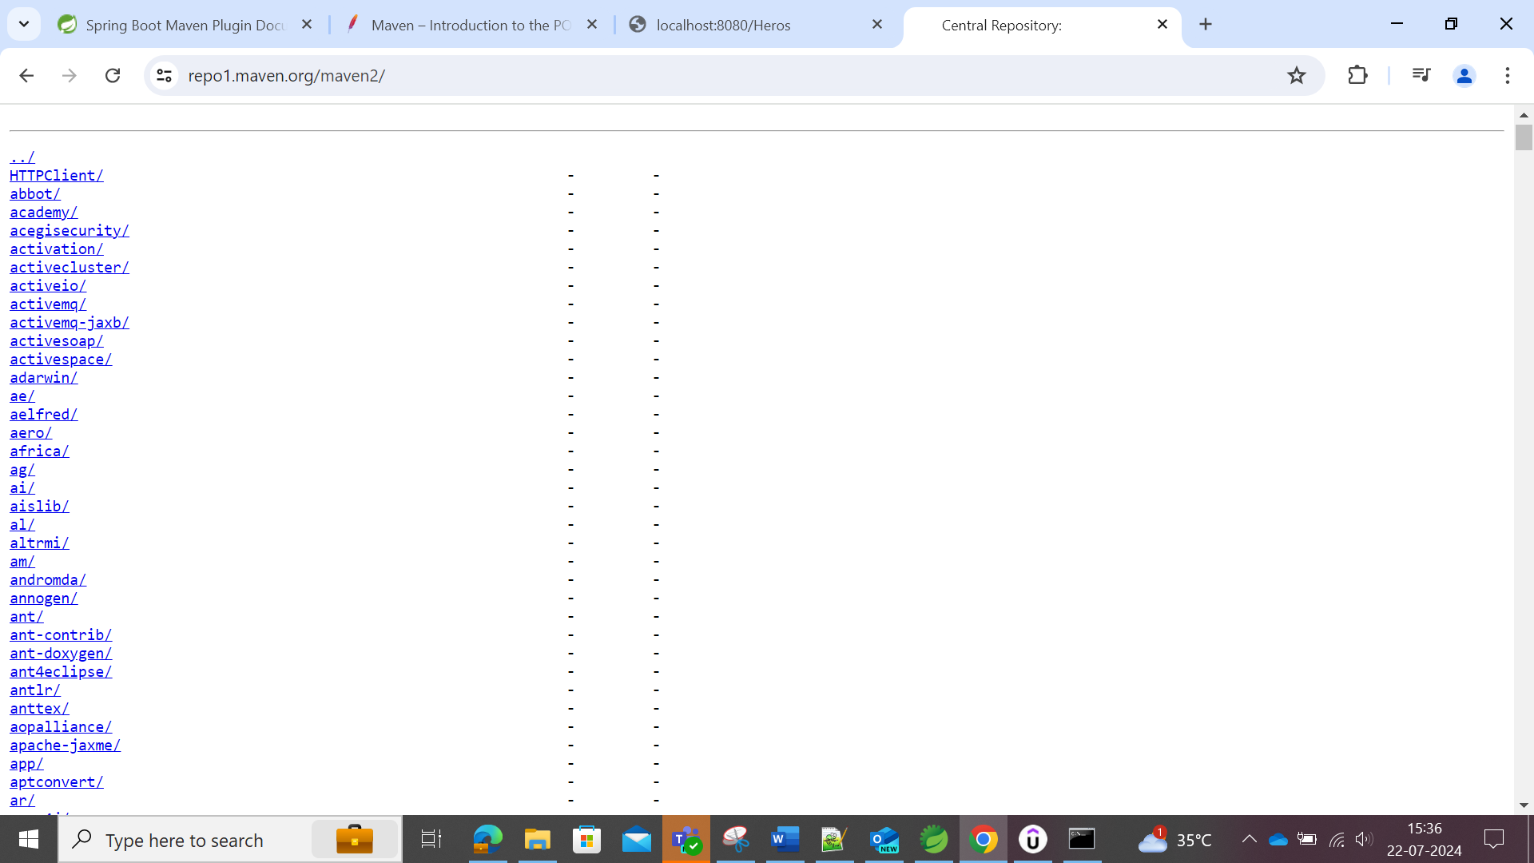

The above image represents the jar files in the Maven Central Repository.

Downloaded Dependencies are stored in the Maven Local Repositories. It is temporary folder in the system, where the maven stores all jars and dependency files that are downloaded from Maven Repositories.

**Version of Maven**

Run as 🡪 Maven Build 🡪 --version <give the name of the goal file> 🡪 save and view the console of the project.

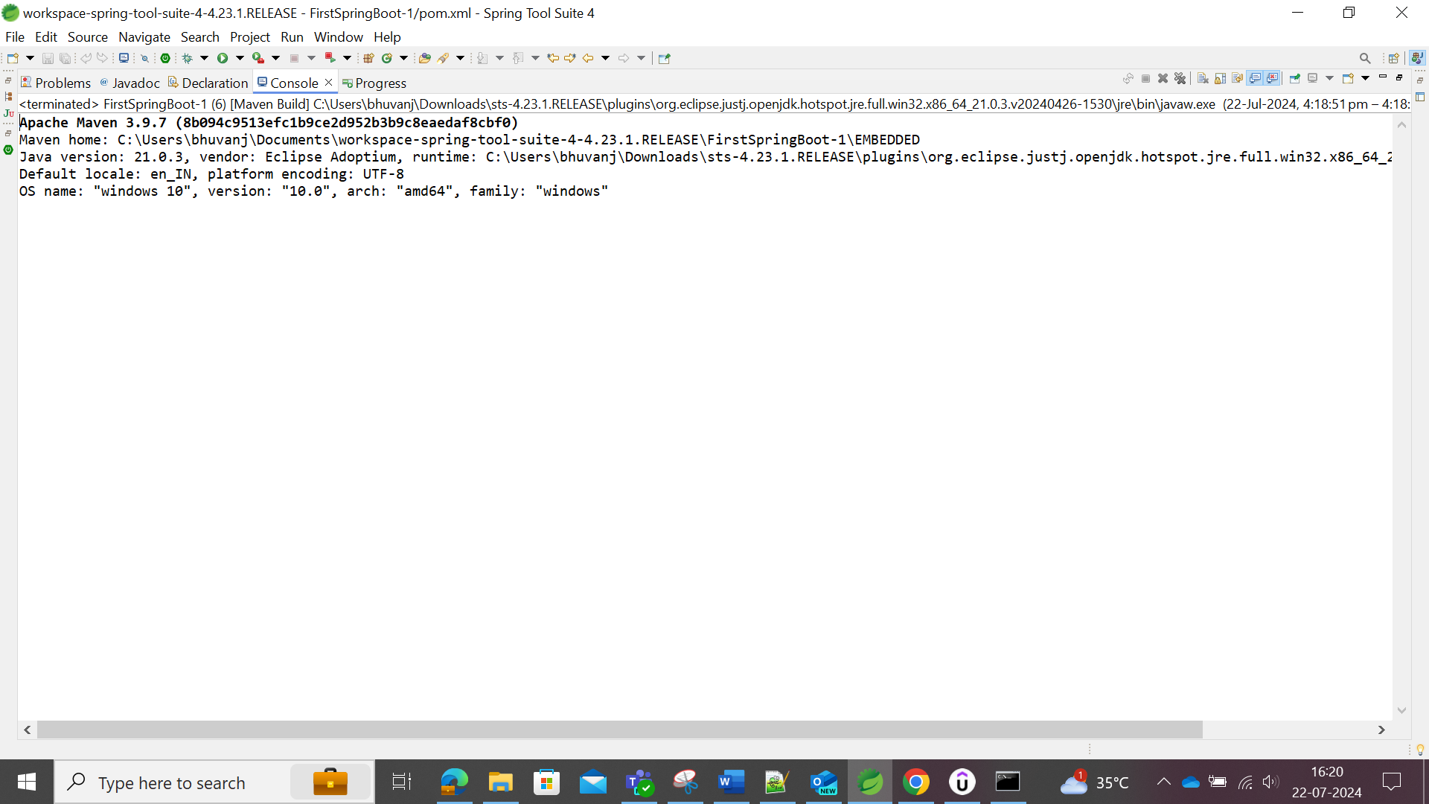

### Important Maven Commands

*mvn --version*

*mvn compile: Compile Source Files*

*mvn test-compile: Compile test files 🡪 this will also compile the source files.*

*mvn clean: delete target directory*

*mvn test: run unit tests*

*mvn package: create a jar*

*mvn help: effective-pom*

*mvn dependency: tree*

The command name comes after mvn should be updated as same in the goal name in order to execute the maven builds successfully.

# JPA and Hibernate

In the context of Spring Boot, JDBC, JPA, and H2 Database serve different purposes related to data persistence and access:

### 1. **JDBC (Java Database Connectivity):**

- **Purpose:** JDBC is a Java API that allows Java applications to interact with databases using standard SQL queries.

- **Usage in Spring Boot:** Spring Boot uses JDBC to provide low-level database operations, such as creating connections, executing queries, and managing transactions directly with the database.

- **Example:** You would use JDBC in Spring Boot to execute SQL queries like `SELECT`, `INSERT`, `UPDATE`, and `DELETE` statements directly against your database.

### 2. **JPA (Java Persistence API):**

- **Purpose:** JPA is a higher-level abstraction over JDBC that simplifies database access in Java applications by providing an object-relational mapping (ORM) framework.

- **Usage in Spring Boot:** Spring Boot integrates with JPA to provide a more object-oriented way to interact with databases. It allows you to define entity classes that represent database tables and perform CRUD (Create, Read, Update, Delete) operations on these entities without writing explicit SQL queries.

- **Example:** With JPA in Spring Boot, you define entities using annotations (`@Entity`, `@Table`, etc.), and Spring Boot handles the mapping of these entities to database tables and the execution of SQL statements behind the scenes.

### 3. **H2 Database:**

- **Purpose:** H2 is a lightweight, in-memory relational database that can be used during development, testing, or prototyping phases of an application.

- **Usage in Spring Boot:** Spring Boot can be configured to use H2 as an embedded database, which means the database runs in the same JVM as the application. This allows for fast and easy setup of a database without requiring a separate database server.

- **Example:** In Spring Boot, you can configure H2 as a dependency (`spring-boot-starter-data-jpa` with H2) and configure it in your `application.properties` or `application.yml` file to create an in-memory database that persists only for the duration of the application runtime.

### **Summary:**

**- **JDBC\*\*** provides low-level access to databases through SQL queries.

**- **JPA\*\*** is a higher-level abstraction that uses ORM to map Java objects to database entities.

- **\*\*H2 Database\*\*** is an in-memory relational database often used in Spring Boot for development and testing purposes.

In a typical Spring Boot application, you might use JDBC for custom SQL operations, JPA for entity management and higher-level database interactions, and H2 Database as a lightweight, embedded database during development and testing phases.

Spring Web, Spring JDBC, Spring JBA, H2 Database are the dependencies that are added in this FirstDataBaseSpringBoot Project.

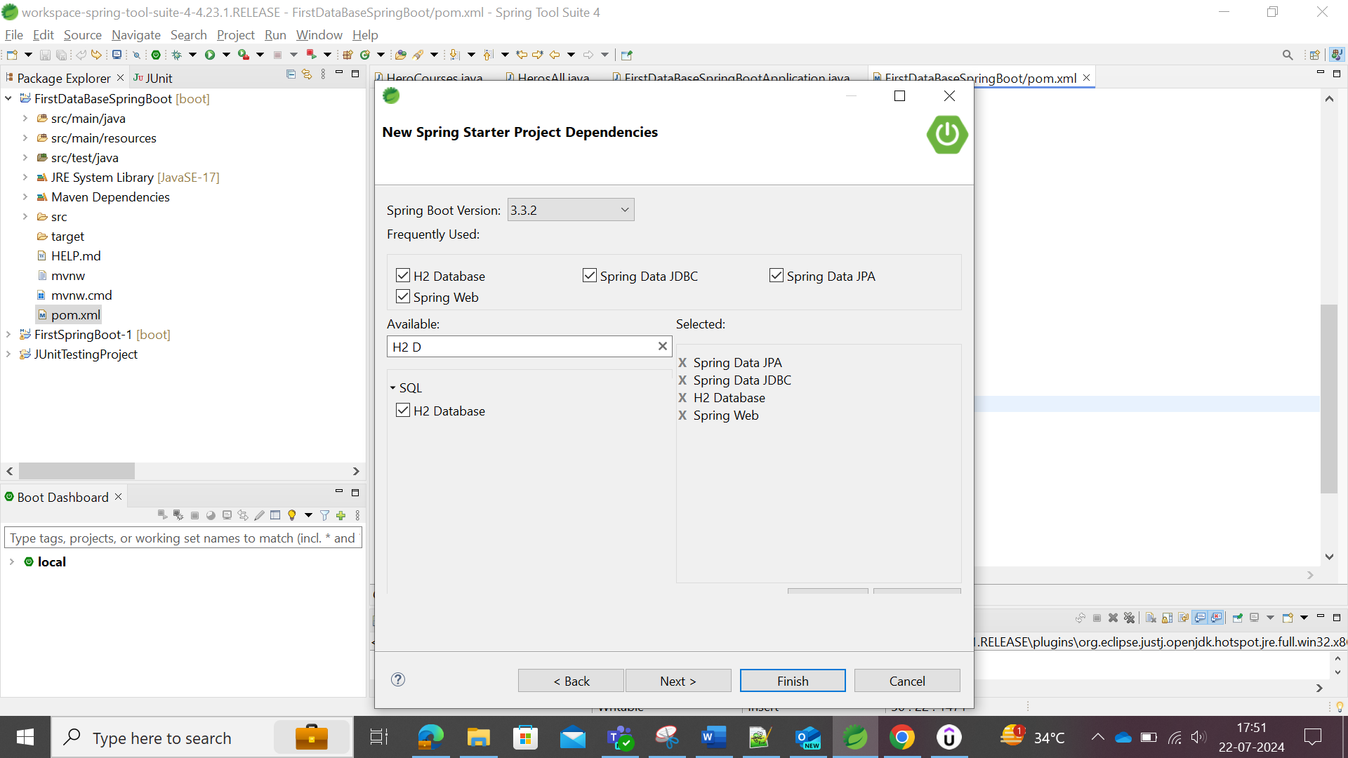

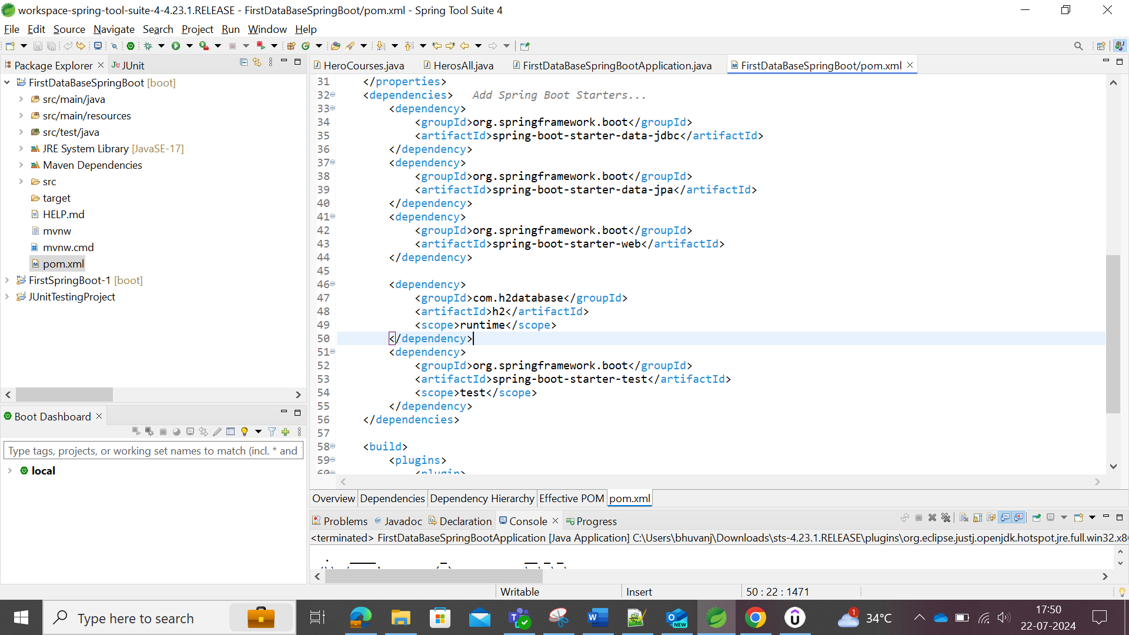

## Establishing H2 Database in the Spring Boot

Database path URL where the H2 database is connected to

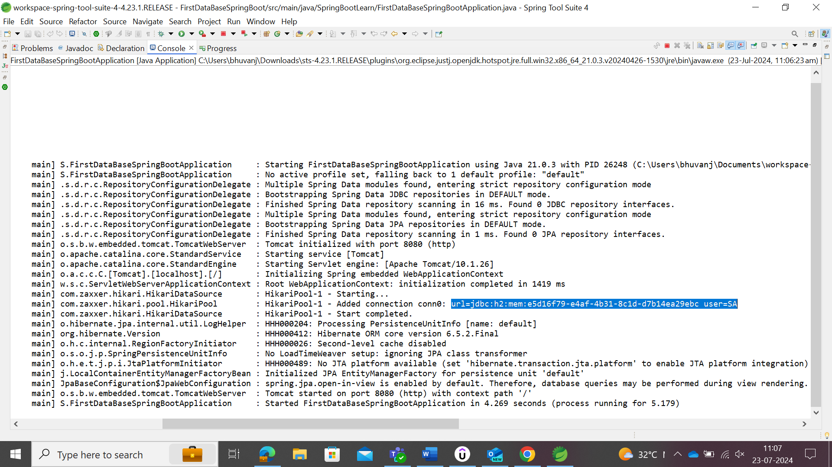The connection is made into that URL and to enable the URL which connect, user could enable by configuring the property.

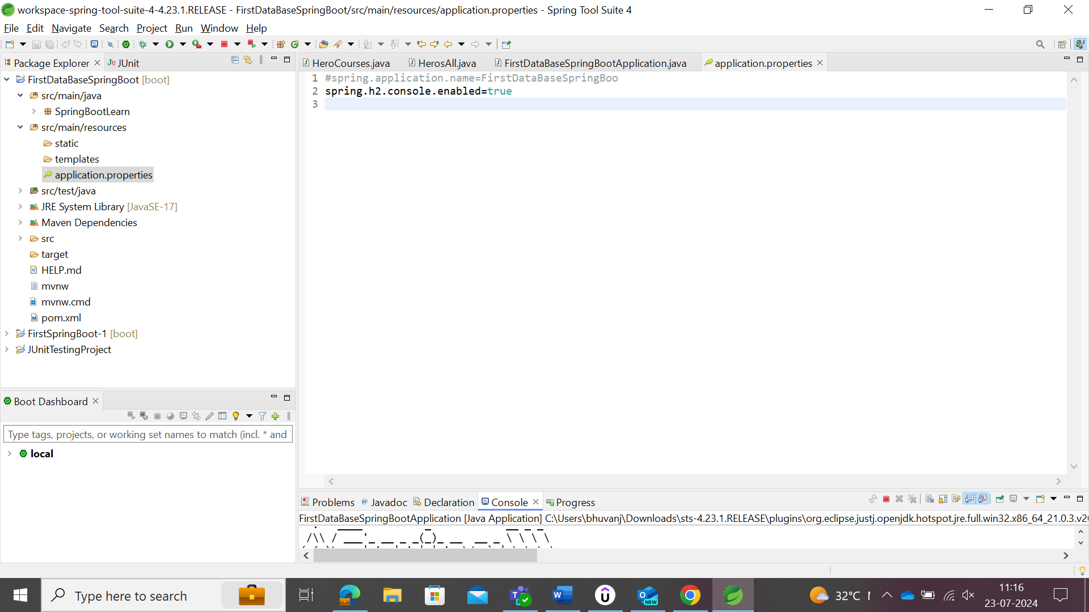

After the above, user need to save and run the property, so it will run the server. Update <http://localhost:8080/h2-console> in the browser so, it will show the database in the browser as follows:

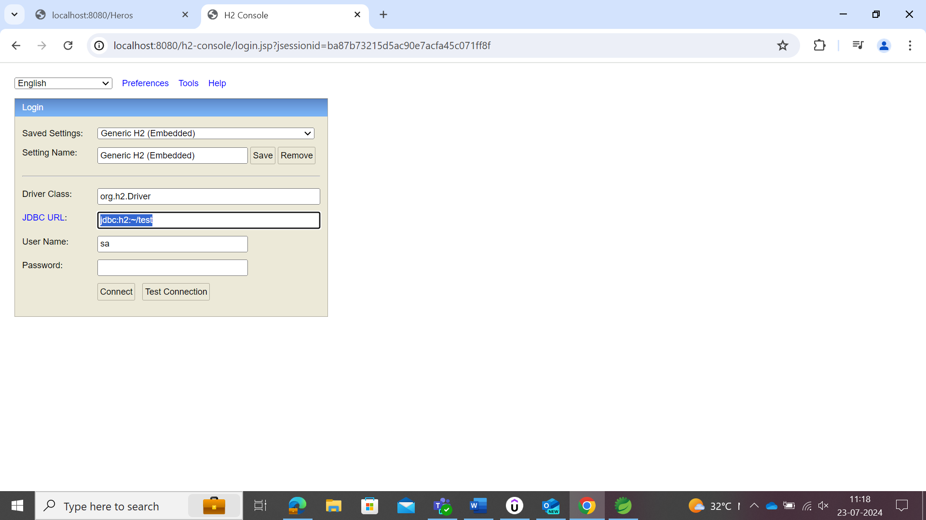

The JDBC URL shown in the website is incorrect, this could be changed by copying the URL in the Spring boot for H2 which is in console.

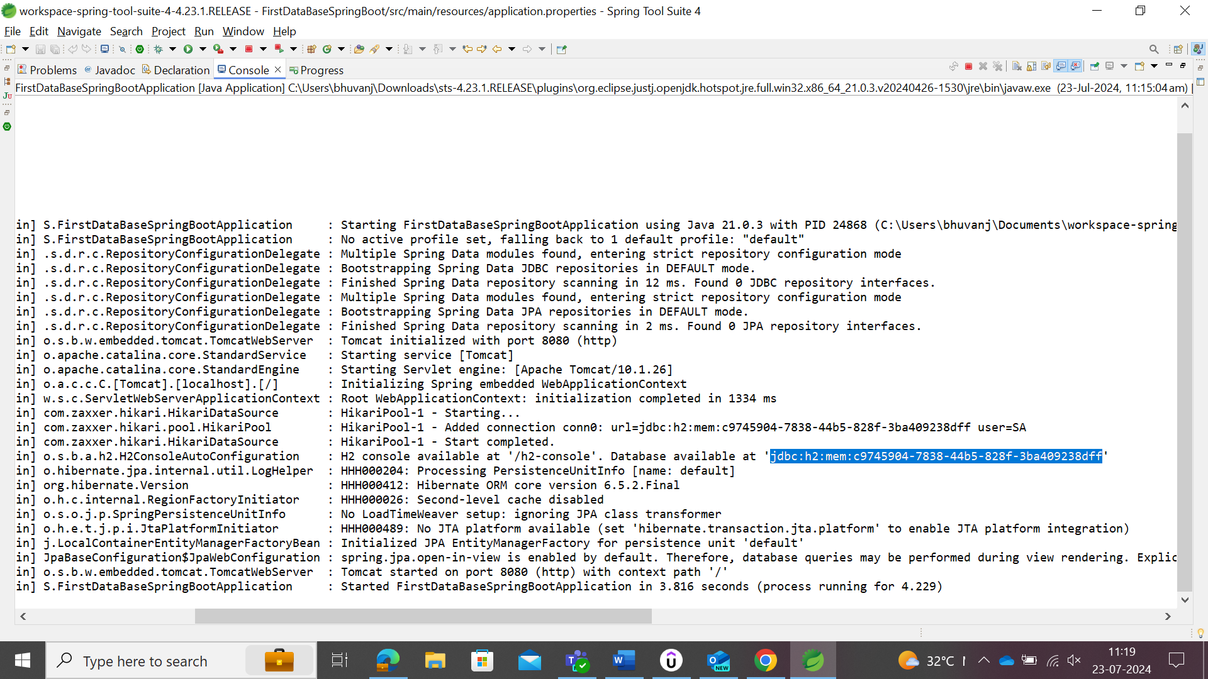

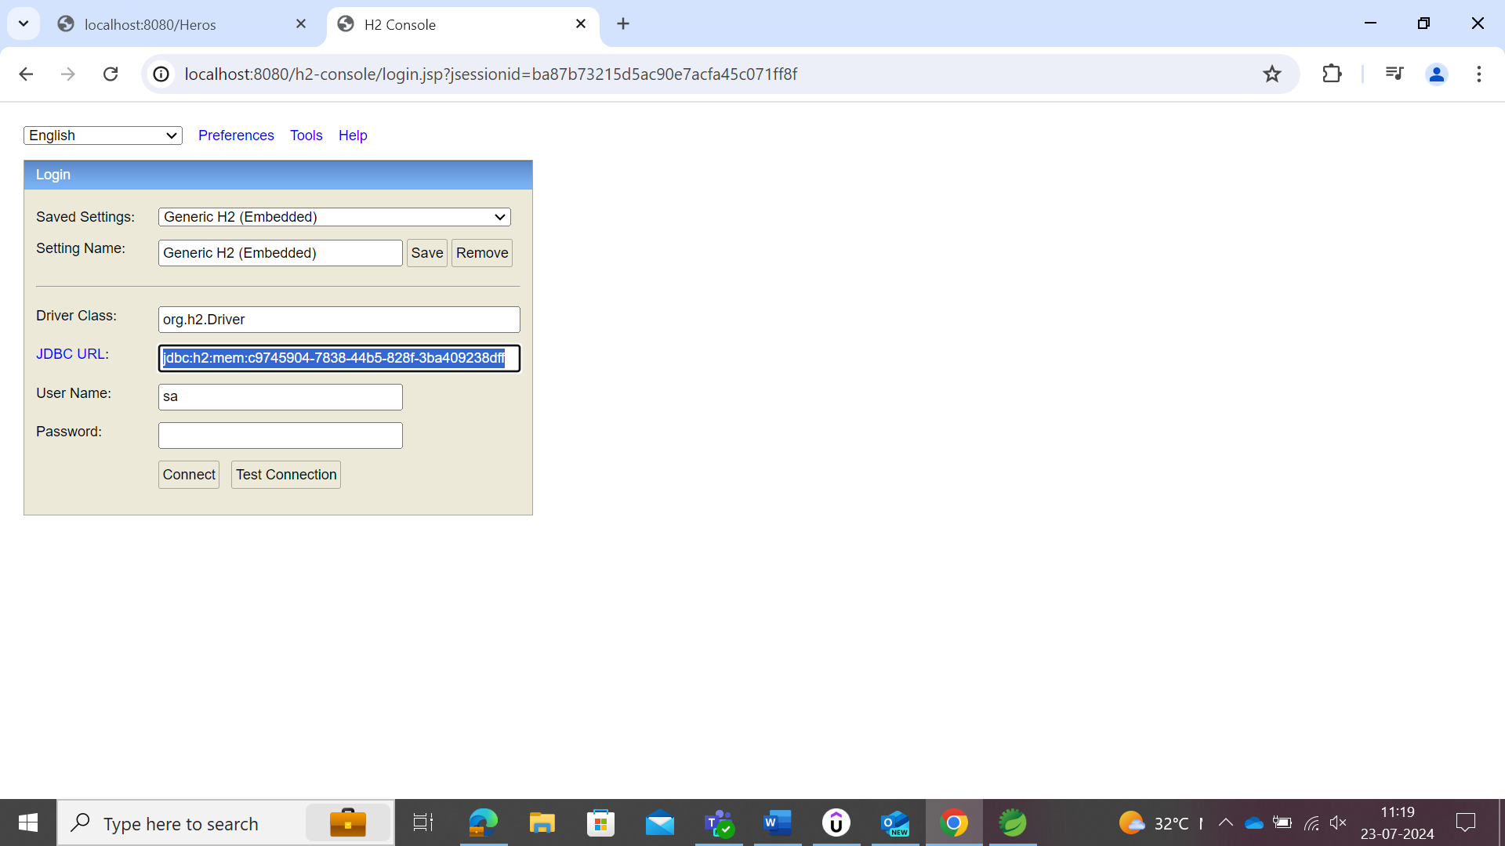

Update the URL and give connect.

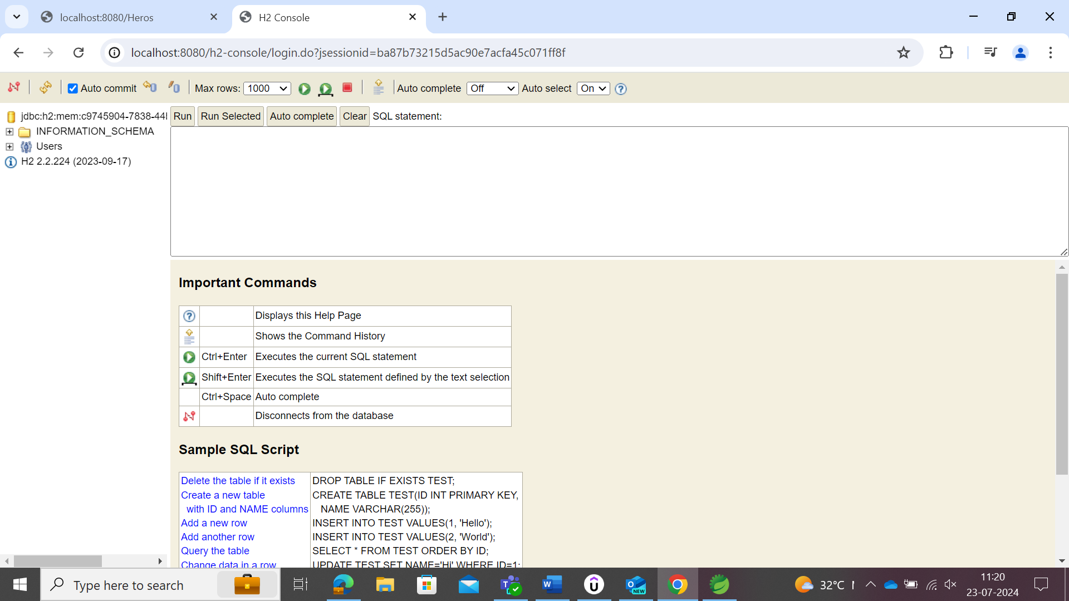

But the above URL is also in dynamic static which needs to be changed each time user run the server. To make the URL connected as static, the property needs to be configured.

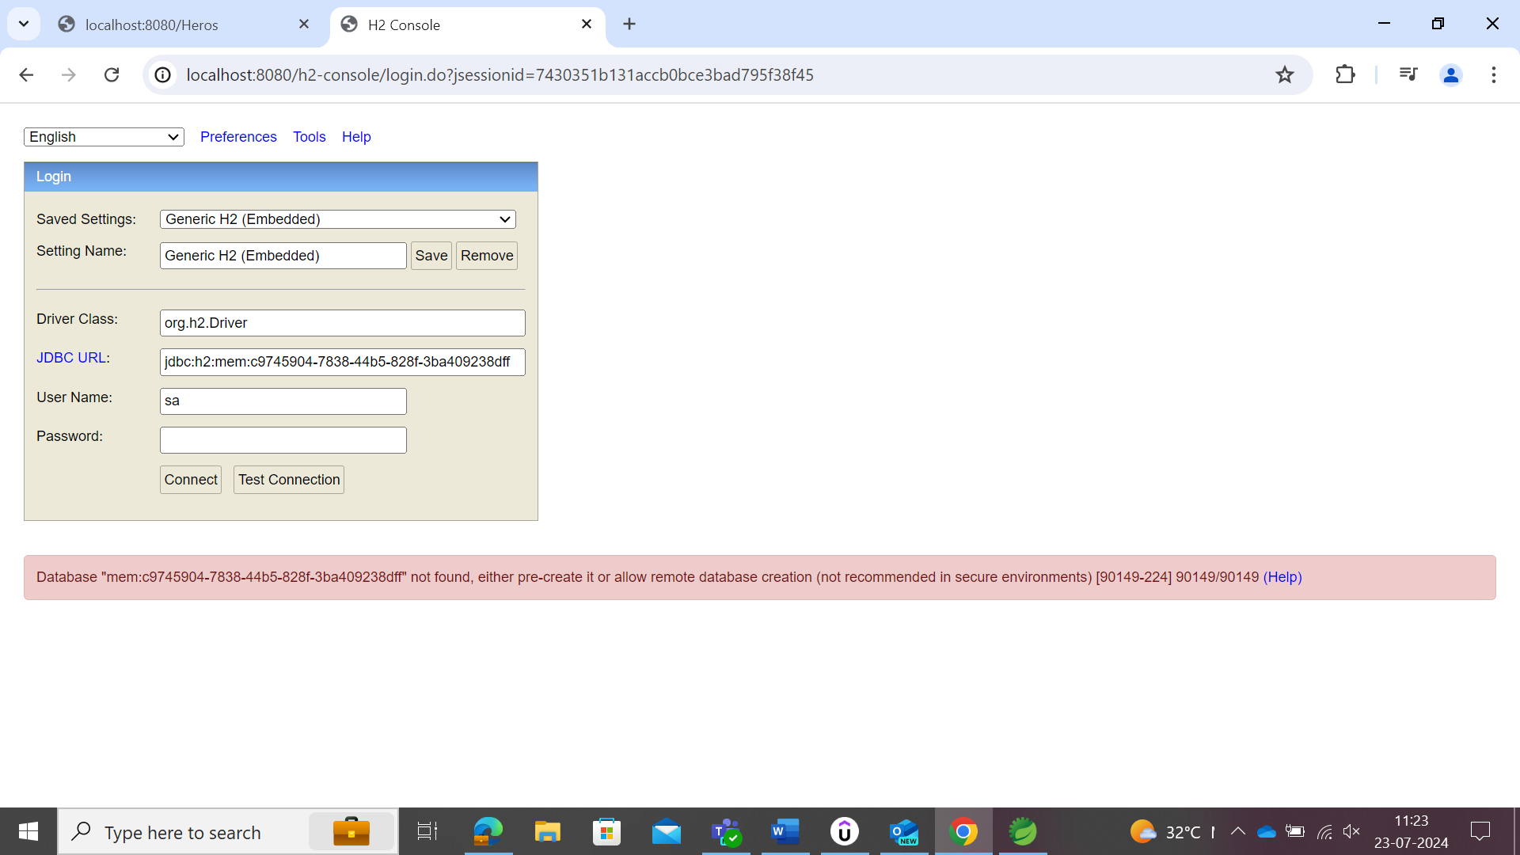

After restarting in spring boot and refreshing the database in server, the above will show as the database url in spring boot changed.

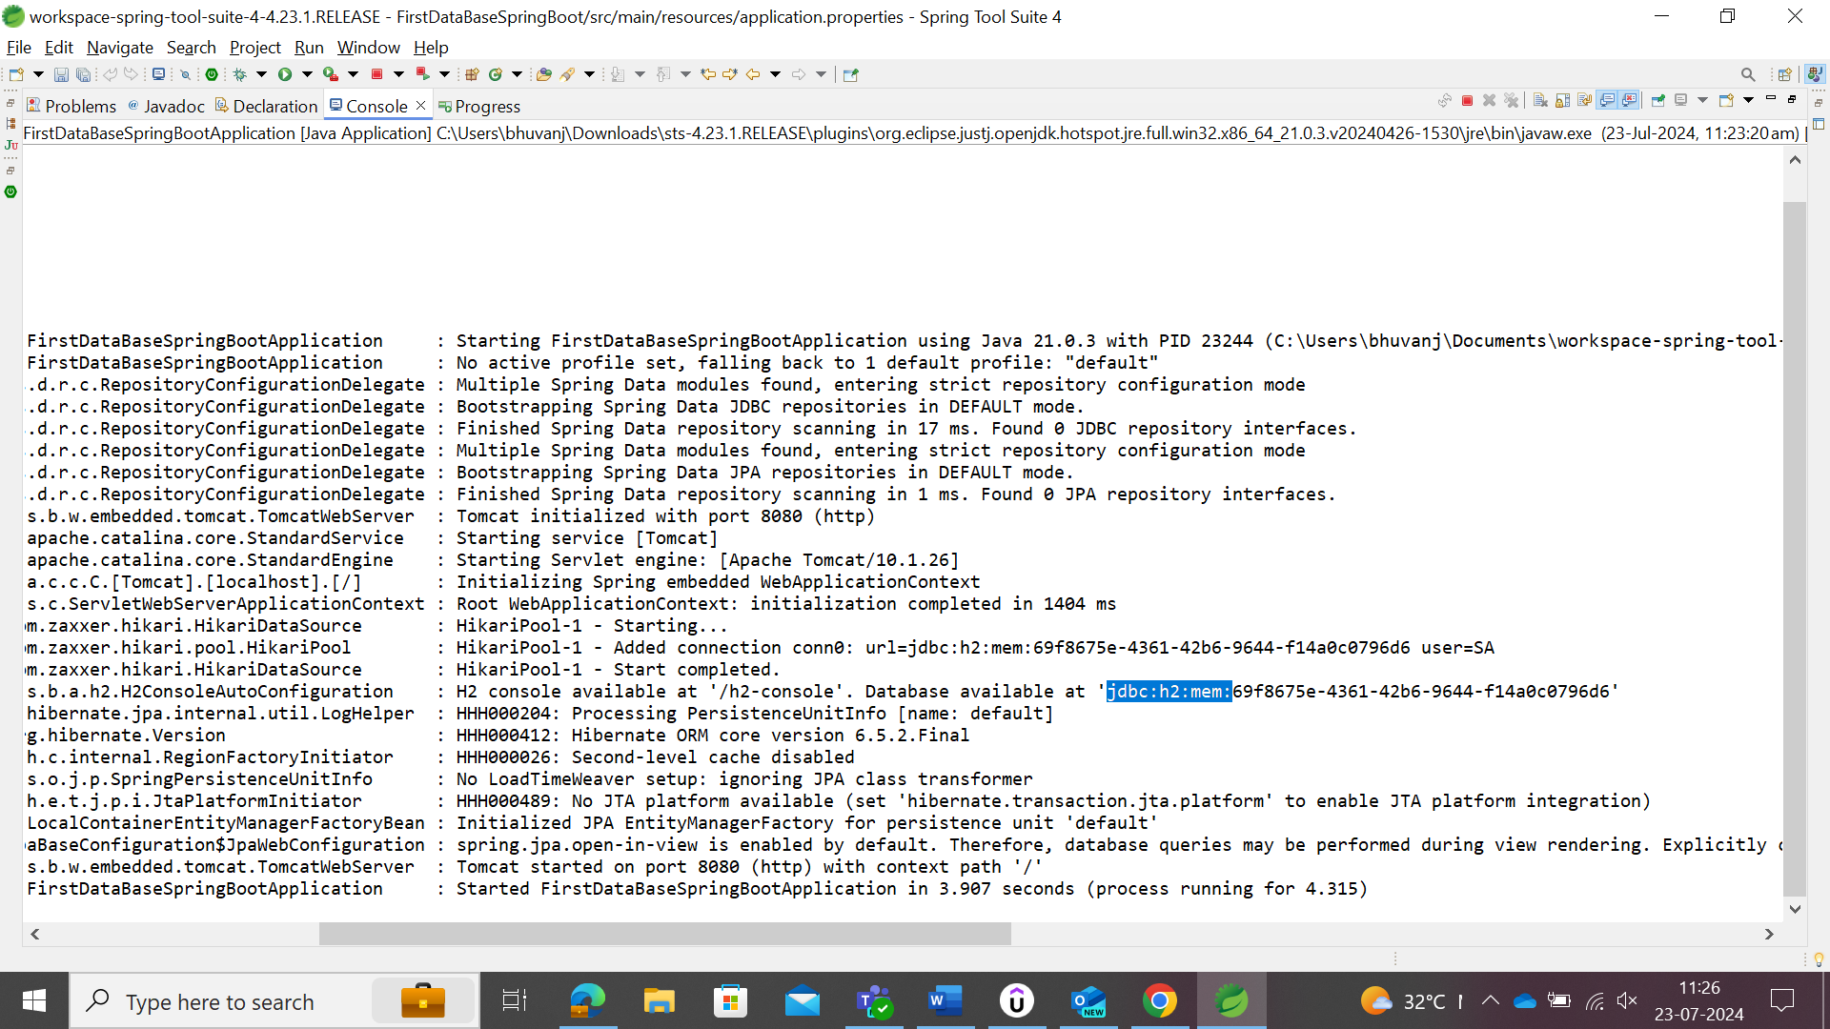

Copy the above url without the random server address.

For making the url as static, make the property configuration as follow and run the server again.

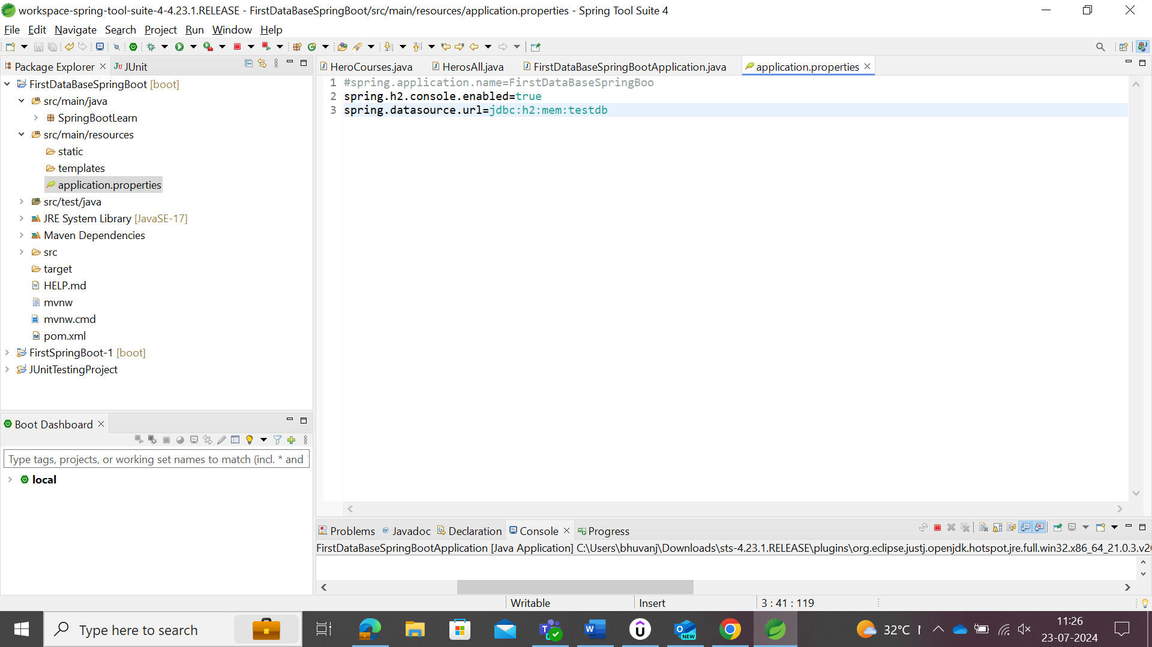

Change the address as follows

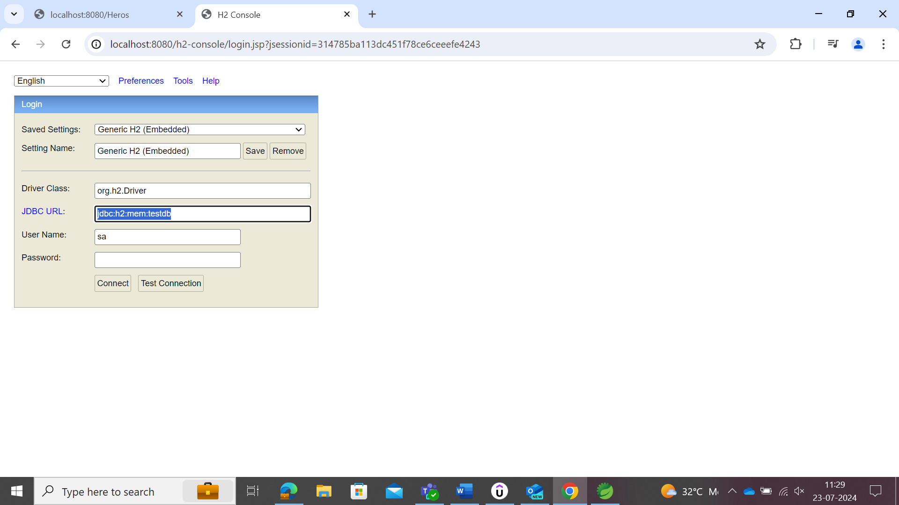

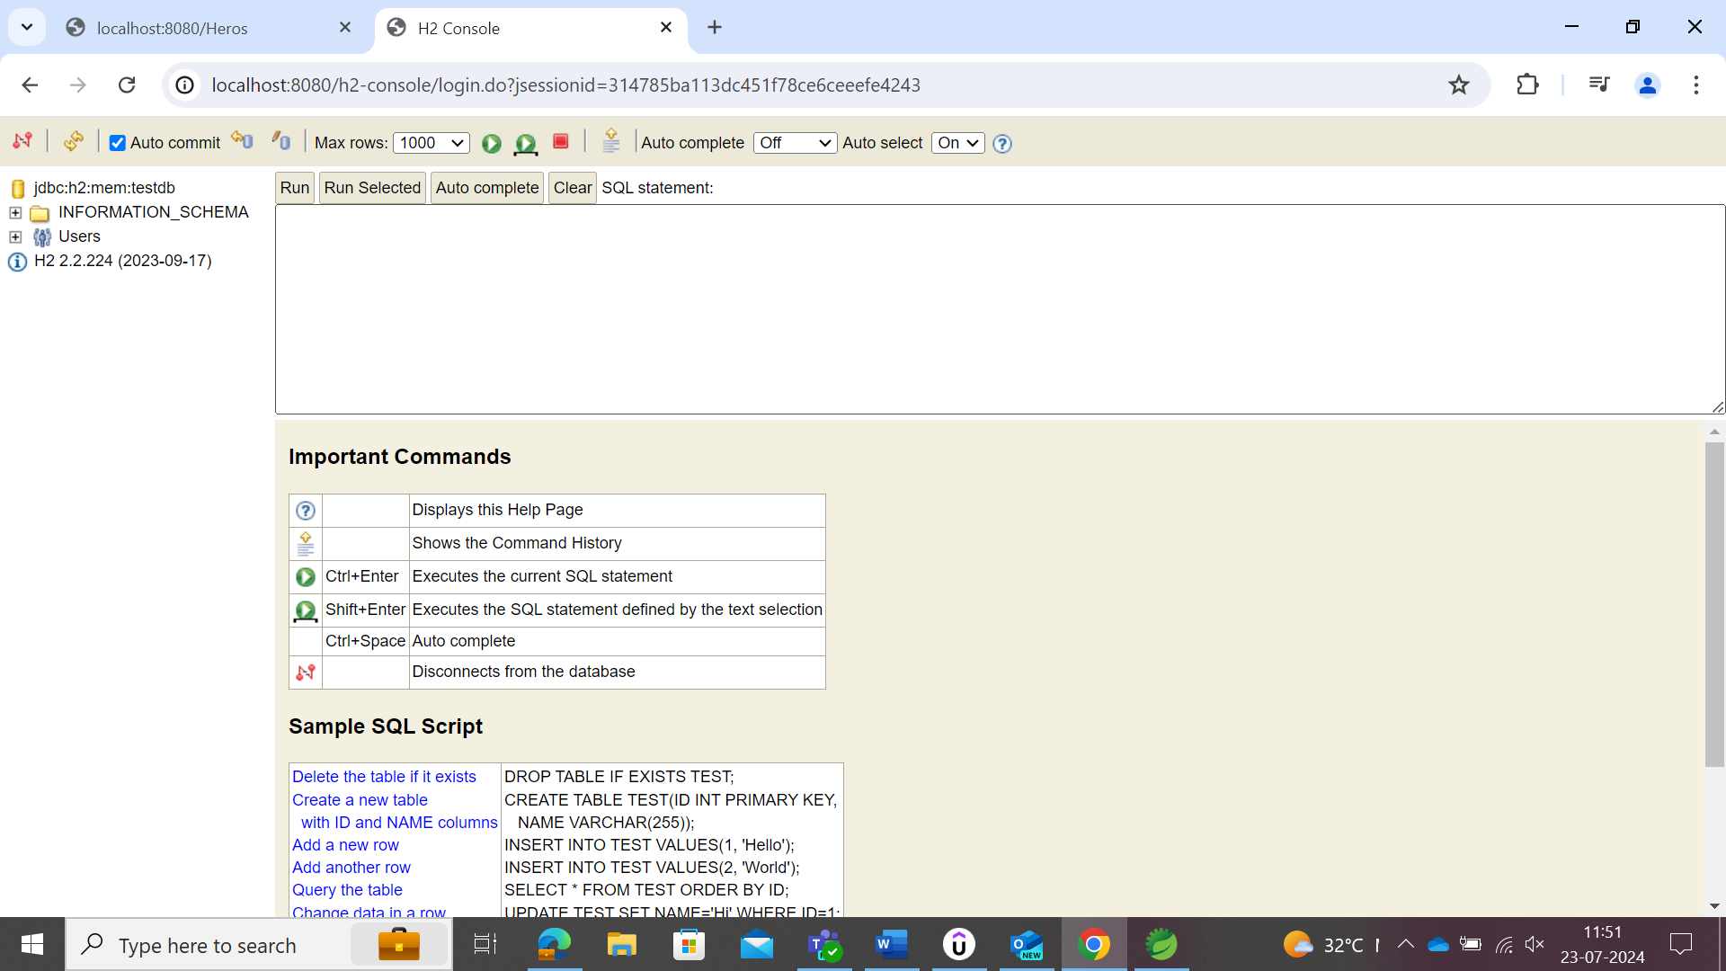

Suppose the user need to create/have own database that needs to be accessed could be done as follows.

Create Untitled Text file 🡪schema.sql 🡪 save as sql file

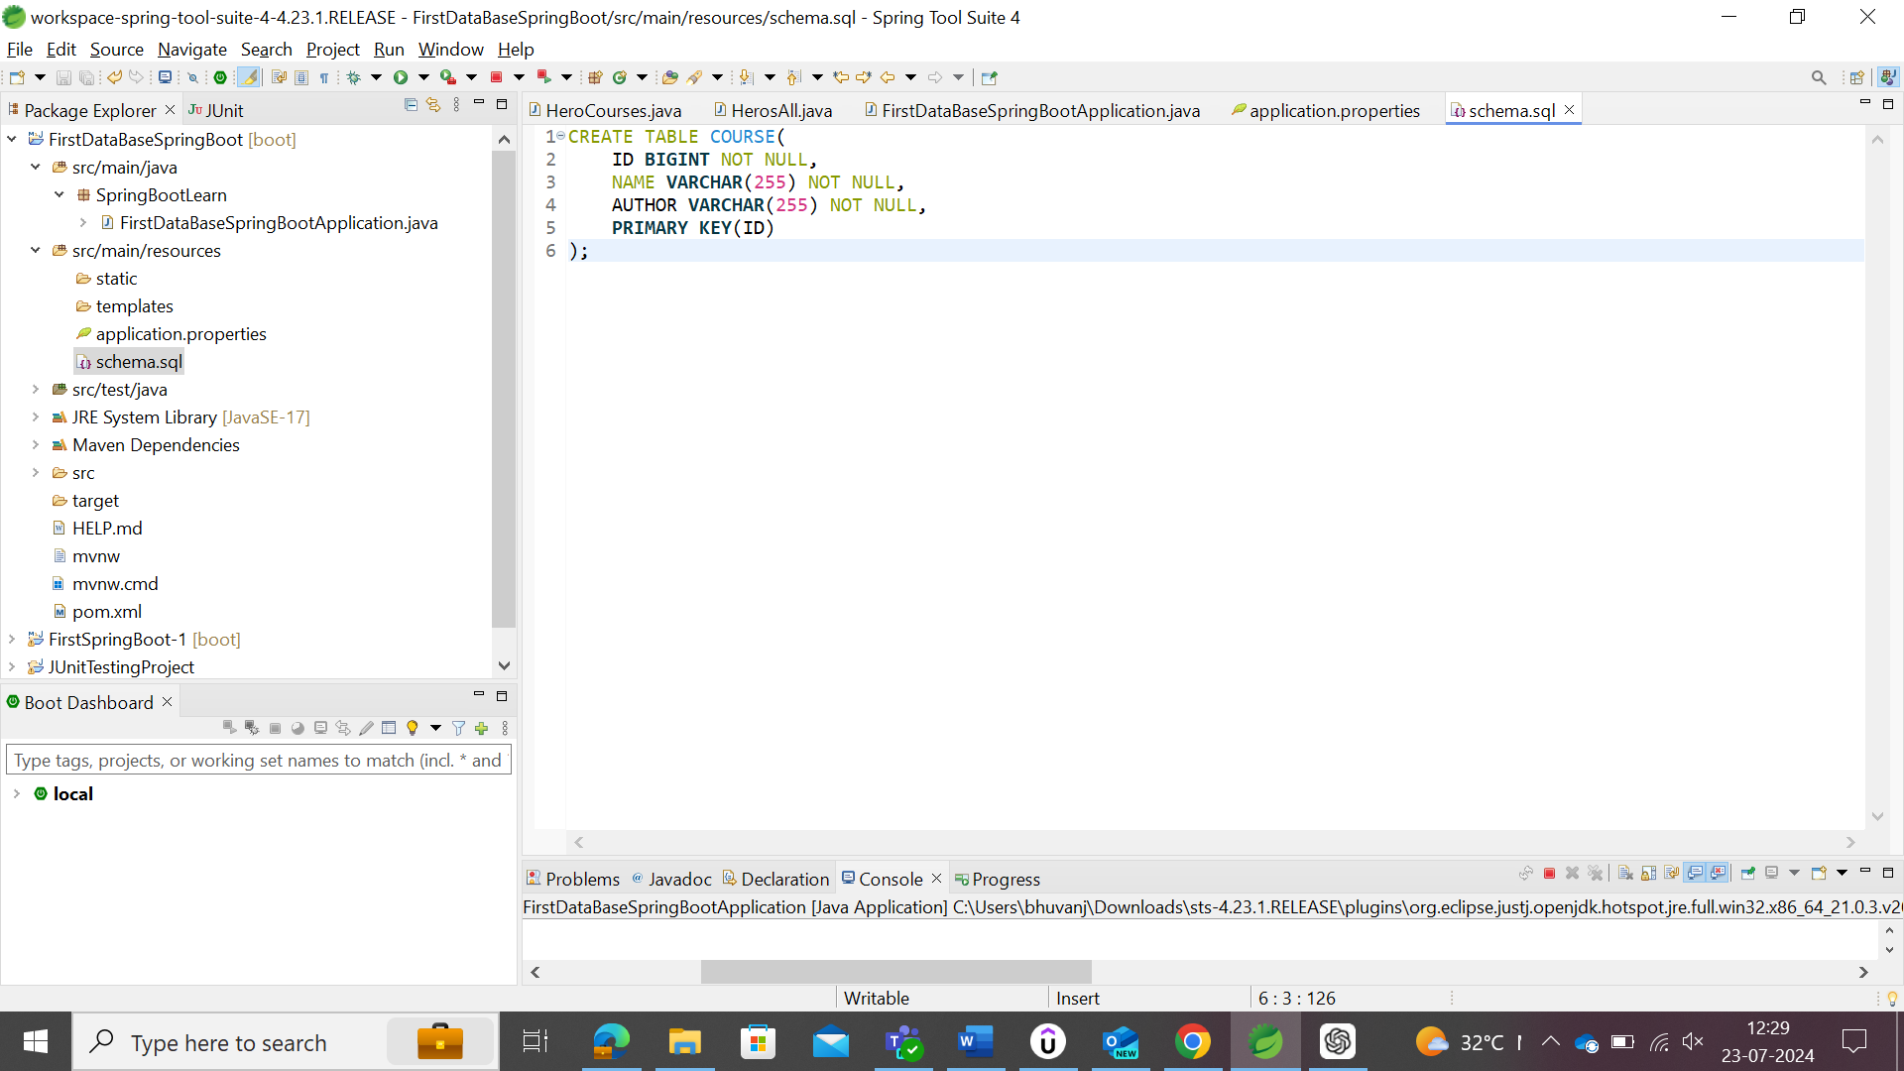

Stop and rerun the program to connect the server.

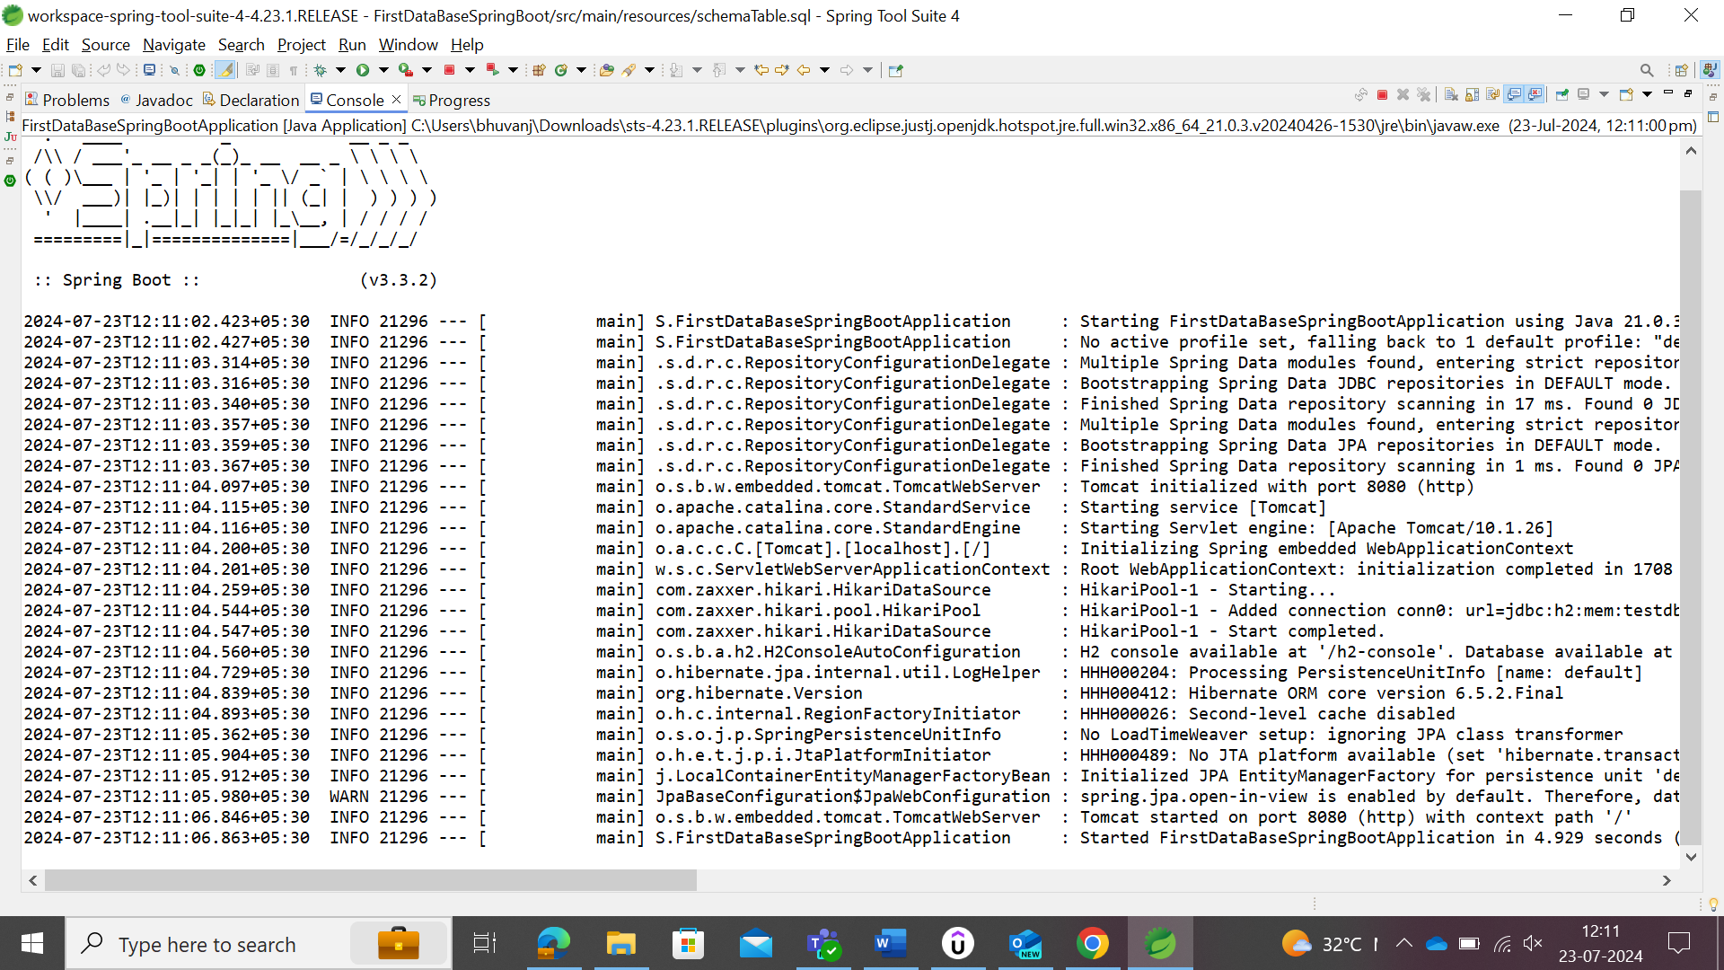

Refresh the browser

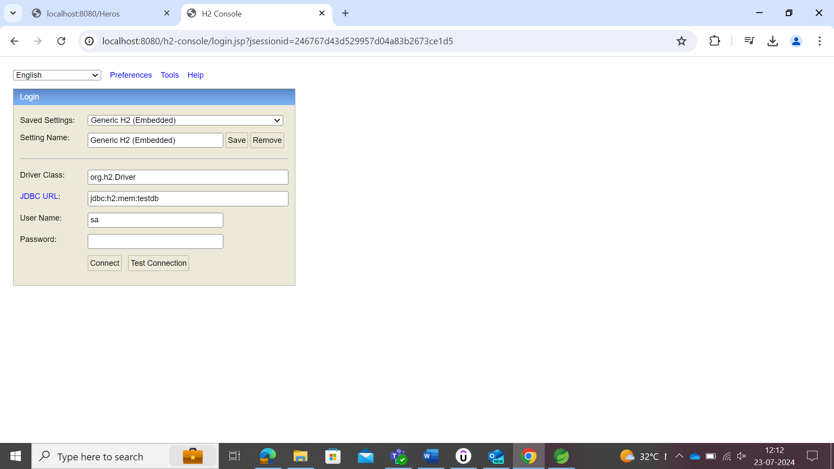

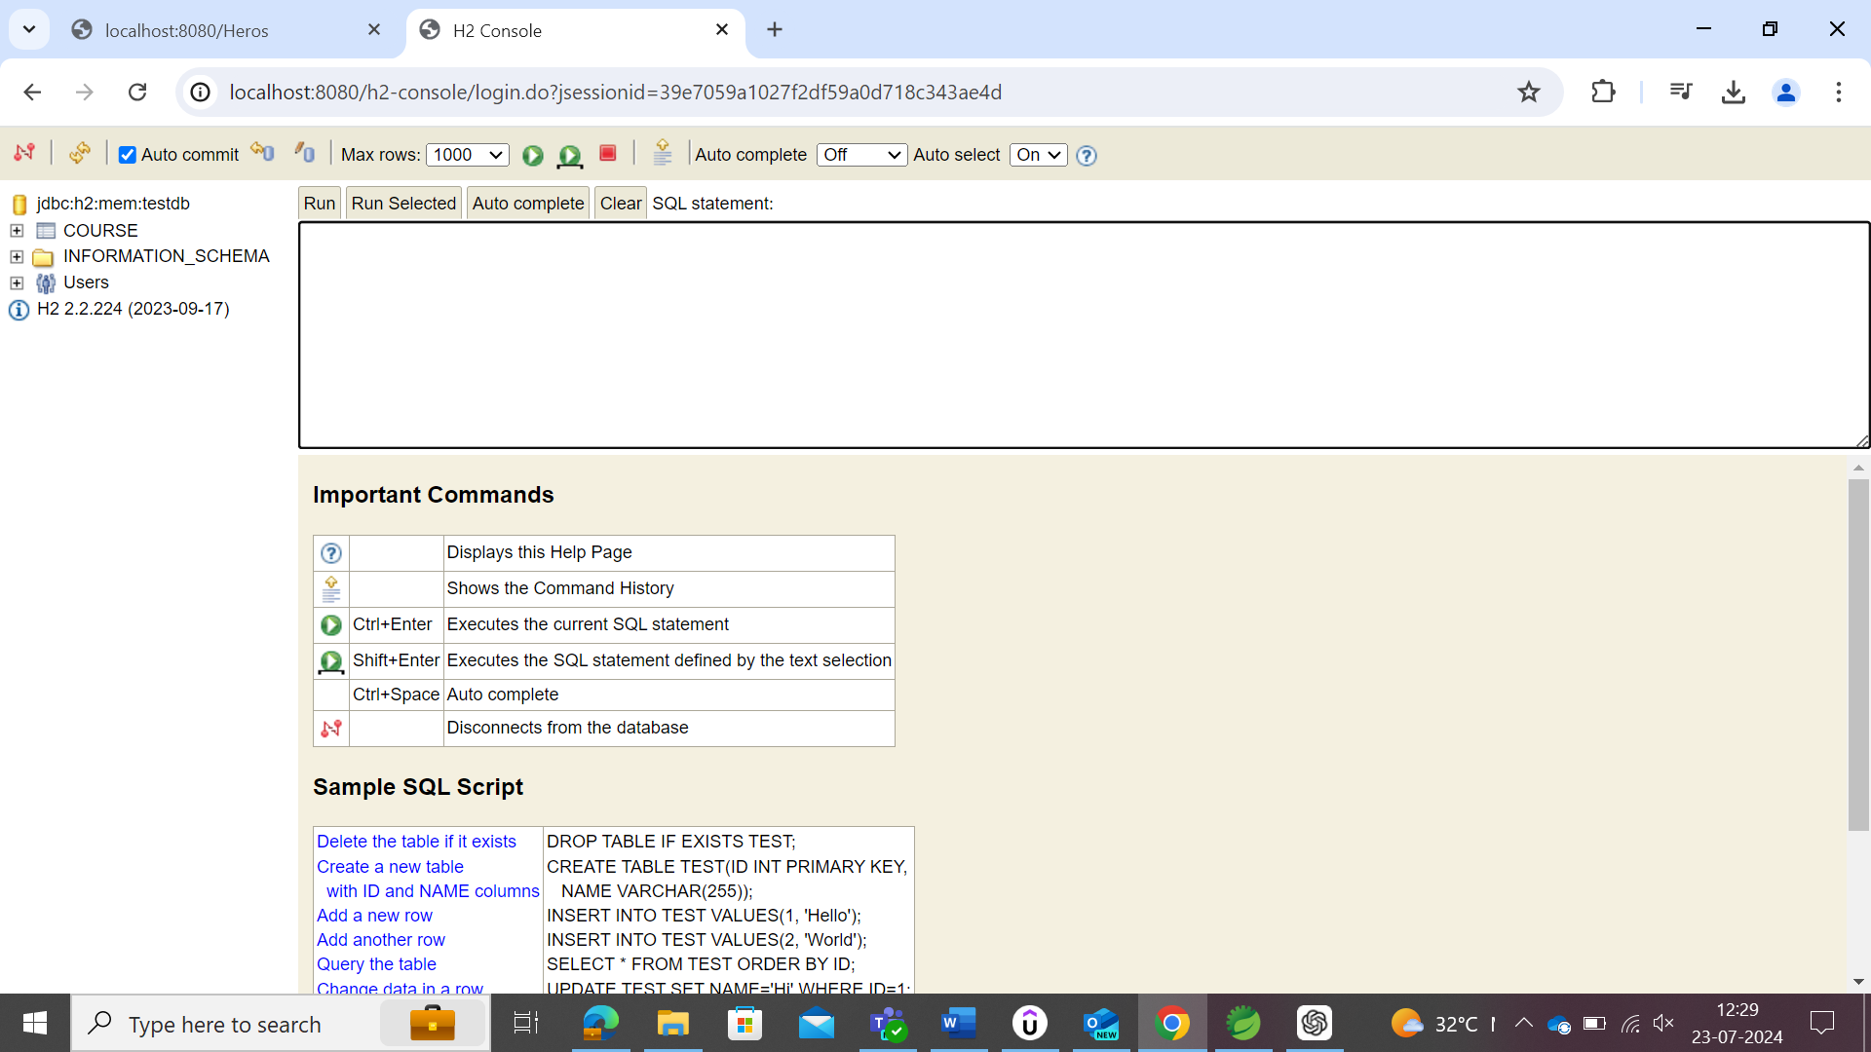

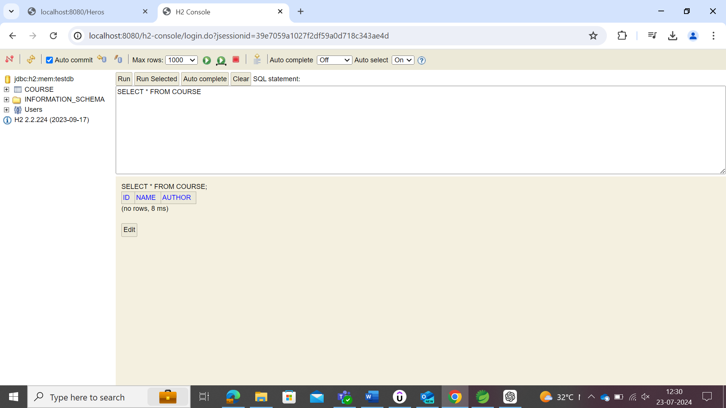

### Spring JDBC with the H2 Database

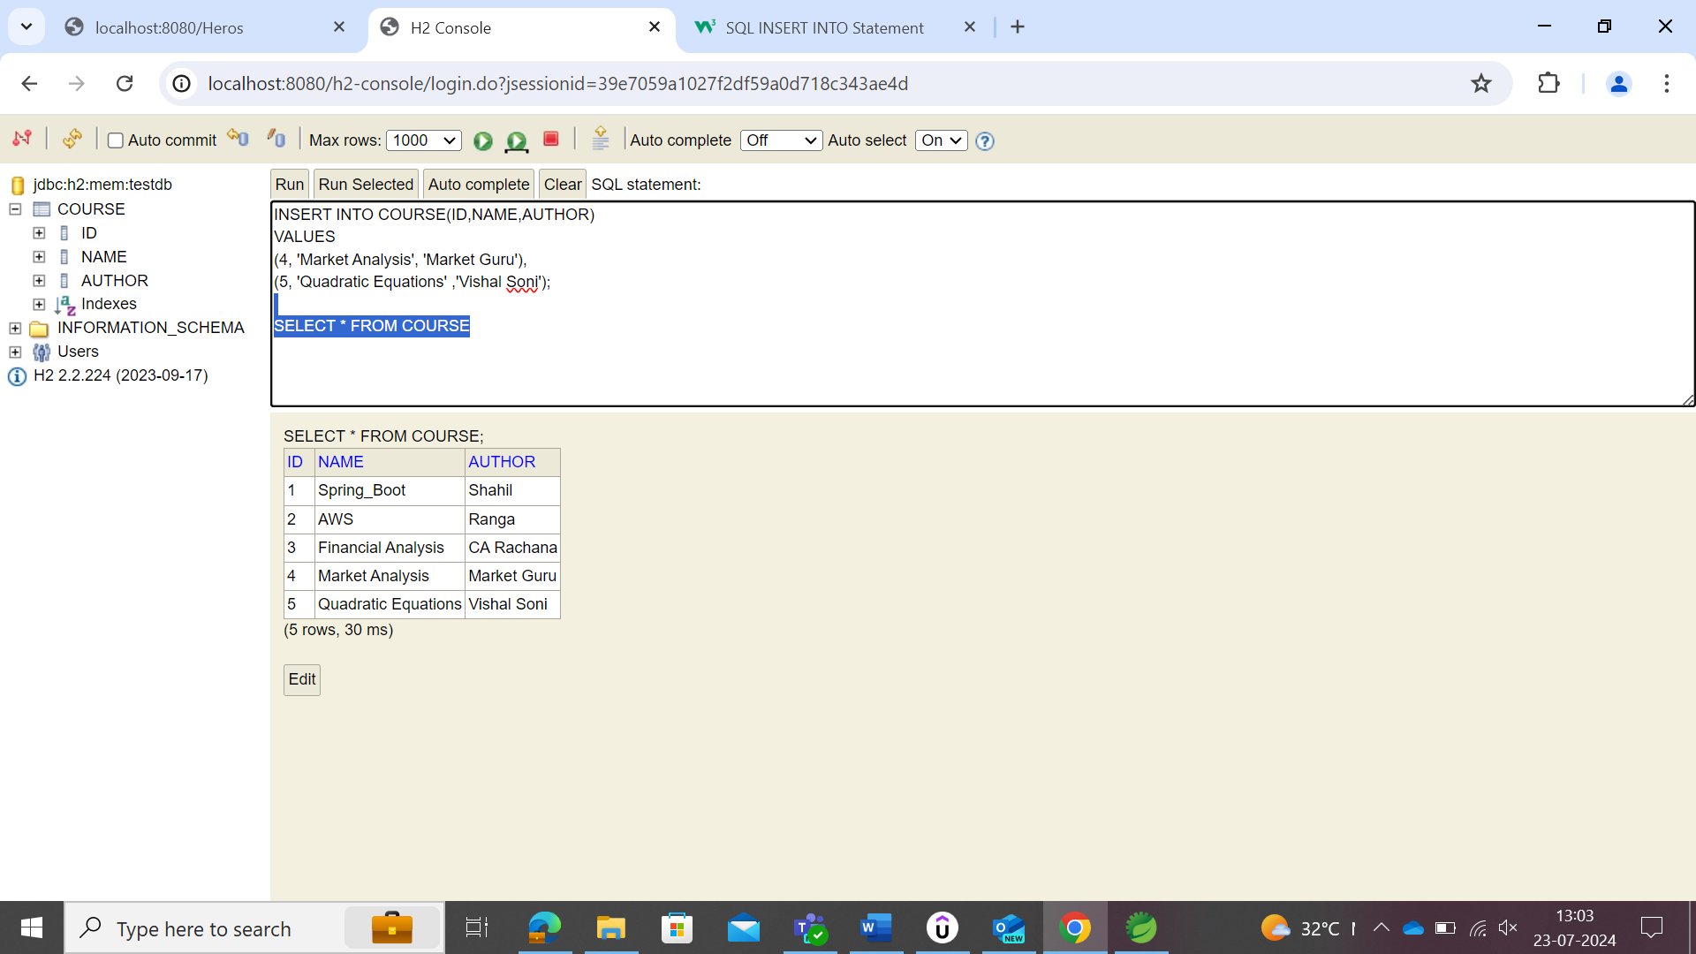

Once the query run, should not re-run for checking which will throw error since the data is already added to the table.

The following hardcoded sql clause couldn’t be directly applied on the course table in the STS. For that, STS need to create class of JDBC to hardcode the data in it.

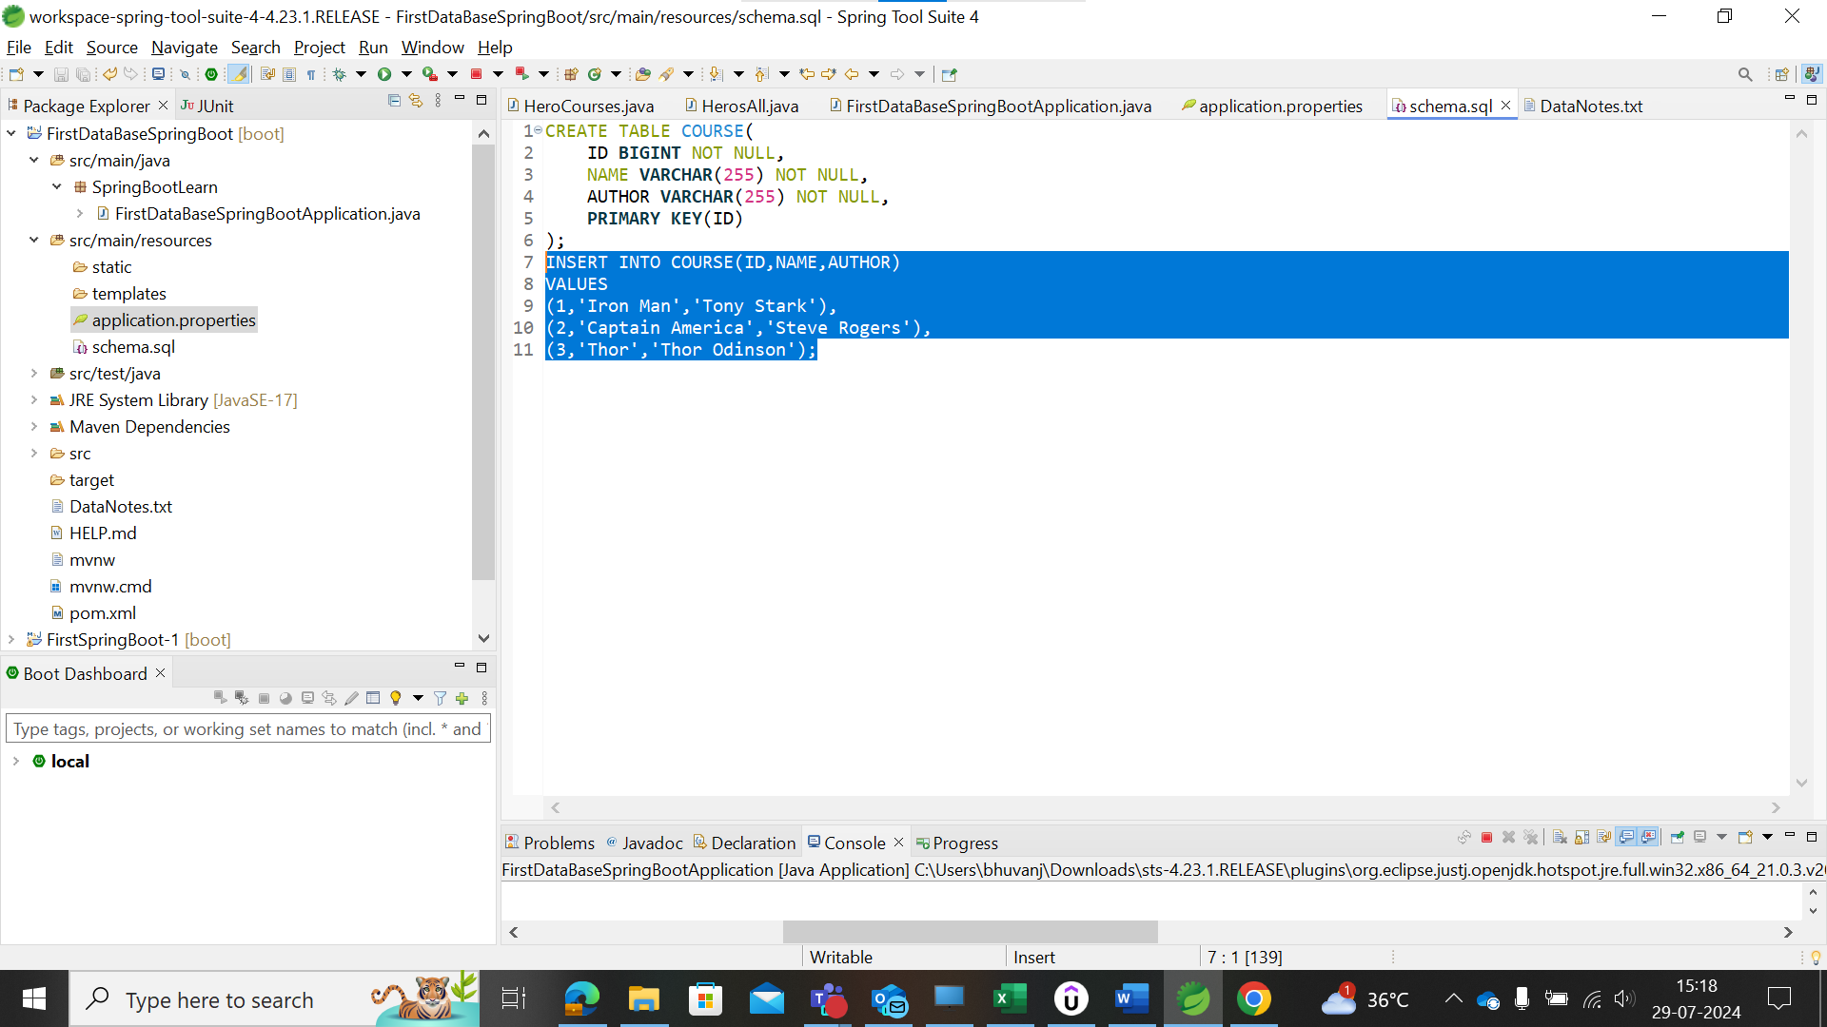

The above were not executed in the Database in the local host of the browser.

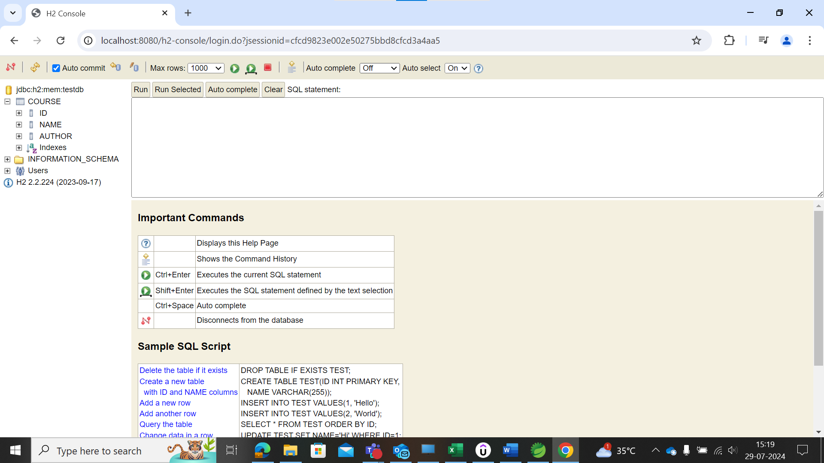

Hence, the schema.sql is used to create the table/structure of the database in it. To create the modifications, user should follow as shown below.

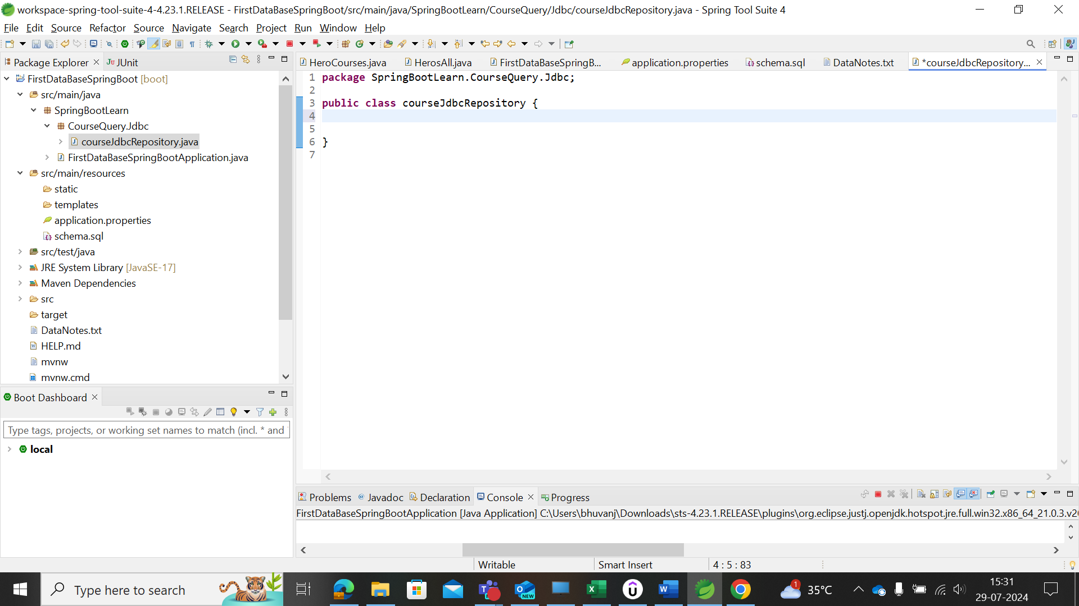

The class is used to fire those queries into the database.

@Repository is the annotations that provides the connection to the database.

up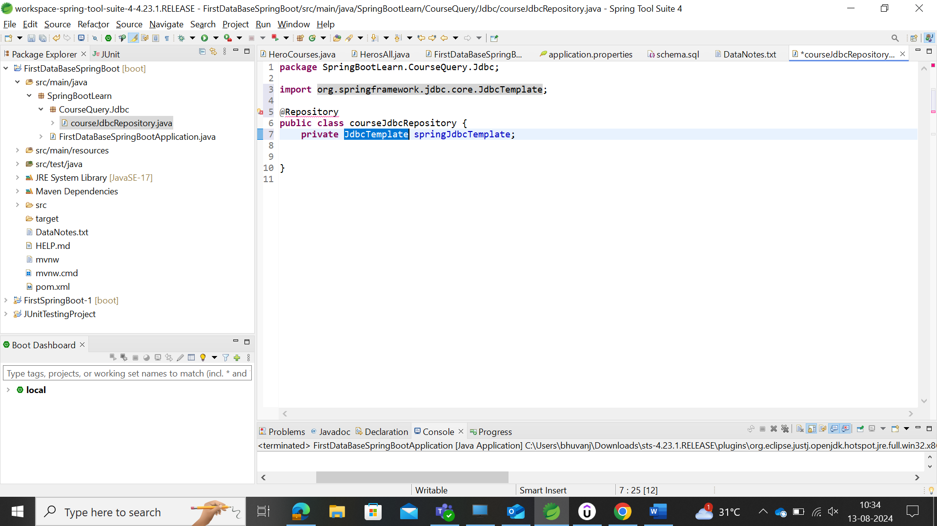

JdbcTemplate is the class with different methods to fire the hardcore queries into the spring class. Spring's JdbcTemplate provides high-level abstraction to perform database operations without having to write boilerplate code.

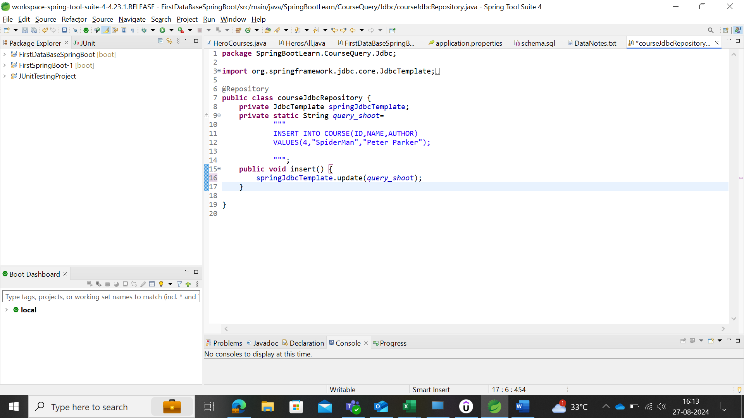

After updating the query to fire, then make use of the command line runner class to execute the query while starting the server.

CommandLineRunner

When user needs to run some logic at the time of starting of the spring application, then user could make use of the ***CommandLineRunner***

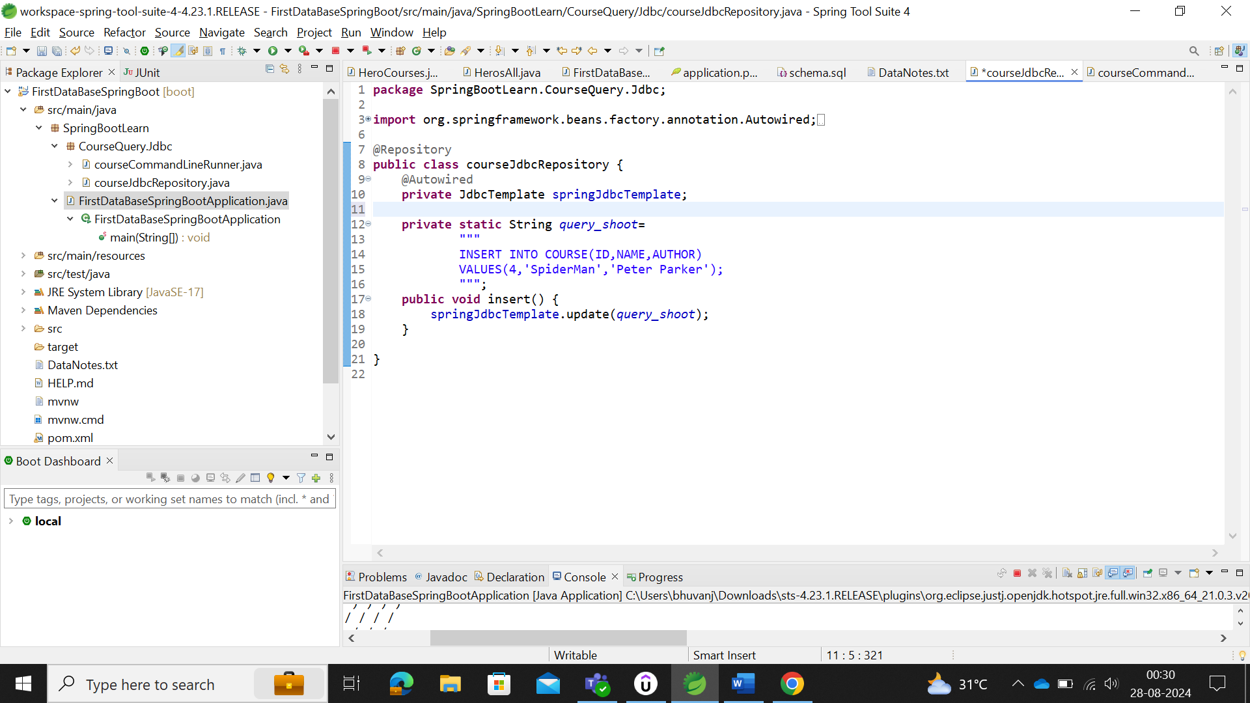

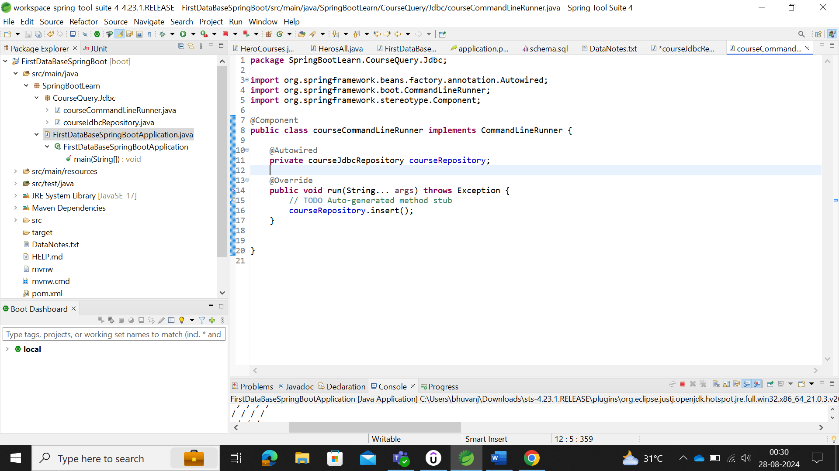

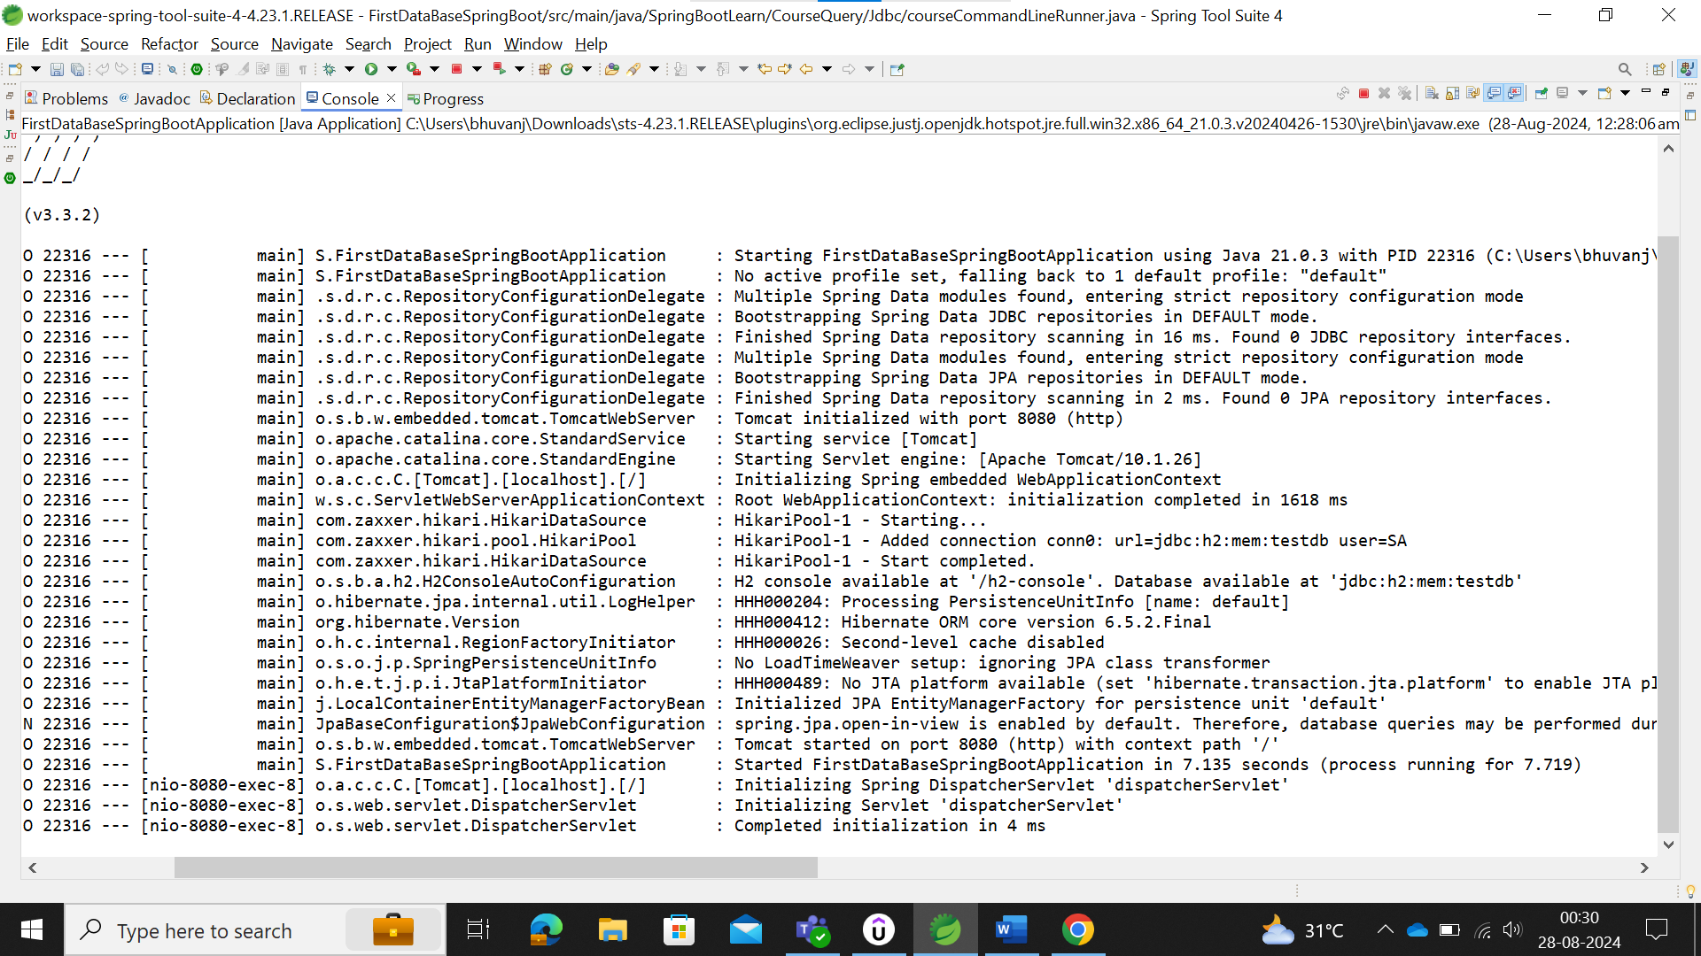

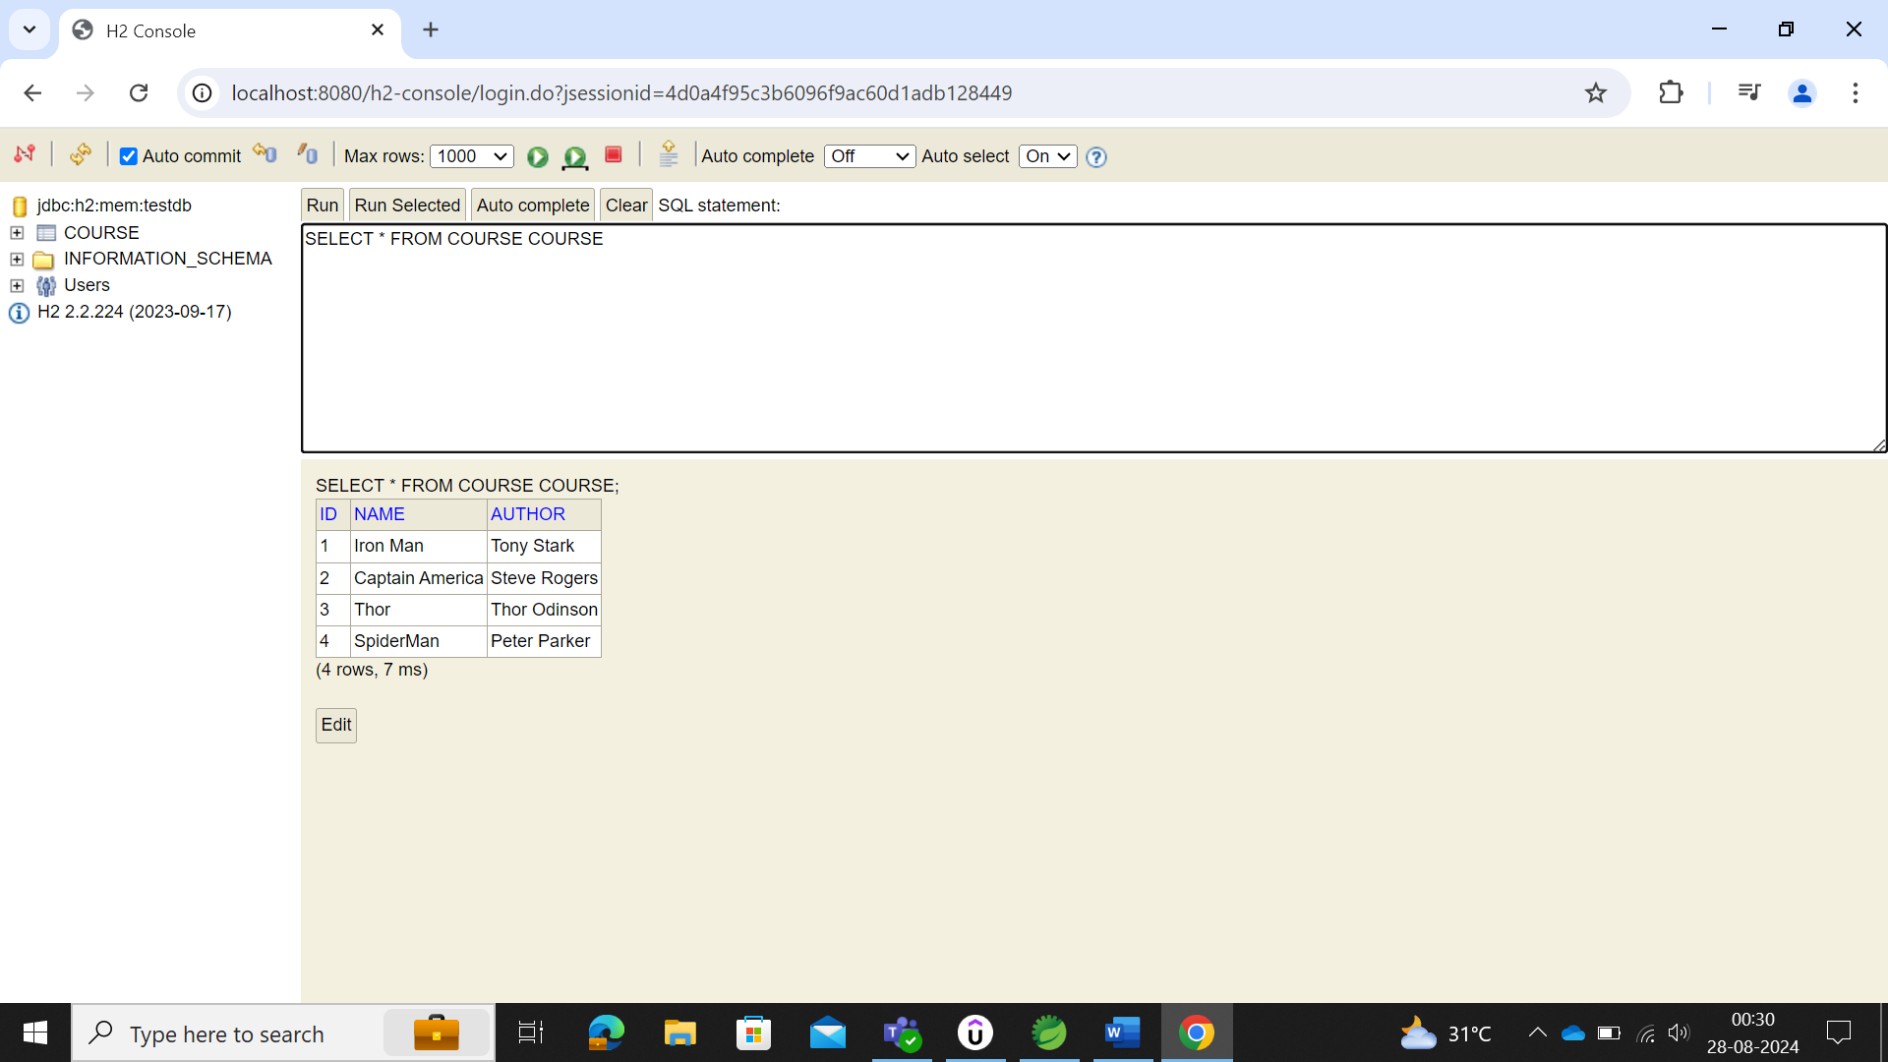

The above is the hardcoded query of SQL in the spring but in order to make it alike the variable to be passed in the code. We could make use of the following.

Create the constructor of the courseClass and update the data that needs to be updated.

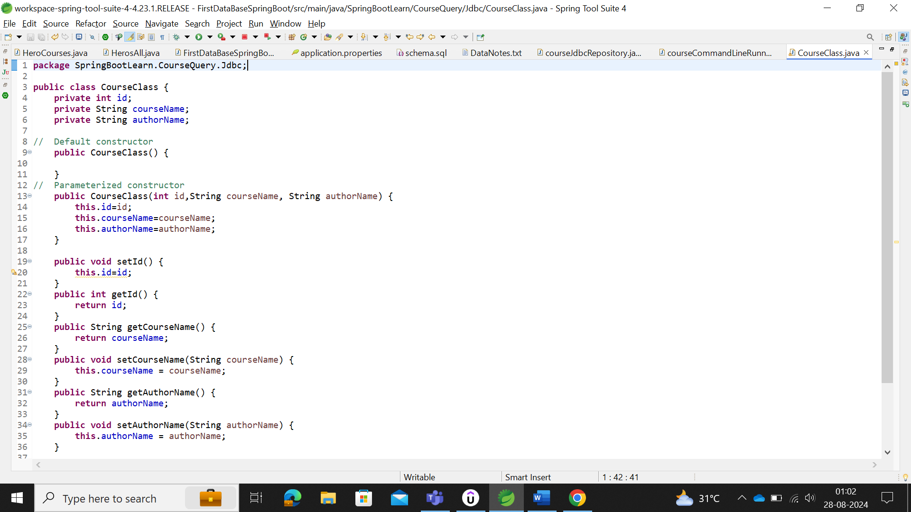

Make the value as ? in the SQL query in the hardcorded query_shoot

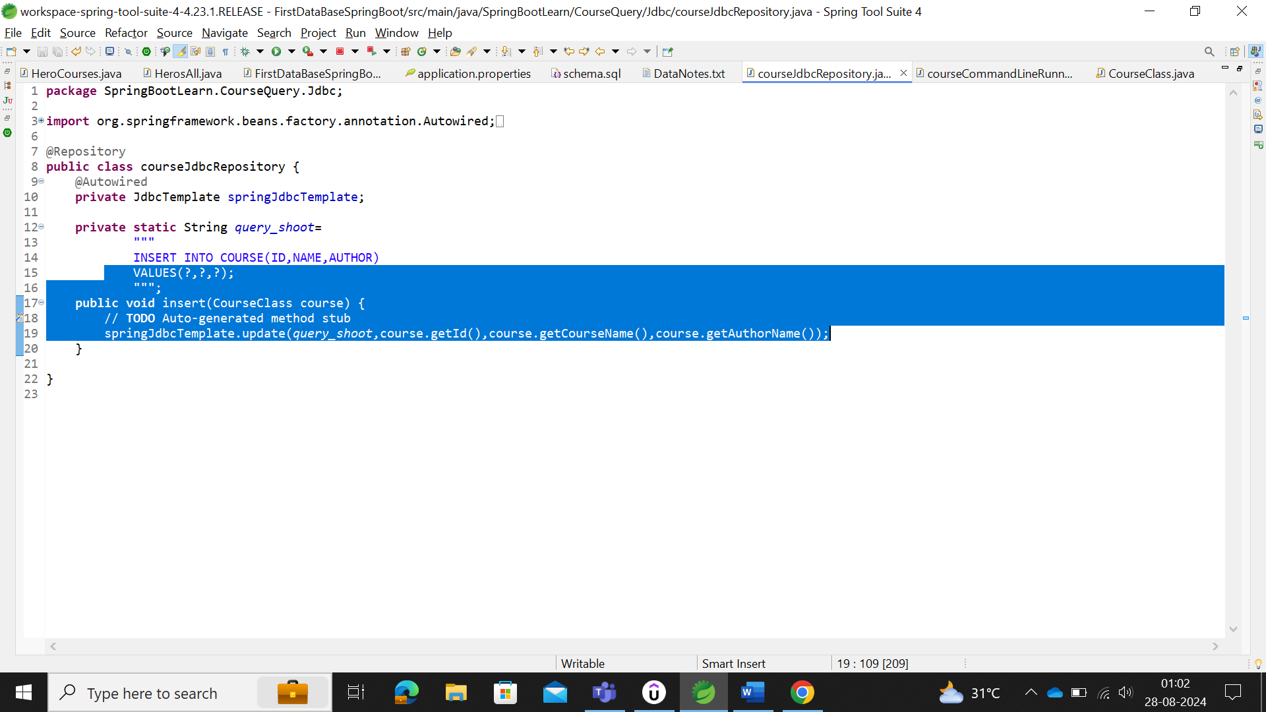

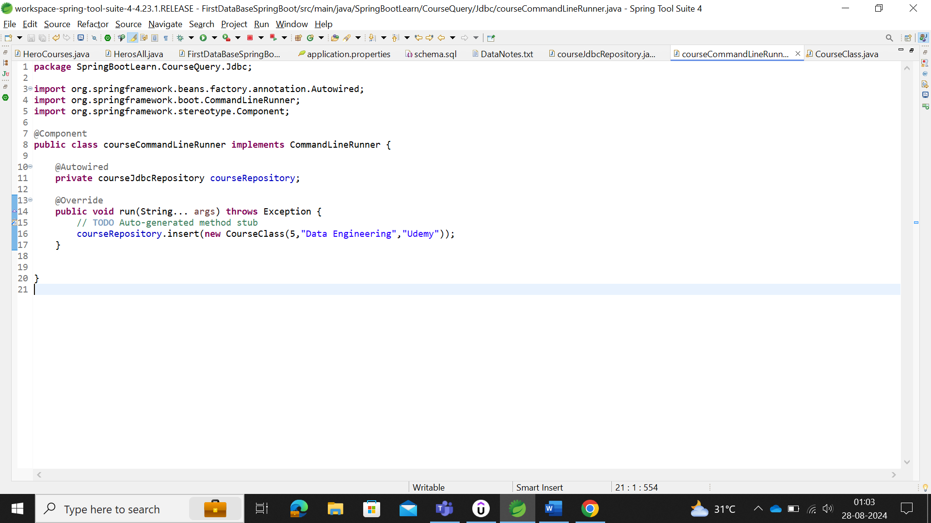

#### Delete Data in Database while running the server

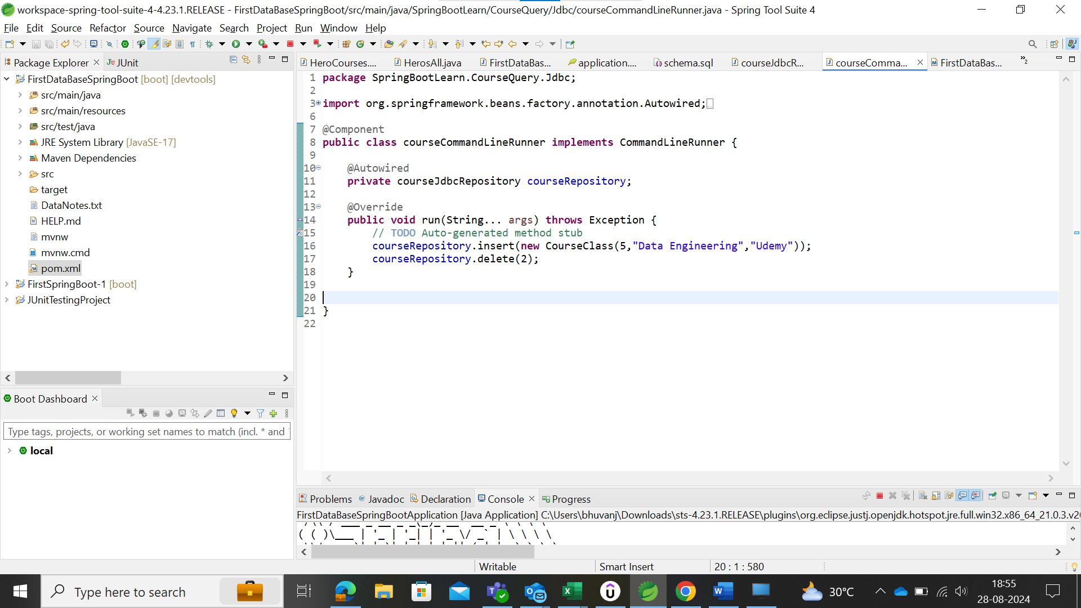

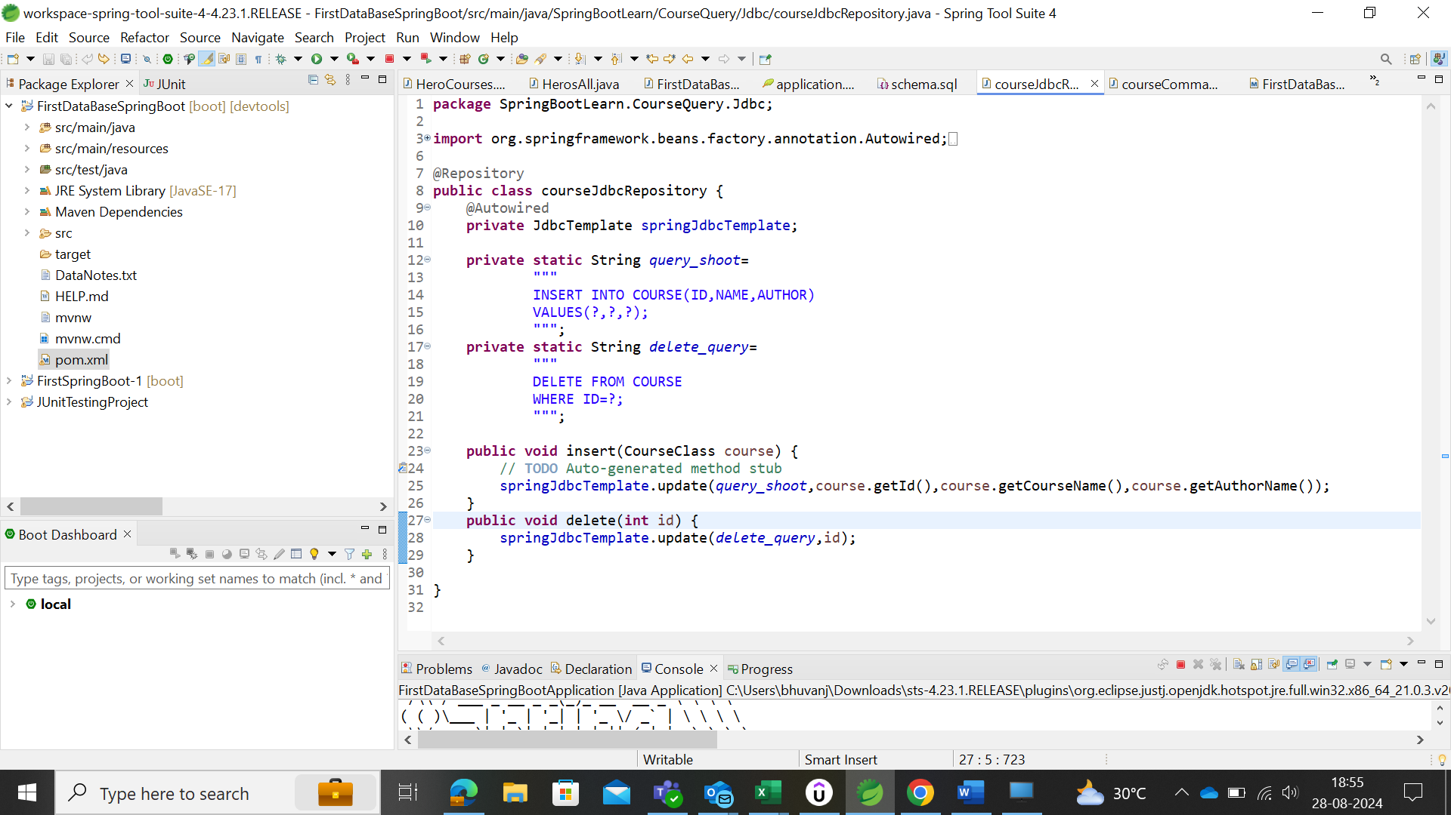

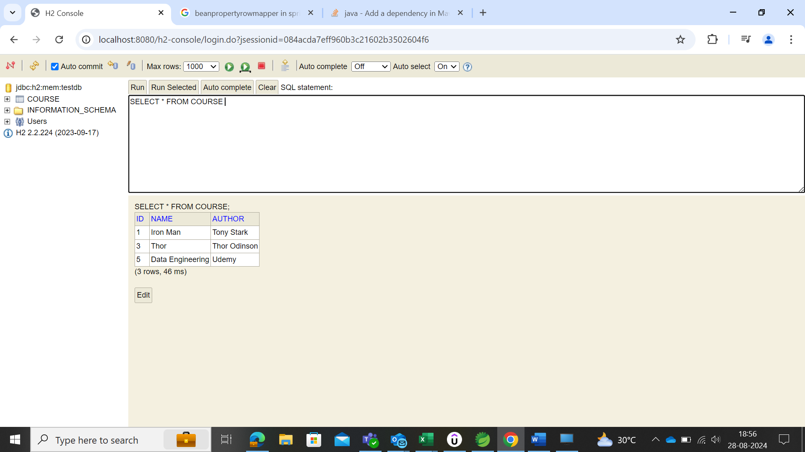

#### Retrieving Data from Database:

The data could be retrieved by making use of SELECT query as hardcoded. But the retrieved data needs to be covered as object, so that it could be printed in the spring by making use of the constructor. This could be achieved by making use of RowMapper which convert the Result sets to beans (objects).

Syntax:

***RepositoryName.queryForObject(Select_Query,new BeanPropertyRowMapper<>(ClassName.class), int id_name));***

### Using EntityManager

First the data table is created here mentioned as Entity which will enable the constructor to create the table.

The EntityManager will take the Entity of the table,

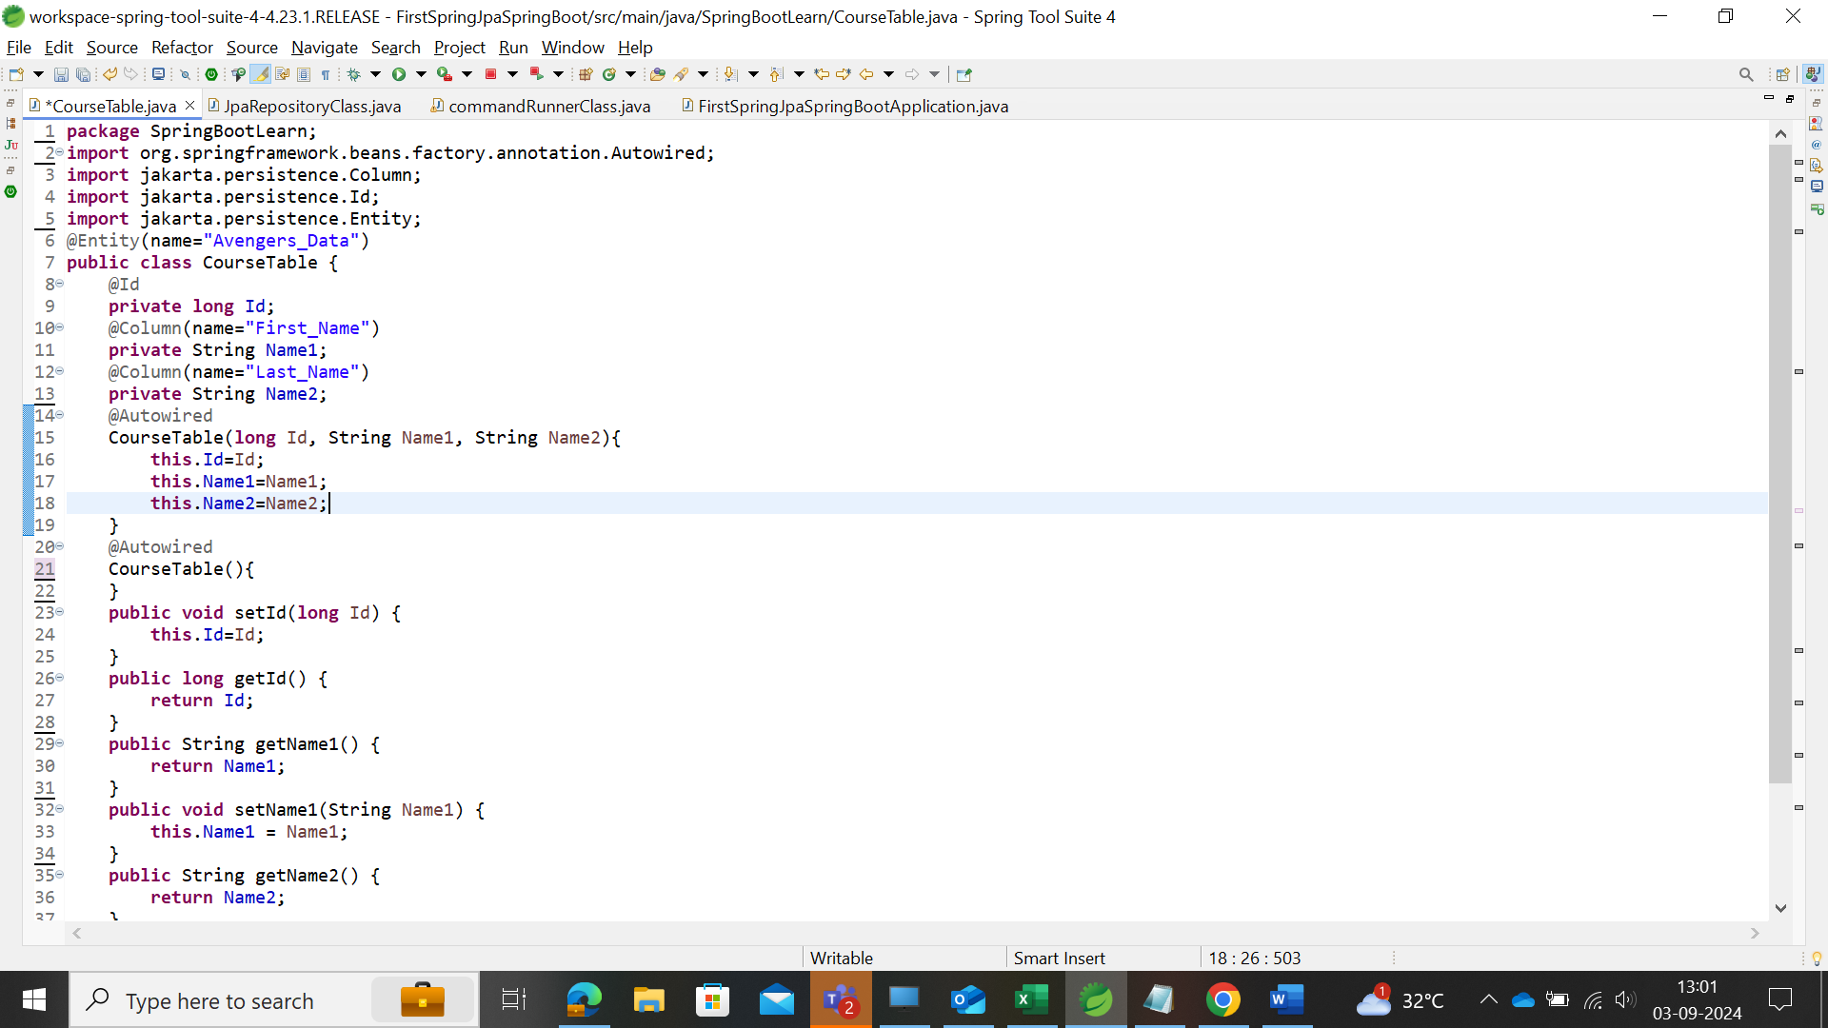

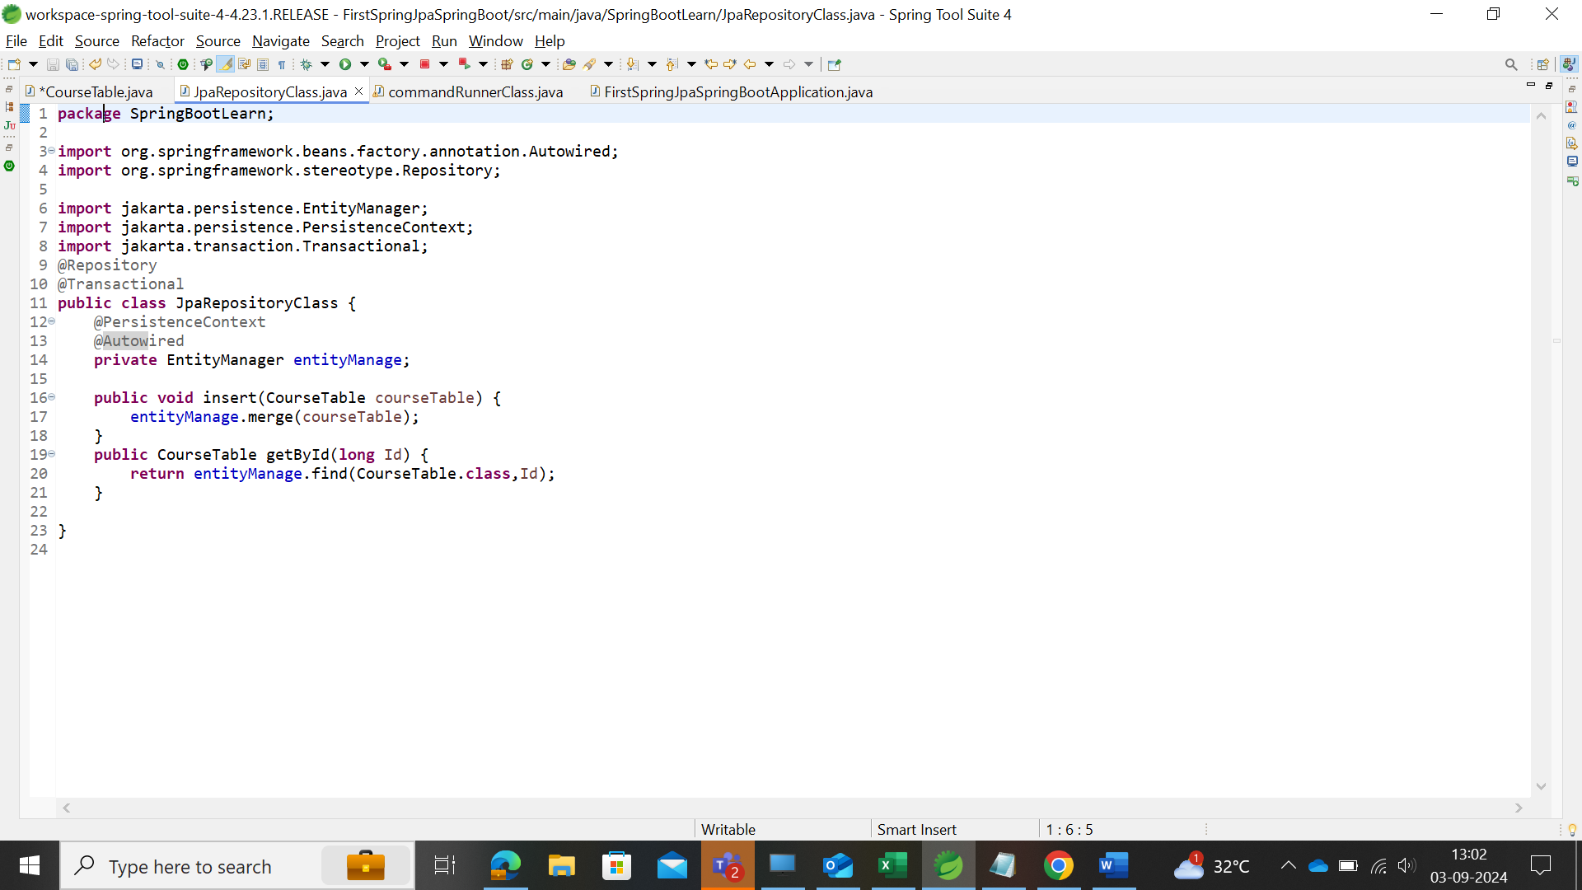

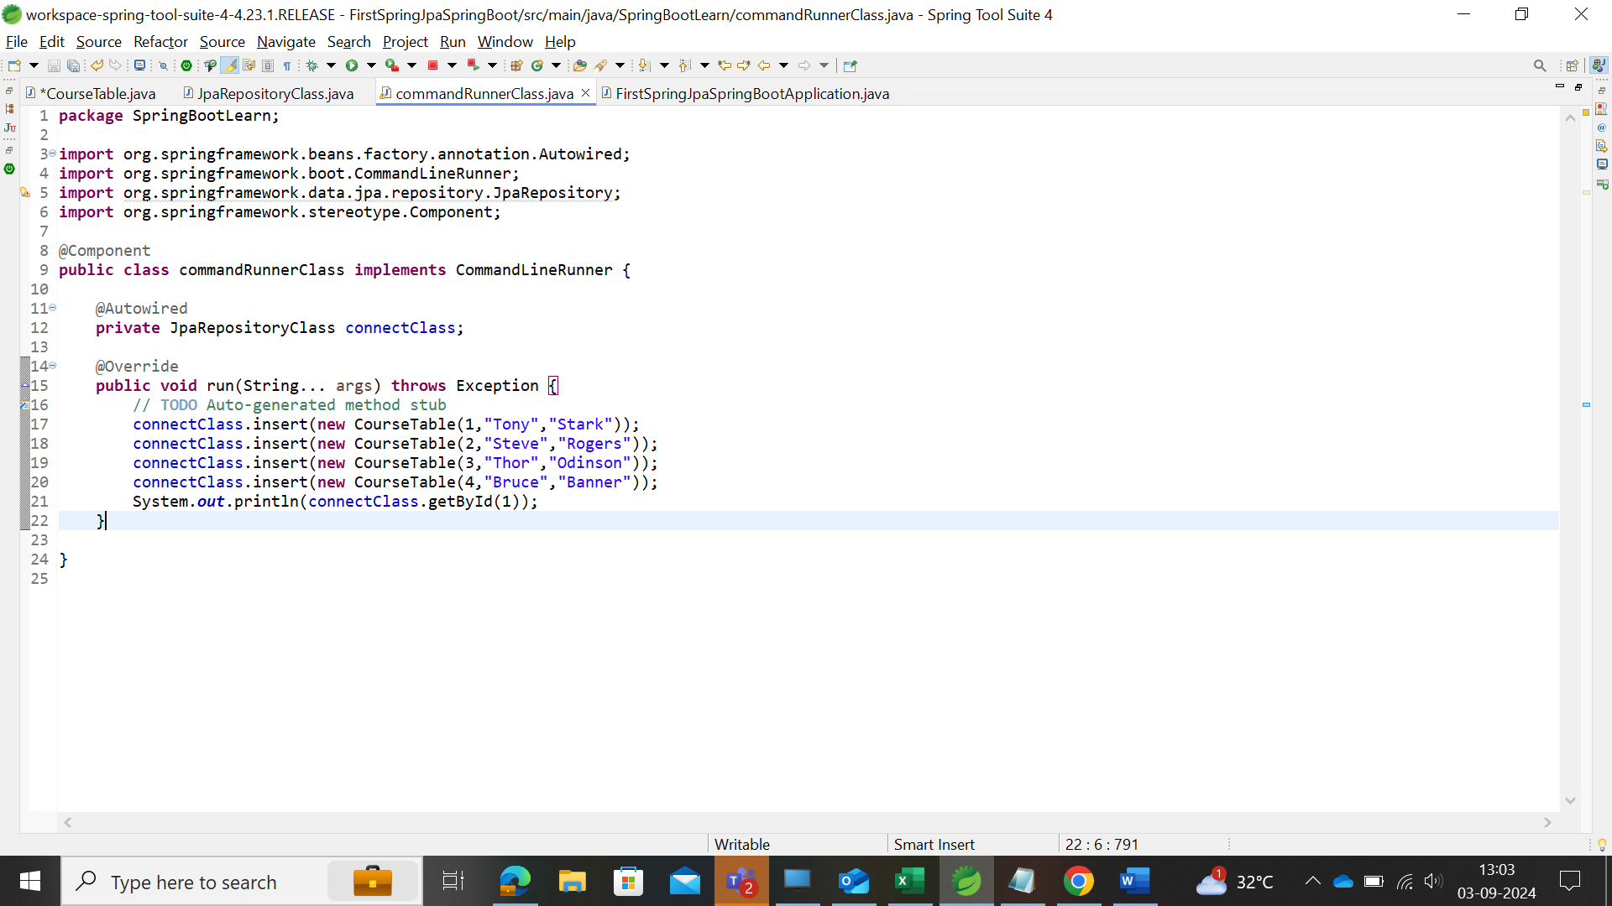

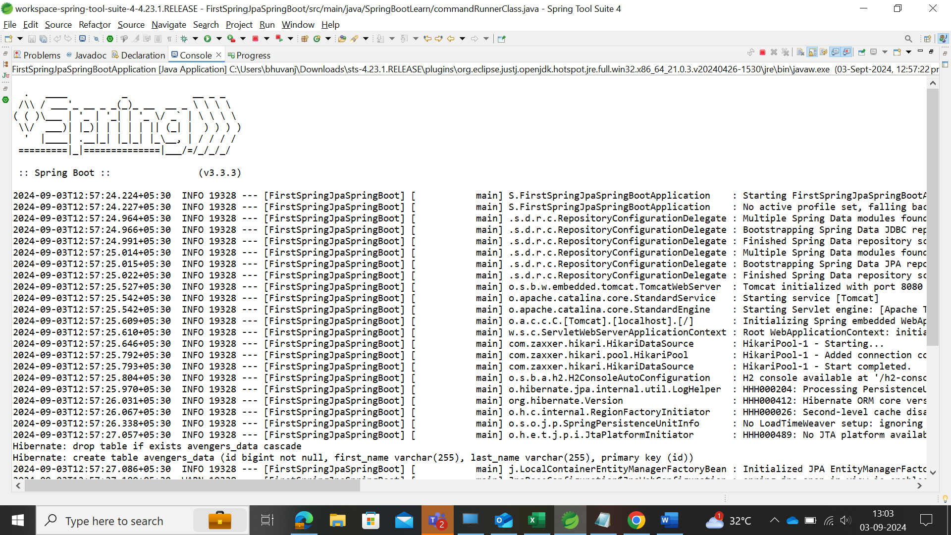

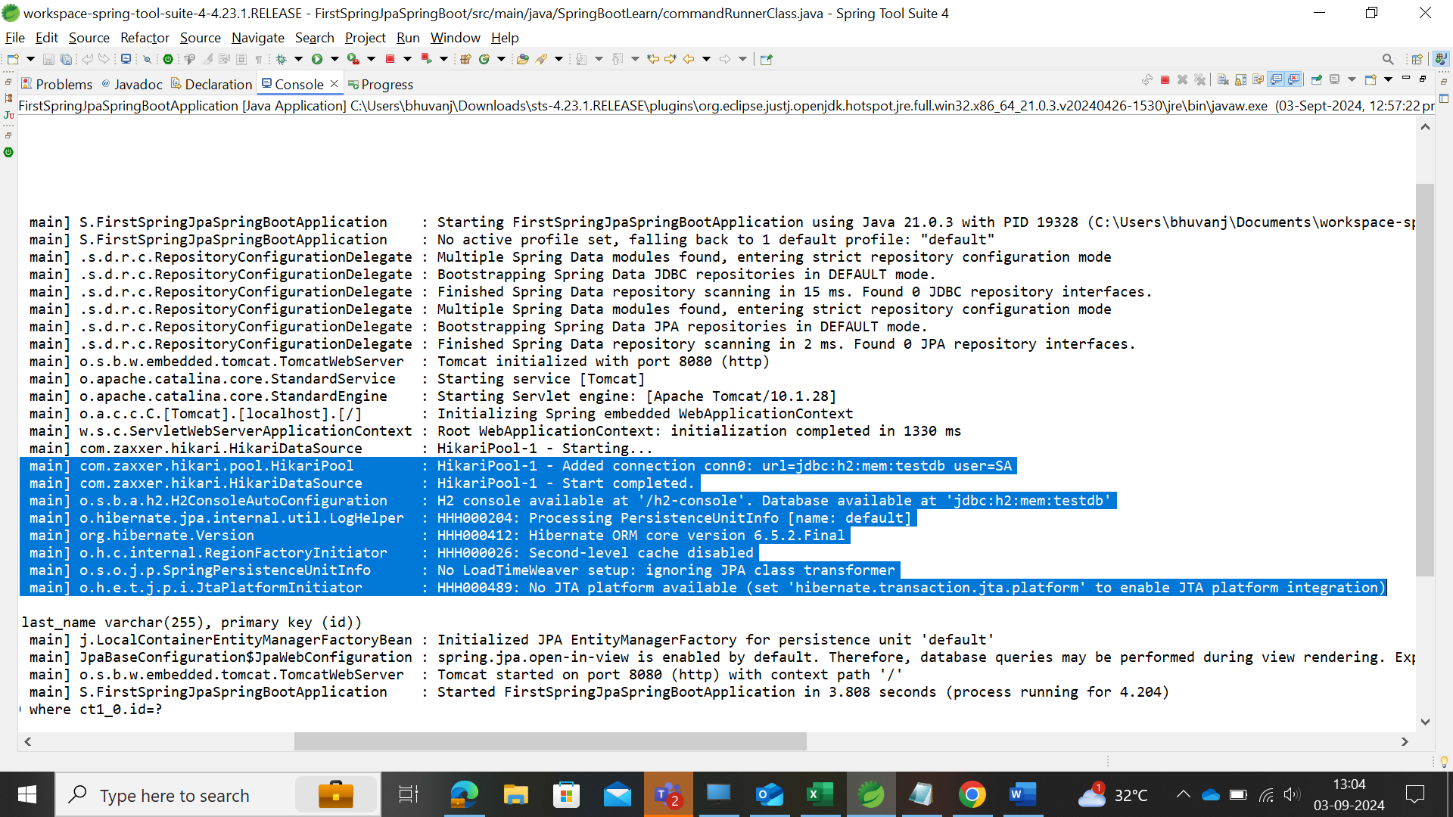

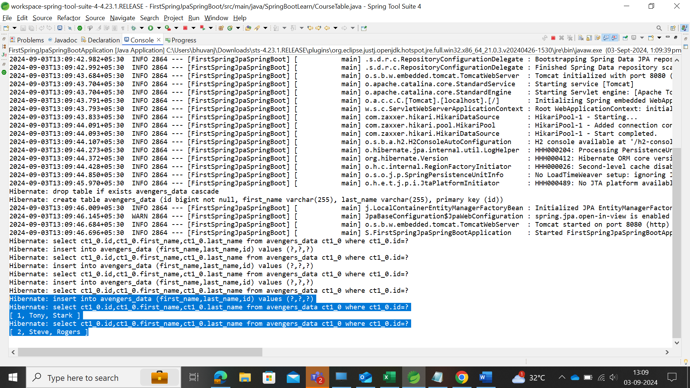

Application Properties – Prerequisites

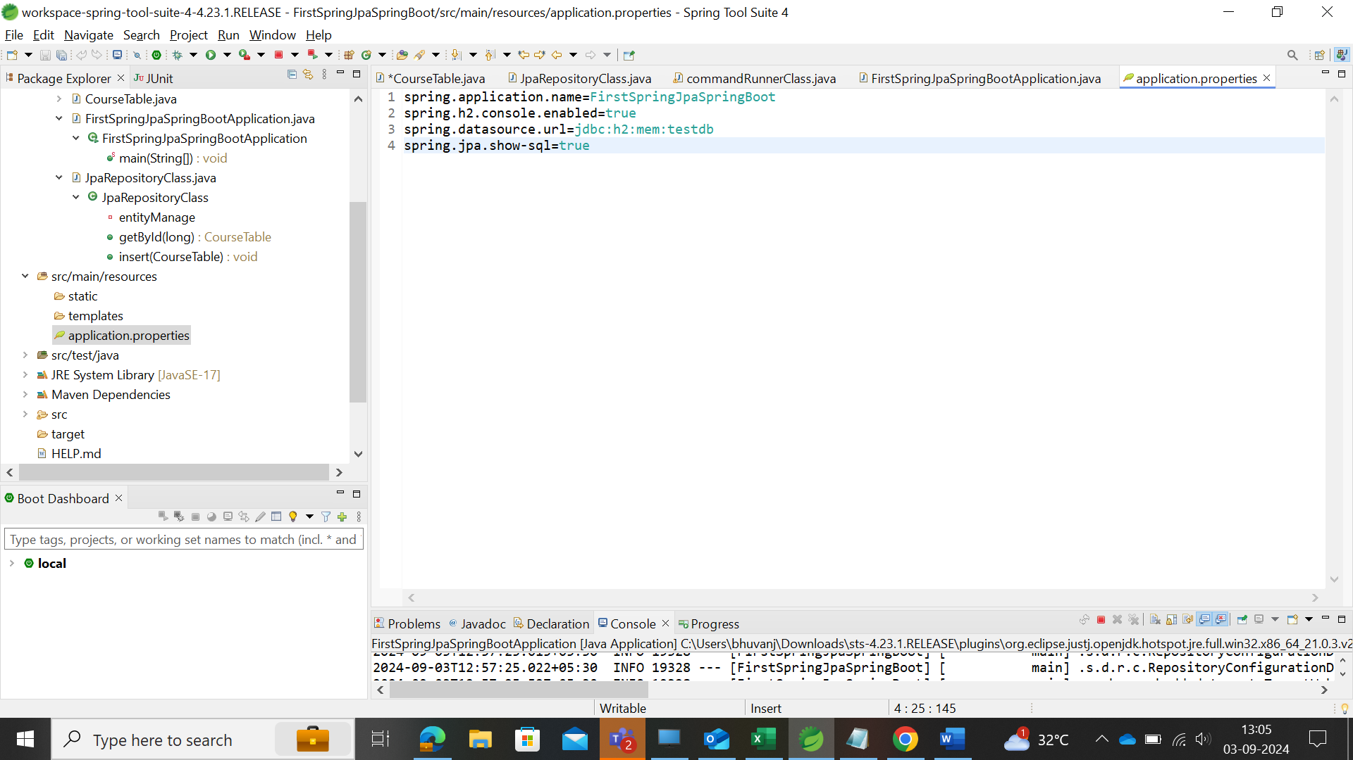

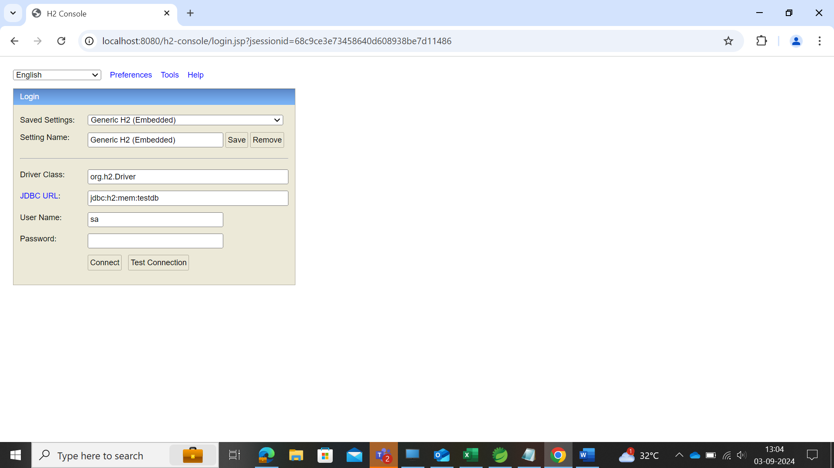

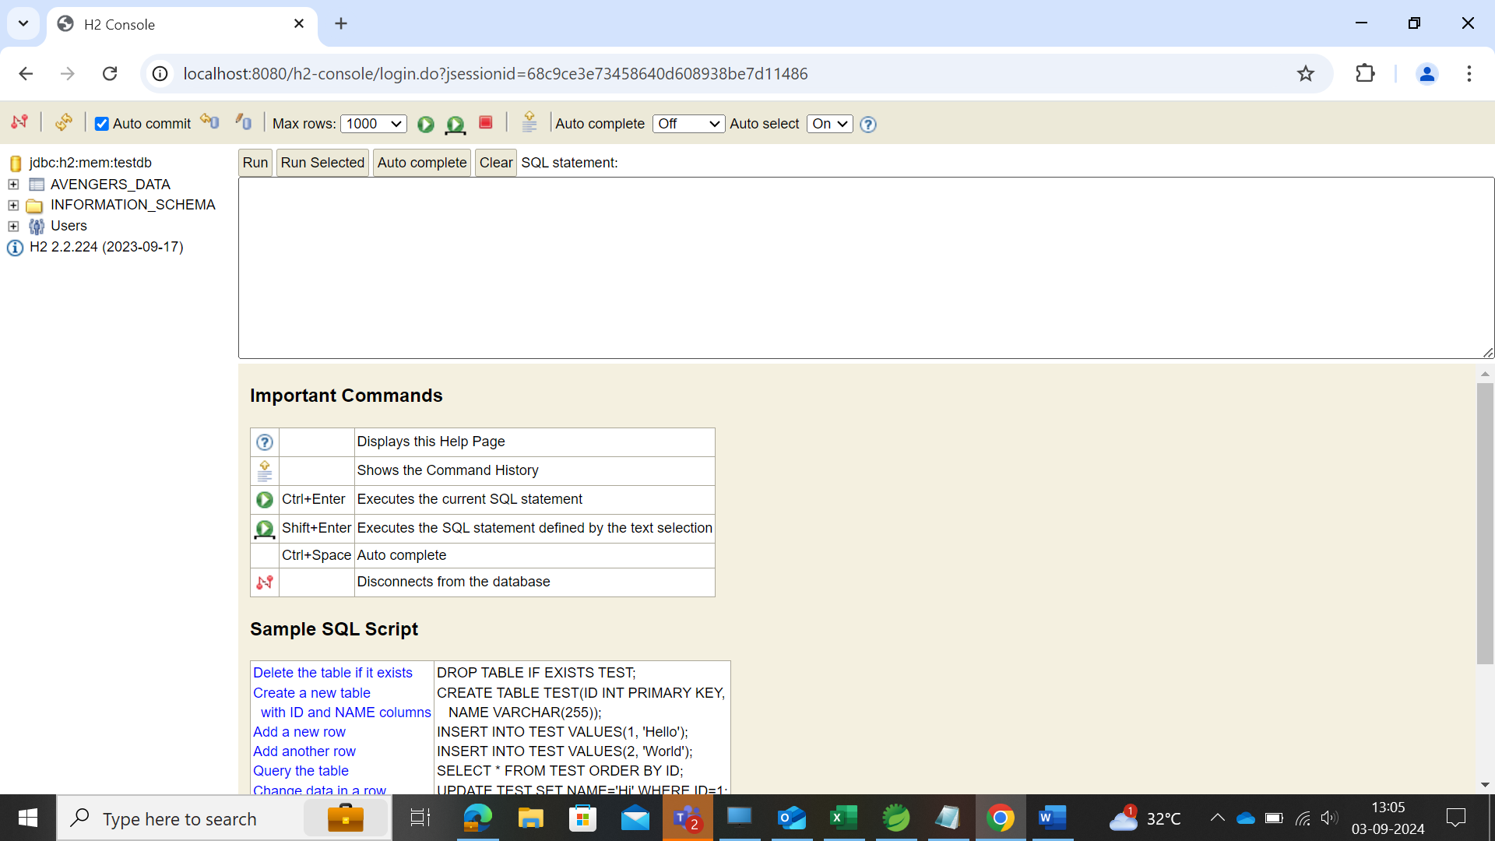

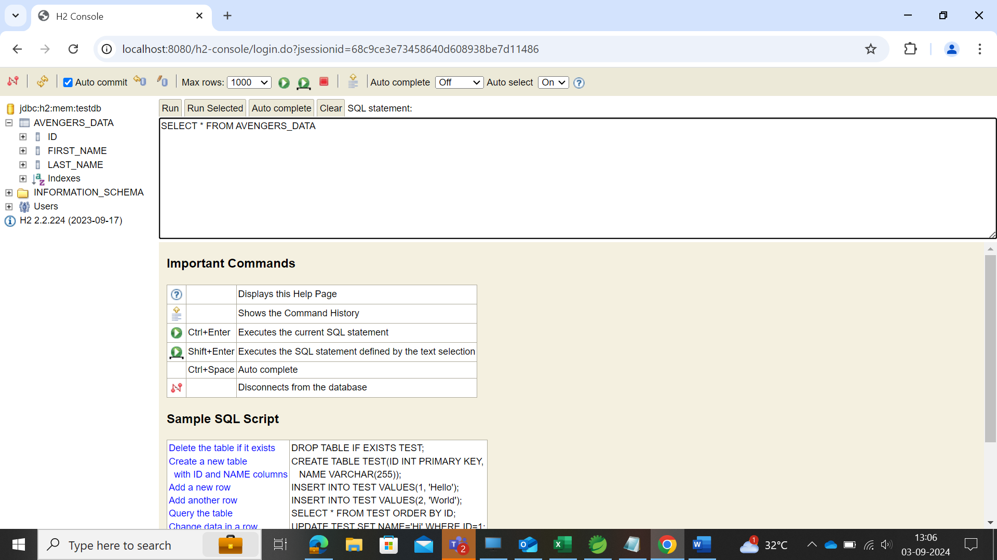

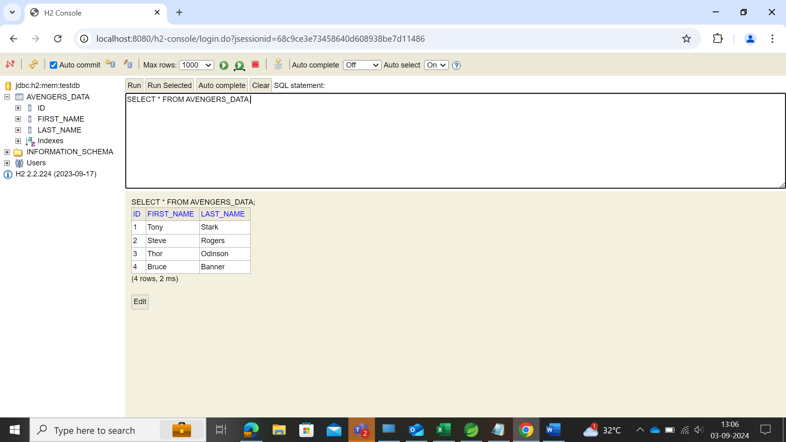

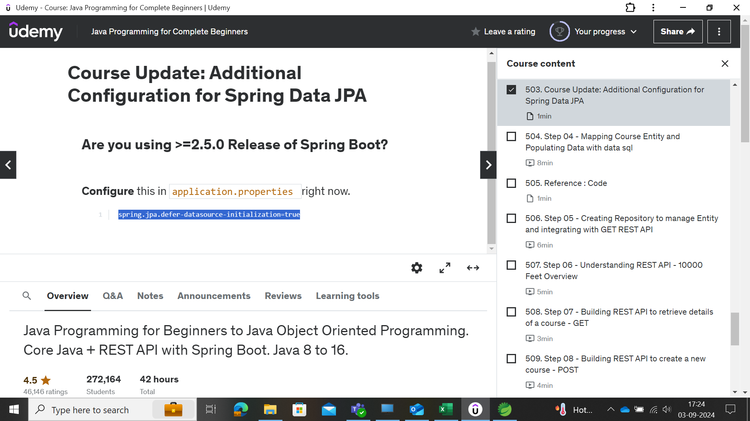

spring.jpa.defer-datasource-initialization=true